# Your Project Title Here

**Operationalizing Machine Leaning Pipeline**

As part of Udacity Machine Learning with Microsoft Azure Nano Degree program, we have to submit two projects to demonstrate operationalizing of Machine Learning pipeline.

We have performed two experiments:

i) Creating and operationalizing a pipeline using AutoML and Studio interface

ii) Creating and operationalizing a pipeline using Python SDK interface.

# Architectural Diagram

**PROJECT: OPERATIONALIZING MACHINE LEARNING**

**EXPERIMENT 1: PIPELINE AUTOMATION USING AUTOMATED ML AND STUDIO INTERFACE**

**Creating Machine Leaning experiment** using AutoML: Consuming bank marketing dataset

Configuring Compute cluster:

Using studio interface

Running Classification Experiment:

Using AUC_Weighted as metric

Select Best Model AND Deployment:

Enabling authentication and using Azure Container Instance

Enabling application insight:

Using Gitbash command line tool

Consume Model using Swagger:

Using Gitbash command line tool

Consume Model End Point:

Run python script with Rest API and Primark Key taken from studio interface. Check return values from model.

**EXPERIMENT 2: PIPELINE AUTOMATION USING AZURE SDK**

Consume Model End Point:

Publish and run from REST endpoint.

Select Best Model And Deployment:

1. Examining all model metrics
2. Selecting and testing model

Running Classification Experiment:

1. Identifying and reviewing dataset
2. ii) Creating pipeline and AutoML steps

**Creating Machine Leaning experiment** using Python SDK: It included

i) initializing Workspace ii) Creating Azure ML Experiment

Configuring Compute cluster:

Using Python SDK Attaching Aml Compute

## Screen Recording

https://www.youtube.com/watch?v=eI8ORMZt8Qc

**## Key Steps**

**PROJECT: OPERATIONALIZING MACHINE LEARNING**

**Experiment 1: PIPELINE AUTOMATION USING AUTOMATED ML AND STUDIO INTERFACE**

**Step 2**



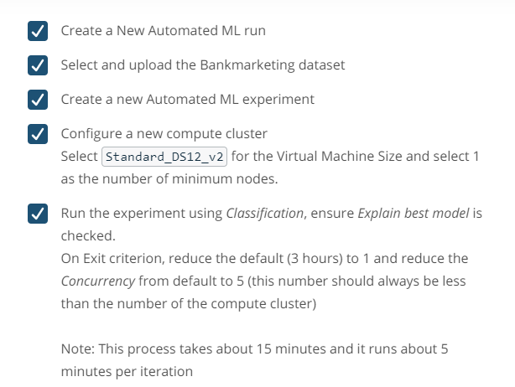

Evidence of work:

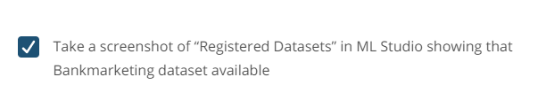

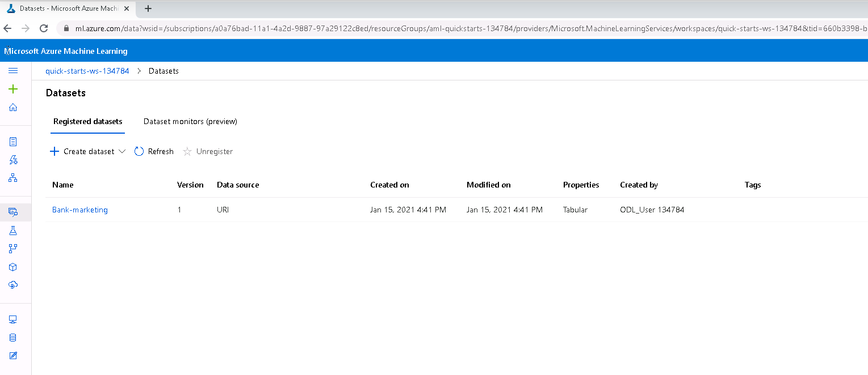

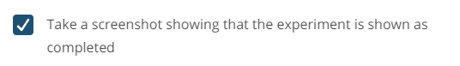

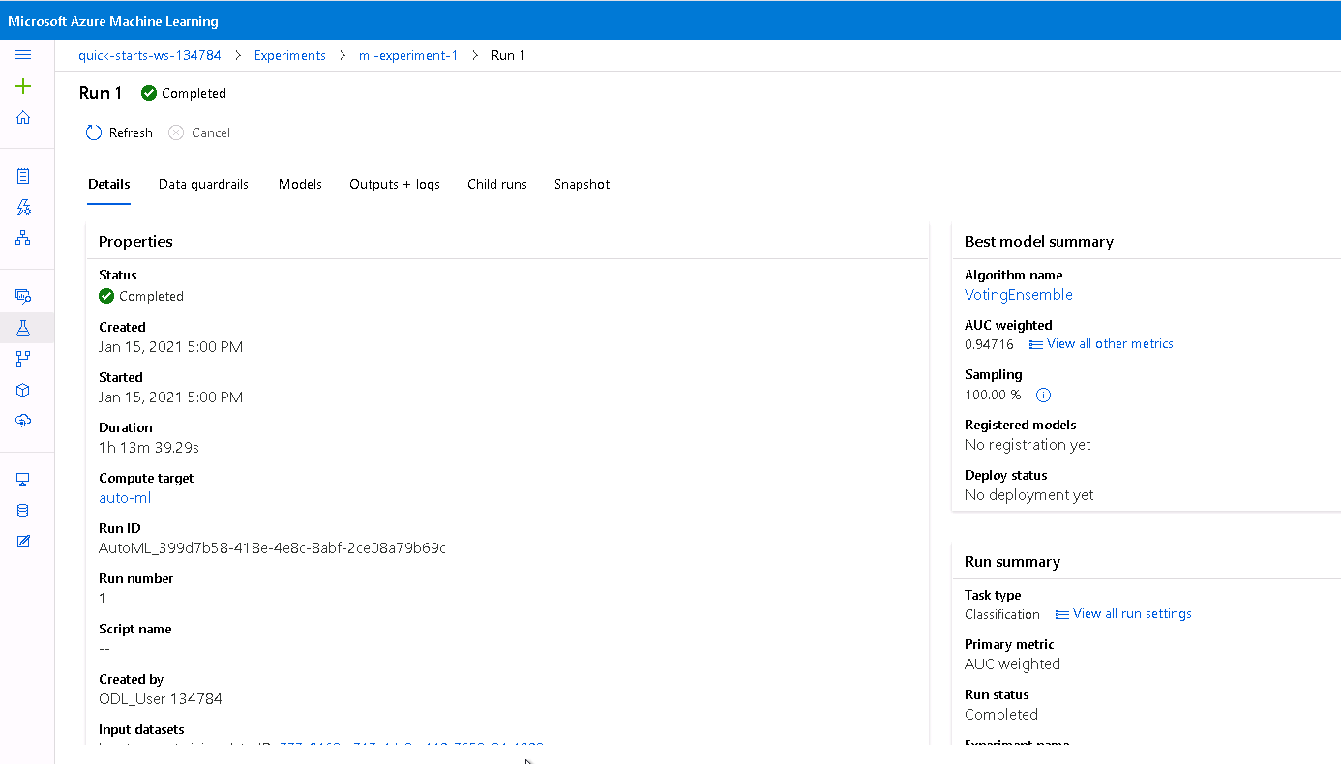



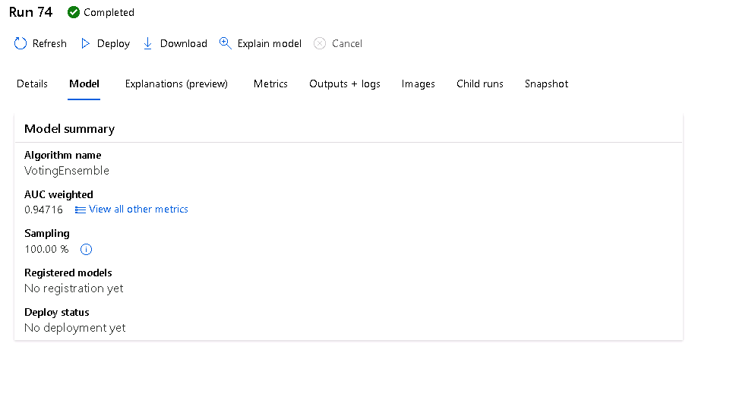

**Step 3**

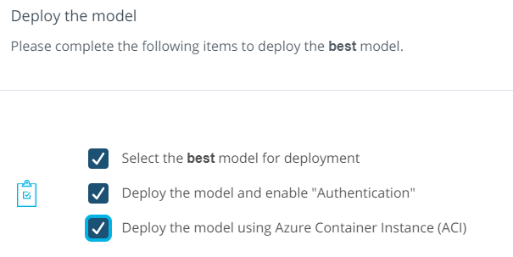

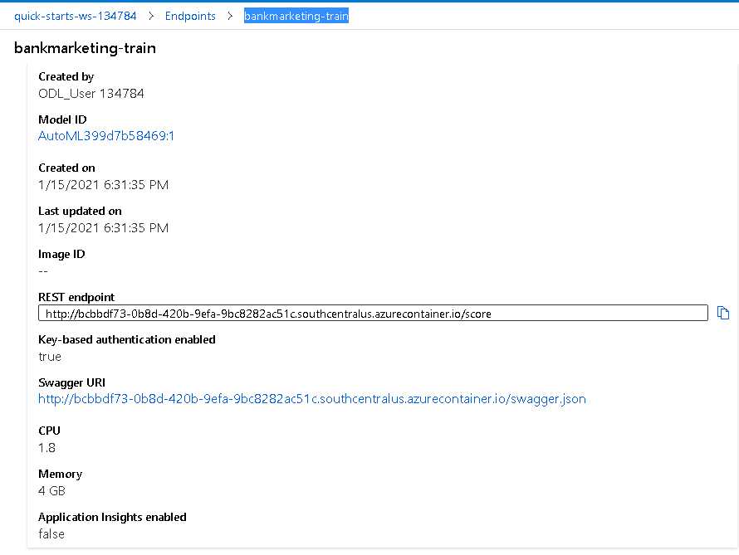

**Step 4**

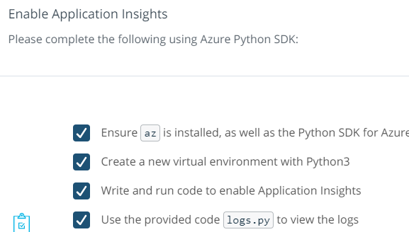

**Evidence of work**



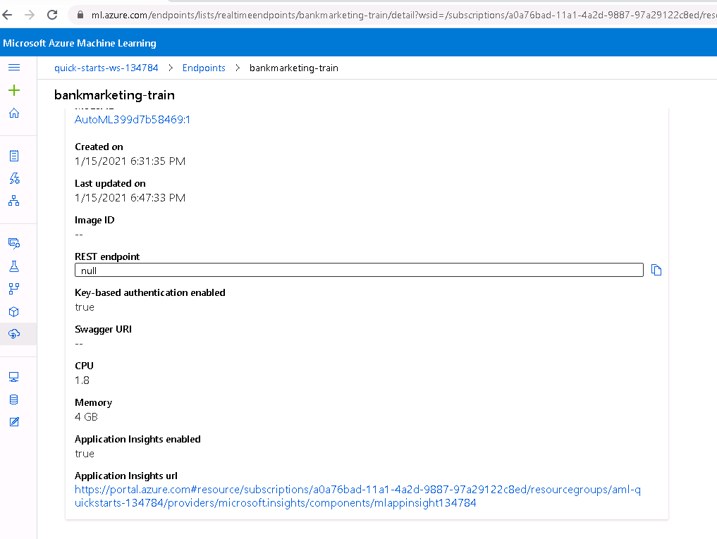

**insight monitoring**

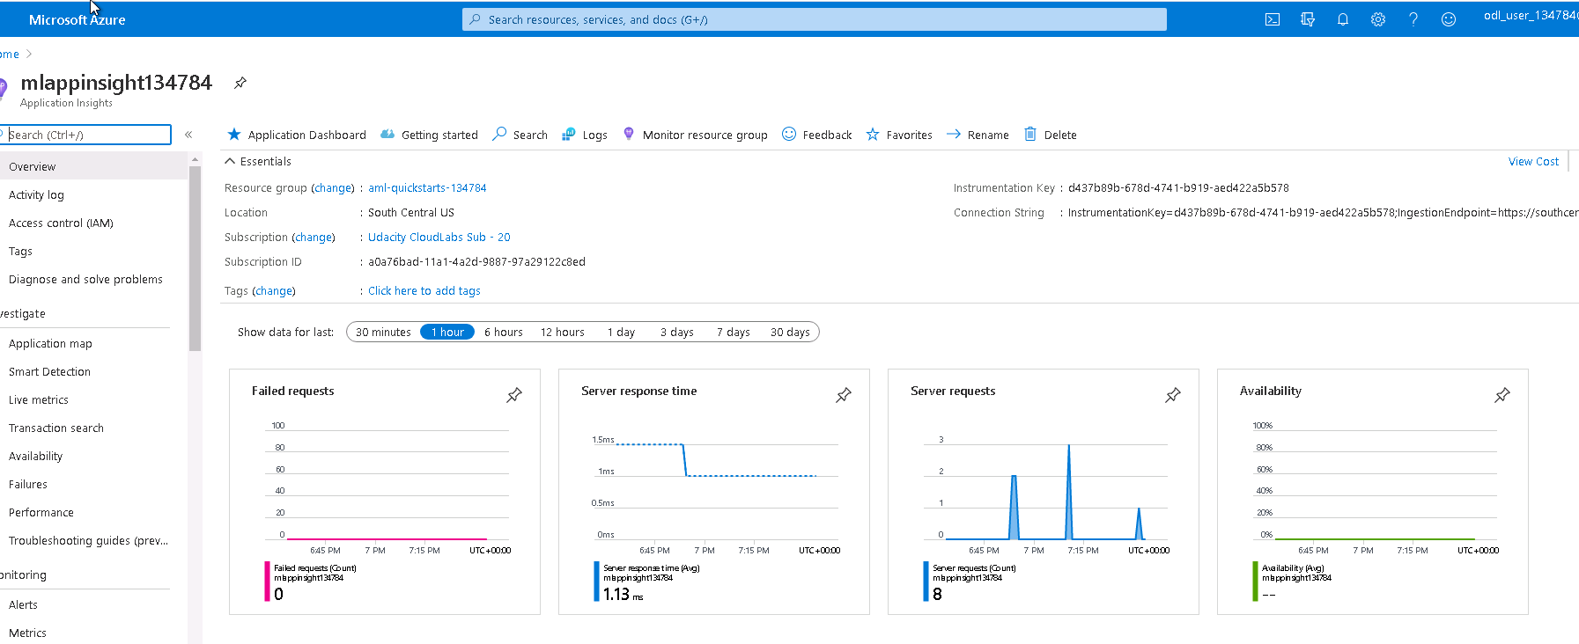

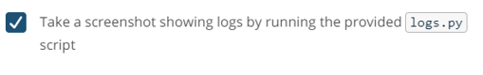

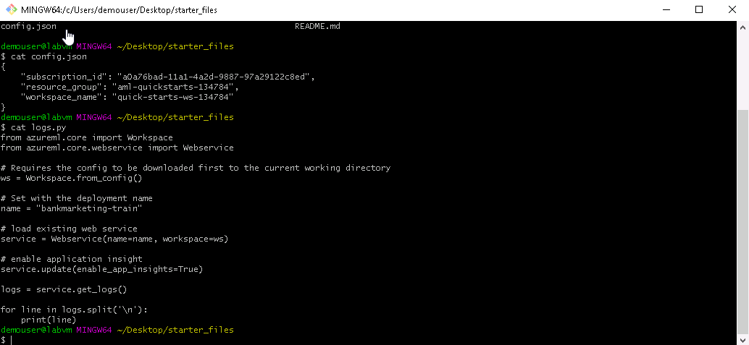

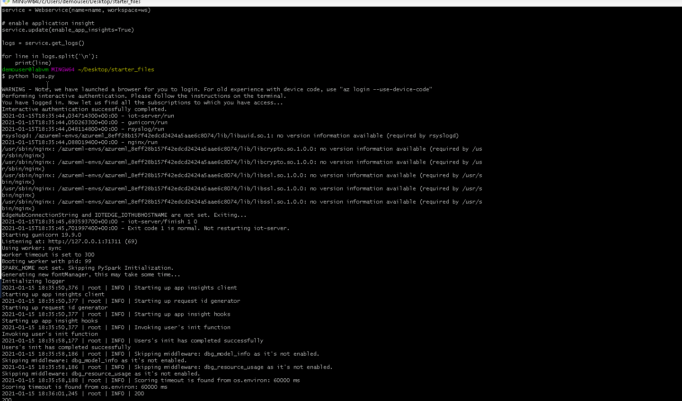

**Step 5**

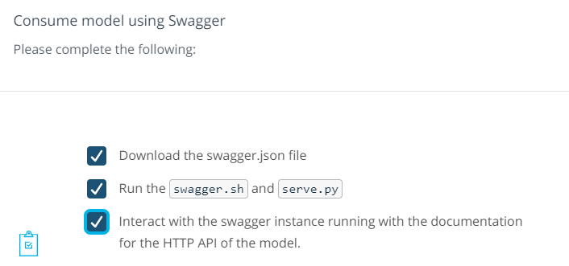

**Evidence**



**Swagger and serve files in Gitbash**

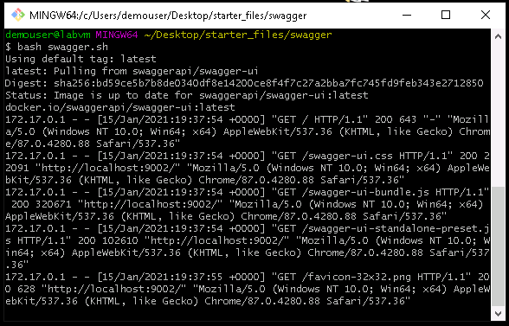

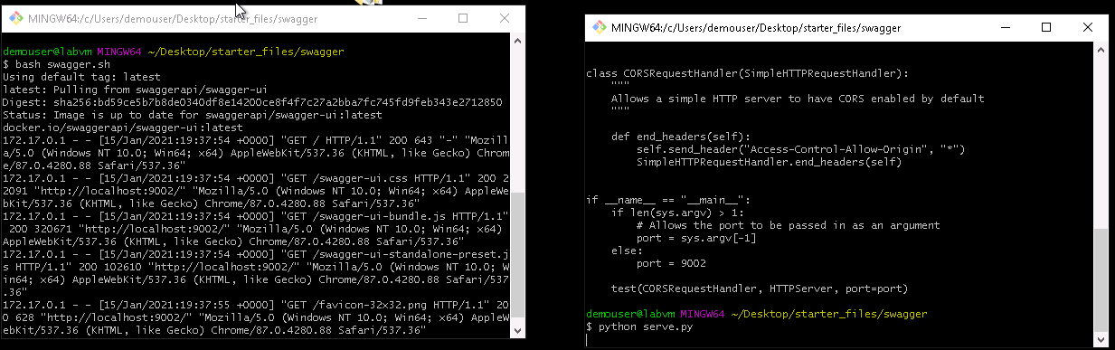

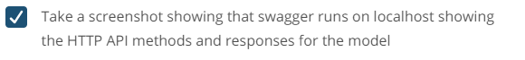

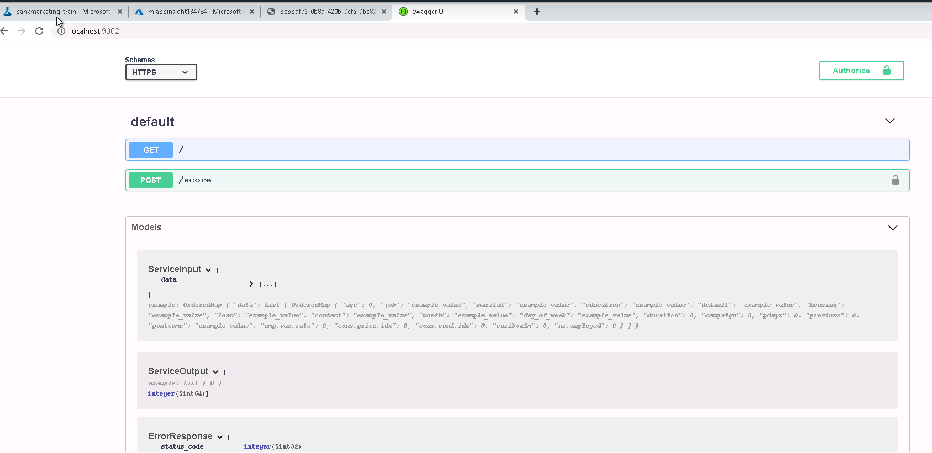

**Step 6**

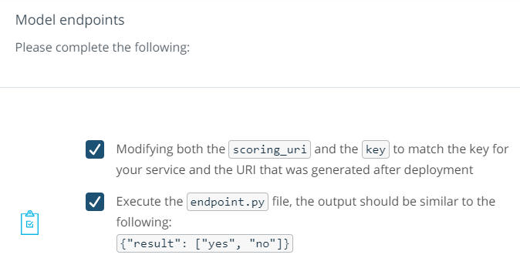

**Evidence**

Endpoint.py file with updated URL and primary keys from deployed model.

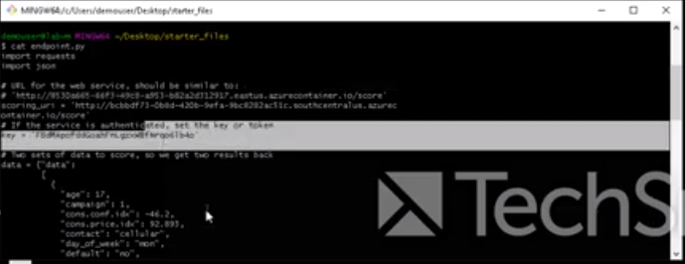

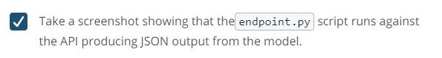

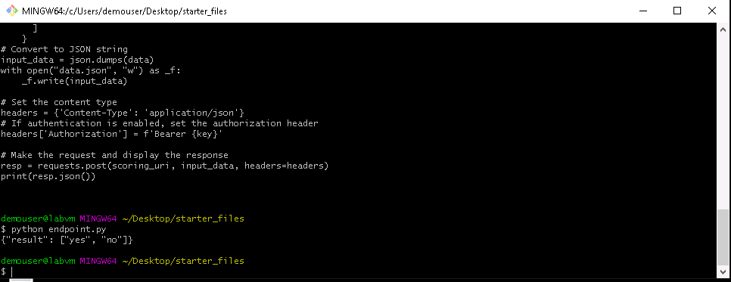

**EXPERIMENT 2: PIPELINE AUTOMATION WITH PYTHON SDK**

**Step 7**

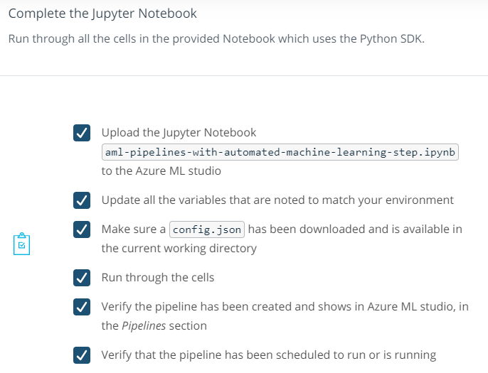

**Experiment run training models:**

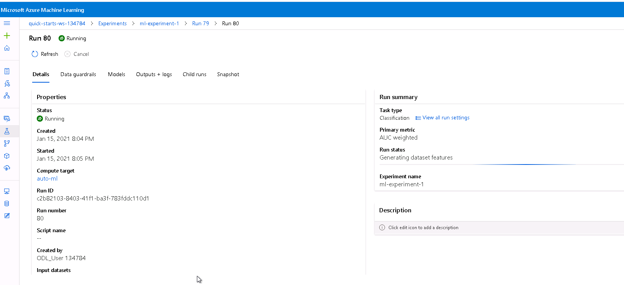

**Evidence**

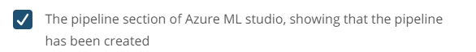

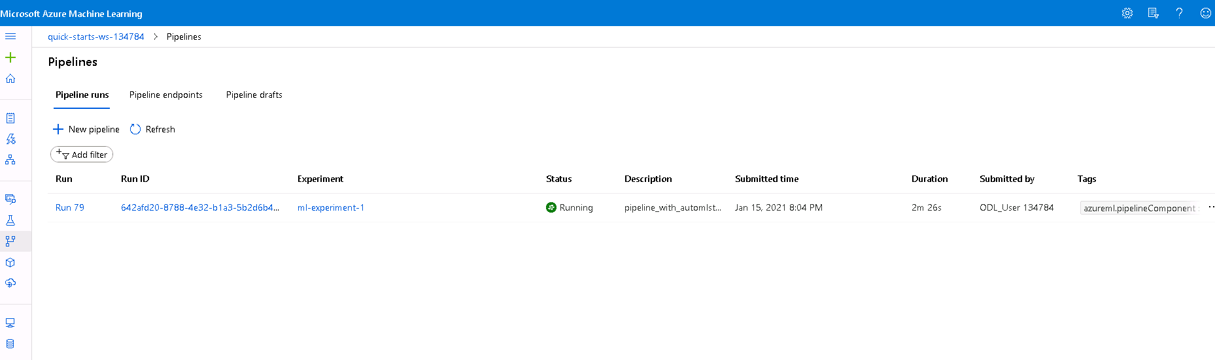

**Best Model Selected**

