


MILITARY COLLEGE OF SIGNALS
NATIONAL UNIVERSITY OF SCIENCES AND TECHNOLOGY

_{Open Ended Lab}

_{Software Construction}

Submitted By | Nabeel Shan
Date | November 11, 2025
Course | BESE 29 (C)
Semester | 5th – Fall 2025

Developing a TODO List Application in Java
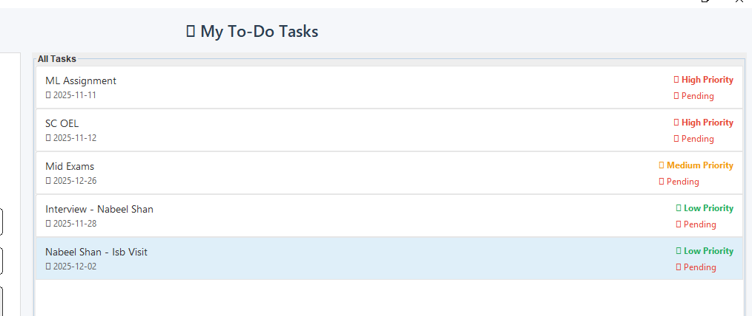

Abstract
This open-ended lab focuses on developing a Java-based desktop To-Do List Application that demonstrates object-oriented programming (OOP) principles such as abstraction, encapsulation, inheritance, and polymorphism. The project was implemented using Java Swing for the GUI, providing CRUD functionality (Create, Read, Update, Delete) and prioritization of tasks. The application enables users to add, modify, remove, and mark tasks as complete, offering a real-world implementation of OOP in a productivity tool context.

Objective
The primary objective of this lab is to design, investigate, and implement a functional To-Do List desktop application using the Java language. Specifically, this exercise aims to demonstrate:
- Effective application of object-oriented design principles and modern software engineering practices, fulfilling the Investigation (WA4/CLO2) target by analyzing requirements and designing an optimal architecture from multiple potential approaches.
- Proficient utilization of modern tools such as the IntelliJ IDEA, Git for version control, and the Java Swing framework, satisfying the Modern Tool Usage (WA5/CLO4) target. The goal is to deliver a maintainable, user-friendly desktop application that manages daily tasks with features like CRUD and task prioritization.

Tools and Technologies
Category | Tool/Technology | Rationale/Application
Programming Language | Java SE | Core language for OOP implementation.
IDE | IntelliJ IDEA | Selected for its advanced debugging, refactoring, and project management capabilities
GUI Framework | Java Swing | Utilized for building the cross-platform desktop UI.
Version Control | Git | Essential for tracking changes, managing branching, and ensuring codebase integrity.
Operating System | Windows 10 | Development and deployment environment.

System Design
The system employs a modular, layered OOP architecture to ensure high cohesion and low coupling, which was determined to be the best policy after considering monolithic and Model-View-Controller (MVC) alternatives.

Key System Components:
- TaskItem (Abstraction/Encapsulation): The base class representing a generic task, encapsulating fundamental attributes like description, dueDate, and isCompleted status, managed via controlled getter and setter methods.
- PriorityTask (Inheritance): Extends TaskItem and introduces the polymorphic priority attribute (an enum of Low, Medium, High). This demonstrates inheritance for feature extension.
- Main (Control Logic): Manages the primary GUI logic, user interaction, and state changes (CRUD operations) through event handling.
- EnhancedRenderer (Polymorphism/Design): A custom ListCellRenderer implementation that uses polymorphism to determine the rendering style (color, font, status icons) based on the task's status and priority, significantly enhancing user readability.
- RoundedBorder (Utility): A dedicated utility class for applying non-standard, modern UI visuals, demonstrating separation of concerns.

Class Diagram
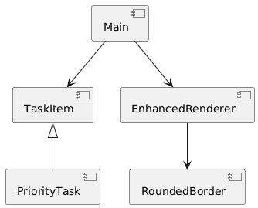

Flow Diagram
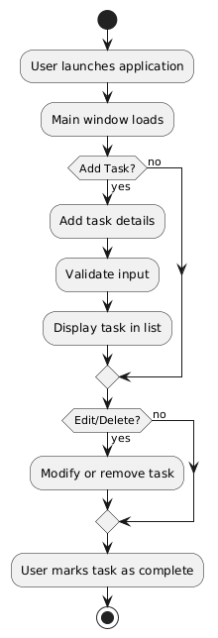

Implementation and Modern Tool Usage
The implementation utilized IntelliJ IDEA for streamlined development, leveraging its integrated debugger and dependency management.

OOP Principles in Code:
- Encapsulation: Task properties are protected and strictly accessed via public methods (e.g., setCompletionStatus(boolean)).
- Inheritance: PriorityTask inherits all base task logic from TaskItem, reducing code redundancy.
- Polymorphism: Utilized in the EnhancedRenderer where the display logic changes (is polymorphic) depending on the task's type and status without explicit type checking in the main logic loop.

Graphical User Interface (GUI) and Features
The UI was constructed with Java Swing components. This framework was selected over JavaFX for its simpler integration with basic desktop applications.
Feature Category | Description
CRUD Operations | Dedicated buttons for Add, Edit, Delete, and Change Status enable full task management.
Task Prioritization | A dedicated dropdown (JCombo Box) allows assigning Low, Medium, or High priority, visually reflected in the styled task list.
User Feedback | Utilized 'Toast-style' messages for non-intrusive feedback on successful operations (e.g., "Task Added Successfully").
Modern UI | Implementation of RoundedBorder and dynamic component colors to enhance user experience beyond default Swing aesthetics.

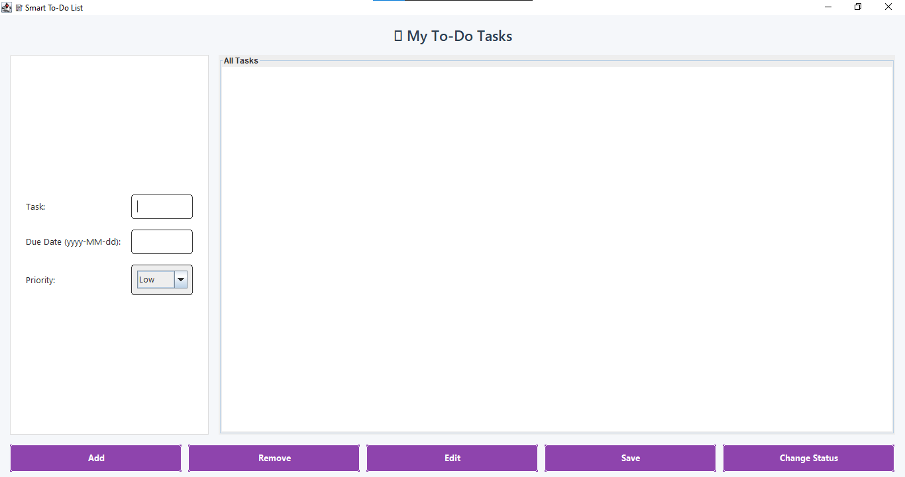
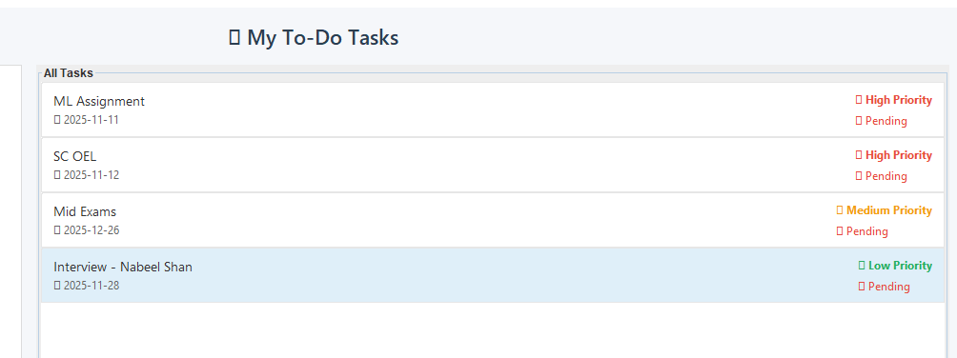

Version Control and Collaboration
Git was the mandatory tool for version control. All development steps were compartmentalized:
- Initial setup and core logic were committed to the main branch.
- Feature additions (e.g., Task Prioritization) and UI improvements were developed on separate, descriptive branches (e.g., feature/task-priority, fix/ui-styling).
- The commit history is traceable and descriptive, demonstrating professional-level version control practices.

Conclusion
This open-ended lab provided invaluable, hands-on experience in applying Object-Oriented Programming (OOP) concepts and utilizing modern development tools (IntelliJ, Git). The development of the To-Do List application reinforced key concepts like abstraction, modularity, and GUI-based user interaction.

