

**Word Journal Of ENT & Head-Neck Surgery (WJEHNS) ISSN 2320-6691 (Online)**

**©Chittaranjan Otorhinolaryngologists Society, India www.wjehns.com**

Angiokeratoma of tongue and scrotum - A rare combination

Dr.****,Department of

Dr****,Department of

**Abstract:** Angiokeratoma is a benign cutaneous vascular disorder of the papillary dermis. Involvement of oral mucosa can be an isolated presentation or in combination with a cutaneous lesion or a component of systemic disorder such as Fabry’s disease. Clinically, the lesion presents as an irregular, pinkish red papule. The etiological factors include trauma or chronic irritation to the wall of papillary dermis. Histologically, it is characterized by hyperkeratosis, acanthosis and dilated vascular spaces with or without organizing thrombi in papillary dermis. Angiokeratomas generally involves the skin. We report this case as a rare presentation due to its involvement in tongue and scrotum without any systemic manifestations.

**Key words**: Angiokeratoma, tongue, scrotum.

Angiokeratomas are a group of rare telangiectasias with prominent epidermal response in the form of hyperkeratosis. They commonly present as red – blue, hyperkeratotic papules measuring about 1-6 mm in size, as solitary lesion or in groups on the skin of the lower limbs, abdomen, trunk, tongue, scrotum and shaft of penis or labia majora. [1]

The prevalence of angiokeratoma of scrotum is poorly described in literature as the lesions often go unnoticed. However, few authors have described

that the prevalence rate increases from 0.6% to 16.6% with increase in age. These lesions occur most commonly in males, with Caucasian and Japanese race being predominantly affected.[2]

Angiokeratoma involving tongue and scrotum with systemic involvement is seen in Fabry’s disease or fucosidosis. These lesions occurring without systemic manifestation seem to be a rather infrequent occurrence and we came across only 5 articles after a thorough search in PubMed. [3-7]

We hereby report a sixth case of above mentioned clinical scenario.

**Case report**:

A 35 year old gentleman with an otherwise unremarkable medical history presented to the Dermatology OPD of our institute with one and half years history of multiple, red, raised lesions over the scrotum. He was referred to ENT OPD as he had similar lesions on the tongue for a year. These lesions were painless, progressive and bled occasionally on trivial trauma. There was no history of local trauma or systemic complaints.

Examination of tongue revealed multiple, tiny, red colored, grouped papular lesions coalescing to form a plaque of about 4x3cm on the posterior part of anterior 2/3rd of dorsum of tongue involving the sulcus terminalis. The lesions were firm in consistency and bled on manipulation.

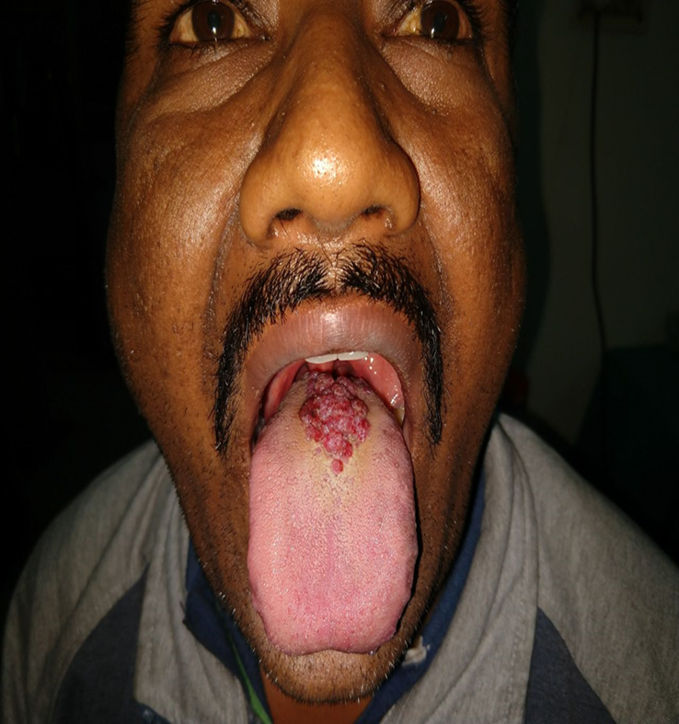

Figure 1: Lesions on the dorsum of the tongue

On scrotal examination there were multiple, discrete and grouped, red to black colored, dome shaped papular and nodular lesions, diffusely distributed over the scrotum and shaft of penis. Lesions measured about 0.2 - 0.5 cm. On palpation, lesions were firm in consistency and did not bleed. There were no visible varicose veins over the scrotum.



Figure 2: Lesions on the scrotum and shaft of the penis

Systemic examination of the patient did not reveal any abnormality.

After haematological and serological work up, an incision biopsy from lesions of the tongue was taken and subjected to histopathological examination. On histology, the microsection showed stratified squamous epithelium lined tissue with acanthosis. Numerous dilated blood vessels were noted within the epidermis with no evidence of malignancy. Biopsy taken from scrotal lesion was also consistent with above findings. Diagnosis of angiokeratoma was proven.

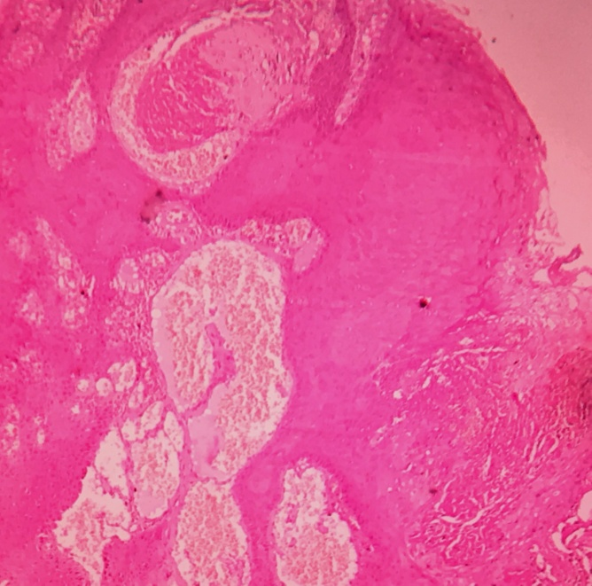

Figure 3: Photomicrography of angiomatous growth over the tongue showing stratified squamous epithelium lined tissue with dilated vascular spaces within epithelium. (Magnification 100 X Haematoxylin and eosin stain)

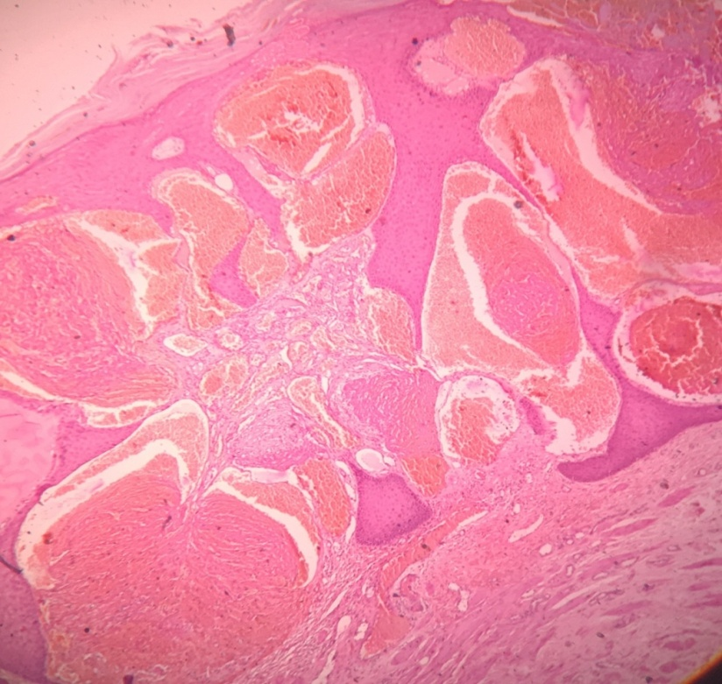

Figure 4: Photomicrography of angiomatous growth over the scrotum showing stratified squamous epithelium lined tissue which shows acanthosis with numerous dilated blood vessels noted within epidermis. (Magnification 100 X Haematoxylin and eosin stain)

Patient was counseled about the benign nature of the disease and was explained about the treatment modalities. Patient opted for sclerosant therapy. Patient was treated with Inj. Sodium tetra decyl sulphate (60mg/2ml ampoule), 1ml (30 mg) intra-lesionally per week for 4 weeks. Patient was assessed at the end of every week and satisfactory treatment was obtained at the end of fourth dose of sclerosant.

Electrocautery was planned for scrotal lesions.

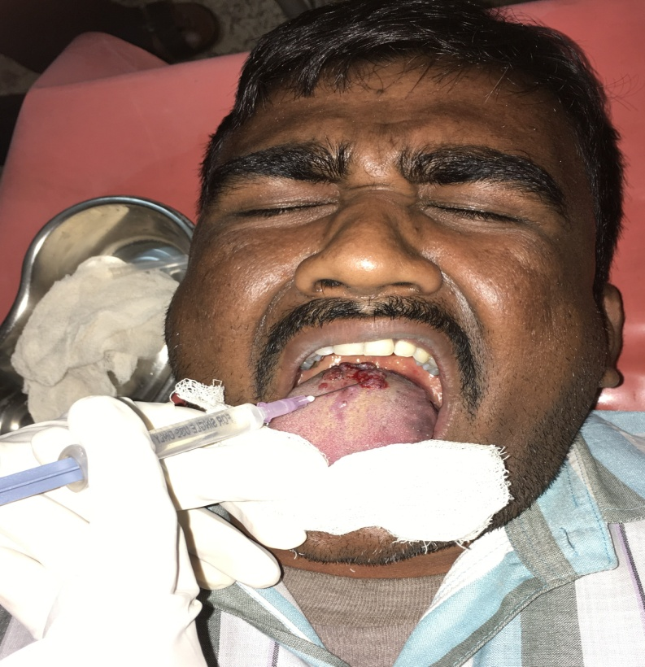

Figure 5: Injection of sclerosant

**Discussion:**

Angiokeratoma is an acquired, benign vascular lesion characterized by dilated blood vessels lying below the epidermis. [8] The epidermal changes are secondary and are characterized by hyperkeratosis and acanthosis. Pathogenesis is unknown. It might be due to local injury to dermal capillary papillaries and venous hypertension. It can be localized or generalized based on which they are classified into five clinical types. (i) Angiokeratoma corporis diffusum of Fabry - a metabolic disorder with widespread angiokeratoma like lesions with systemic involvement. (ii) Angiokeratoma of Mibelli - commonly seen in females with autosomal dominant inheritance. It is characterized by papules occurring on the dorsum of fingers and toes. (iii) Angiokeratoma of Fordyce – most common form seen in middle aged and older patients. It presents as red papules on scrotum. (iv) Solitary papular angiokeratoma – appears between second and fourth decade of life as a response to trauma. (v) Angiokeratoma circumscriptum- It is congenital and is associated with cavernous haemangioma. [9]

Angiokeratoma involving the scrotum was first described by Fordyce in 1896. [10].The lesions are usually multiple and are located mainly on the scrotum. Occasionally they can also be found on the shaft or glans of the penis.

Angiokeratoma involving only the oral cavity is rare. It commonly occurs as a part of systemic disease and usually involves the dorsum or lateral border of tongue. Etiology is attributed to trauma, high venous pressure, or vascular malformation. [11].The primary event is vascular ectasia within the papillary dermis just below the basement membrane. Proliferation of the epithelium occurs because of its close proximity to the vascular spaces. [9, 12]

Review of literature shows only few articles describing angiokeratoma of the oral cavity associated with angiokeratoma of scrotum. Fabry’s disease and fucosidosis are the metabolic disorders wherein mucosa is involved along with systemic manifestations. Rappaport I et al [7] described involvement of mucosa of jejunum along with oral and scrotal lesions. Our patient did not present with any systemic involvement.

Lesions can be treated with simple excision, cryosurgery, electrodesiccation, or lasers (KTP laser or argon laser, Co2 with pulsed dye laser). We employed local application of sclerosant as it was simple, cost effective, does not need general anaesthesia, can be done as an outpatient procedure and does not need a sophisticated set-up unlike lasers or cryosurgery. [13] The only disadvantage was the pain associated with local infiltration of sclerosant and weekly visits which definitely outweighs the cost and expertise involved in latest modalities of treatment.

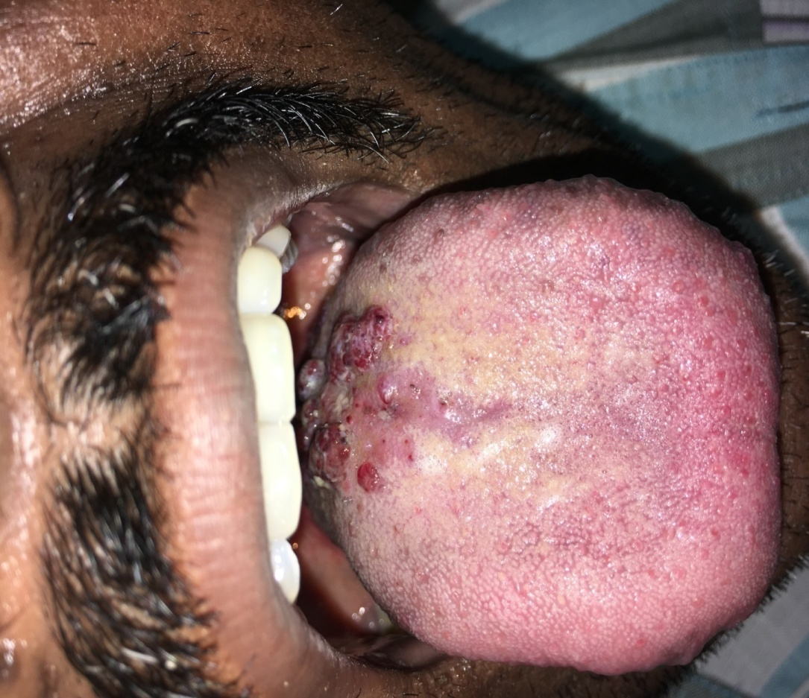

Figure 5: Response after 2nd dose of sclerosant injection

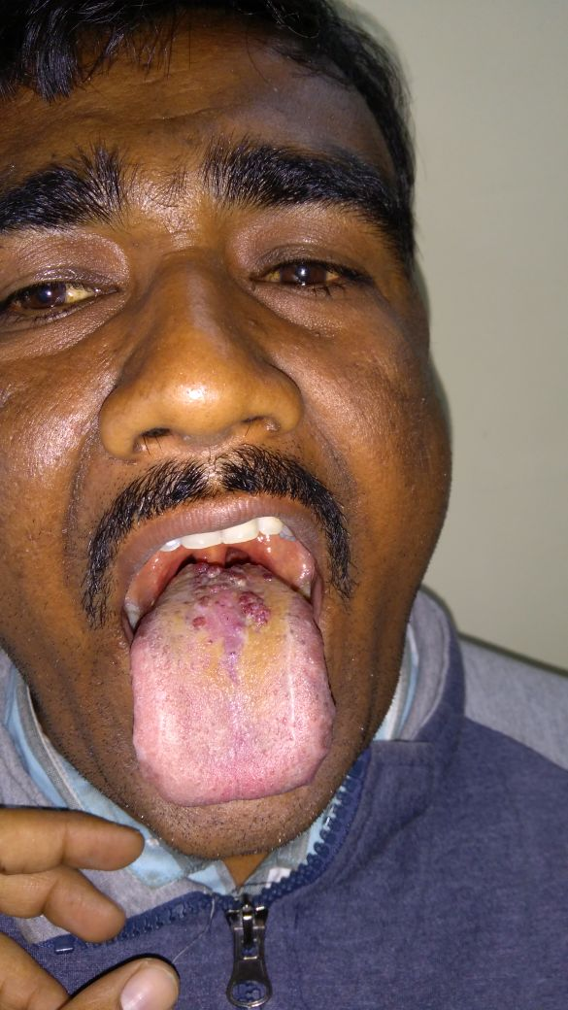

Figure 6: Response after 3rd dose of sclerosant injection

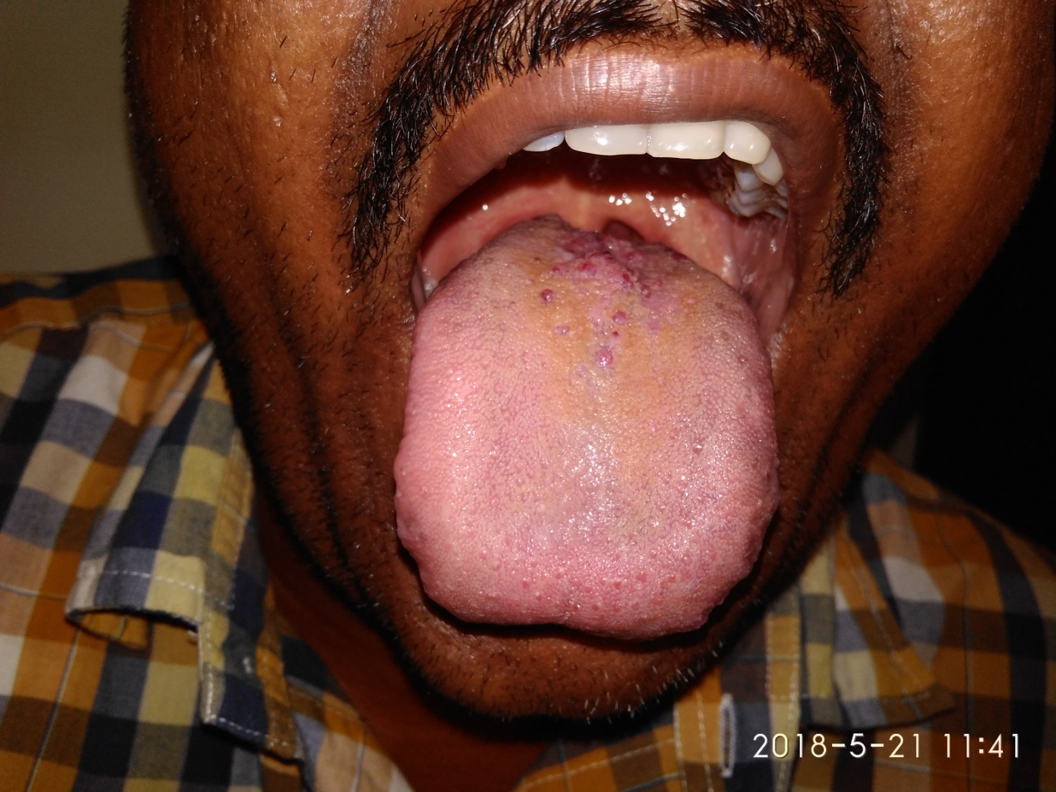

Figure 7: Response after 4th dose of sclerosant injection

Thorough search for associated disorders which can increase the scrotal venous pressure and lead to vascular ectasia should be kept in mind and looked for, particularly varicocele or inguinal hernia. Treatment of such underlying cause would lead to regression of the lesions.

In our patient, however, there was no such precipitating factor. There has been no recurrence of the lesion after a period of one year.

**Conclusion:**

Angiokeratomas of the oral cavity along with scrotum are rare vascular lesions. Although they can appear as isolated lesions, their presence should prompt further investigations to rule out systemic disease. Even with advances in the modern medicine, sclerosants still play an efficient role in the treatment of vascular lesions in developing countries.

**Declaration of patient consent:**

The authors certify that they have obtained all appropriate patient consent forms. In the form the patient has given his consent for images and other clinical information to be reported in the journal. The patient understands that his name and initial will not be published and due efforts will be made to conceal his identity but anonymity cannot be guaranteed.

Financial support and sponsorship – Nil.

Conflicts of interest – No.

Address of correspondent:

**References**

1. Erkek E, Basar M M, Bagci Y. et al Fordyce angiokeratomas as clues to local venous hypertension. Arch Dermatol. 20051411325–1326. [[PubMed](https://www.ncbi.nlm.nih.gov/pubmed/16230581)]

2. Atherton D J, Moss C. Naevi and other developmental defects. In: Burns T, Breathnach S, Cox N, et al eds. Rook's textbook of dermatology. Oxford: Blackwell 200489–90.

3. [Pahwa P](https://www.ncbi.nlm.nih.gov/pubmed/?term=Pahwa%20P%5BAuthor%5D&cauthor=true&cauthor_uid=22707780), [Meena D](https://www.ncbi.nlm.nih.gov/pubmed/?term=Meena%20D%5BAuthor%5D&cauthor=true&cauthor_uid=22707780), [Tanveer N](https://www.ncbi.nlm.nih.gov/pubmed/?term=Tanveer%20N%5BAuthor%5D&cauthor=true&cauthor_uid=22707780), [Sharma VK](https://www.ncbi.nlm.nih.gov/pubmed/?term=Sharma%20VK%5BAuthor%5D&cauthor=true&cauthor_uid=22707780), [Sethuraman G](https://www.ncbi.nlm.nih.gov/pubmed/?term=Sethuraman%20G%5BAuthor%5D&cauthor=true&cauthor_uid=22707780). Punctate vascular papules on the tongue and scrotum. [Indian J Dermatol.](https://www.ncbi.nlm.nih.gov/pubmed/22707780) 2012 May; 57(3):228-9.

4. [Jansen T](https://www.ncbi.nlm.nih.gov/pubmed/?term=Jansen%20T%5BAuthor%5D&cauthor=true&cauthor_uid=12353715), [Bechara FG](https://www.ncbi.nlm.nih.gov/pubmed/?term=Bechara%20FG%5BAuthor%5D&cauthor=true&cauthor_uid=12353715), [Stücker M](https://www.ncbi.nlm.nih.gov/pubmed/?term=St%C3%BCcker%20M%5BAuthor%5D&cauthor=true&cauthor_uid=12353715), [Altmeyer P](https://www.ncbi.nlm.nih.gov/pubmed/?term=Altmeyer%20P%5BAuthor%5D&cauthor=true&cauthor_uid=12353715). Angiokeratoma of the scrotum (Fordyce type) associated with angiokeratoma of the oral cavity. [Acta Derm Venereol.](https://www.ncbi.nlm.nih.gov/pubmed/12353715) 2002; 82(3):208-10.

5. [Karthikeyan K](https://www.ncbi.nlm.nih.gov/pubmed/?term=Karthikeyan%20K%5BAuthor%5D&cauthor=true&cauthor_uid=10721665), [Sethuraman G](https://www.ncbi.nlm.nih.gov/pubmed/?term=Sethuraman%20G%5BAuthor%5D&cauthor=true&cauthor_uid=10721665), [Thappa DM](https://www.ncbi.nlm.nih.gov/pubmed/?term=Thappa%20DM%5BAuthor%5D&cauthor=true&cauthor_uid=10721665). Angiokeratoma of the oral cavity and scrotum. [J Dermatol.](https://www.ncbi.nlm.nih.gov/pubmed/10721665) 2000 Feb; 27(2):131-2.

6. [Miller DA](https://www.ncbi.nlm.nih.gov/pubmed/?term=Miller%20DA%5BAuthor%5D&cauthor=true&cauthor_uid=5636063), [Akers WA](https://www.ncbi.nlm.nih.gov/pubmed/?term=Akers%20WA%5BAuthor%5D&cauthor=true&cauthor_uid=5636063). Multiple phlebectasia of the jejunum oral cavity, and scrotum. [Arch Intern Med.](https://www.ncbi.nlm.nih.gov/pubmed/5636063) 1968 Feb; 121(2):180-2.

7. Rappaport I, Shiffman MA. Multiple phlebectasia involving jejunum oral cavity, and scrotum. JAMA. 1963;185:437–40. [[PubMed](https://www.ncbi.nlm.nih.gov/pubmed/13973122)]

8. Braverman IM, Keh-Yen A. Ultrastructural and three dimentional reconstruction of several macular and popular telangiectasias. J Invest Dermatol. 1983:81:489-97.

9. Schiller PI, Itin PH. Angiokeratomas: an update. Dermatology. 1996;193:275-82.

10. Fordyce JA. Angiokeratoma of the scrotum. J Cutan Dis 1896; 14: 81–89.

11. M. J. Fern´andez-Ace˜nero, J. R. Biel, and G. Renedo, “Solitary angiokeratoma of the tongue in adults,” *Romanian Journal of* *Morphology and Embryology*, vol. 51, no. 4, pp. 771–773, 2010.)

12. H. K. Kar and L. Gupta, “A case report of Angiokeratoma circumcriptum of the tongue, response with carbon dioxide and pulsed dye laser,” *Journal of Cutaneous and Aesthetic Surgery*,

vol. 4, pp. 205–207, 2011.

13. [Hopp RN](https://www.ncbi.nlm.nih.gov/pubmed/?term=Hopp%20RN%5BAuthor%5D&cauthor=true&cauthor_uid=23600987), [de Siqueira DC](https://www.ncbi.nlm.nih.gov/pubmed/?term=de%20Siqueira%20DC%5BAuthor%5D&cauthor=true&cauthor_uid=23600987), [Sena-Filho M](https://www.ncbi.nlm.nih.gov/pubmed/?term=Sena-Filho%20M%5BAuthor%5D&cauthor=true&cauthor_uid=23600987), [Jorge J](https://www.ncbi.nlm.nih.gov/pubmed/?term=Jorge%20J%5BAuthor%5D&cauthor=true&cauthor_uid=23600987). Oral vascular malformation in a patient with hereditary hemorrhagic telangiectasia: a case report. [Spec Care Dentist.](https://www.ncbi.nlm.nih.gov/pubmed/23600987) 2013 May-Jun; 33(3):150-3.