DATABASE SYSTEM (CS-532)

Project 2: Retail Business Management System

Team Report

Nabha kumthekar ([nkumthe1@binghamton.edu](mailto:nkumthe1@binghamton.edu))

Nikhil Chaudhari([nchaudha1@binghamton.edu](mailto:nchaudha1@binghamton.edu))

Abhijit Fulsagar ([afulsag1@binghamton.edu)](mailto:afulsag1@binghamton.edu))

**INTRODUCTION:**

The project is to use Oracle’s PL/SQL and JDBC to implement the Retail Business Management System (RBMS). Java Swing is used to develop graphical user interface (GUI). It is an application software which helps in maintaining the details of retail businesses which includes information regarding customers, employers, suppliers, products and the purchases made by the customers.

**IMPLEMENTATION DETAILS:**

The implementation is done in 3 parts,

1. PL/SQL Procedure, Functions and Triggers.
2. Interface using Java and JDBC.
3. GUI using Java Swing.

**PL/SQL IMPLEMENTATION:**

The details of various procedures, functions, sequences and triggers is as follows,

* Package

We have only one package named as “RETAILBUISNESS”. This package as in all 13 procedures and 1 function.

* Procedure
* spShowCustomers
* This procedure shows data from Customers table.
* OUT Parameters: ref cursor pointing to the table.
* spShowDiscounts
* This procedure shows data from Discounts table.
* OUT Parameters: ref cursor pointing to the table.
* spShowEmployees
* This procedure shows data from Employees table.
* OUT Parameters: ref cursor pointing to the table.
* spShowLogs
* This procedure shows data from Logs table.
* OUT Parameters: ref cursor pointing to the table.
* spShowProducts
* This procedure shows data from Products table.
* OUT Parameters: ref cursor pointing to the table.
* spShowPurchases
* This procedure shows data from Purchases table.
* OUT Parameters: ref cursor pointing to the table.
* spShowSuppliers
* This procedure shows data from Suppliers table.
* OUT Parameters: ref cursor pointing to the table.
* spShowSupplies
* This procedure shows data from Supplies table.
* OUT Parameters: ref cursor pointing to the table.
* monthly_sale_activities
* This procedure shows data about each purchase like which employer was involved in that purchase, purchase id, the month and year in which the purchase was done, total sales done in a particular month, the total quantity sold in a month, total amount sold in a month.
* IN Parameters: eid
* OUT Parameters: ref cursor pointing at table which displays the monthly sales for that product
* add_customer
* This procedure inserts a tuple into customer table.
* IN Parameters: cid, name, telephone
* add_purchase
* This procedure inserts a tuple into purchase table when the requested quantity is less than qoh.
* IN Parameters: cid, eid, pid, qty
* delete_purchase
* This procedure deletes a particular purchase from purchase table.
* IN Parameter: pur
* get_qoh
* This procedure selects qoh from products for a particular product.
* Functions
* fPurchase_saving
* This function shows the amount saved on a particular purchase.
* IN Paramter: pur#
* Sequence
  + purchaseSequence
    - To assign pur# in purchases table which starts with 100015 and increments by 1.
  + suppliesSequence
    - To assign sup# in supply table which starts with 1010 and increments by 1.
  + logsSequence
    - To assign log# in logs table which starts with 10000 and increments by 1.
* Triggers
* insertCustomer
* This trigger is created to add a tuple in logs table where tuple_pkey for that tuple is customer cid whenever a tuple is inserted into customers table.
* updateCustomer
* This trigger is created to add a tuple in logs table where tuple_pkey for that tuple is customer cid whenever last_visit_date attribute is updated in customers table.
* insertPurchases
* This trigger is created to add a tuple in logs table where tuple_pkey for that tuple is purchase id (pur#) whenever a tuple is inserted into purchase table.
* updateProducts
* This trigger is created to add a tuple in logs table where tuple_pkey for that tuple is products pid whenever qoh attribute is updated in products table.
* insertSupplies
* This trigger is created to add a tuple in logs table where tuple_pkey for that tuple is supplies sup# whenever a tuple is inserted into supplies table.
* check_qoh_insertPurchases
* This trigger is created to update qoh (reduce it by given qty) in products when a tuple is inserted into purchase. It also checks whether the qoh is less than threshold value, if so then it updates the qoh in products by (quantity supplies+qoh) and inserts a tuple in supplies where quantity attribute will be the quantity supplied.
* deletePurchases
* This trigger is created when a tuple is deleted from purchases, then it updates the qoh in products by increasing its quantity by quantity purchased. Also visits made by customer is incremented by 1.
* purchaseSeqtrigger
* This trigger is created to increment to pur# by 1 using “purchaseSequence” sequence.
* suppliesSeqtrigger
* This trigger is created to increment to sup# by 1 using “suppliesSequence” sequence.
* Logseqtrigger
* This trigger is created to increment to log# by 1 using “logSequence” sequence.

**GRAPHICAL USER INTERFACE USING JAVA SWING:**

It provides following functionalities:

* Insert tuples in the tables
* Select the table from drop down menu and click on insert button. It will display a window showing attributes of that table.
* Display table
* Select the table from drop down menu and click on display button. It will display all the tuples on that table.
* Saving
* When clicked on this button it displays another window which asks for purchase id. Based on given purchase id, it displays the total amount saved on that purchase.
* Monthly Sale
* When clicked on this button it displays another window which asks for employee eid. Based on given employee eid, it displays the total sales done by that employee in a particular month and year.
* Delete Purchase
* When clicked on this button it displays another window which asks for purchase id (pur). Based on given purchase id, it deletes that particular purchase
* Close
* When clicked on this button it closes the database connection and the main window.

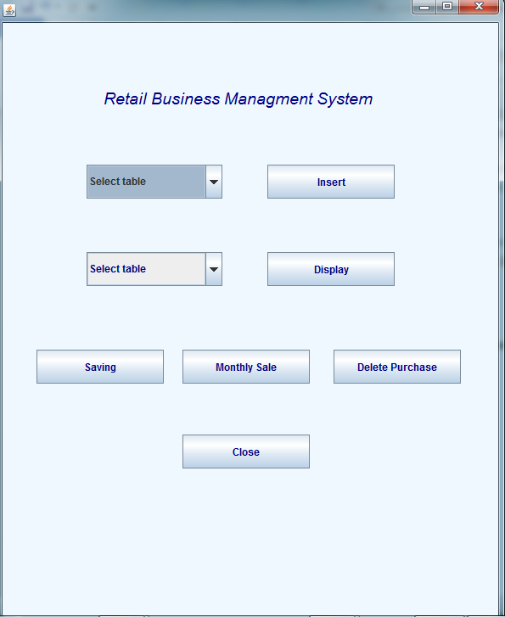

**TEAM MEETINGS:**

* November 13, 2017: Read project in detail went through project requirement
* November 15 16 17: Started working on creation of database and queries
* November 20: Learn java swing and created GUI design
* November 21 22: Completed GUI development
* November 23 24: Implemented business logic like database connectivity
* November 25 26: Worked on bug solving and testing of project

**RESPOSIBILITIES:**

* Nikhil Chaudhari: Wokerd on 1st,5th and 6th query.
* Nabha Kumthekar: Worked on 2nd, 3th and 4th query.
* Abhijit Fulsagar: Worker on 8th and 9th query.
* All three of us worked on 7th query.
* All three of us worked on GUI designing.
* GUI development by Nabha Kumthekar.
* UI testing and bug report by Abhijit Fulsagar and Nikhil Chaudhari.
* All three of us worked on Java business logic.

**LESSONS LEARNT:**

* Teamwork: Teamwork is very essential to complete a project within a deadline.
* Coordination: Each member of the team comes with different set of skills. It is important to consolidate them for the successful completion of the completion of the project.
* Time management: Some tasks may take more time to complete, while others make take less. It is important to estimate the effort needed for each task and plan accordingly.
* UI and backend integration.