This assignment shows a simple way to protect passwords with hashing. I wrote a PHP program that uses random_bytes(16) to create a different salt for each new user, joins the password with that salt, and calculates a SHA-256 hash; it saves only the login name, salt, and hash in users.txt, never the plain-text password. During registration the program rejects empty or duplicate names, and during login it uses the saved salt to hash the entered password again and compares the result with the saved hash. I tested the application through the local XAMPP page: registration succeeded, login with the correct password succeeded, and both an incorrect password and an unregistered username were rejected. The screenshots show these actual results and confirm that the program responds as expected.
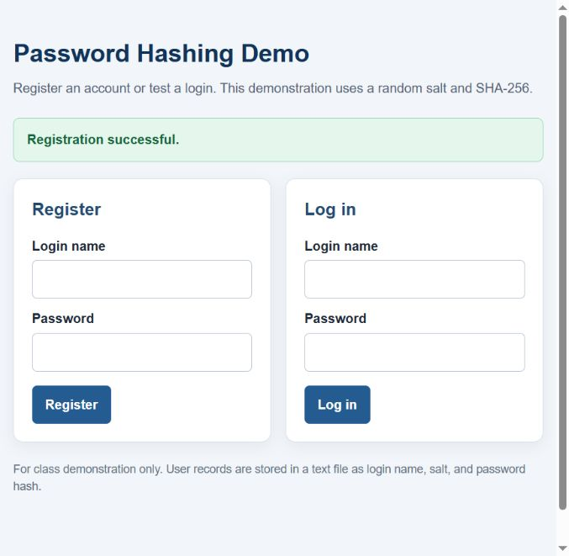 | 