GEOSPATIAL CASE STUDY / NABHONIL SARKAR / NOVEMBER 2026

Surface change across Jakarta from 2020 to 2025
I started with a question about subsidence risk: does sinking ground have the same implications beneath homes, factories and open land? My radar measurements could not support a reliable absolute rate. I narrowed the aim to a question the observations can answer: where and when did Jakarta’s satellite surface descriptions differ most?
I set three objectives: reproduce the annual processing on one grid; compare the timing and location of the largest differences; and test how much independent evidence supports their interpretation.
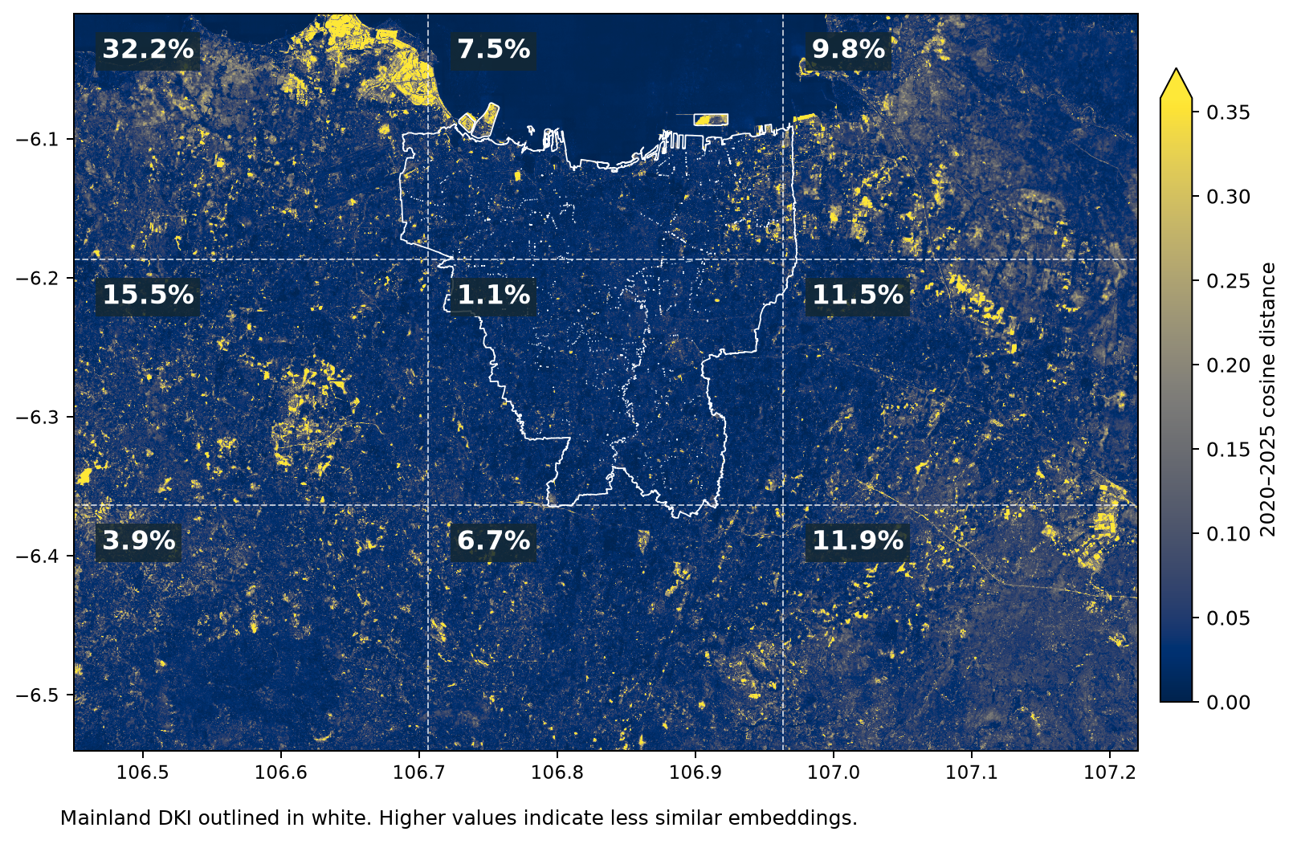
Brighter colours mean less similar satellite observations, not faster sinking. Labels give each sector’s share of all top-1% cells. The white outline marks mainland Jakarta.
Nearly a third of the most extreme differences lay in the northwest, which held only 11% of valid cells. The concentration persisted on 2020 land and after excluding the western tile sliver. It identifies a place to investigate, not confirmed reclamation or risk.

01 / STUDY AREA AND TOOLS

What was measured and where
The study rectangle on Java’s north coast spans approximately 85 × 59 km (106.45–107.22°E, 6.54–6.01°S). It includes sea and areas outside the administrative city. “Northwest” means the upper-left ninth of that rectangle; “North Jakarta” means the administrative area used in the radar coverage check.
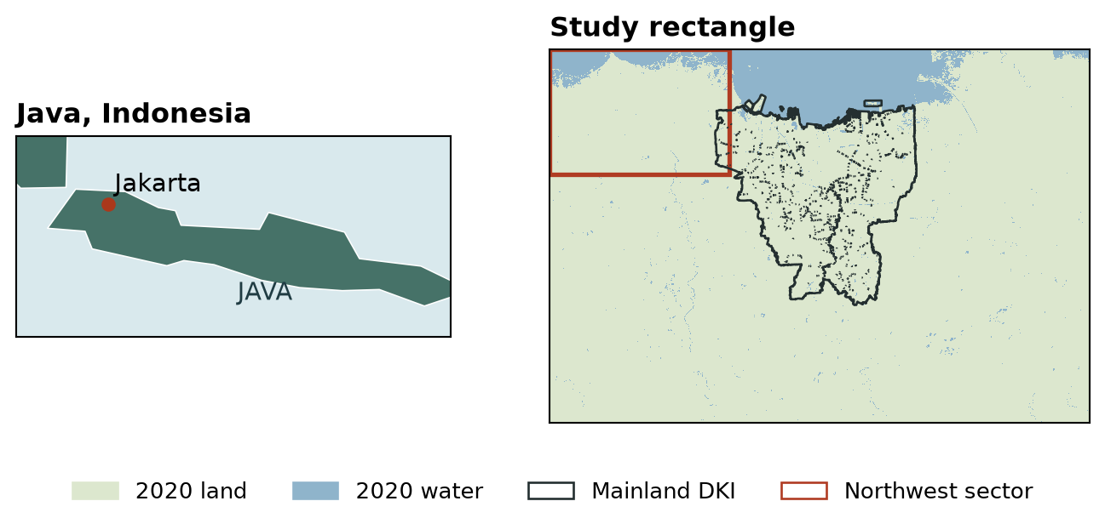
Regional inset: Natural Earth land. Local view: WorldCover 2020 at grid centres, not a 2025 shoreline. The rectangular frame is the analysis extent.
Task | Data or tool | What it contributed
Ground movement | COMET–LiCSAR, LiCSBAS, Colab | Sentinel-1 radar pairs and time-series quality checks; line-of-sight motion relative to a reference.
Annual surface context | AlphaEarth via Google Cloud Storage | Six annual 64-value descriptions per location. Earth Engine supplied the earlier 2023 reference export only.
Alignment and comparison | Python: Rasterio, NumPy, GeoPandas | Sample grid centres, compare all axes, screen missing cells and align geographic boundaries.
Interpretation | ESA WorldCover; dated imagery; published Java observations | Check land-only sensitivity, audit independent imagery and retain measured ground-motion points separately.
Software verification | pytest; Git and GitHub Actions | Local regression tests, reproducible code revisions and automated repository checks. The full 183-test count is local, not a CI claim.

02 / FROM THE ORIGINAL QUESTION TO THE CURRENT METHOD

Why I withdrew the absolute subsidence rate
Radar measures motion along the satellite’s line of sight. I kept those physical measurements separate from the 64 surface features: similarity in land appearance is not a measure of subsidence, exposed assets or vulnerability.

The ascending track lost coverage where it mattered
I recovered 609 complete radar pairs. Full-frame factor-2 and factor-5 runs failed loop-closure checks; the coarser factor-10 result remained diagnostic. Cropping to Jakarta and treating multiple reference loops improved the network, but 173 of 609 pairs failed the check, above the 25% limit I had set for that experiment. I did not raise the threshold.
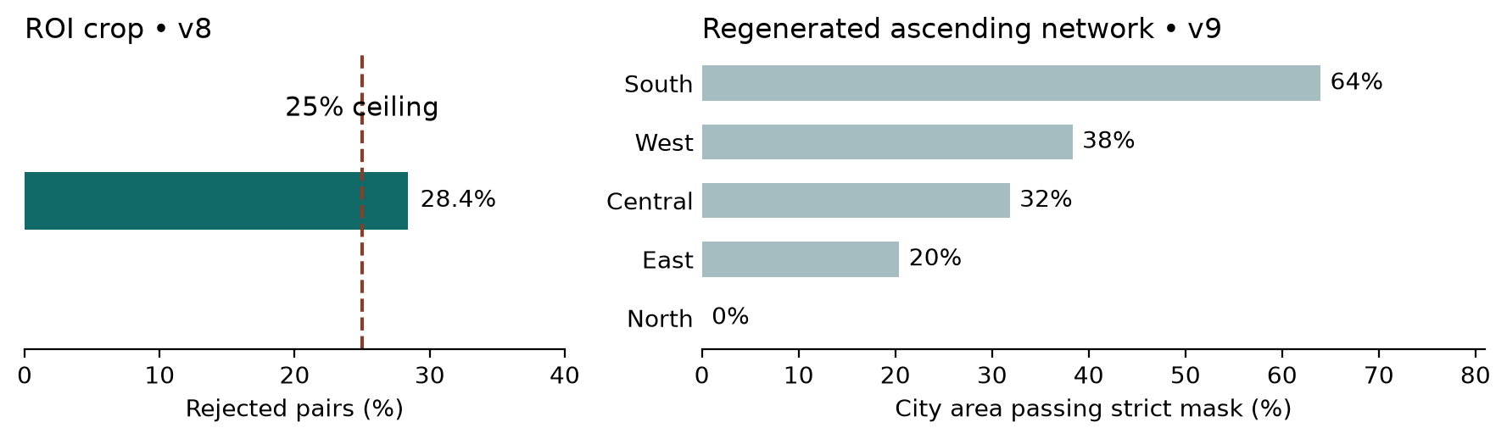
Left: v8 crop, not a universal rejection standard. Right: v9 after consistent interferogram regeneration. The network held together, but only 29.8% of mainland Jakarta passed the strict mask.

A relative pattern survived on a different track
On the descending track (January 2020–June 2023), the strict mask covered 68.4% of North Jakarta. Changing the reference area preserved the centred spatial pattern, but shifted the median line-of-sight rate across a range of 8.05 mm/year. My limit was 3 mm/year. I kept the pattern as a case study and withdrew the absolute-rate claim. I did not combine the tracks or fill uncovered areas.

A software check changed a label
A synthetic −150 mm/year rate fell outside the original classification ranges and silently received the default label “stable.” I changed the code to require an explicit class for every valid value. An unclassified value now stops the pipeline.

03 / METHOD AND QUALITY CHECKS

How the annual comparisons were made

Reproduce one year before comparing six
Sampling Google’s native 10 m product at 18 reference locations reproduced none of the earlier 2023 export vectors. Sampling its stored 20 m overview at the centres of the frozen nominal 30 m grid reproduced every one of the 64 values at all 5,619,719 in-boundary cells. I used that same method for 2020 through 2025. This checks my processing, not the stability of the source product across years.

Measure difference without assigning a cause
I decoded all 64 axes, normalised each vector and calculated one minus the cosine of the angle between years. A larger value means less similar observations. I used jointly valid cells, including water; I did not independently standardise each year. The endpoint compares 2020 and 2025 directly. It is not the sum of the five annual changes.

Test the tile boundary before interpreting the northwest
The two source tiles met at the same line in all six years despite different identifiers. Before examining strip contrasts, I fixed two primary tests: the 2022–2023 jump and the 2020–2025 endpoint, both on all valid cells. I compared 120 m strips on each side of the line along 28 two-kilometre segments, against 20 parallel control lines. An unusual step had to be stronger than every eligible control and consistent in direction. Appendix A gives the full rule.
A separate check removed the whole western sliver across the study rectangle. I kept the original northwest boundary and compared the top cells both at the original cutoff and after calculating a fresh 99th percentile.

Screen published ground motion independently
The published 2017–2023 Java observations have different dates and measurement support. Repeated records conflicted at 40,661 coordinates; I excluded those locations rather than averaging them. Requiring finite vertical motion and positive reported uncertainty left 48,883 mainland Jakarta locations, including 10,051 in North Jakarta. These counts describe observations, not continuous coverage.

04 / RESULTS BY YEAR

The largest annual difference came in 2022 to 2023
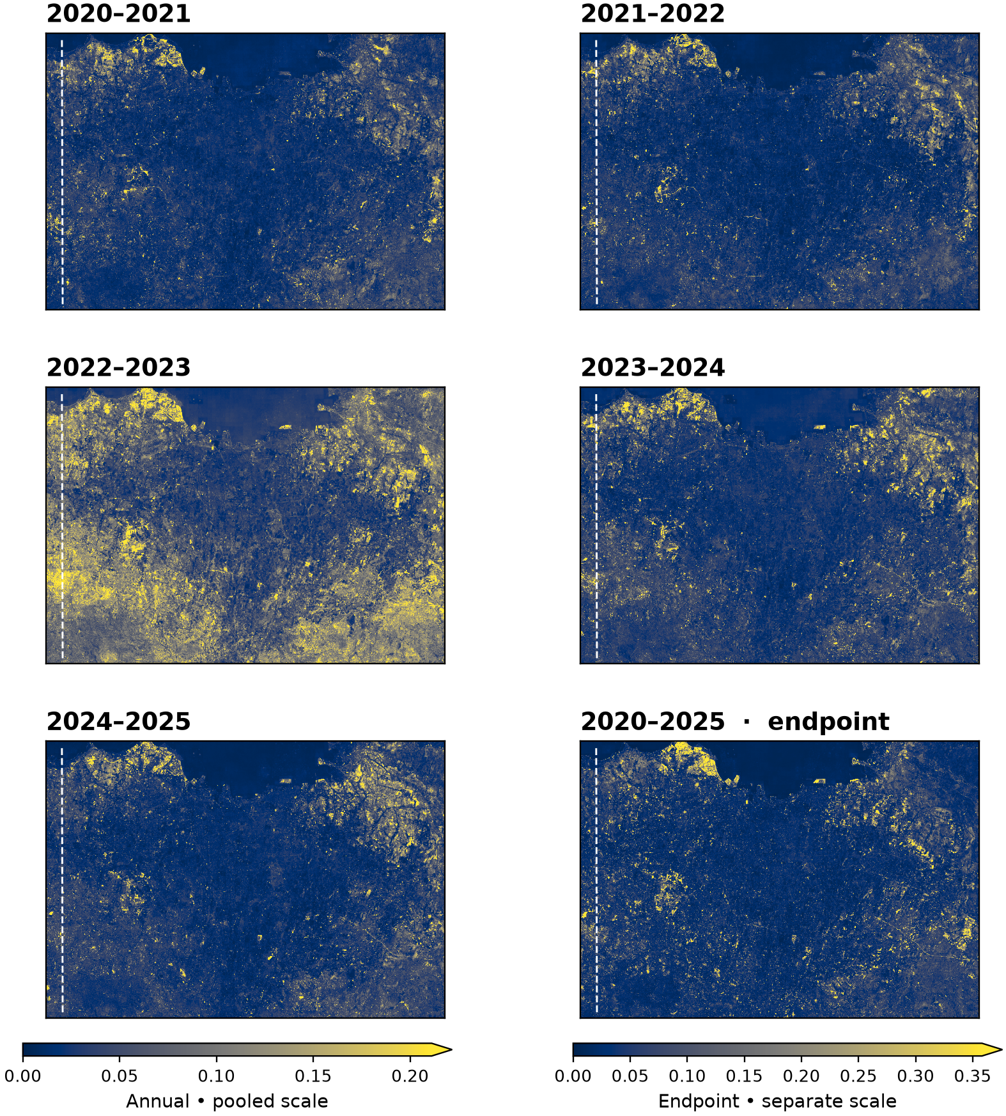
Dashed line: tested tile boundary. At or above the shared annual colour cap (0.21112), the shares of valid cells were 2020–21: 0.52%, 2021–22: 0.55%, 2022–23: 2.21%, 2023–24: 1.01%, 2024–25: 0.71%. Endpoint: 1.00% at its separate 0.35809 cap. Brighter capped cells cannot be distinguished by colour. Statistics use uncapped values.
Brightening in 2022–2023 appears broad, particularly in outer and southern sectors, and less pronounced centrally. The median was 0.112 in the southeast and 0.033 in the north-central sector. This describes geography; it does not establish a cause.

05 / RESULTS BY PLACE AND TIME

The northwest concentration survives both exclusions
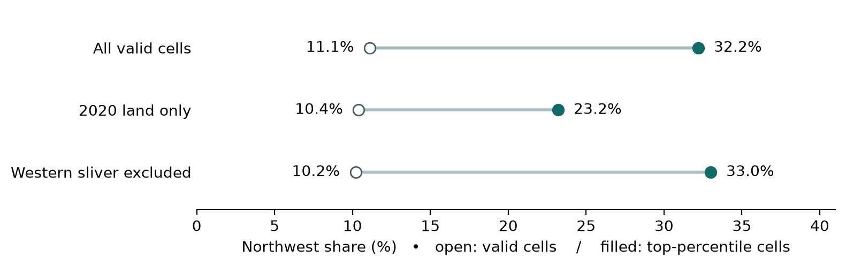
On land mapped in 2020, the northwest held 23.2% of the land-only top percentile on 10.4% of valid land cells. This is a conservative coastal check: it also excludes any land created after 2020 in cells mapped as water that year.
Only 254 of the northwest’s 18,096 original extreme cells lay west of the seam (1.4%). Removing the western sliver left 32.97% of all remaining extremes in the northwest at the old cutoff; re-ranking gave 32.99%, on 10.20% of remaining valid cells. The headline does not depend on that sliver.

Neither primary comparison flagged the seam
In 2022–2023 the seam contrast was weaker than all 20 control lines, with only 50% directional agreement. For the endpoint it exceeded 11 of 20, with 57% agreement. Of 18 tests, 12 did not flag and six water-only tests were inconclusive: only two segments qualified, against six required. This argues against an unusually sharp step at this width, not against a shift shared by both tiles.

The jump was widespread but did not persist everywhere
The 2022–2023 transition was the largest at 85.4% of valid cells. Its median distance was 0.069, compared with 0.024–0.032 for the other transitions. In 2024, 81% of cells were closer to their 2023 than their 2022 vector. In 2025, 68% were closer to 2022. That reversal concerns the observations; it does not mean the land reverted.
The 2020–2023 comparison ends in the year of the jump. The direct 2020–2025 map may be less affected by that particular shift; this does not show which map is more accurate.

06 / OBJECTIVES AND CONCLUSION

What the evidence supports
Objective | Outcome | Evidence and limits
Reproduce annual processing | Met for processing | The six years use one sampling rule. The 2023 reference was reproduced across all valid cells; this is not an across-year accuracy test.
Locate differences in space and time | Described | Northwest led the endpoint extremes. The southeast had the highest sector median for the 2022–2023 transition. These answer different questions.
Check geographic sensitivity | Completed with limits | The northwest held up on 2020 land and without the western sliver. The water-only seam tests lacked support.
Compare embeddings with simpler predictors | Not scored | Independent dated imagery was insufficient for the pre-set spatial benchmark.
Original risk-zoning ambition | Withdrawn as a deliverable | No validated absolute deformation field or adequate independent exposure evidence.

Why the benchmark stopped
I selected 300 patches without using their change scores and kept spatial blocks separate for development and evaluation. Across 93 Wayback releases, 94 patches had candidate imagery at both endpoints. The development split covered 16 blocks and evaluation covered 22; both needed 20. Pléiades catalogue footprints did not provide access to full-resolution imagery. I therefore did not score embeddings against vegetation and built-up indices.

What I would test next
I would compare the 2022–2023 jump across surface types and check dated imagery at locations selected independently of the change scores. That is a proposed test, not a result. A northwest site selected from this map could illustrate a high score, but cannot independently validate the method.
Before comparing published subsidence with surface differences, I would define spatial units, minimum point support and sensitivity to exclusions. For now, the deliverable is a reproducible map of differences and two findings worth checking—not a hazard, exposure or risk classification.
Explore the analysis and tests on GitHub

APPENDIX A / READING AND REPRODUCING THE MAPS

Definitions and reproducibility
Term | Meaning here
Embedding | A 64-number description of a grid cell for one year; not a land-use label.
Cosine distance | Difference in vector direction. A colour cap controls display only; the 99th percentile is not a noise floor.
Valid cell | An in-boundary grid centre with finite, non-zero observations in both years.
Line of sight | Motion toward or away from the satellite relative to a reference; not automatically vertical subsidence.
Seam | The shared source-tile edge at easting 663,840 m in UTM zone 48S. The analysis grid itself is geographic (EPSG:4326).

Frozen seam test
Use the median east-minus-west contrast per segment; strength is the absolute median across matched segments. Require ≥60 cells on each side, ≥6 matched segments and ≥19 controls (≥9 per side). A flag must exceed all controls in strength and meet both 75% sign consistency and the control 90th percentile of consistency. Controls are not independent trials. All five annual pairs and the endpoint were tested for all cells, land and water.

Reproduction and sources
From the repository root and locked environment, run the following modules in order with python -m scripts.<module>: build_alphaearth_full_grid, audit_alphaearth_full_2023, alphaearth_full_grid_change, render_alphaearth_change. Large local rasters are not shipped with the repository. The archived insar-risk-zoning command is not the annual workflow.
The registered seam test ran once at commit ed87fd936daacb7609981296dfcd87612e1d3067. All 183 tests passed locally on Windows with project data before the run. The changelog records the protocol and result hashes, all 18 outcomes and the original counts.
Repository and commands / Test record / AlphaEarth source guide
WorldCover 2020 / Published Java observations / Natural Earth land
The AlphaEarth Foundations Satellite Embedding dataset is produced by Google and Google DeepMind. Land mask: © ESA WorldCover project 2020, v100 (CC BY 4.0). Regional inset: Natural Earth, public domain.

