Syed Nabi Hassan

17k-3622

Web Programming Assignment 1

Section 7C

Project url: [​https://nabi-hassan.github.io/17k3622-Static/index.html](https://nabi-hassan.github.io/17k3622-Static/index.html)

**WEBSITE SCREENSHOTS:**

**1. Home Page**

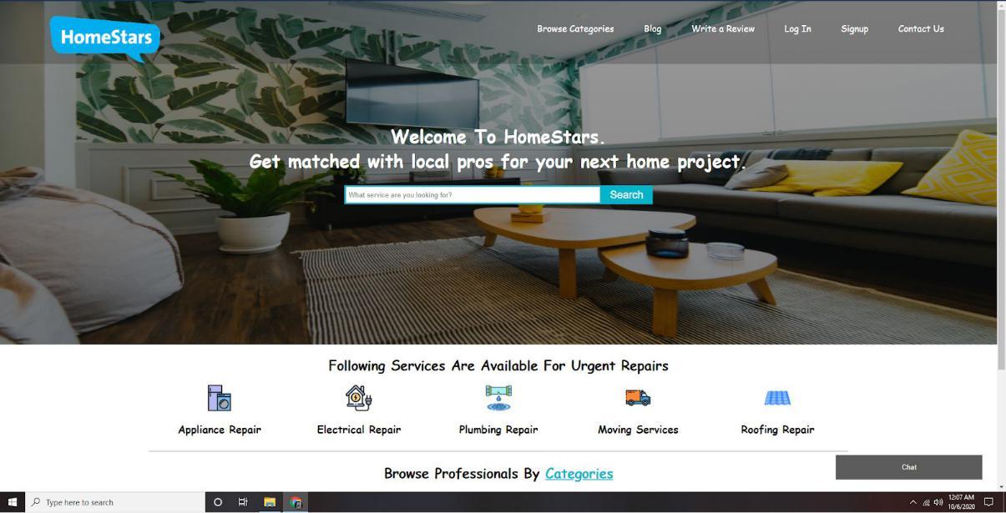

1. **Browse Categories**

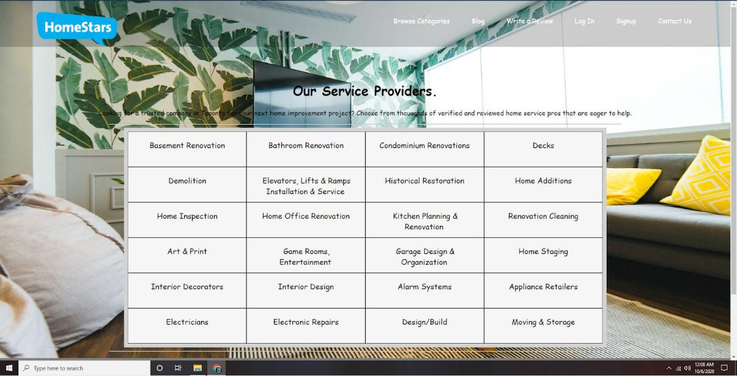

1. **Blog**

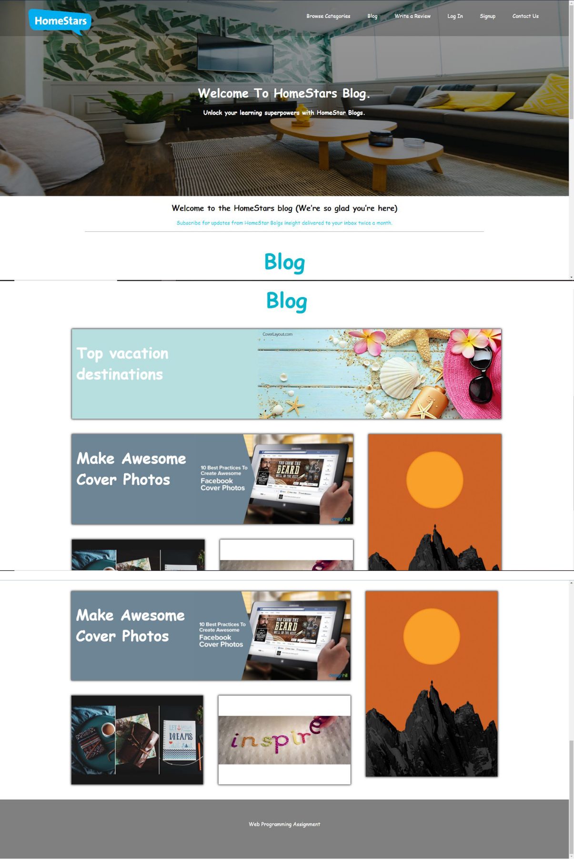

1. **Write a Review**

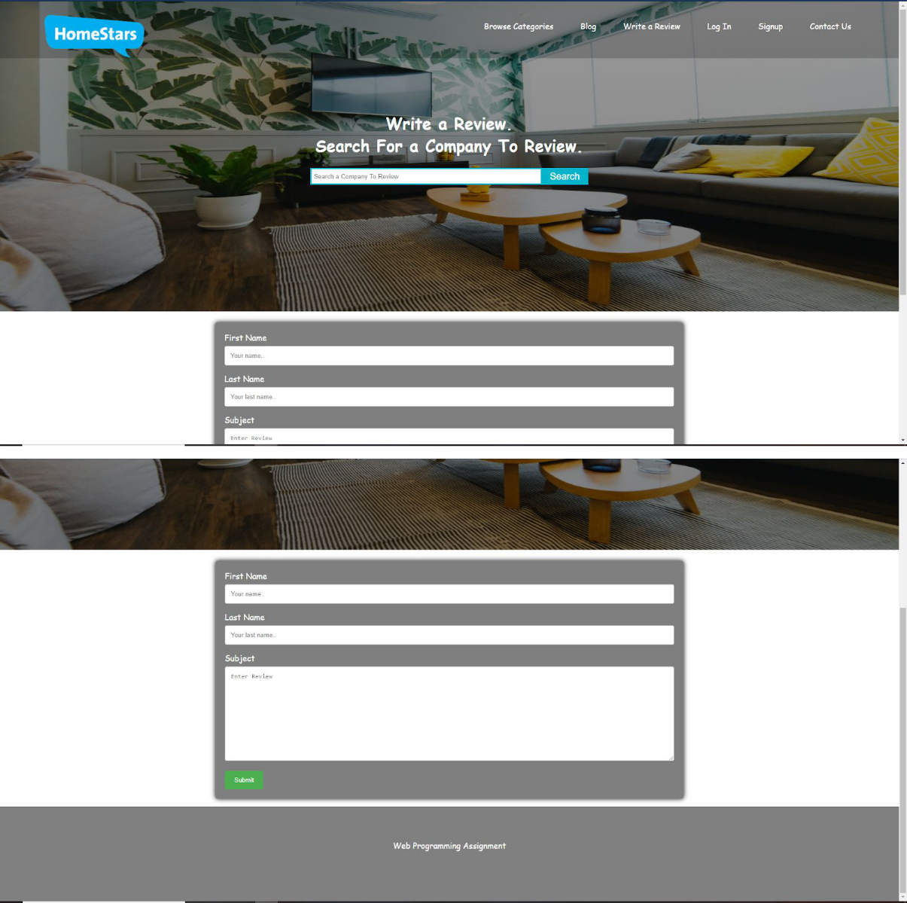

1. **Login**

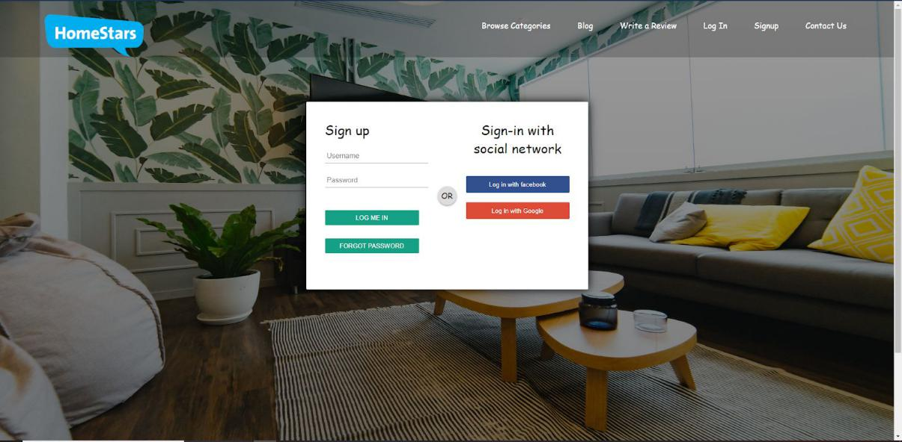

1. **Signup**

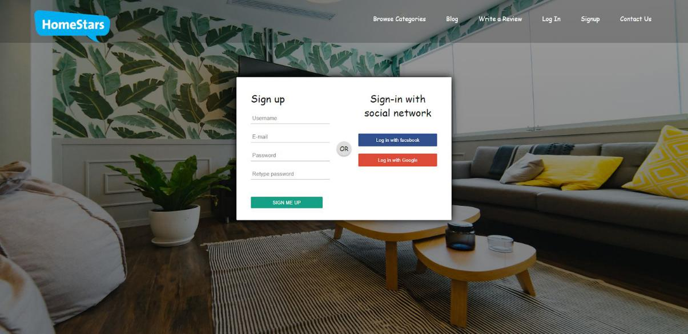

1. **Forget Password**

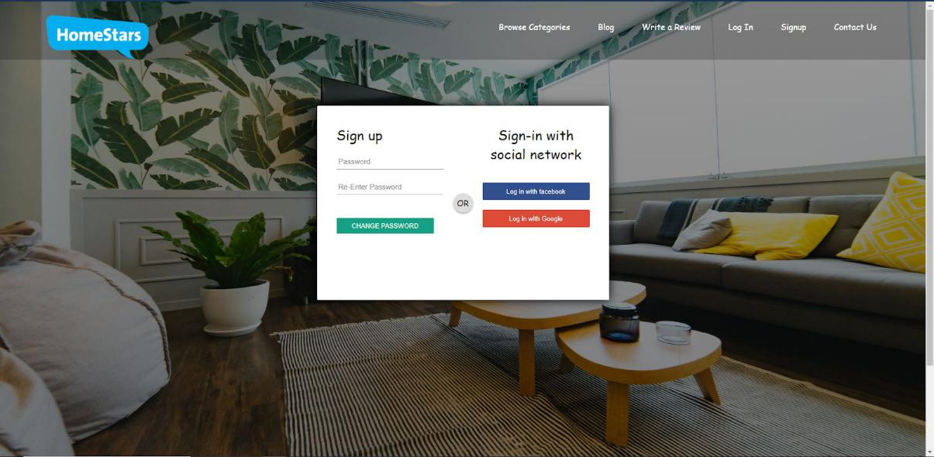

1. **Contact Us**

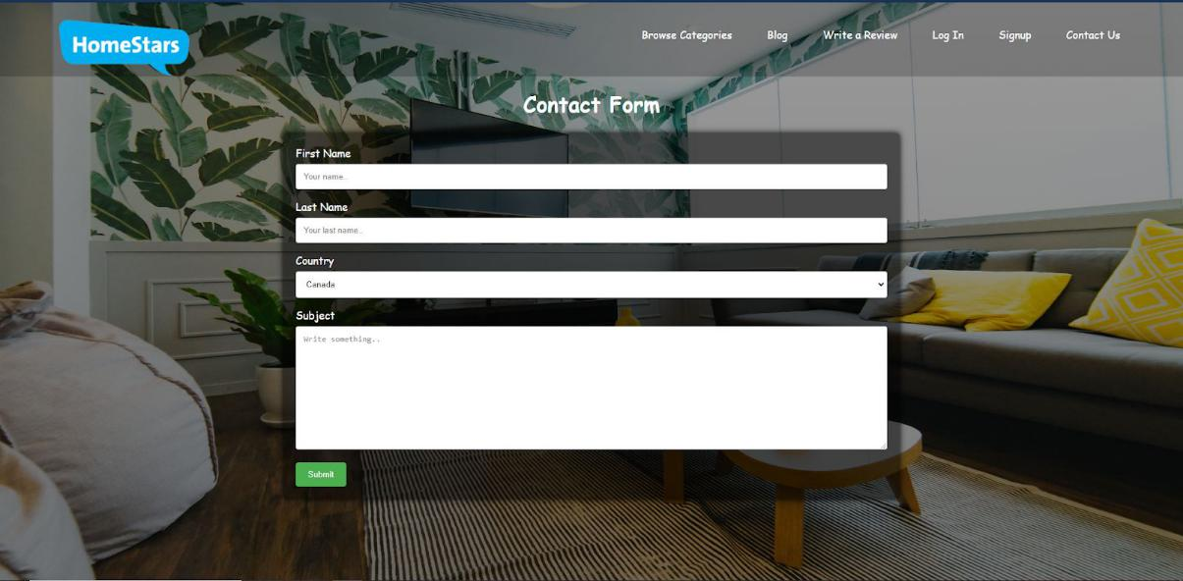

1. **Chat Interface**

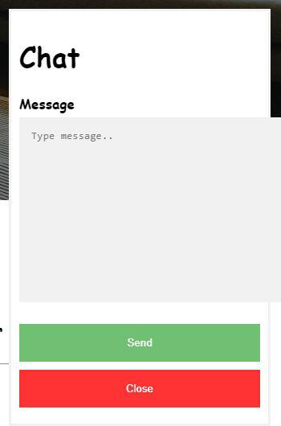

**W3C Validator:**

**1. Home**

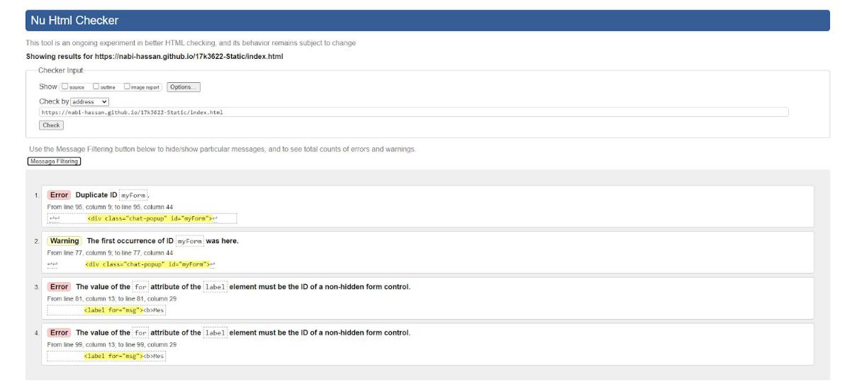

**2. Browse categories**

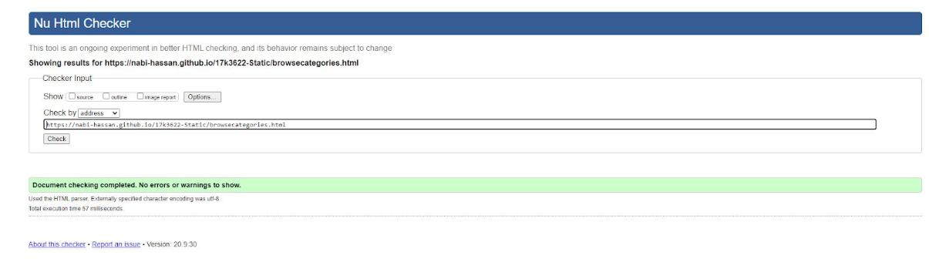

**3. Blog**

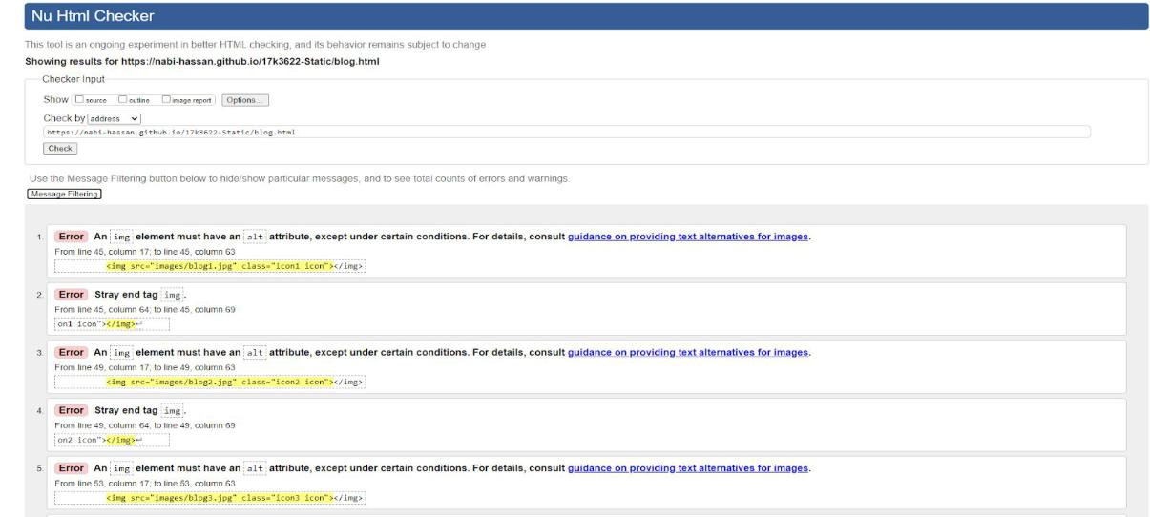

1. **Write a review**

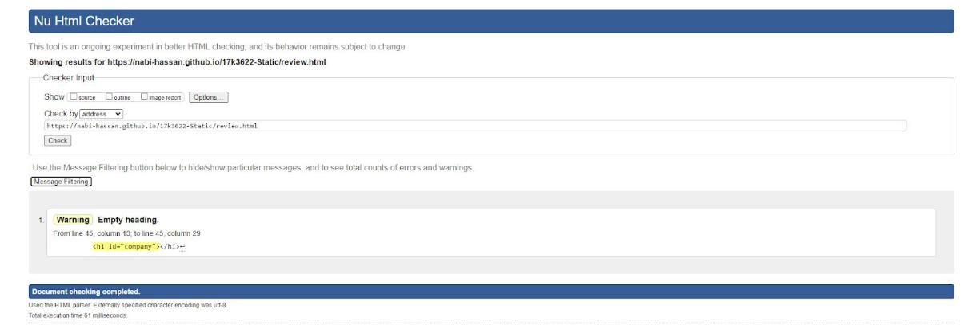

1. **Login**

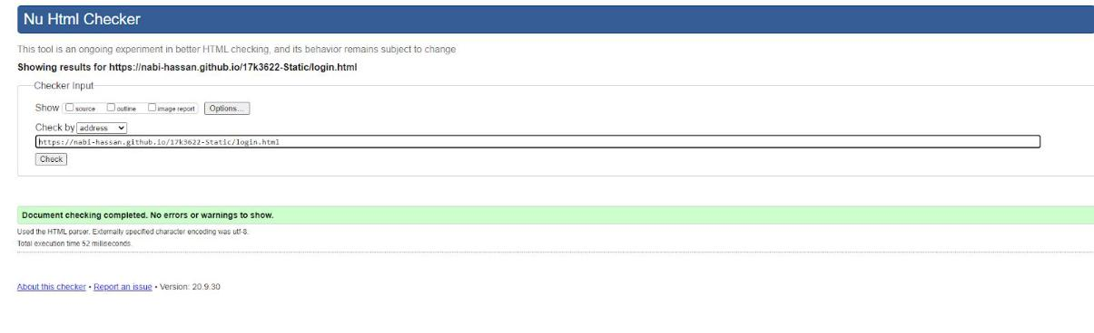

1. **Signup**

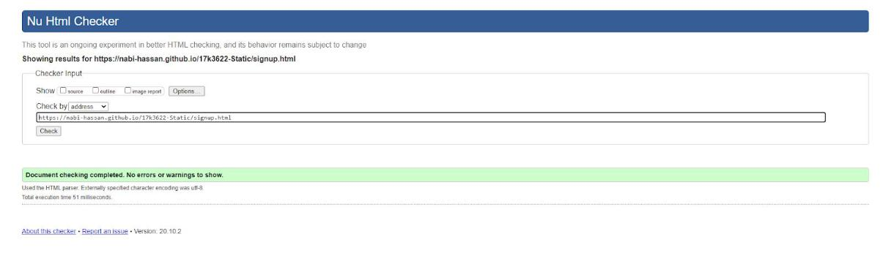

1. **Forgot password**

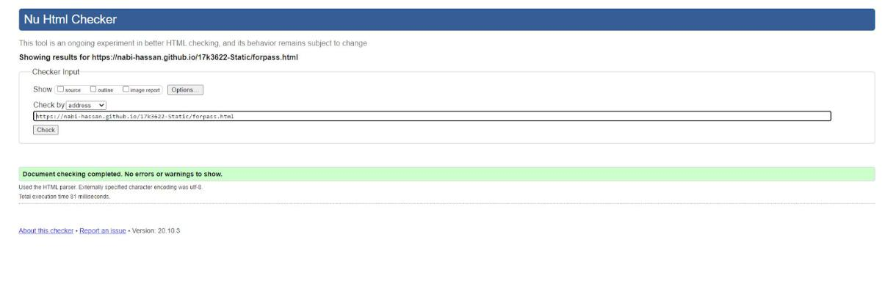

1. **Contact us**

