Syed Nabi Hassan

17k-3622

Web Programming Assignment 2

Section 7C

Project url: [​](https://nabi-hassan.github.io/17k3622-Static/index.html)https://nabi-hassan.github.io/assignment2/index.html

**WEBSITE SCREENSHOTS:**

**1. Index Page**

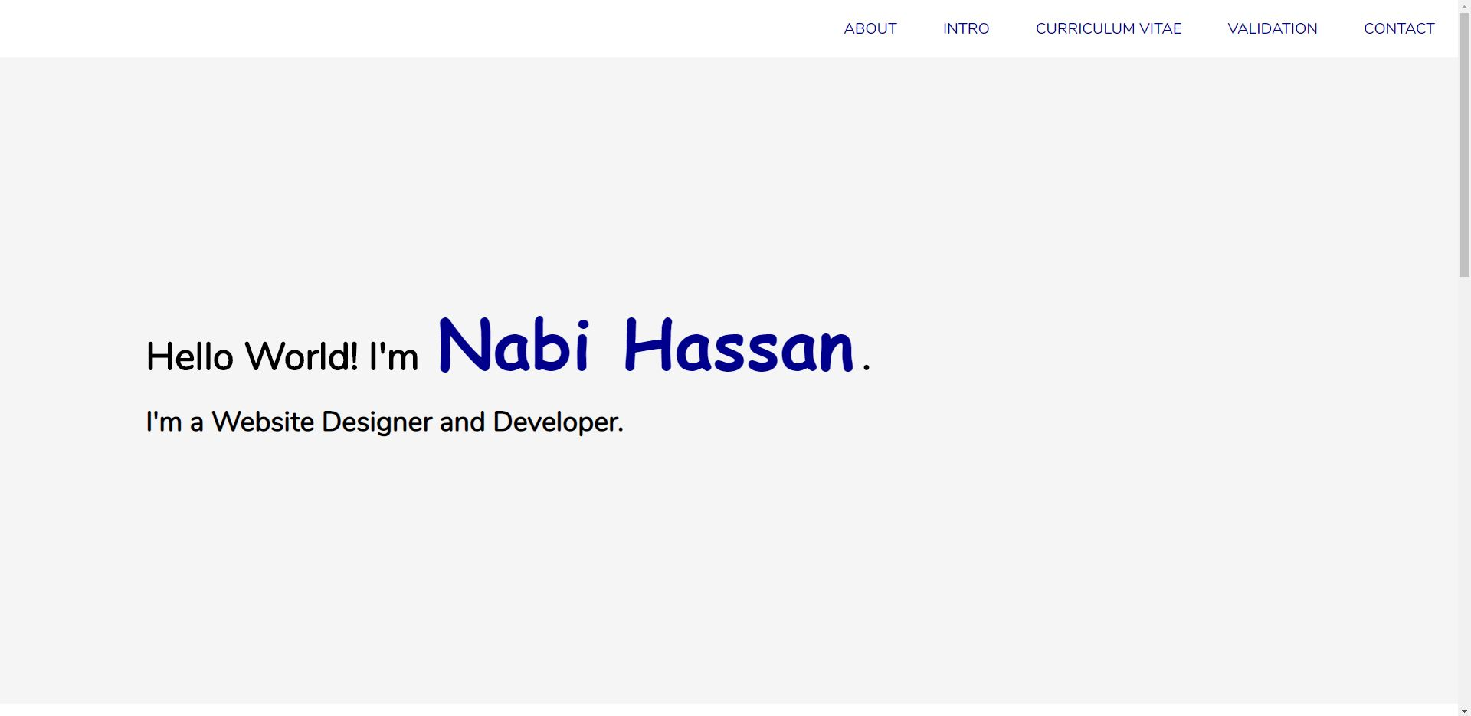

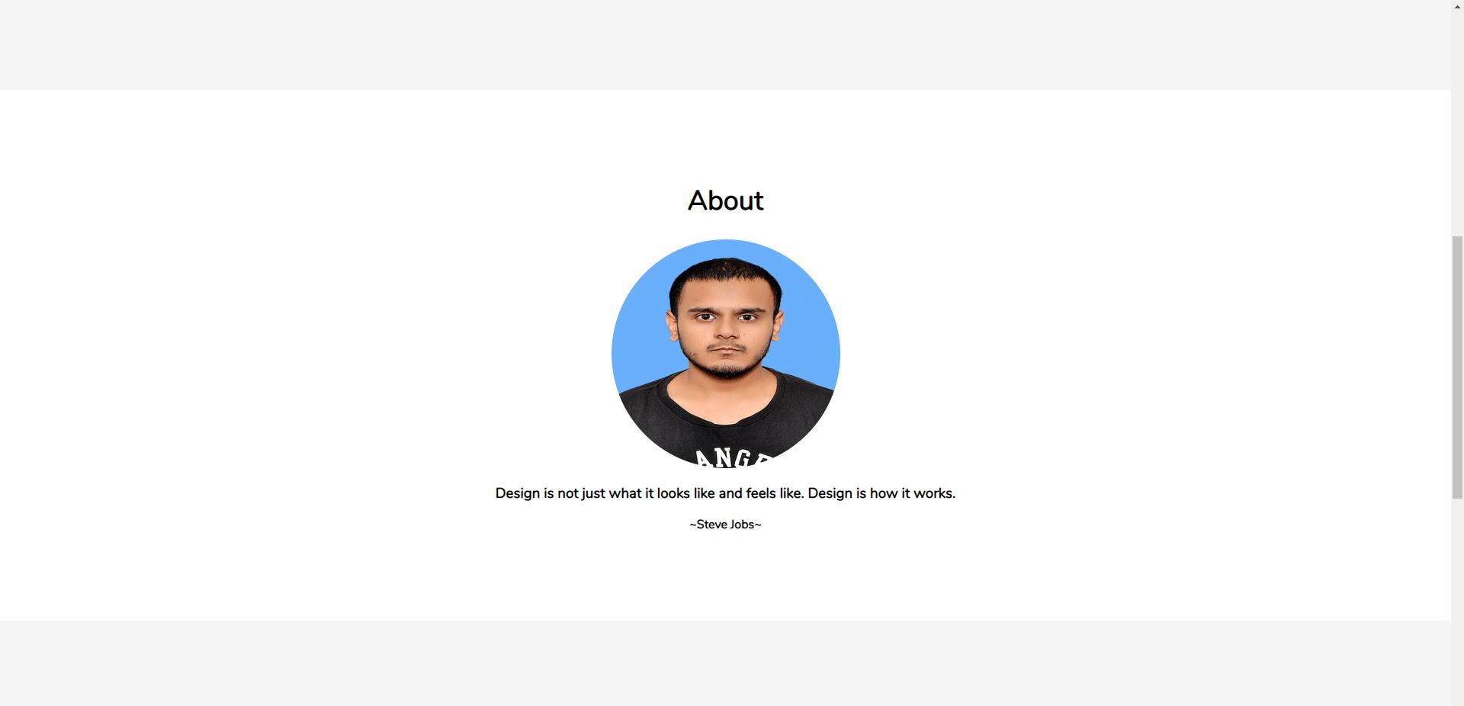

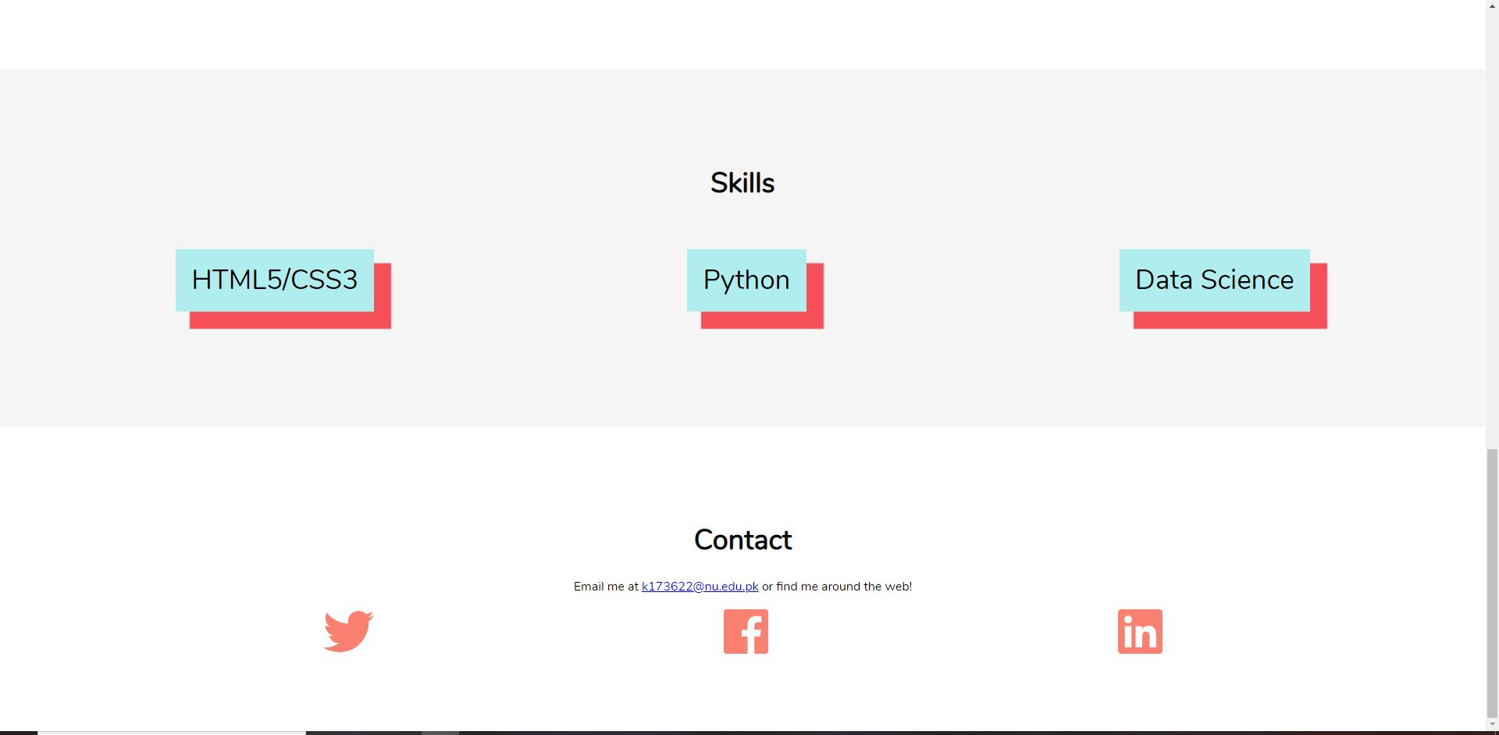

1. **Intro Page**

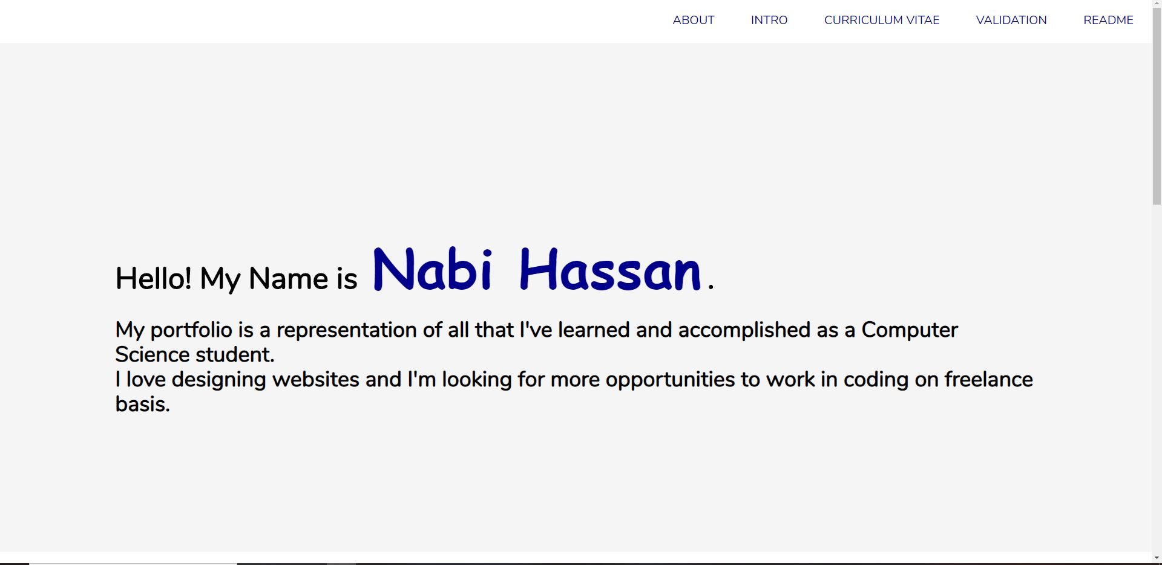

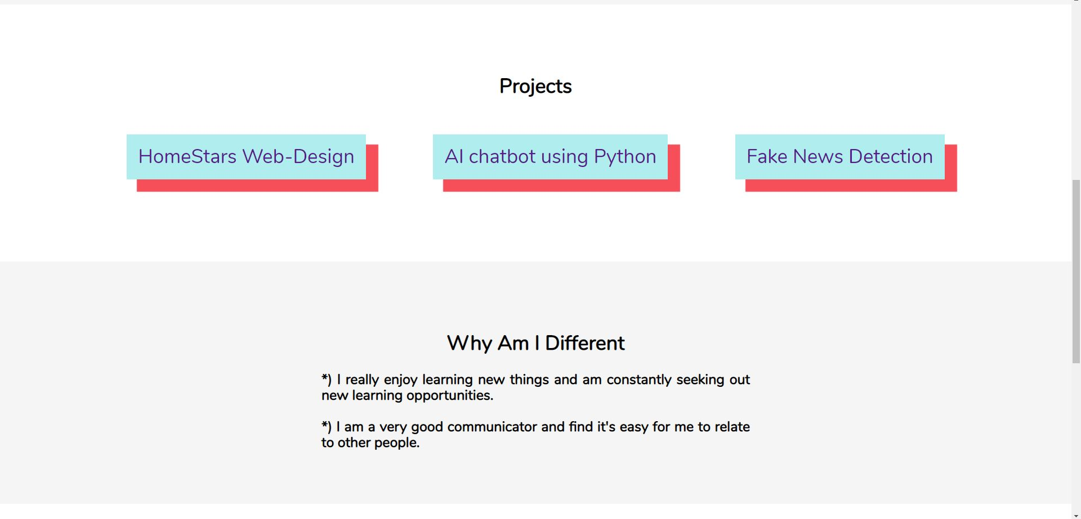

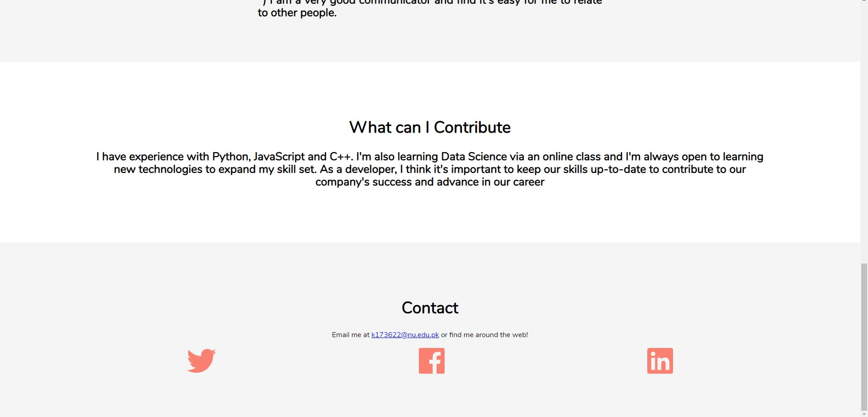

1. **CV Page**

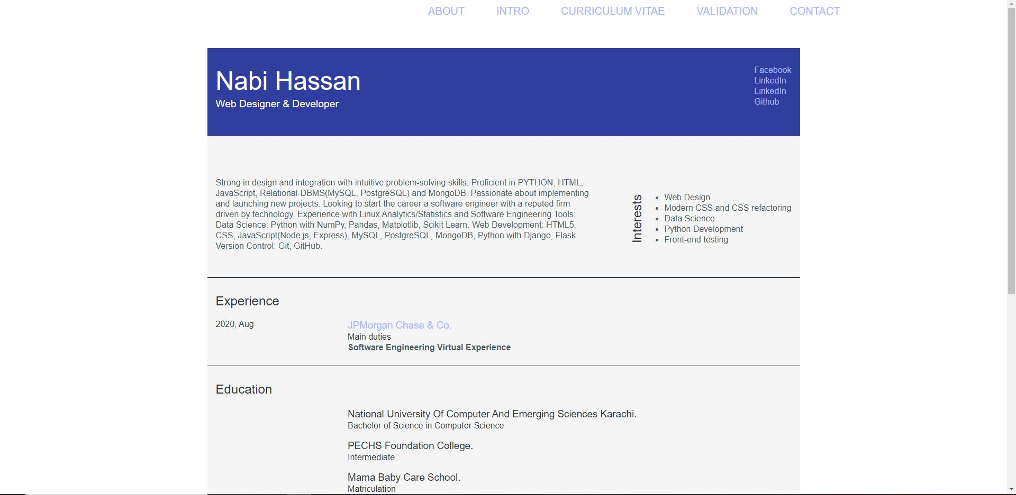

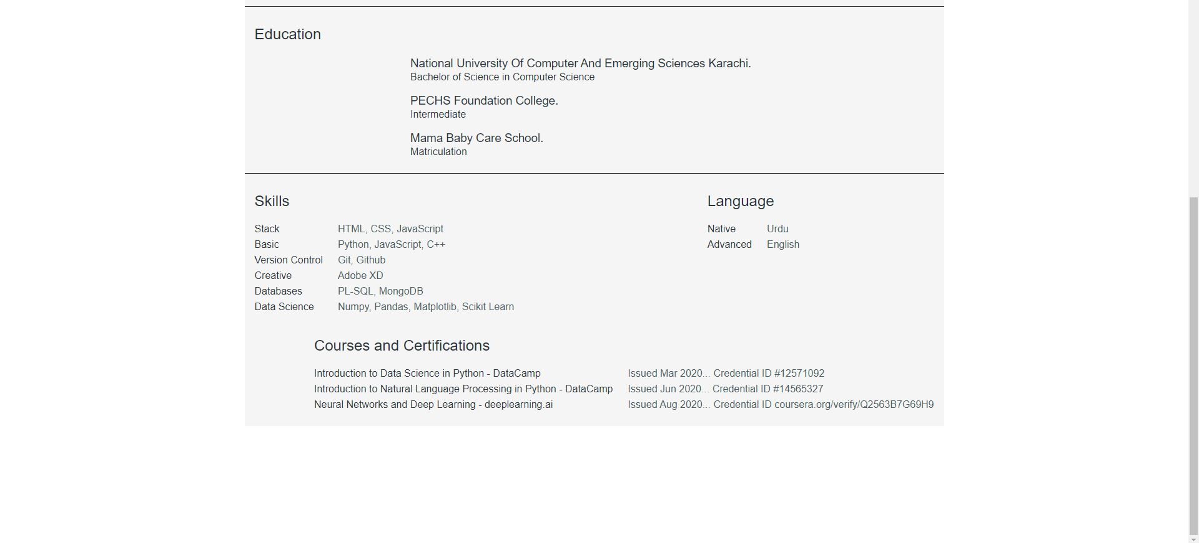

1. **Readme**

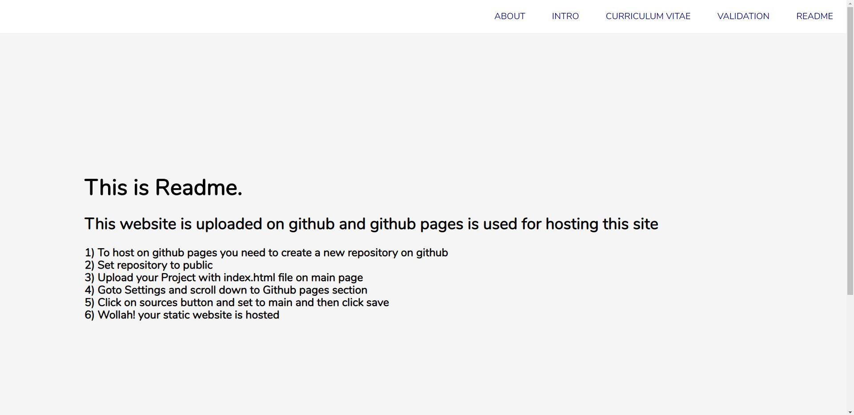

1. **Validation**

