EF-101 FALL 2026 | SHORT REPORT | SUBMISSION: MONDAY, 9 NOVEMBER 2026
EF101-P04: How a Laptop Behaves Under Load
Computer Hardware Stress Testing and Resource Analysis

Item | Details
Group members | Nabia Shamsi, EE-001  Areeza Rehan, EE-010  Abdul Muqeet, EE-038
GitHub repository | https://github.com/<username>/EF101-P04 (replace with your real link before submitting)
Test laptop | HP EliteBook 850 G5, Intel Core i5-8250U (4 cores, 8 threads), 8 GB RAM, 256 GB SSD, Intel UHD 620, Windows 10 Pro

1. What the project does
We gave one laptop different kinds of work (CPU, memory, storage, graphics and a mixed real-life load) and recorded its numbers every 2 seconds into CSV files. We compared every test with an idle baseline and found which part limits the laptop in each case. We also checked whether the processor slows down from heat (Bonus A) and built our own logging script (Bonus B).
97.6 %  CPU busy, no throttling | 1.1 GB  lowest free RAM | 257 MB/s  SSD write speed | 17.5 %  CPU in the mixed test, yet slow

2. Visual schema
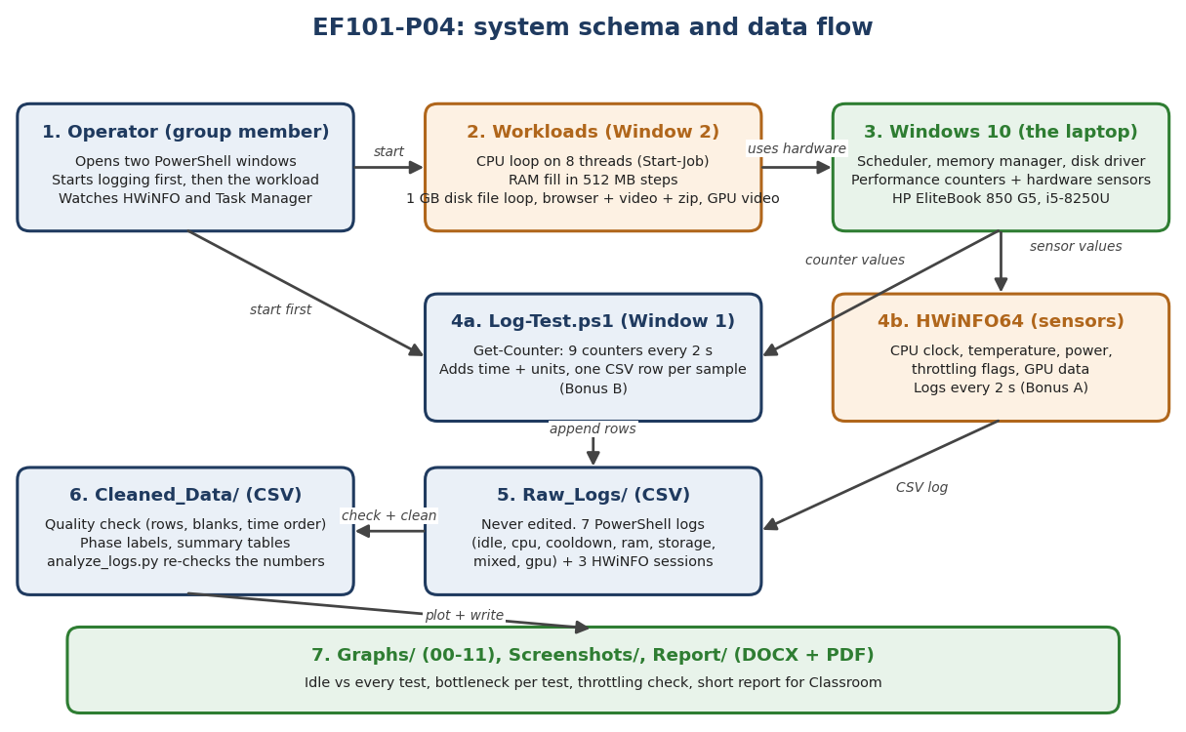
Figure 1. Schema of the project: workloads, Windows counters, logging script, HWiNFO, raw data, cleaning, graphs and report.

3. Method and main code segments
Table 1. Main parts and code segments
Part | What it does
Workloads (Window 2) | CPU: loop on all 8 threads (Start-Job), about 9 min. RAM: fills memory in 512 MB steps. Storage: writes and reads a 1 GB file. Mixed: browser with 5 tabs + video + zipping 600 MB. GPU: 5 min full-screen video.
Log-Test.ps1 (Window 1) | Get-Counter reads 9 Windows counters every 2 s. Each reading becomes one row (time, elapsed seconds, 9 values) and Export-Csv -Append saves it at once. try/catch prints an error instead of crashing.
HWiNFO64 | Records what Windows counters cannot show: CPU clock, temperature, power, throttling flags, GPU data (every 2 s).
analyze_logs.py | Checks every raw file (rows, blank cells, time order) and recalculates the summary table. Raw files are never edited.

4. Results
Table 2. Each test compared with idle (averages over the load time)
Test | CPU avg | Lowest free RAM | Disk write | Disk busy | Limit (bottleneck)
Idle (baseline) | 6.1 % | 3.06 GB | 0.3 MB/s | 1.1 % | none
CPU load | 97.6 % | 3.25 GB | 0.4 MB/s | 13.6 % | Processor
RAM load | 11.2 % | 1.10 GB | 0.7 MB/s | 1.2 % | Memory (pagefile used)
Storage load | 18.4 % | 1.83 GB | 256.7 MB/s | 46.3 % | Disk
Mixed load | 17.5 % | 1.53 GB | 10.4 MB/s | 3.9 % | Memory, then disk
GPU (video) | 39.3 % | 2.47 GB | 2.1 MB/s | 2.7 % | none (GPU 20.5 % avg, 55 °C max)

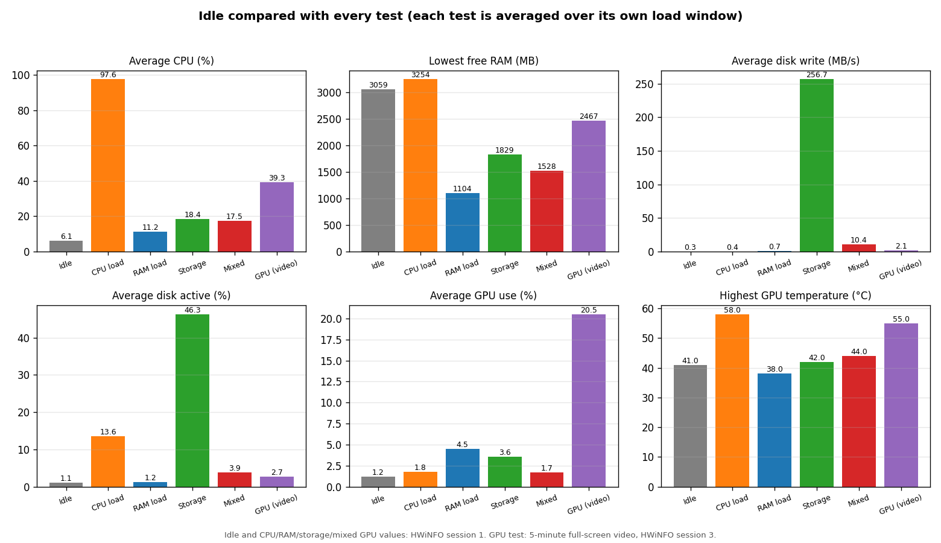
Figure 2. Idle compared with every test.
- Utilization is not performance: in the CPU test the CPU was 97.6 % busy and still fast (clock steady near 2 GHz). In the mixed test it was only 17.5 % busy but the computer waited for memory and disk.
- RAM pressure: free memory fell from 3.4 GB to 1.1 GB, committed memory rose from 59 % to 86 %, and Windows moved data to the pagefile on the SSD (paging peak about 4,200 pages/s).
- Bonus A, throttling: two CPU runs on two days. Clock stayed near 2 GHz (2005 to 2063 MHz and 2022 to 1975 MHz), temperature levelled off at 66 to 67 °C, power about 8.5 W (limit 18 W), no throttling flags. No throttling was observed in these runs.
- Main lesson: when a computer feels slow, check memory and disk before blaming the CPU.

5. How to run
Windows 10/11 with PowerShell. Put the folder at Documents\EF101-P04, open PowerShell and run:
Set-ExecutionPolicy -Scope Process -ExecutionPolicy Bypass -Force
. "$([Environment]::GetFolderPath('MyDocuments'))\EF101-P04\Scripts\Log-Test.ps1"
Log-Test -Test demo -Minutes 1

A CSV file appears in Raw_Logs, one row every 2 seconds. To re-check the numbers: python Scripts/analysis/analyze_logs.py (needs pandas).

6. Contribution
All three members ran every test together on the same laptop. Afterwards the work was shared:
Table 3. Contribution of each member
Member | Main work
Nabia Shamsi (EE-001) | Data cleaning and quality check, summary tables, graphs, bottleneck analysis, report
Areeza Rehan (EE-010) | Specifications, HWiNFO logging, Log-Test.ps1 (Bonus B), thermal-throttling analysis (Bonus A), GPU results
Abdul Muqeet (EE-038) | Raw-data checks, Practice_Runs, idle and mixed workload set-up, live demo

7. Limitations, safety and AI disclosure
- RAM, storage, mixed and GPU tests were run once; only the CPU test was repeated. The first CPU attempt was invalid and is kept in Practice_Runs.
- The idle baseline had only about 20 seconds of rest. The GPU test is a light video test on an integrated GPU, not a 3D stress test. Storage read speed is affected by the Windows cache. One laptop only.
- Safety: no overclocking, no voltage change, thermal protection untouched, stop rule at 95 °C (never reached). Our own laptop was used.
- AI disclosure: an AI assistant (Claude, by Anthropic) helped write the scripts and drafts. The group ran everything and checked the numbers against the raw files.

