Table of Contents
ABSTRACT 1
1: INTRODUCTION 2
2: REQUIREMENTS ANALYSIS 5
3: SYSTEM DESIGN 8
4: SDLC IMPLEMENTATION 11
5: PROTOTYPE DEVELOPMENT 13
6: PROJECT MANAGEMENT 21
7. GIT AND GITHUB INTEGRATION 23
8.TESTING, EVALUATION, CONCLUSION AND RECOMMENDATIONS 25
8 DIAGRAMS 27
10 Recommendations 28
10 Conclusion 29
REFERENCES 30

SABSTRACT
Access to accurate and timely student information remains a significant challenge for many schools in Sierra Leone. Attendance records, academic performance, and communication between schools and parents are often managed manually using paper-based systems, resulting in inefficiencies, errors, and delays in decision-making. These challenges make it difficult for teachers and administrators to monitor student progress effectively and provide timely interventions when needed.
This project presents EduTrack SL, a School Resource and Attendance Tracking System designed to digitise attendance management, academic performance monitoring, and communication between teachers, parents, and school administrators. The system provides role-based access for Teachers, Parents, and Administrators, enabling efficient management of student records, attendance tracking, performance recording, and report generation.
The system was designed using the Agile Software Development Life Cycle (SDLC) methodology and modelled using software engineering tools including Use Case Diagrams, Activity Diagrams, Sequence Diagrams, Class Diagrams, System Architecture Diagrams, and Entity Relationship Diagrams (ERD). A high-fidelity prototype comprising fifteen screens was developed to demonstrate system functionality and user interaction across the Teacher, Parent, and Administrator modules.
EduTrack SL aligns with United Nations Sustainable Development Goal 4 (Quality Education) by improving educational management, strengthening school-parent communication, and supporting early intervention for students experiencing attendance or academic challenges. The project demonstrates how digital technology can enhance educational administration and contribute to improved learning outcomes in Sierra Leone.
Keywords: School Management System, Attendance Tracking, Educational Technology, SDG 4, Agile SDLC, EduTrack SL, Sierra Leone.

1: INTRODUCTION
1.1 Background of the Study
Education plays a critical role in national development and social progress. Effective educational management requires accurate monitoring of student attendance, academic performance, and communication among stakeholders. In many schools across Sierra Leone, attendance and performance records are still maintained manually using paper registers and record books. These traditional methods are often time-consuming, vulnerable to loss, and prone to human error.
The increasing availability of Information and Communication Technology (ICT) presents an opportunity to modernise school administration. Digital systems can streamline record management, improve accessibility of information, and facilitate communication between schools and parents.
EduTrack SL was conceived as a digital solution to address these challenges by providing an integrated platform for attendance tracking, academic performance monitoring, and administrative reporting.

1.2 Problem Statement
Many schools in Sierra Leone continue to rely on manual processes for managing attendance and academic records. This creates challenges in monitoring student progress, identifying absenteeism trends, and generating timely reports.
Parents often have limited visibility into their children's attendance and academic performance, while administrators face difficulties in consolidating information across multiple classes. The lack of a centralised system reduces efficiency and limits informed decision-making.

1.3 Aim of the Project
To design and develop EduTrack SL, a School Resource and Attendance Tracking System that improves attendance monitoring, academic performance management, and communication between schools and parents.

1.4 Objectives of the Project
General Objective
To develop a digital solution that enhances educational administration and improves access to student information.
Specific Objectives
To digitise student attendance management.
To provide tools for recording academic performance.
To improve communication between schools and parents.
To support data-driven decision-making through reporting and analytics.
To maintain centralised educational records.
To provide administrators with monitoring and management capabilities.

1.5 Scope of the Project
The project focuses on attendance tracking, performance recording, user management, reporting, and school-parent communication. The prototype includes Teacher, Parent, and Administrator modules, with core workflows covering authentication, attendance capture, grade recording, and report generation. The system is designed as a role-based platform accessible via a mobile and web interface, with functionality demonstrated through a high-fidelity prototype rather than a fully deployed production system.

1.6 Significance of the Study
The project benefits the following stakeholder groups:
Teachers through efficient attendance and grading tools.
Parents through real-time visibility of student progress.
Administrators through centralised management and reporting.
Students through improved monitoring and support.

1.7 SDG Alignment
The project aligns with SDG 4: Quality Education by supporting effective educational management and improved learning outcomes. By strengthening the link between schools and parents and providing administrators with reliable data, EduTrack SL contributes directly to Target 4.1 (ensuring inclusive and equitable quality education) and Target 4.a (building and upgrading education facilities that are effective learning environments), positioning ICT as an enabler of stronger educational governance in Sierra Leone.

2: REQUIREMENTS ANALYSIS
2.1 Overview
Requirements analysis identifies system needs and stakeholder expectations to ensure successful system development. This chapter presents the stakeholders involved in EduTrack SL, the functional requirements that define what the system must do, and the non-functional requirements that define the qualities the system must exhibit.
2.2 Stakeholders
Teachers
Mark attendance, record grades, and communicate with parents. Teachers are the primary data entry point for daily classroom activity.
Parents
Monitor attendance and academic performance of their children remotely, without needing to visit the school in person.
Administrators
Manage records, monitor activities across classes, and generate school-wide reports for planning and accountability.
Students
Indirect beneficiaries whose attendance and performance records are managed and safeguarded by the system.

2.3 Functional Requirements
Table 2.1 summarises the functional requirements grouped by system capability.
Category | Requirement
User Authentication | Registration
 | Login
 | Password Recovery
Attendance Management | Mark attendance
 | View attendance history
 | Attendance analytics
Academic Performance Management | Record scores
 | Generate report cards
 | View performance history
User Management | Manage students
 | Manage teachers
 | Manage profiles
Reporting | Attendance reports
 | Performance reports
 | School-wide analytics
Table 2.1: Functional Requirements Summary
2.4 Non-Functional Requirements
Security
Secure authentication and role-based access control ensure that each user can only view or modify data relevant to their role.
Reliability
The system maintains consistent operation, ensuring attendance and performance data is recorded accurately without loss.
Performance
Fast response times are maintained for attendance marking and report generation, even during peak periods such as morning registration.
Usability
Simple and intuitive interfaces reduce the learning curve for teachers, parents, and administrators with varying levels of digital literacy.
Scalability
The architecture supports future expansion to accommodate additional schools, classes, and users without redesign.

3: SYSTEM DESIGN

3.1 System Overview
EduTrack SL follows a three-tier architecture comprising presentation, application, and database layers. This separation of concerns allows each layer to be developed, tested, and scaled independently, while keeping the system maintainable as new features are added.
3.2 Use Case Design
The primary actors of the system are the Teacher, Parent, and Administrator. The major use cases supported by the system are Login, Mark Attendance, Record Performance, View Reports, and Manage Records. Each actor interacts with a distinct subset of these use cases according to their assigned role: Teachers primarily interact with attendance and performance recording, Parents primarily interact with viewing reports, and Administrators interact with the full range of management and reporting functions.

3.3 Activity Diagram
The attendance recording workflow begins when a Teacher logs into the system and selects a class register. The Teacher marks each student as present, absent, or late, and submits the attendance record. The system validates the submission and stores it against the corresponding class and date. Administrators can then monitor submitted attendance records in real time, and the system flags irregular absenteeism patterns for administrative follow-up.

3.4 Sequence Diagram
The interaction sequence for a typical operation, such as marking attendance, follows a consistent pattern across the system: the user interface captures the user's input, the application layer validates and processes the request, and the database layer persists the resulting record. The response then flows back through the application layer to the interface, which updates to confirm the action to the user. This consistent request-response pattern is applied across attendance recording, performance recording, and report generation.

3.5 Class Diagram
The core classes of the system and their responsibilities are summarised below.
User
Base entity holding shared authentication attributes (username, password hash, role) inherited by Teacher, Parent, and Administrator.
Teacher
Extends User; associated with one or more classes and responsible for attendance and performance entries.
Parent
Extends User; linked to one or more Student records for monitoring purposes.
Administrator
Extends User; has elevated privileges for managing users and generating school-wide reports.
Student
Represents an enrolled learner; linked to a class, a Parent, and associated attendance and performance records.
AttendanceRecord
Stores date, status (present/absent/late), class, and the Teacher who submitted the entry.
PerformanceRecord
Stores subject, score, term, and the Teacher who submitted the entry.

3.6 System Architecture
Presentation Layer
Provides user interfaces and dashboards for Teachers, Parents, and Administrators, built for both mobile and web access.
Application Layer
Handles business logic, including validation of attendance and performance entries, role-based access control, and report generation.
Database Layer
Provides structured storage and retrieval of all persistent records, including users, students, attendance, and performance data.
3.7 Database Design
The system's relational database is organised into the following main tables:
Table | Description
Users | Stores login credentials and role assignment for all system users.
Students | Stores student bio-data and class enrolment information.
Teachers | Stores teacher profile information and assigned classes.
Parents | Stores parent profile information and linked student records.
AttendanceRecords | Stores daily attendance entries linked to Student, Class, and Teacher.
PerformanceRecords | Stores academic scores linked to Student, Subject, and Term.
Table 3.1: Database Table Overview

4: SDLC IMPLEMENTATION
4.1 Agile Methodology
Agile was selected as the guiding methodology because it promotes flexibility, iterative development, and continuous improvement. Rather than committing to a rigid, fully specified design upfront, Agile allowed the project team to refine requirements and prototype designs across short iterative cycles, incorporating feedback at each stage before proceeding to the next.

4.2 Planning Phase
Problem identification
Requirement gathering
Project scope definition

4.3 Requirements Analysis Phase
Stakeholder analysis
Requirement specification

4.4 Design Phase
UML modelling
Architecture design
Database design
Interface design

4.5 Development Phase
Modules developed:
Teacher Module
Parent Module
Administrator Module

4.6 Testing Phase
Functional testing
Navigation testing
User interface testing
4.7 Deployment Phase
Proposed deployment channels:
Mobile application
Web portal
Cloud database
4.8 Maintenance Phase
Future maintenance activities:
Bug fixes
Security updates
Feature enhancements

4.9 Summary of the SDLC
Each phase of the SDLC was executed with attention to stakeholder needs identified in Chapter Two. The Planning phase established the problem context and defined the boundaries of the project. The Requirements Analysis phase translated stakeholder needs into concrete functional and non-functional requirements. The Design phase produced the structural blueprint of the system, including its class structure, architecture, and database schema. The Development phase implemented this design across three functional modules corresponding to the three primary user roles. The Testing phase validated that each module behaved as expected under normal and edge-case conditions. Finally, the Deployment and Maintenance phases describe how the system would be rolled out and sustained beyond the prototype stage.

5: PROTOTYPE DEVELOPMENT

This chapter presents the fifteen screens developed for the EduTrack SL prototype. The screens are organised by module - onboarding and authentication, Teacher, Parent, and Administrator - reflecting the role-based structure of the system. For each screen, the purpose, key features, expected inputs, generated outputs, navigation behaviour, and user benefit are described.

5.1 Screen 1: Splash Screen
Purpose
Introduces the EduTrack SL brand while the application initialises.
Features
Application logo, tagline, loading indicator.
Inputs
None (automatic transition).
Outputs
Transition to the Onboarding Screen after initialisation completes.
Navigation
Automatically forwards to the Onboarding Screen.
User Benefits
Provides a professional first impression and confirms the application has launched successfully.

5.2 Screen 2: Onboarding Screen
Purpose
Introduces new users to the core capabilities of EduTrack SL before account creation.
Features
Swipeable feature highlights, skip option, progress indicators.
Inputs
Swipe gestures, Skip or Get Started tap.
Outputs
Navigation to the Login or Registration Screen.
Navigation
Leads to the Login Screen (or Registration Screen for new users).
User Benefits
Reduces confusion for first-time users by previewing attendance, performance, and communication features.

5.3 Screen 3: Login Screen
Purpose
Authenticates returning users and directs them to their role-specific dashboard.
Features
Username/email field, password field, forgot-password link, role-aware authentication.
Inputs
Username or email, password.
Outputs
Authenticated session and redirection to the appropriate dashboard (Teacher, Parent, or Administrator).
Navigation
Leads to Registration Screen (new user) or the relevant Dashboard (successful login).
User Benefits
Provides secure, role-based entry into the system for all user types.

5.4 Screen 4: Registration Screen
Purpose
Allows new Teachers, Parents, or Administrators to create an account.
Features
Role selector, personal details form, password creation with confirmation, validation messaging.
Inputs
Full name, role, email/phone, password, confirm password.
Outputs
New user account created and stored in the Users table; confirmation message displayed.
Navigation
Returns to Login Screen on completion.
User Benefits
Streamlines onboarding of new users without requiring administrative account creation for every user.

5.5 Screen 5: Teacher Dashboard
Purpose
Serves as the central hub for a Teacher's daily activities.
Features
Summary cards for classes, attendance status, and pending grading; quick-access shortcuts.
Inputs
Taps on shortcut cards or navigation menu items.
Outputs
Navigation to Attendance Management, Performance & Grading, or Class Roster screens.
Navigation
Central hub linking to all Teacher-module screens.
User Benefits
Gives Teachers an at-a-glance view of daily responsibilities, reducing time spent navigating menus.

5.6 Screen 6: Attendance Management
Purpose
Enables Teachers to record daily attendance for a selected class.
Features
Class/date selector, per-student present/absent/late toggle, bulk-mark option, submit button.
Inputs
Class selection, date, attendance status per student.
Outputs
Attendance record saved to the AttendanceRecords table; confirmation displayed.
Navigation
Accessible from the Teacher Dashboard; returns to Dashboard after submission.
User Benefits
Replaces the paper attendance register with a faster, error-resistant digital process.

5.7 Screen 7: Performance & Grading
Purpose
Allows Teachers to record and update student academic scores.
Features
Subject and term selector, per-student score entry, automatic grade calculation.
Inputs
Subject, term, student scores.
Outputs
Performance record saved to the PerformanceRecords table.
Navigation
Accessible from the Teacher Dashboard; returns to Dashboard after submission.
User Benefits
Centralises grade capture and removes reliance on separate manual mark sheets.

5.8 Screen 8: Class Roster & Student Details
Purpose
Provides a Teacher with an overview of all students in an assigned class.
Features
Searchable student list, individual student profile view showing attendance and performance history.
Inputs
Search query, student selection.
Outputs
Display of the selected student's attendance and performance summary.
Navigation
Accessible from the Teacher Dashboard.
User Benefits
Gives Teachers quick access to a consolidated view of each student's progress.

5.9 Screen 9: Parent Dashboard
Purpose
Serves as the central hub for Parents to monitor their children.
Features
Child selector (for parents with multiple children), summary cards for attendance and performance, notifications.
Inputs
Taps on child selector or summary cards.
Outputs
Navigation to Child Attendance or Child Academic Performance screens.
Navigation
Central hub linking to all Parent-module screens.
User Benefits
Gives Parents immediate visibility into their child's school activity without visiting the school.

5.10 Screen 10: Child Attendance
Purpose
Displays a detailed attendance history for a Parent's selected child.
Features
Calendar-style attendance view, attendance rate summary, filter by month or term.
Inputs
Child selection, month/term filter.
Outputs
Rendered attendance history and summary statistics.
Navigation
Accessible from the Parent Dashboard.
User Benefits
Helps parents identify attendance issues early and engage teachers or administrators proactively.

5.11 Screen 11: Child Academic Performance
Purpose
Displays a Parent's child's academic performance across subjects and terms.
Features
Subject-by-subject score breakdown, term-over-term trend indicators.
Inputs
Child selection, subject/term filter.
Outputs
Rendered performance report for the selected child.
Navigation
Accessible from the Parent Dashboard.
User Benefits
Enables informed conversations between parents and children about academic progress.

5.12 Screen 12: Administrator Dashboard
Purpose
Serves as the central hub for school-wide monitoring and management.
Features
School-wide attendance and performance summary cards, alerts for irregular activity, quick-access shortcuts.
Inputs
Taps on summary cards or navigation menu items.
Outputs
Navigation to Student Management, Teacher Management, or Reports & Analytics screens.
Navigation
Central hub linking to all Administrator-module screens.
User Benefits
Gives Administrators a consolidated, real-time view of school operations.

5.13 Screen 13: Student Management
Purpose
Allows Administrators to add, update, or deactivate student records.
Features
Student list with search and filter, add/edit student form, class re-assignment.
Inputs
Student details (name, class, parent link), search queries.
Outputs
Updated Students table records; confirmation messaging.
Navigation
Accessible from the Administrator Dashboard.
User Benefits
Centralises student record management, reducing duplication and inconsistency across classes.

5.14 Screen 14: Teacher Management
Purpose
Allows Administrators to add, update, or deactivate teacher accounts and class assignments.
Features
Teacher list with search and filter, add/edit teacher form, class assignment.
Inputs
Teacher details, class assignments, search queries.
Outputs
Updated Teachers table records; confirmation messaging.
Navigation
Accessible from the Administrator Dashboard.
User Benefits
Gives Administrators direct control over staff accounts and class allocation without external processes.
5.15 Screen 15: Reports & Analytics
Purpose
Generates consolidated attendance and performance reports for the whole school.
Features
Report type selector (attendance/performance/school-wide), date/term range filter, export option.
Inputs
Report type, date/term range.
Outputs
Generated report displayed on screen and available for export.
Navigation
Accessible from the Administrator Dashboard; terminal screen within the module.
User Benefits
Supports data-driven decision-making by giving Administrators consolidated insight across all classes.

6: PROJECT MANAGEMENT
6.1 Project Schedule
The project was executed across seven sequential phases, from initial planning through to final presentation. The table below summarises the schedule at a high level; detailed task-level timing was tracked internally by the project team throughout the semester.
Phase | Duration | Key Deliverable
Planning | Week 1 - Week 2 | Problem statement, scope definition, initial stakeholder list
Analysis | Week 3 - Week 4 | Functional and non-functional requirements
Design | Week 5 - Week 7 | UML models, system architecture, database design
Development | Week 8 - Week 9 | Fifteen-screen prototype across three modules
Testing | Week 10 | Test case execution and defect resolution
Documentation | Week 10 - Week 11 | Final report and supporting materials
Presentation | Week 11 | Project defense and demonstration
Table 6.1: Project Schedule
6.2 Resource Planning
The project was resourced primarily by the three-member project team, supported by lecturer guidance during scheduled consultation sessions. Development tools included prototyping and design software, a shared cloud storage folder for document collaboration, and a GitHub repository for version control. No specialised hardware was required beyond standard personal computing devices, keeping the resource footprint of the project low and appropriate for an academic prototype.

6.3 Risk Assessment
Risk | Mitigation | Likelihood | Impact
Data Loss | Backup Systems | Low | High
Internet Issues | Offline Access | Medium | Medium
Time Constraints | Project Schedule | Medium | High
Software Errors | Regular Testing | Medium | Medium
Table 6.2: Risk Assessment
6.4 Milestones
Completion of requirements analysis and sign-off on scope.
Completion of UML models and system architecture design.
Completion of the fifteen-screen prototype across all three modules.
Completion of functional, navigation, and interface testing.
Submission of the final report and presentation for project defense.

7. GIT AND GITHUB INTEGRATION
7.1 Repository Overview
Git was used throughout the project to manage version control, track incremental changes, and maintain a reliable backup of all project artefacts. Each significant change to the prototype design or supporting documentation was committed with a descriptive message, allowing the team to trace the evolution of the project and revert to earlier states if necessary.
GitHub was used to host the project repository, providing centralised access for all three team members. Beyond acting as a backup, the repository served as a single source of truth for documentation, design files, and prototype assets, and supported collaborative review of work before it was considered final.
7.2 Repository Structure
/documentation
Contains the final report, supporting write-ups, and reference material.
/diagrams
Contains design artefacts referenced in Chapter Three (use case, activity, sequence, class, architecture, and ERD descriptions).
/prototype
Contains the fifteen-screen prototype assets described in Chapter Five.
/README.md
Provides an overview of the project, setup notes, and links to key documentation.
/LICENSE
Contains the repository's open-source license.
7.3 Version Control Activities
Version control activities included regular commits with descriptive messages, periodic pushes to the shared remote repository, and coordination among team members to avoid conflicting changes to the same files. This ensured the project history remained a reliable record of progress throughout the semester.

7.4 License Selection
The repository was released under the MIT License. This license was selected because it is permissive and widely recognised, allowing the project's design and documentation to be freely reused, referenced, or extended by future student cohorts working on related educational technology projects, while still attributing the original authors.

8.TESTING, EVALUATION, CONCLUSION AND RECOMMENDATIONS
8.1 Testing Strategy
Testing focused on validating that each core workflow behaved correctly from the perspective of its intended user role. Three categories of testing were applied: functional testing (verifying that features produce correct outcomes), navigation testing (verifying that screen transitions behave as designed), and user interface testing (verifying that layouts render correctly and remain usable across the target screens).
8.2 Test Cases and Results
Test ID | Description | Steps | Expected Result | Status
TC-01 | Login | Enter valid credentials and submit. | User is authenticated and redirected to the role-specific dashboard. | Passed
TC-02 | Registration | Complete registration form with valid details and submit. | New account is created and user is returned to the Login Screen. | Passed
TC-03 | Attendance Recording | Select a class, mark attendance for all students, and submit. | Attendance record is saved and confirmation is displayed. | Passed
TC-04 | Performance Recording | Select subject and term, enter scores, and submit. | Performance record is saved and confirmation is displayed. | Passed
TC-05 | Report Generation | Select report type and date range, then generate. | Correct report is rendered on screen and available for export. | Passed
Table 8.1: Test Cases and Results
8.3 Evaluation
The prototype successfully demonstrates all major system functions and satisfies the identified requirements. Each of the fifteen screens was reviewed against its intended purpose from Chapter Five, and the navigation flow between the Teacher, Parent, and Administrator modules was confirmed to be consistent and intuitive.
8.4 Challenges
Coordinating design consistency across three team members working on different modules.
Balancing the depth of functionality against the time available within the semester.
Ensuring the prototype remained usable for users with limited digital literacy.

8 DIAGRAMS
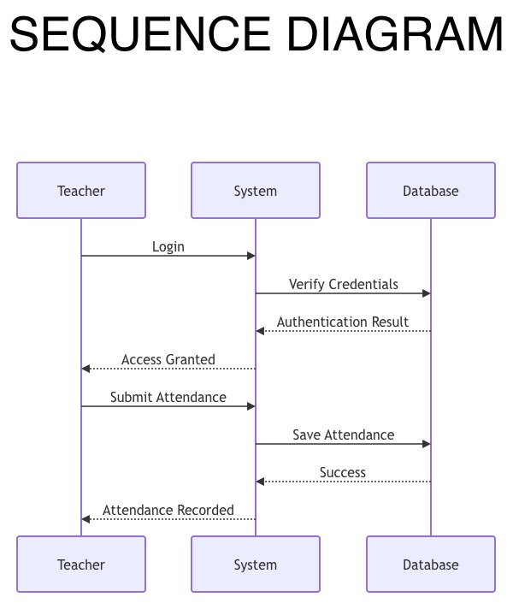
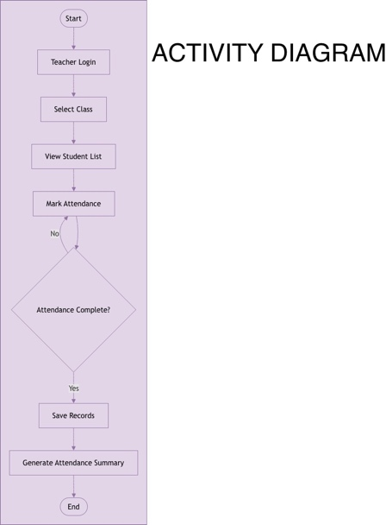

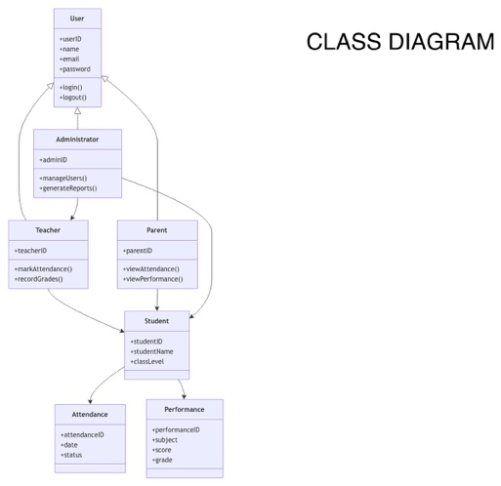
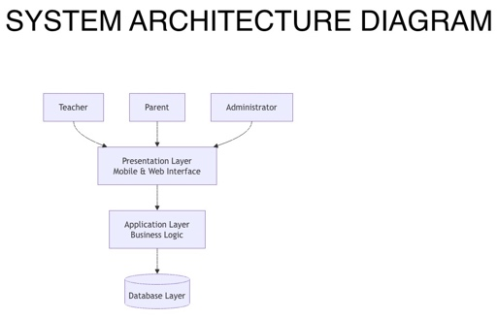
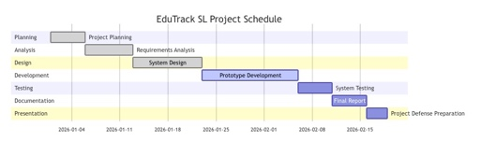

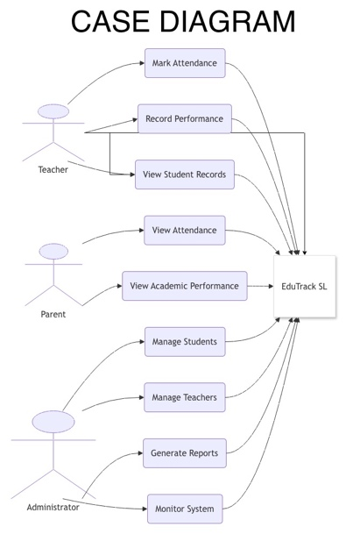

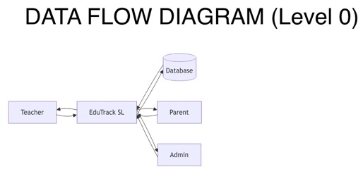
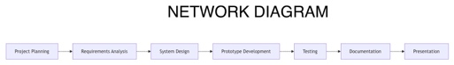

10 Recommendations
- SMS integration
- Multi-school support
- Biometric attendance
- Advanced analytics
- Ministry of Education integration

10 Conclusion
EduTrack SL provides a practical digital solution for improving attendance tracking, academic performance management, and communication within schools. Through the application of software engineering principles, Agile SDLC, system design techniques, and prototype development, the project demonstrates how technology can address educational administration challenges in Sierra Leone. The proposed system supports SDG 4 by promoting effective educational management and improved learning outcomes, making it a valuable foundation for future implementation and expansion.

REFERENCES
Sommerville, I. (2016) Software Engineering. 10th edn. Harlow: Pearson Education.
Beck, K. et al. (2001) Manifesto for Agile Software Development. Available at: https://agilemanifesto.org
United Nations (2015) Transforming our World: The 2030 Agenda for Sustainable Development. New York: United Nations.
UNESCO (2023) Technology in Education: A Tool on Whose Terms? Global Education Monitoring Report. Paris: UNESCO.
Pressman, R. S. and Maxim, B. R. (2020) Software Engineering: A Practitioner's Approach. 9th edn. New York: McGraw-Hill Education.
Elmasri, R. and Navathe, S. B. (2015) Fundamentals of Database Systems. 7th edn. Harlow: Pearson Education.
Ministry of Basic and Senior Secondary Education, Sierra Leone (2022) Education Sector Plan 2022-2026. Freetown: Government of Sierra Leone.
World Bank (2021) Digital Technologies in Education: Sierra Leone Country Note. Washington, DC: World Bank Group.

