LAB – 4 LAUNCH AZURE SQL

1. Deploy SQL DB

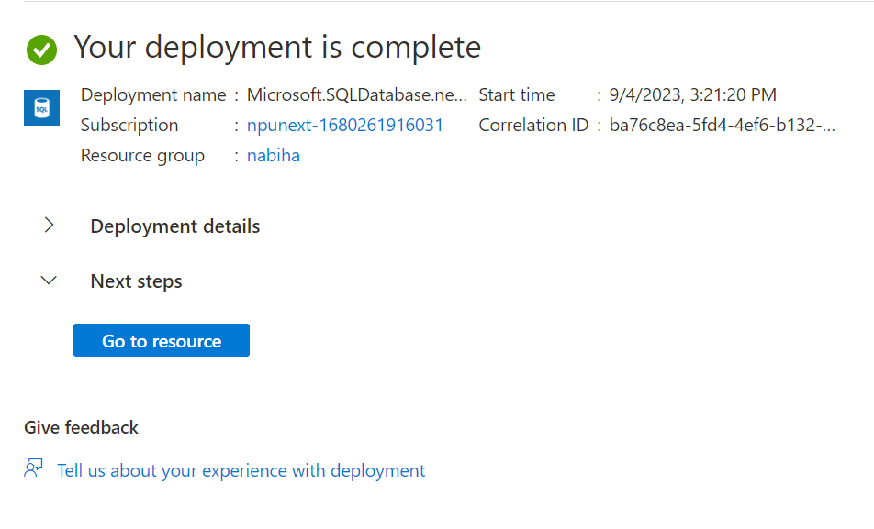

1. 