LAB – 5 DEMO ON AZURE COSMOS DB

1. Azure Cosmo DB account created

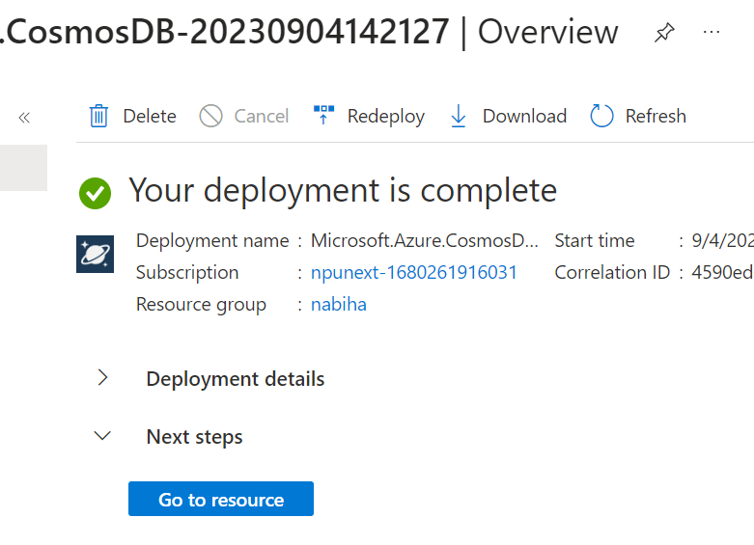

1. Add Container

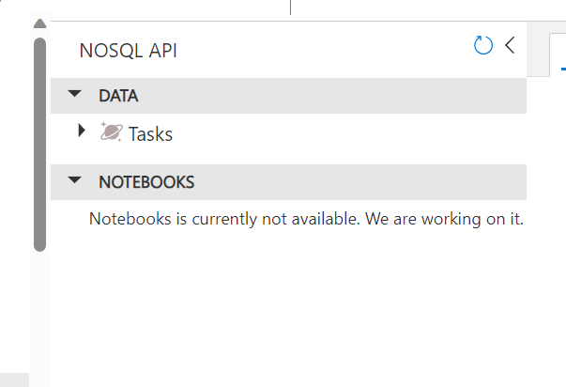

1. Adding Items

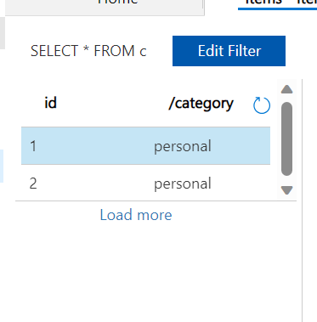

1. Apply queries

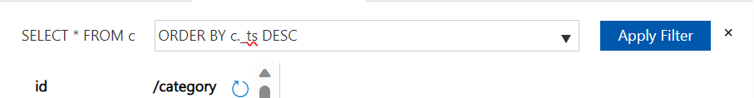

1. Storage Account

