C Program Tasks



Assignment Title: C Programs Tasks
Subject Name: Programming Fundamentals Lab
Submitted By: Nabiha Shaukat
Roll Number: 26k-3166
Submitted To: Sir Shayan Ali
Date Of Submission: 9 Sep 2026

QUESTION 01:
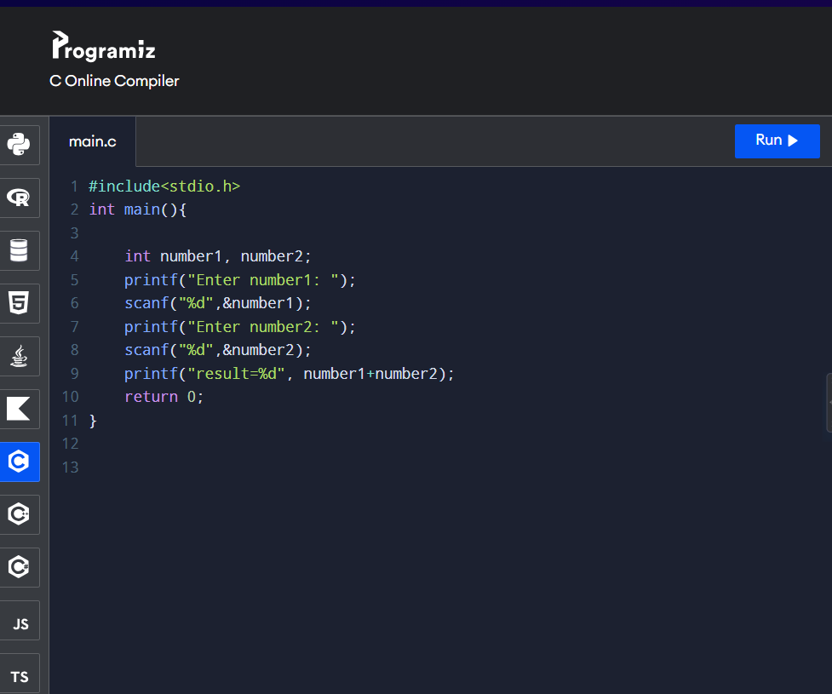
Fig1: addition input on C Compiler

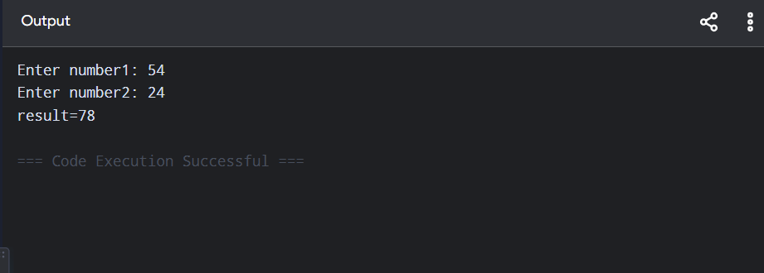
Fig2: addition output on C Compiler

QUESTION 02:
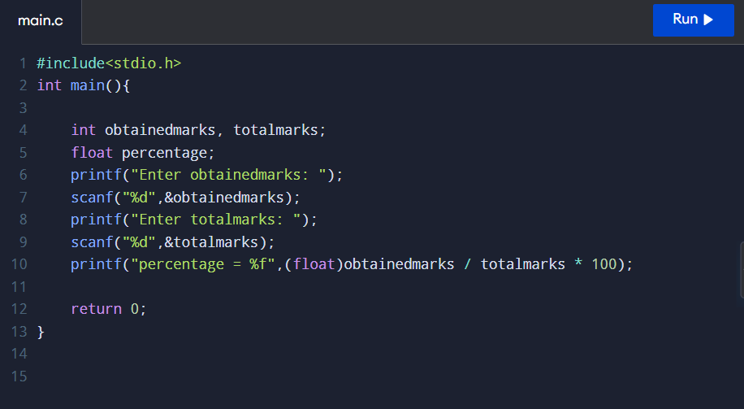
Fig3: Input of obtained marks, total marks & percentage on C Compiler

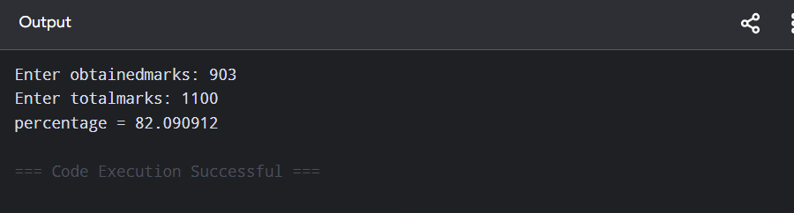
Fig4: output of obtained marks, total marks & percentage on C Compiler

QUESTION 03:
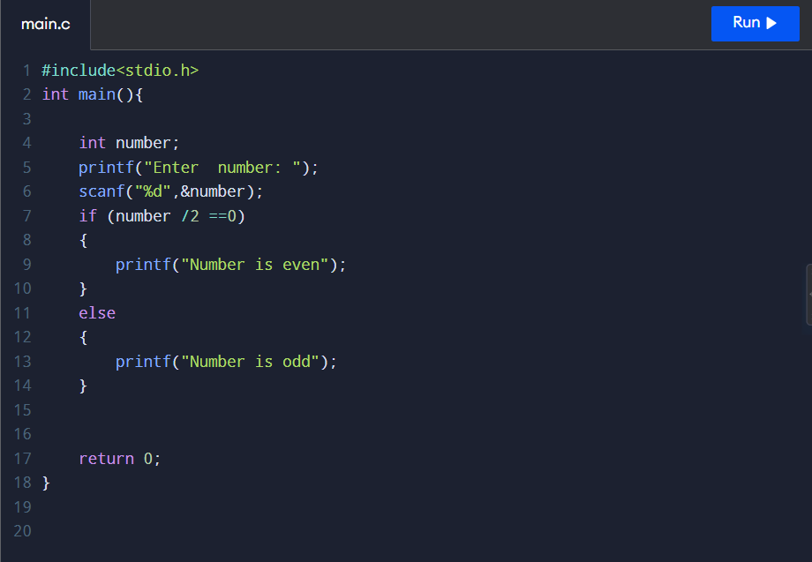
Fig5: Input of even or odd number on C Compiler

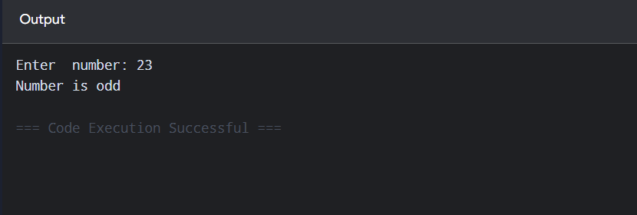
Fig6: output of even odd number on C Compiler

QUESTION 04:
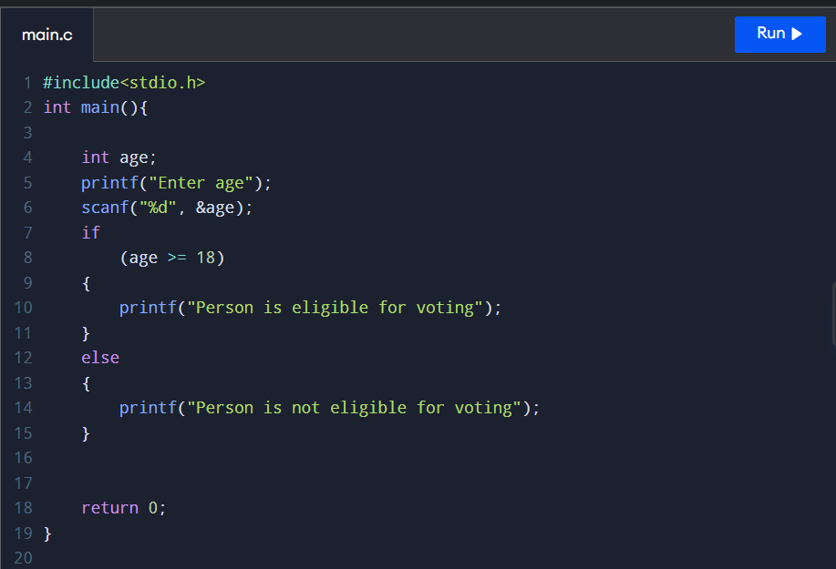
Fig7: Input of person’s age on C Compiler

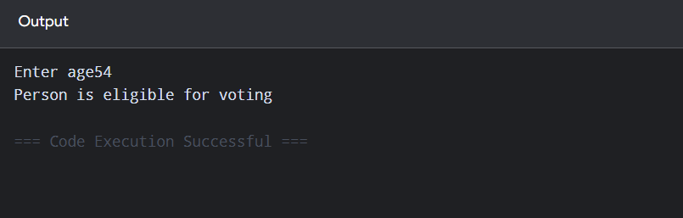
Fig8: output of person’s age on C Compiler

QUESTION 05:
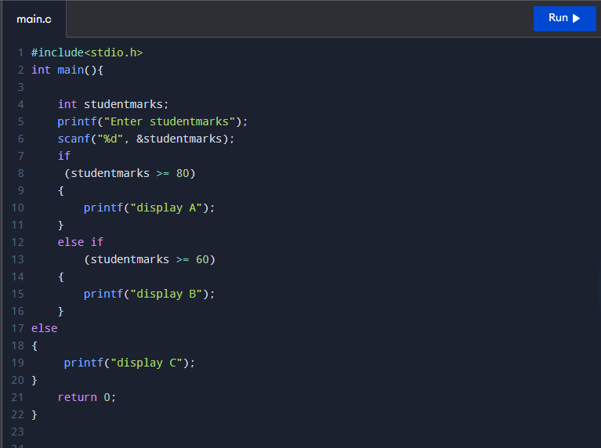
Fig9: Input of student’s grade on C Compiler

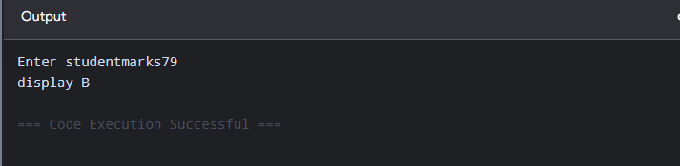
Fig10: output of student’s grade on C Compiler

QUESTION 06:
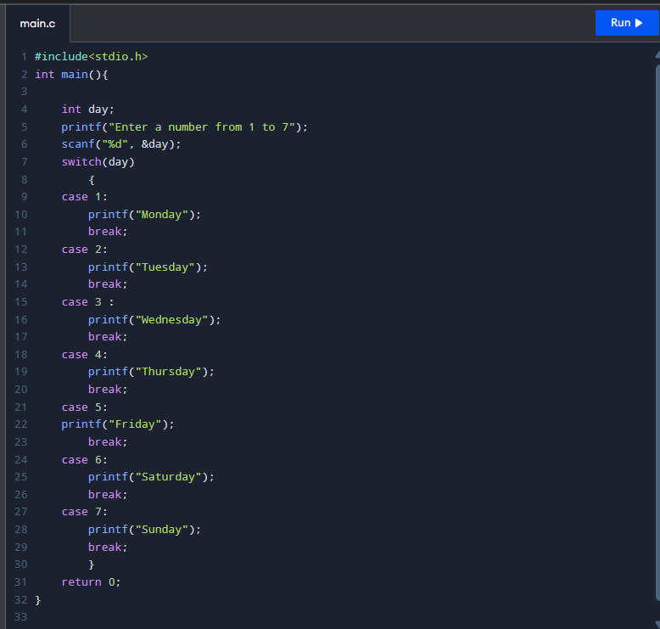
Fig11: Input of weekdays on C Compiler

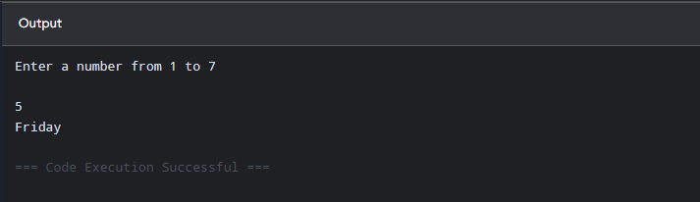 Fig12: output of weekdays on C Compiler

