FAST — National University of Computer and Emerging Sciences
Karachi Campus
Department of Software Engineering
PF LAB TASKS

Course Code: | C1002
Subject: | Programming Fundamentals
Section: | D & C
Instructor: | Mr. Shayan Ali
STUDENT SUBMISSION DETAILS
Name: | Nabiha Shaukat
Roll No / ID: | 26k-3166
Class / Section: D | BSE-1C
Date of Submission: | 27 Sep 2026
Submission Guidelines
1. Write and compile each program separately in a C compiler (e.g. Code::Blocks, Dev-C++, or an online IDE).
2. Test each program with more than one input where relevant, to confirm all conditions work correctly.
3. Submit all tasks before the given deadline.

TASK # 01 — Temperature Status (if-else)
A weather monitoring system takes the temperature in Celsius from the user. Write a C program using if-else to display "Cold" if the temperature is below 15, "Normal" if the temperature is between 15 and 30, and "Hot" if the temperature is above 30.
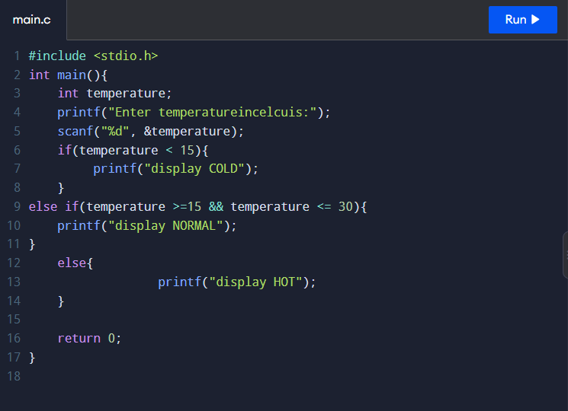
Fig 1: Input of temperature using if-else

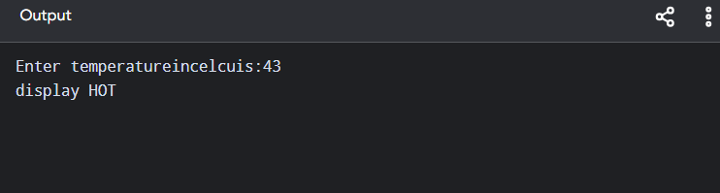
Fig 2: Output of temperature using if-else

TASK # 02 — Mobile Data Package (if-else)
A mobile service provider checks a customer's remaining balance before activating a package. Write a C program that takes the balance as an integer and uses if-else to display "Low Balance" if the balance is below 500, "Sufficient Balance" if it is between 500 and 2000, and "Premium Balance" if it is above 2000.
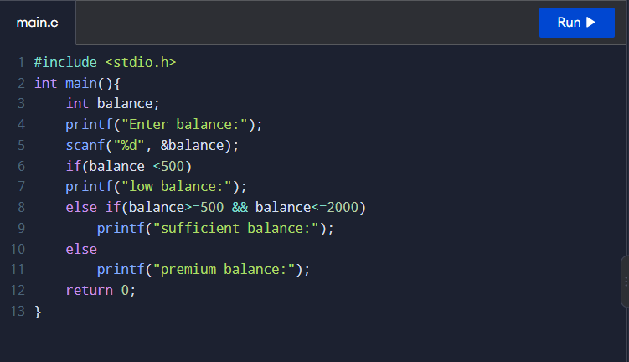
Fig 3: Input of balance using if-else

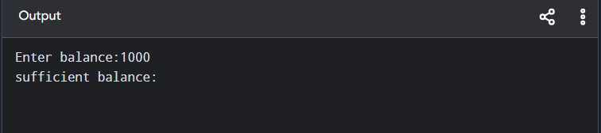
Fig 4: Output of balance using if-else

TASK # 03 — Hospital Appointment (nested if-else)
A hospital appointment system asks the patient to enter three integer values: appointment, doctorAvailable, and registrationCompleted, where 1 means yes and 0 means no. Write a C program using nested if-else statements to first check whether the patient has an appointment, then check whether the doctor is available, and finally check whether the registration is completed before displaying whether the patient can meet the doctor.
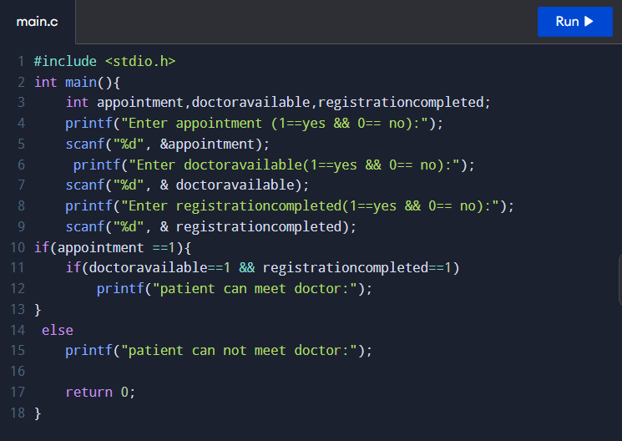
Fig 5: Input of program using nested if-else

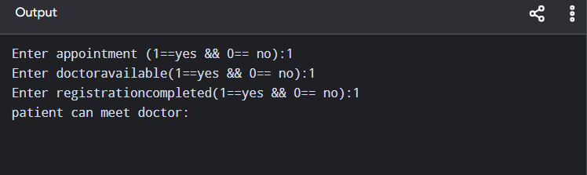
Fig 6: Output of program using nested if-else

TASK # 04 — Online Food Order (nested if-else)
An online food delivery system asks the customer to enter three integer values: restaurantOpen, itemAvailable, and balanceSufficient, where 1 means yes and 0 means no. Write a C program using nested if-else statements to first check whether the restaurant is open, then whether the selected item is available, and finally whether the customer has sufficient balance before displaying the appropriate order status.
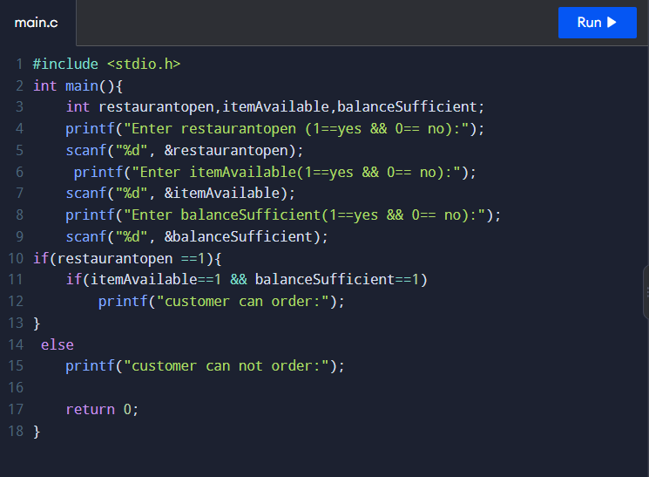
Fig 7: Input of program using nested if-else

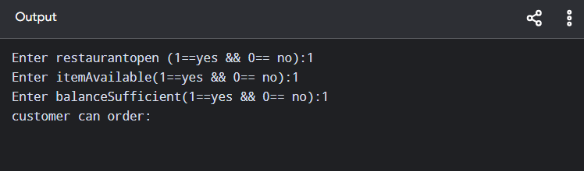
Fig 8: Output of program using nested if-else

TASK # 05 — ATM and Transaction Selection (Nested switch):
An ATM provides four operations: 1 for Balance Inquiry, 2 for Cash Withdawal, 3 for Cash Deposit, and 4 for PIN Change. After the user selects an operation, the ATM displays a second menu related to that operation; for example, after selecting Cash Withdrawal, the user can choose 1 for Savings Account or 2 for Current Account. Write a C program using a nested switch statement to take both choices as integer inputs and display the selected operation and account type
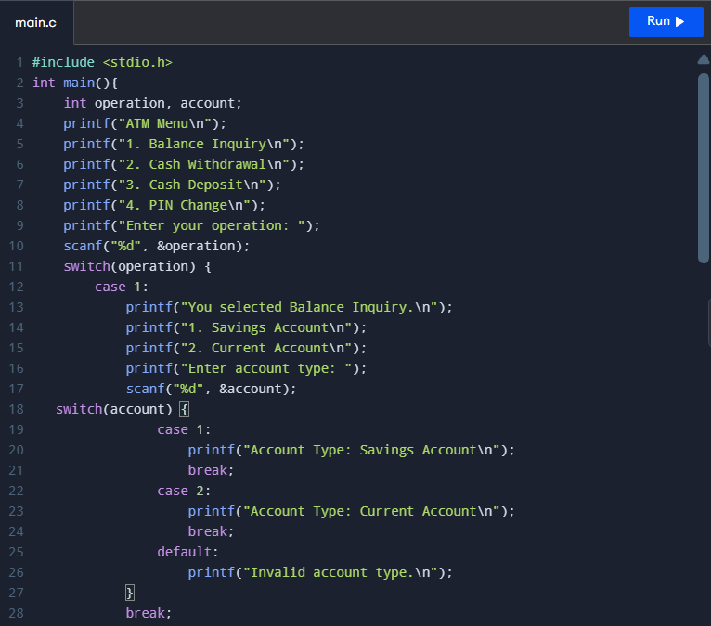
Fig 9: Input of program using nested switch

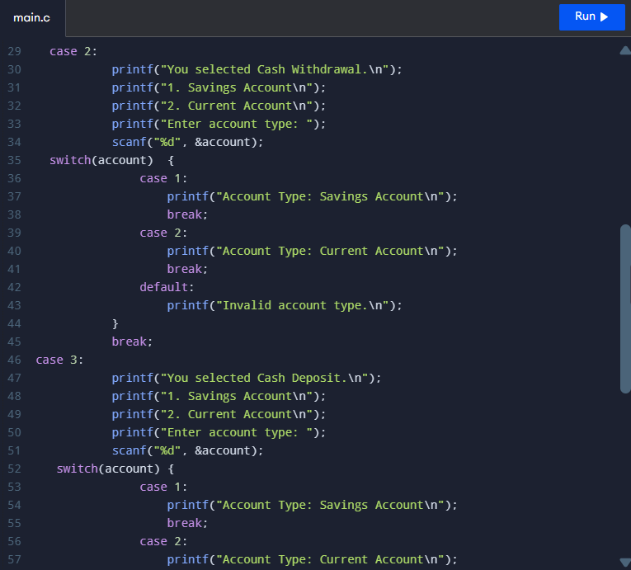
Fig 10: Input of program using nested switch

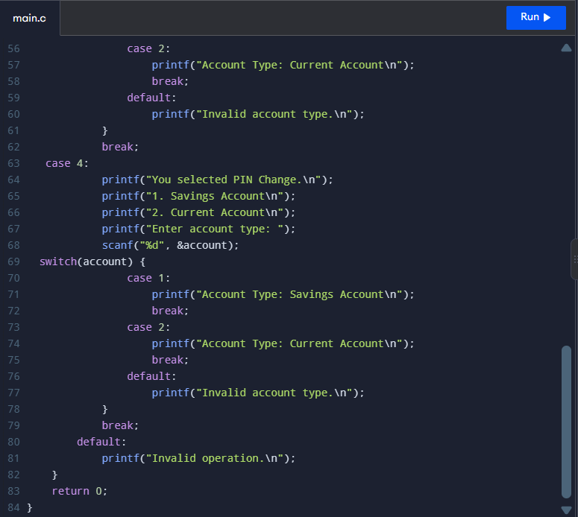
Fig 11: Input of program using nested switch

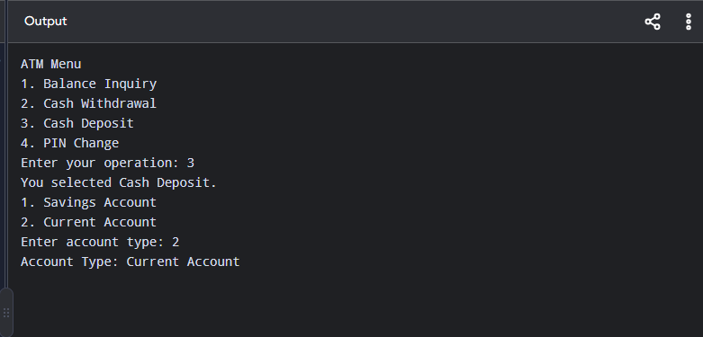
Fig 12: Output of program using nested switch

