American International University-Bangladesh (AIUB)
Faculty of Science and Technology
Department of Computer Science

Web Technologies
CSE 4101
PROJECT REPORT

Project Title:
PharmaQuick — Online Medicine Shop

Semester: Spring 2025–2026
Submission Date: 19 may, 2026
Section: H

Submitted To:
Wahidul Alam Riyad
lecturer, Faculty
DEPARTMENT OF COMPUTER SCIENCE
American International University-Bangladesh

Group Information
Fill in all fields below. Each group member must sign before submission.

Group Number: 07

Project Title: PharmaQuick — Online Medicine Shop

Student Information:

Full Name: AL RAFAT KHANDOKER
Student ID: 23-51462-1
Program: CSE
Email: 23-51462-1@student.aiub.edu

Signature: _____________________________

Declaration: We hereby declare that this project report is our original work. Any external resources or references used have been properly cited. We have not engaged in any form of academic dishonesty.

Marks Sheet
To be filled by the instructor only. Students must NOT write in this section.

Group No. |  | Section
Member 1 ID

CO3: Illustrate Multi-Tier Web Application for Targeted Society
Feature Implementation (0-3) |  |  | Feature Implementation (0-3) |  | Completeness (0-3)
Basic Web Security | UI (HTML/CSS) | Feature Completeness | DB | Auth (Session/cookie) | MVC
CO4: Coordinate with Group Members to Develop Multi-Tier Application
Technical Knowledge (0-3) |  |  | Collaborative Teamwork (0-3) |  |  | Communication/Promptness (0-3)
JS validation | PHP Validation | Ajax/JSON | Git Contribution |  |  | VIVA
Expected Outcome (0-2) |  | CO3 Total | CO4 Total |  |  | Project Total

Evaluated By: __________________________ Date: __________________

Course Teacher Signature: _______________________

Table of Contents

1. Group Information 2
2. Marks Sheet 3
3. Table of Contents 4
4. Chapter 1: Project Overview 9
4.1 Project Description 9
4.1 Technologies Used 10
4.3 System Architecture / MVC Diagram 11
4.4 Database Schema 12
5. Chapter 2: Git Contribution & Task Allocation 13
5.1 GitHub Repository Link 13
5.2 Git Contribution Screenshot 14
6. Chapter 3: Features, Source Code & Screenshots 16
7. Chapter 5: Conclusion & Future Work 18

Chapter 1: Project Overview

1.1 Project Description
The Online Medicine Shop is a web-based pharmacy management system developed using PHP and MVC architecture. The system allows users to browse medicines online while admins and vendors manage products and inventory.
My assigned responsibility was the Vendor Module. Initially, the vendor section included cart and order features, but later the requirements were updated. The final vendor module allows vendors to:
- view vendor dashboard
- add medicines
- edit medicines
- delete medicines
- manage medicine stock and pricing
The vendor can only manage medicines that belong to their own account.

1.2 Technologies Used.

Layer | Technology / Tool | Purpose
Frontend | HTML5, CSS3 | User Interface
Frontend Logic | JavaScript, AJAX | Client-side validation, Dynamic Operations
Backend | PHP | Server-side logic
Database | MySQL | Data storage
Auth | PHP Sessions / Cookies | Vendor Login management
Version Control | Git / GitHub | Collaboration & versioning
Server | XAMPP / Apache | Local Server development

1.3 System Architecture / MVC Diagram
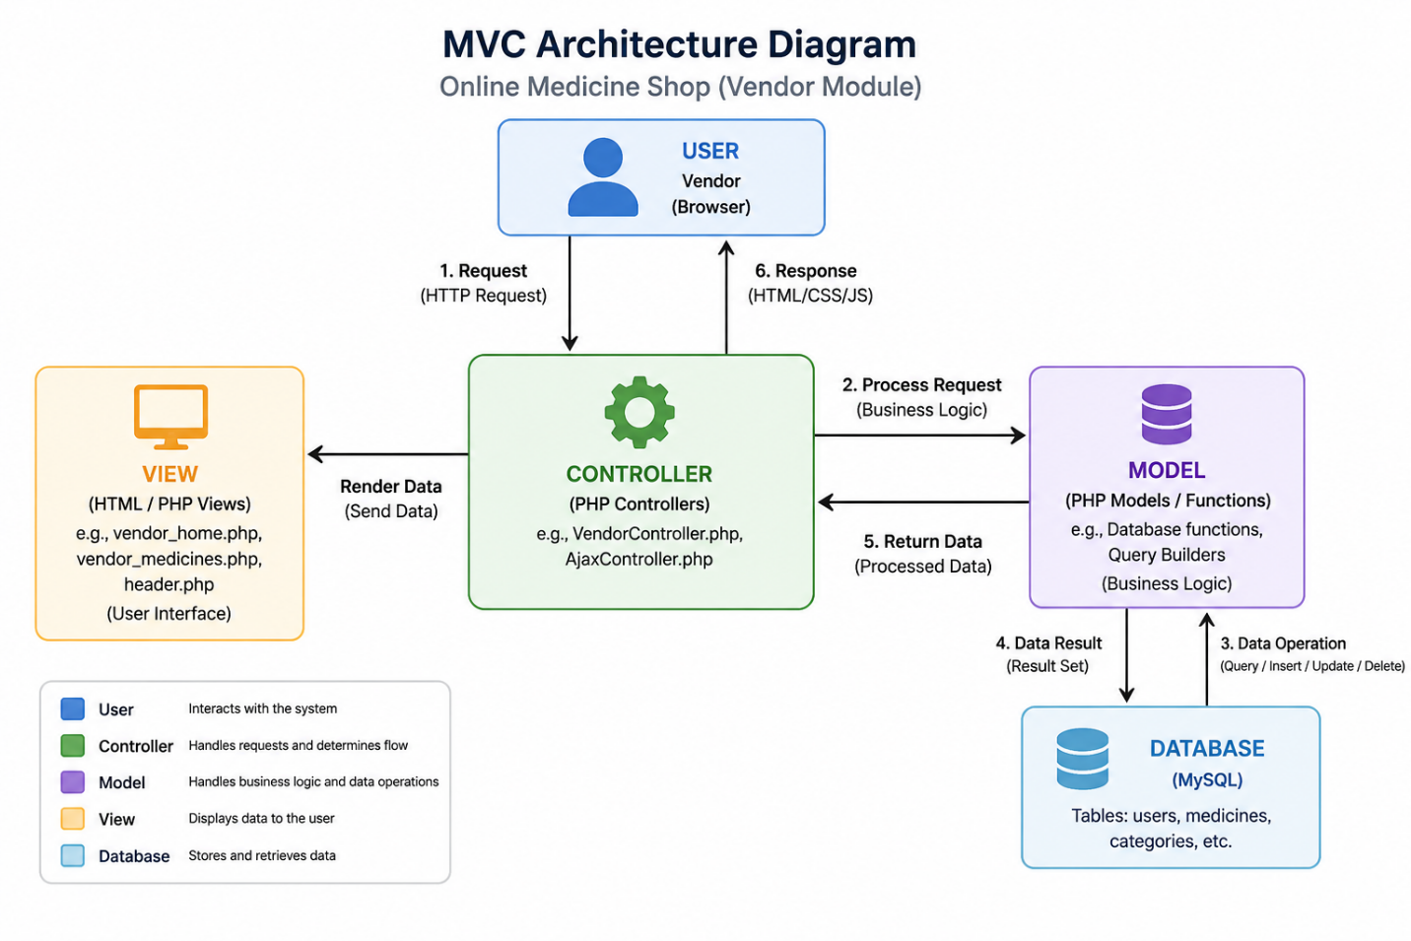

1.4 Database Schema
List your database tables and their key fields.
Table Name | Field Name | Data Type | Description
[e.g., users] | [e.g., user_id] | [e.g., INT] | [Primary Key]
 | [e.g., username] | [e.g., VARCHAR(50)]
[Table 2]

Chapter 2: Git Contribution & Task Allocation

2.1 GitHub Repository Link
Repository URL: https://github.com/nabil-adib/online-medicine-shop

2.2 Git Contribution Screenshot
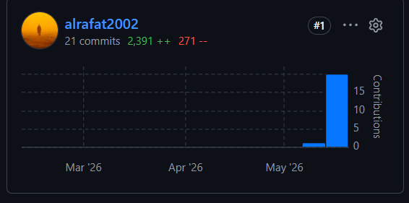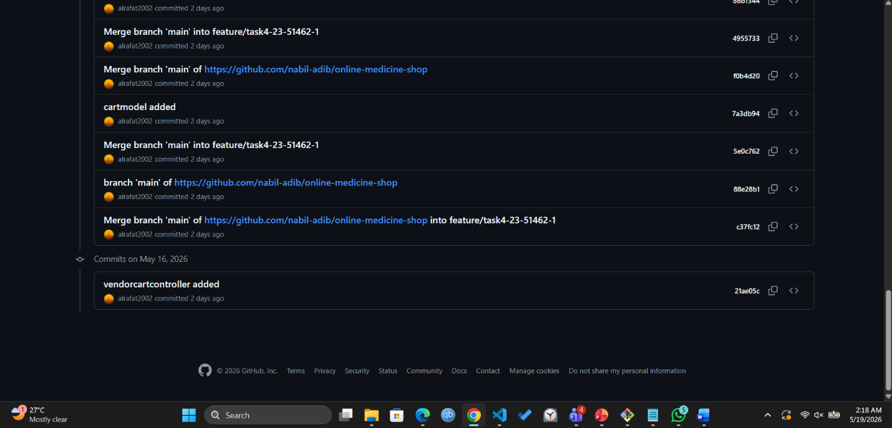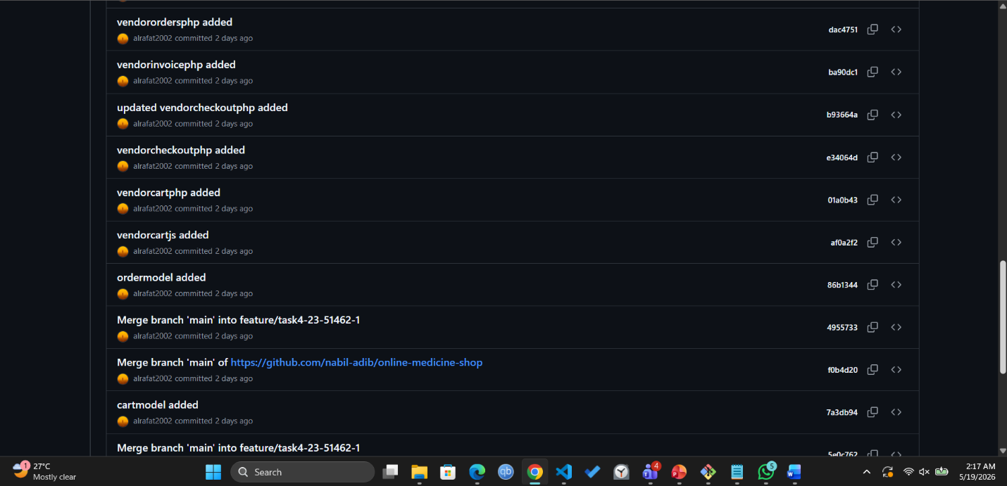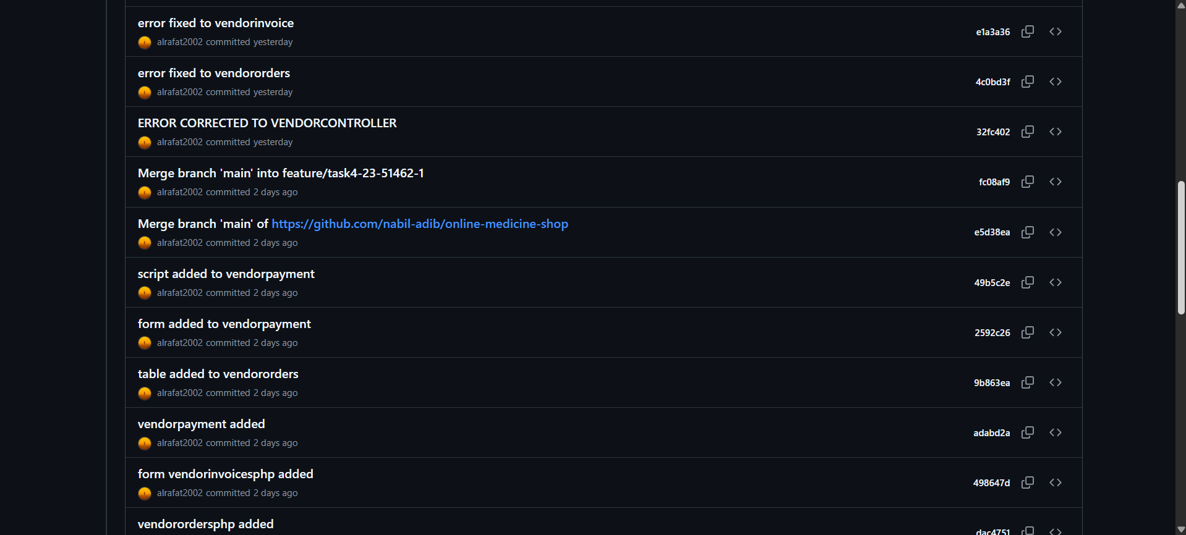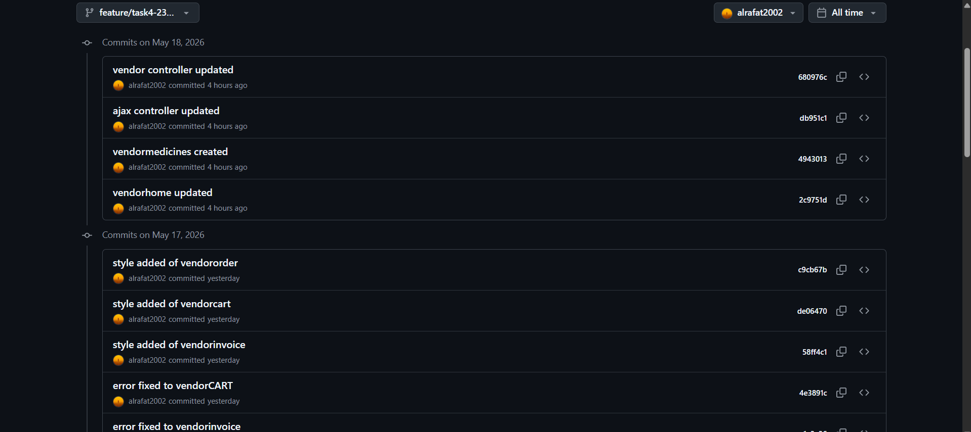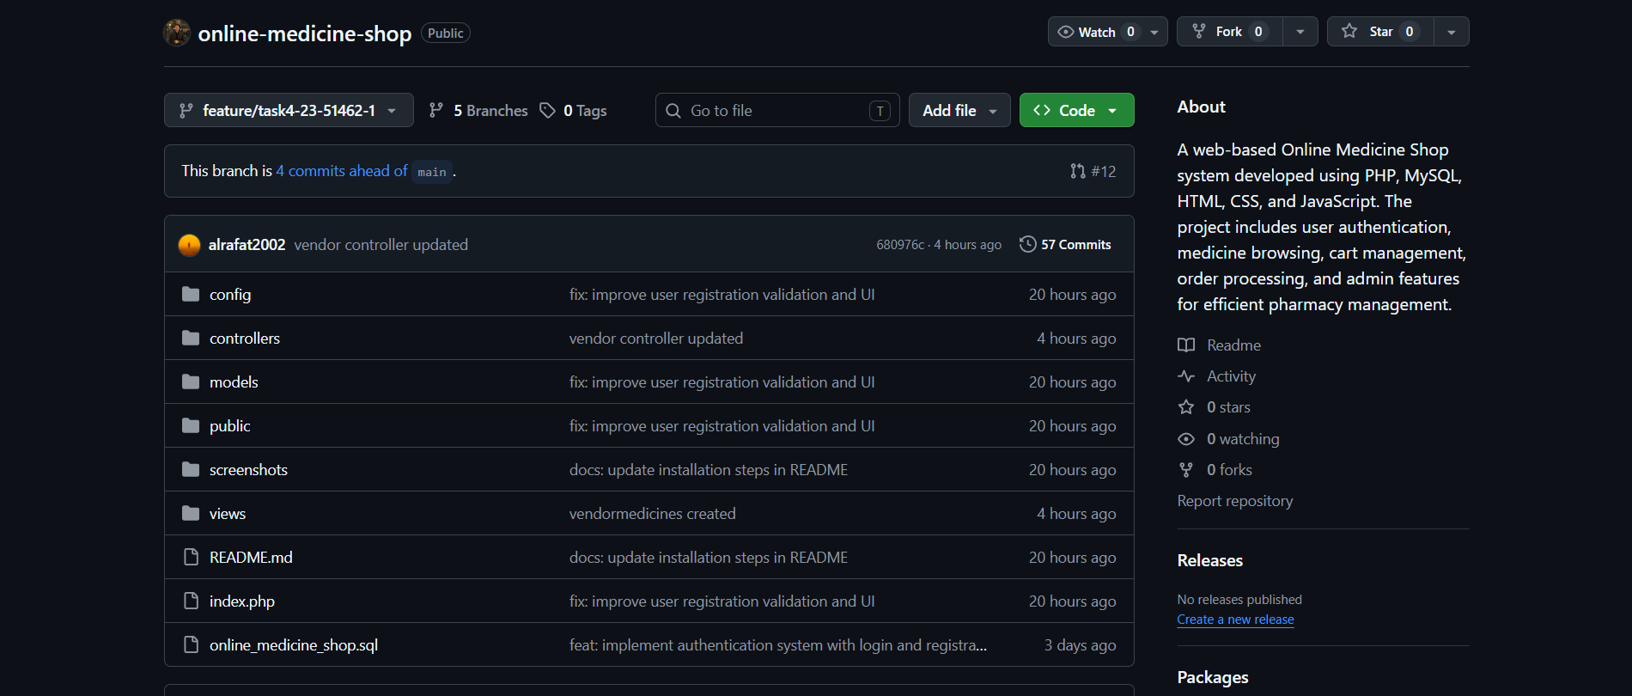

Chapter 3: Features, Source Code & Screenshots
For each feature implemented in the project, provide the following: a description, the relevant source code with explanation, and screenshot(s) of the UI.
Duplicate the feature section (Feature 1 block) as many times as needed — one block per feature.

Feature-1 : Vendor Dashboard

Description

The vendor dashboard displays:

total medicines

available categories

vendor medicine list

The dashboard provides a quick overview of vendor products.

Relevant Source Code.

File: views/vendor_home.php
// Paste your source code here
// Example (PHP):
<?php
if (!isset($_SESSION['user_id']) || $_SESSION['user_role'] !== 'vendor') {
header('Location: index.php?page=login');
exit;
}
require 'views/header.php';
?>

<div class="container">
<!-- Welcome Banner -->
<div style="background: linear-gradient(135deg, #2563eb 0%, #1e40af 100%); border-radius: 1rem; color: white; padding: 2rem; margin-bottom: 2rem;">
<h1 style="font-size: 1.875rem; font-weight: bold; margin-bottom: 0.5rem;">Welcome, <?= htmlspecialchars($_SESSION['user_name']) ?>!</h1>
<p style="color: #bfdbfe;">Vendor Dashboard - Manage your pharmacy products and orders</p>
</div>

<!-- Stats Cards -->
<div style="display: grid; grid-template-columns: repeat(auto-fit, minmax(250px, 1fr)); gap: 1.5rem; margin-bottom: 2rem;">
<div style="background: white; border-radius: 0.75rem; padding: 1.5rem; border: 1px solid #e5e7eb; text-align: center;">
<h3 style="font-size: 1.875rem; font-weight: bold; margin: 0.5rem 0;"><?= count($medicines ?? []) ?></h3>
<p style="color: #6b7280;">Your Medicines</p>
</div>

<div style="background: white; border-radius: 0.75rem; padding: 1.5rem; border: 1px solid #e5e7eb; text-align: center;">
<h3 style="font-size: 1.875rem; font-weight: bold; margin: 0.5rem 0;"><?= count($categories ?? []) ?></h3>
<p style="color: #6b7280;">Categories Available</p>
</div>

<div style="background: white; border-radius: 0.75rem; padding: 1.5rem; border: 1px solid #e5e7eb; text-align: center;">
<h3 style="font-size: 1.875rem; font-weight: bold; margin: 0.5rem 0;">0</h3>
<p style="color: #6b7280;">Orders Received</p>
<a href="index.php?page=vendor_orders" style="display: inline-block; margin-top: 1rem; color: #2563eb; text-decoration: none;">View Orders →</a>
</div>
</div>

<!-- Your Products Section -->
<div style="background: white; border-radius: 0.75rem; padding: 1.5rem; border: 1px solid #e5e7eb;">
<h3 style="font-size: 1.25rem; font-weight: bold; margin-bottom: 1rem;">Your Products</h3>
<?php if (!empty($medicines)): ?>
<div style="overflow-x: auto;">
<table style="width: 100%; border-collapse: collapse;">
<thead>
<tr>
<th style="padding: 0.75rem; text-align: left; border-bottom: 1px solid #e5e7eb;">Name</th>
<th style="padding: 0.75rem; text-align: left; border-bottom: 1px solid #e5e7eb;">Category</th>
<th style="padding: 0.75rem; text-align: left; border-bottom: 1px solid #e5e7eb;">Price</th>
<th style="padding: 0.75rem; text-align: left; border-bottom: 1px solid #e5e7eb;">Stock</th>
</tr>
</thead>
<tbody>
<?php foreach (array_slice($medicines, 0, 10) as $med): ?>
<tr style="border-bottom: 1px solid #e5e7eb;">
<td style="padding: 0.75rem;"><?= htmlspecialchars($med['name']) ?></td>
<td style="padding: 0.75rem;"><?= htmlspecialchars($med['category_name']) ?></td>
<td style="padding: 0.75rem;">৳<?= number_format($med['price'], 2) ?></td>
<td style="padding: 0.75rem;"><?= $med['availability'] ?></td>
</tr>
<?php endforeach; ?>
</tbody>
</table>
</div>
<?php else: ?>
<p style="text-align: center; padding: 3rem; color: #9ca3af;">
No products found. Medicines are managed by admin.
</p>
<?php endif; ?>
</div>
</div>

<?php require 'views/footer.php'; ?>

Code Explanation
- count() counts vendor medicines
- Medicine statistics are displayed dynamically
- Vendor-specific data is shown using session authentication

Screenshot(s)
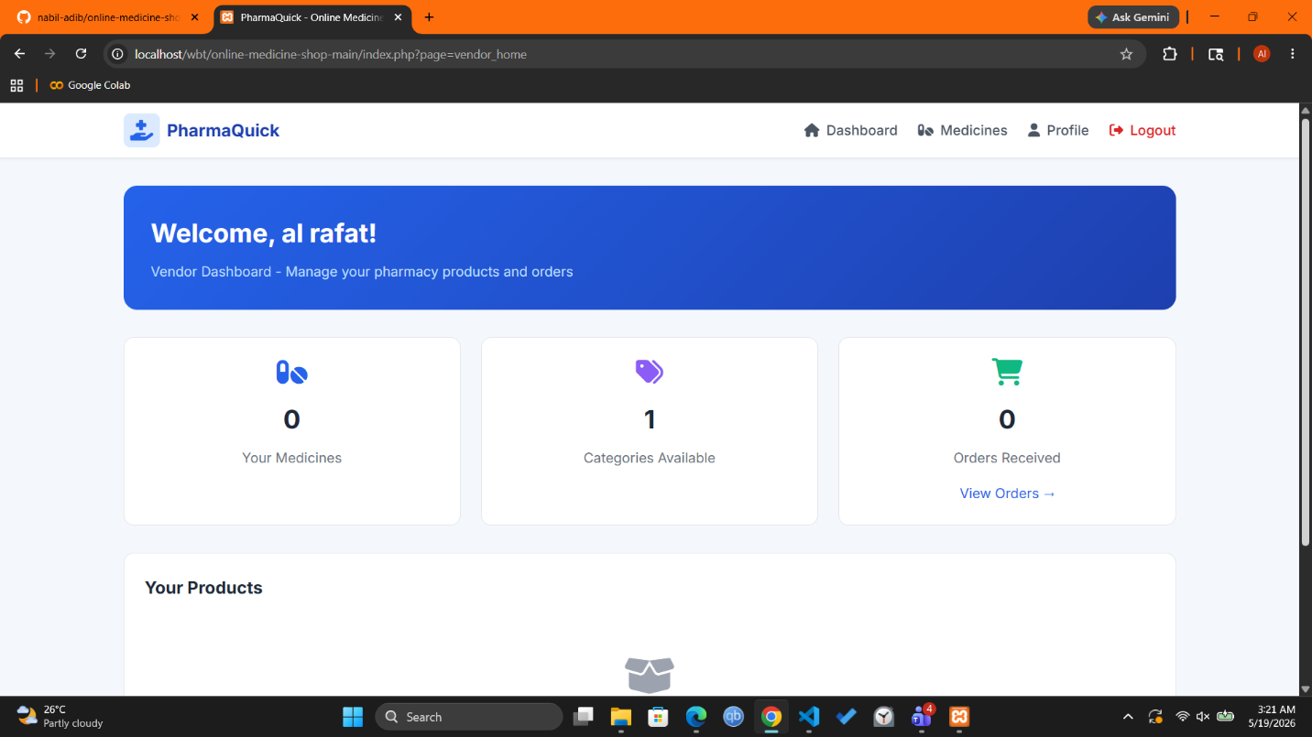

Feature-2 : Add Medicine
Description
This feature allows vendors to add new medicines into the system using AJAX-based form submission.
Fields:
- medicine name
- category
- description
- price
- stock quantity

Relevant Source Code

File: AjaxController.php
// Paste your source code here
// Example (PHP):
function handle_vendor_add_medicine($conn) {

$stmt = mysqli_prepare(
$conn,

"INSERT INTO medicines
(
name,
category_id,
description,
price,
availability,
vendor_name
)

VALUES (?, ?, ?, ?, ?, ?)"
);
}

Code Explanation
- Validates vendor session
- Collects medicine information
- Uses prepared statements for security
- Inserts medicine into database
- Returns JSON response

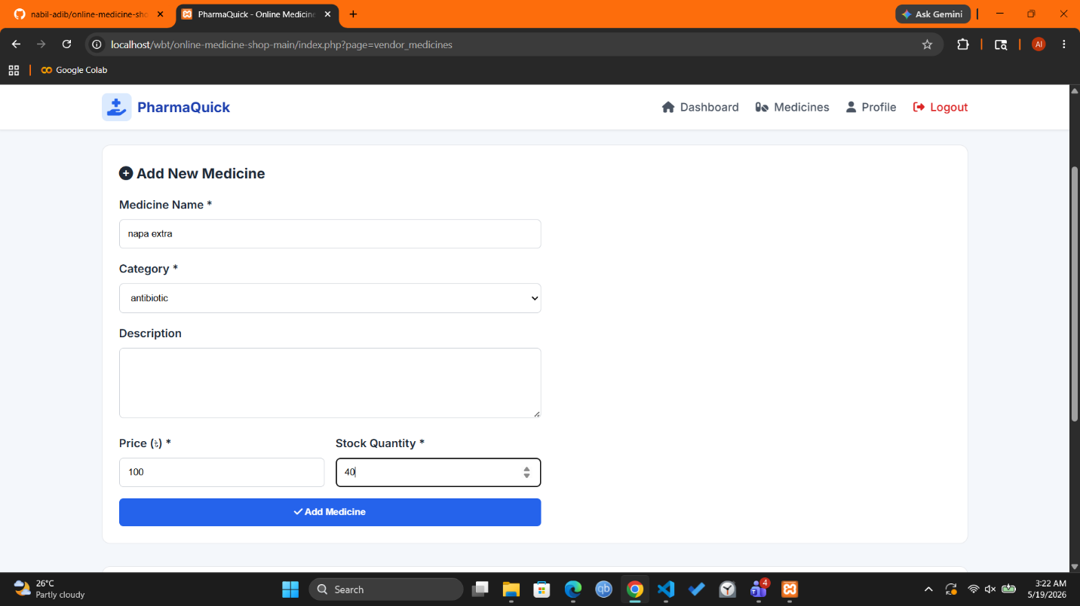
Feature-3 : Edit Medicine

Description

This feature allows vendors to update existing medicine information through a popup modal form.

Vendors can edit:

medicine name

category

description

price

stock

.

Relevant Source Code
File: views/ vendor_medicines.php
// Paste your source code here
// Example (PHP):
function editMedicine(
id,
name,
categoryId,
description,
price,
availability
)

Code Explanation
- Opens edit modal popup
- Fills existing medicine data automatically
- Sends updated data using AJAX
- Updates medicine without page reload
Screenshot(s)
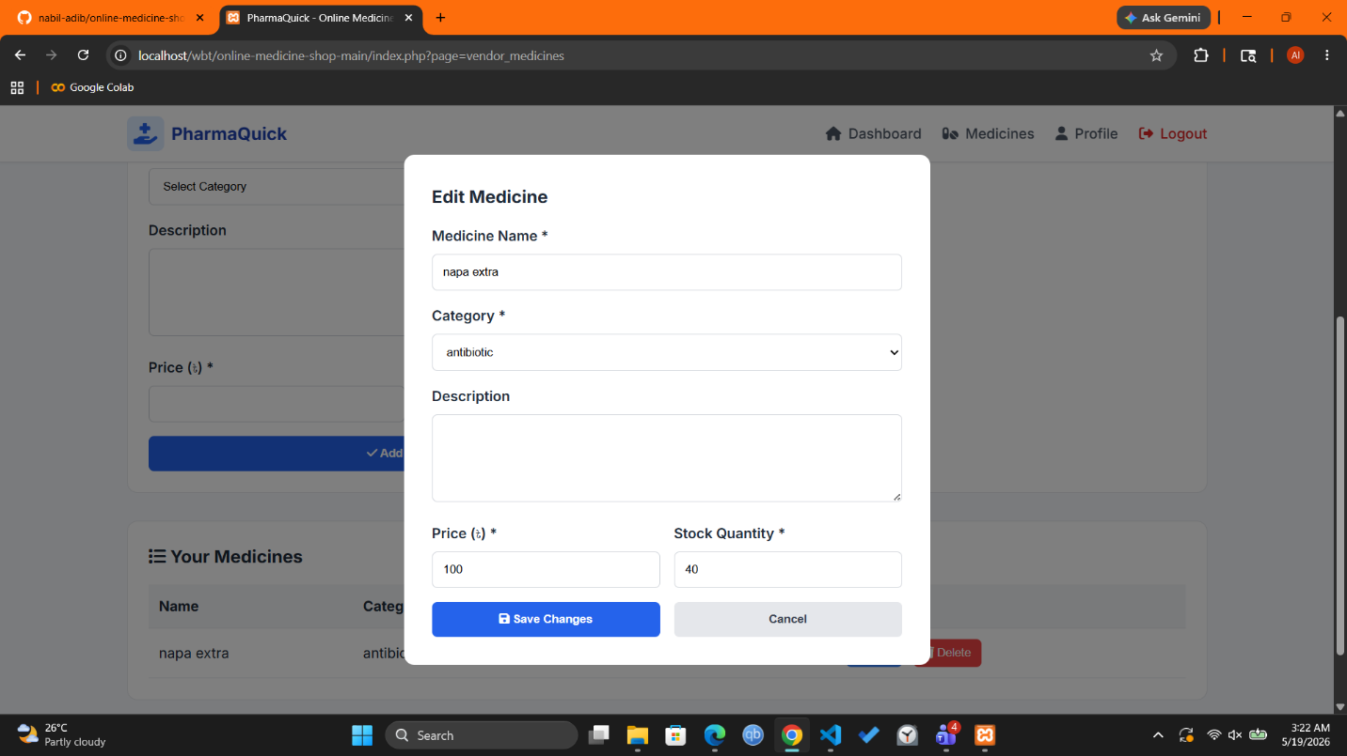

Feature- 4: Delete Medicine

Description

This feature allows vendors to delete their own medicines from the database.

Ownership verification prevents unauthorized deletion.

.

Relevant Source Code
File: AjaxController.php
// Paste your source code here
// Example (PHP):
function handle_vendor_delete_medicine($conn) {

$stmt = mysqli_prepare(
$conn,

"DELETE FROM medicines
WHERE id = ?
AND vendor_name = ?"
);
}

Code Explanation
- Checks vendor ownership
- Prevents unauthorized deletion
- Uses prepared statements
- Deletes selected medicine securely
Screenshot(s)
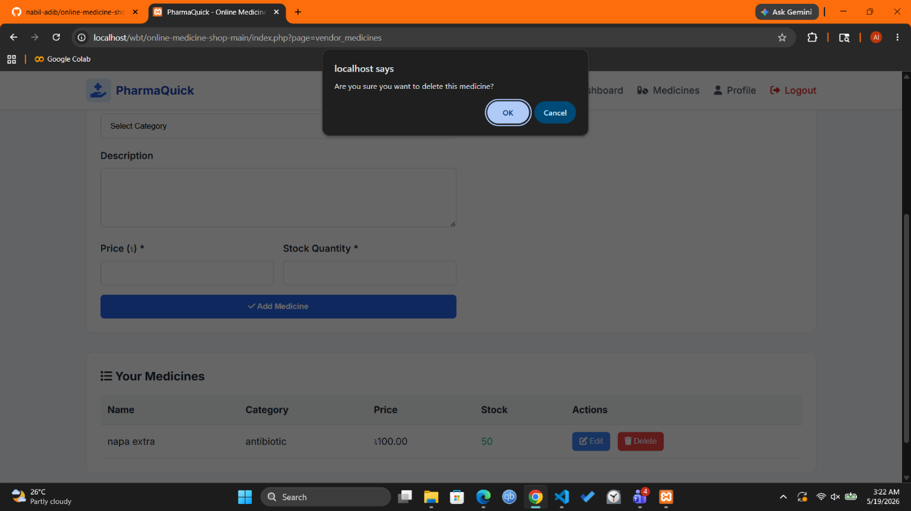

Feature- 5: Vendor Controller

Description

The vendor controller manages:

vendor dashboard

medicine page

vendor session authentication

.

Relevant Source Code
File: controllers/VendorController.php
// Paste your source code here
// Example (PHP):
<?php

function vendor_home_ctrl($conn) {
if (!isset($_SESSION['user_id']) || $_SESSION['user_role'] !== 'vendor') {
header('Location: index.php?page=login');
exit;
}

// Get medicines for this vendor
$vendor_name = $_SESSION['user_name'];
$stmt = mysqli_prepare($conn, "SELECT m.*, c.name AS category_name FROM medicines m JOIN categories c ON m.category_id = c.id WHERE m.vendor_name = ? ORDER BY m.id DESC");
mysqli_stmt_bind_param($stmt, "s", $vendor_name);
mysqli_stmt_execute($stmt);
$result = mysqli_stmt_get_result($stmt);
$medicines = [];
while ($row = mysqli_fetch_assoc($result)) {
$medicines[] = $row;
}

// Get categories
$categories = get_all_categories($conn);

require 'views/vendor_home.php';
}

function vendor_medicines_ctrl($conn) {
if (!isset($_SESSION['user_id']) || $_SESSION['user_role'] !== 'vendor') {
header('Location: index.php?page=login');
exit;
}

// Get medicines for this vendor
$vendor_name = $_SESSION['user_name'];
$stmt = mysqli_prepare($conn, "SELECT m.*, c.name AS category_name FROM medicines m JOIN categories c ON m.category_id = c.id WHERE m.vendor_name = ? ORDER BY m.id DESC");
mysqli_stmt_bind_param($stmt, "s", $vendor_name);
mysqli_stmt_execute($stmt);
$result = mysqli_stmt_get_result($stmt);
$medicines = [];
while ($row = mysqli_fetch_assoc($result)) {
$medicines[] = $row;
}

// Get categories
$categories = get_all_categories($conn);

require 'views/vendor_medicines.php';
}
?>

Code Explanation
- Verifies vendor login
- Retrieves vendor medicines
- Loads categories
- Displays vendor medicine view
Screenshot(s)


Chapter 5: Conclusion & Future Work

5.1 Summary
The Vendor Module of the Online Medicine Shop was successfully implemented using PHP MVC architecture. The module allows vendors to manage medicines through add, edit, and delete operations. AJAX functionality improved system responsiveness and user experience.

5.2 Challenges Faced
- Updating vendor module requirements
- Managing AJAX form submissions
- Implementing secure ownership verification
- Handling Git branch and Pull Request workflow

5.3 Future Improvements
- Medicine image upload support
- Advanced medicine search and filtering
- Real-time stock alerts
- Vendor sales analytics dashboard

References

[1] PHP Documentation — https://www.php.net/

[2] MySQL Documentation — https://dev.mysql.com/doc/

[3] GitHub Documentation — https://docs.github.com/
[4] W3Schools — https://www.w3schools.com/
[5] OpenAI ChatGPT — https://chat.openai.com/

