

American International University-Bangladesh (AIUB)  
**Department of Computer Science  
Faculty of Science &Technology (FST)  
Spring 21_22  
CSC 2210 Object Oriented Analysis and Design (OOAD)**

**Section: A  
Group No: 03**

**Blood Bank Management**

An Object-Oriented Analysis and Design (OOAD) project submitted

By

|  |  |  |  |  |
| --- | --- | --- | --- | --- |
| **Semester: Spring_21_22** | | **Section:** | **Group Number:** | |
| SN | Student Name | Student ID | Contribution  (%) | Individual Marks |
| 02 | Chowdhury, Farhan | 18-37884-2 | 20% |  |
| 07 | Hadiur Rahman Nabil | 20-42095-1 | 20% |  |
| 10 | Rashique Habib Chowdhury | 20-42269-1 | 20% |  |
| 11 | Muhammad Akib Al Islam | 20-42289-1 | 20% |  |
| 13 | S M Abu Huryra | 20-42480-1 | 20% |  |

The project will be evaluated for the following Course Outcomes

|  |  |
| --- | --- |
| **CO2:** Design a Complex engineering problem using UML Tools and explain the system using a project report and presentation | Total Marks |
|  |
| Project Content Knowledge (e.g., project background and narration) [5Marks] |  |
| Completeness, Correctness, and Diagram Standard [5Marks] |  |
| Use of UML tool and Report Organization [5Marks] |  |
| Submission and Presentation Delivery [5Marks] |  |

Description of Student’s Contribution in the Project work

|  |
| --- |
| Student Name: Chowdhury , Farhan  Student ID: 18-37884-2  Contribution in Percentage (%): 20%  Contribution in the Project:   * Use Case Diagram * Class Diagram   Farhan  ___________________  Signature of the Student |
| Student Name: Hadiur Rahman Nabil  Student ID: 20-42095-1  Contribution in Percentage (%):20%  Contribution in the Project:   * Use Case Diagram * Point number 1.1 * Activity Diagram   **Nabil**  ___________________  Signature of the Student |
| Student Name: Rashique Habib Chowdhury  Student ID: 20-42269-1  Contribution in Percentage (%):20%  Contribution in the Project:   * Use Case Diagram * Class Diagram   Rashique  ___________________  Signature of the Student |
| Student Name: Muhammad Akib Al Islam  Student ID: 20-42289-1  Contribution in Percentage (%):20%  Contribution in the Project:   * Use Case Diagram * Sequence Diagram   **Akib**  ___________________  Signature of the Student |
| Student Name: S M Abu Huryra  Student ID: 20-42480-1  Contribution in Percentage (%):20%  Contribution in the Project:   * Use Case Diagram * Point number 1.2 * Sequence Diagram   Huryra  ___________________  Signature of the Student |

# CHAPTER 1: PROBLEM DOMAIN

## Project Background Analysis

“Blood For Life” (BFL) is a Blood Bank Management System that is structured for people to provide blood when needed. This Blood Bank Management System will provide services for both sending the blood and receiving the request for the blood. This system will work as a bridge between the donor, and recipient during any emergency situation. To use this system new users, have to register first. After that, they need to login into their account to get the dedicated dashboard for them. In the login section, they have to go through using the specific username and password. During the registration process, they have to enter their name, age, NID, and blood group. Then the system maintainer verified those documents and create a profile for those users. At this time new users must have to choose whether they are donors or receivers. After successful login the recipient has to enter the blood group, he/she needs, also the related data such as date, and blood quantity. Besides the donor have to choose the blood group he/she wants to donate, relevant medical reports, and date. When a recipient order for blood the system maintainer forward this order to the blood bank administrator and recommend some donor profile to the administrator. Then the donor calls a donor after selecting. After the Hematology department did its job and test the blood is perfect or not. There are a few divisions operating in this department such as the Blood House division, Blood Transfusion division, and Blood Distribution division. The Blood House division collects blood from the donor, the Blood Transfusion division tests the blood in different ways to make sure it is safe and after that, the Blood Distribution division allocates those blood to the recipients.

## Project Solution and Feasibility Analysis

Problem definition deals with observation, site visits, and discussions to identify analyze and document project requirements and carry out feasibility studies and technical assessments to determine the best approaches for full system development. The addition of new features is very difficult and creates more overheads. In the existing system, data are not maintained properly which leads to the followed-ups slow and a lack of reports. The changes in one module or any part of the system are widely affected by other parts or sections. Keeping the problem definition in mind the proposed system evolves which is user-friendly, easy to update with the new features, data is maintained and reports generated will be more useful for management to take quick business and so on. The population of the world is multiplying with each coming year and so are the diseases and health issues. With an increase in the population, there is an increase in the need for blood. Due to the lack of communication between the blood donors and the blood recipients, most of the patients in need of blood do not get blood on time and hence lose their lives. The purpose of Red Drops is to bridge the gap between Recipient, Donor, and Blood Bank with the motive of saving lives. This blood bank management system also helps in case of any emergency at any time, thus playing an important role in saving a person’s life. This system provides end-to-end encryption and access to unauthorized people is not possible. If a person wants to donate his/her blood, one must undergo some steps according to the system. Donors' every detail including medical certificates had been checked via the Blood Transfusion Unit to serve 100% healthy blood. And the person who wants to receive blood can request it via the system. In between them, technical experts and the administrator of the blood bank connect the perfect match and then do the transaction successfully

# CHAPTER 2: UML DIAGRAM

## 2.1 Use Case Diagram

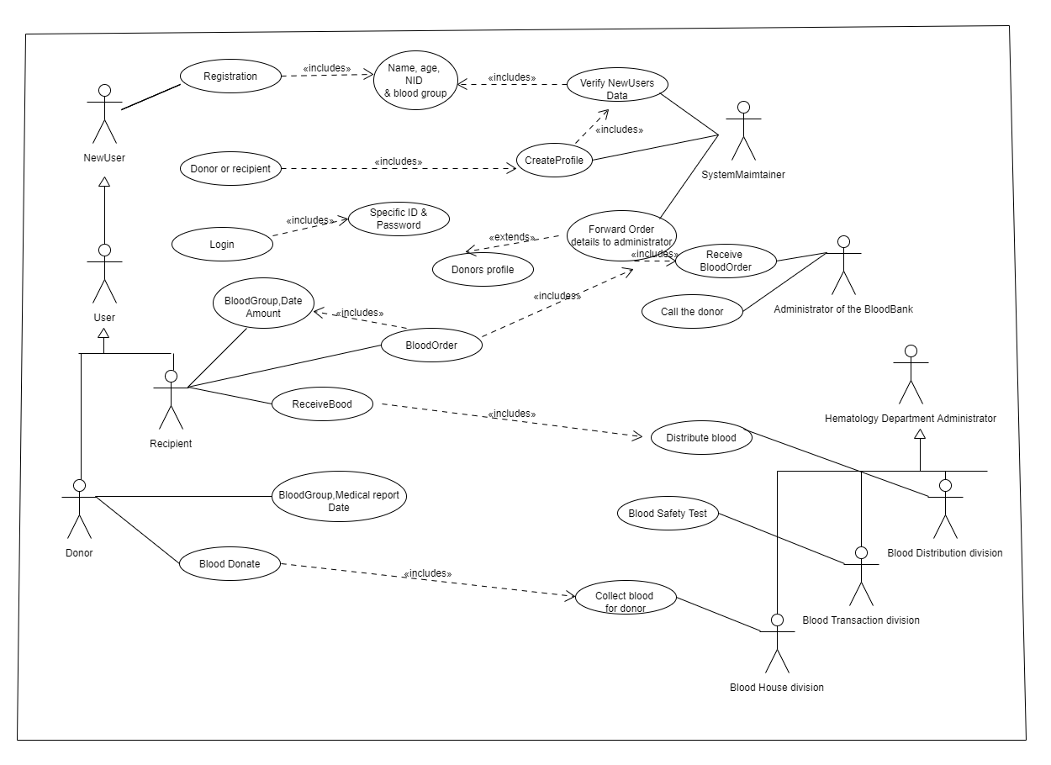

**Class Diagram:**

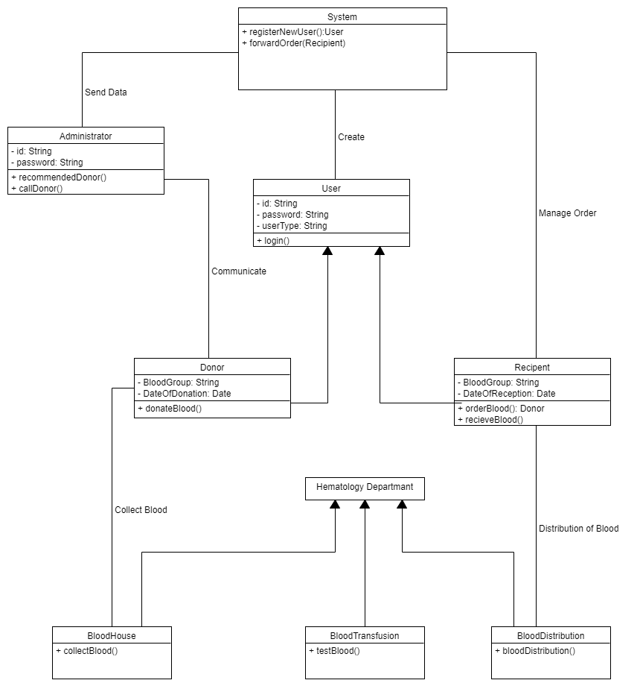

**Activity Diagram:**

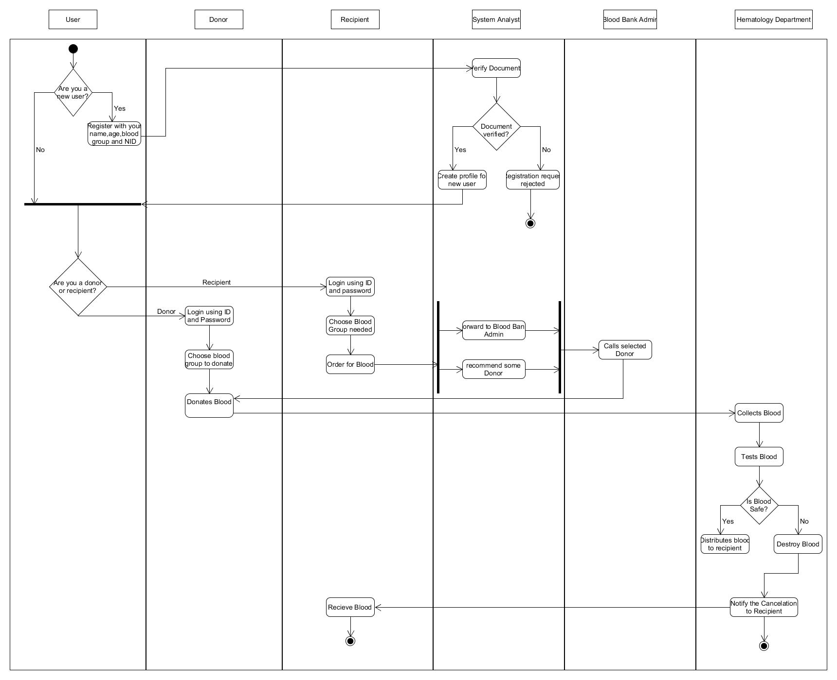

**Sequence Diagram of the project**:

