1. Create [Github](https://github.com/) account  
   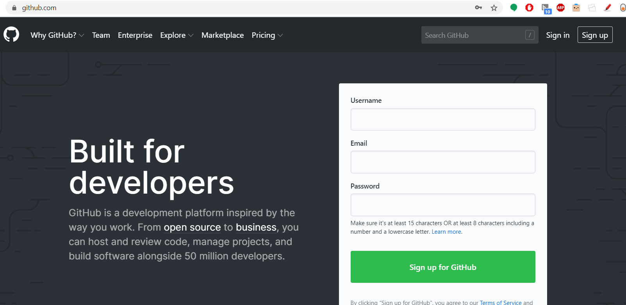
2. Download and install <https://desktop.github.com/>  
   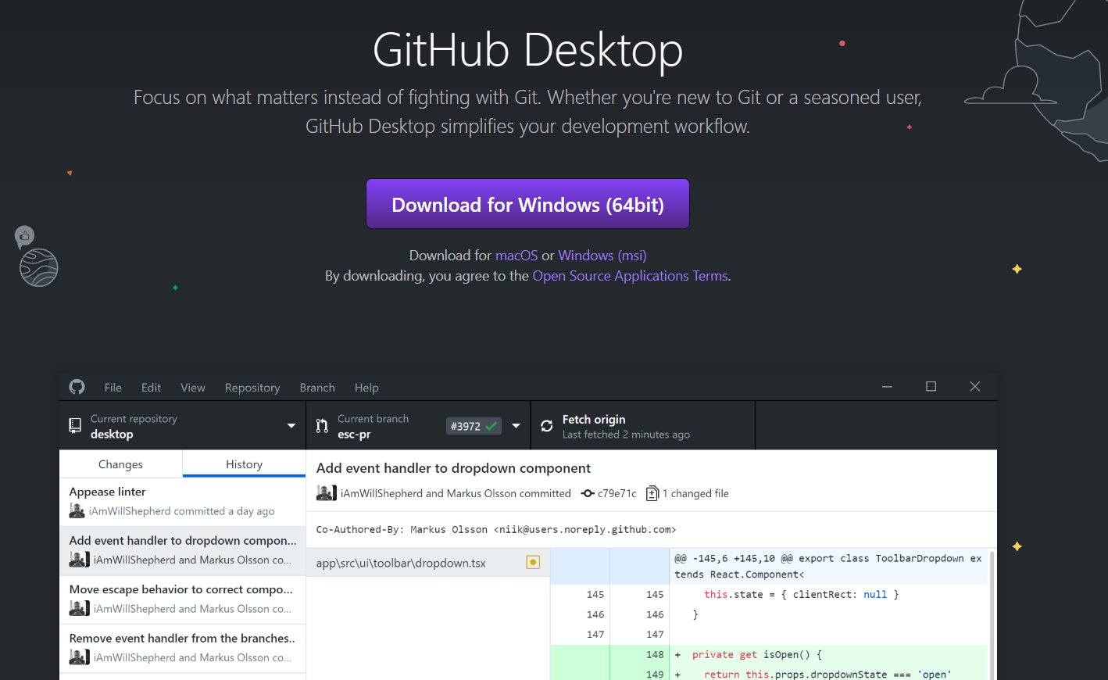
3. Create a *repo* 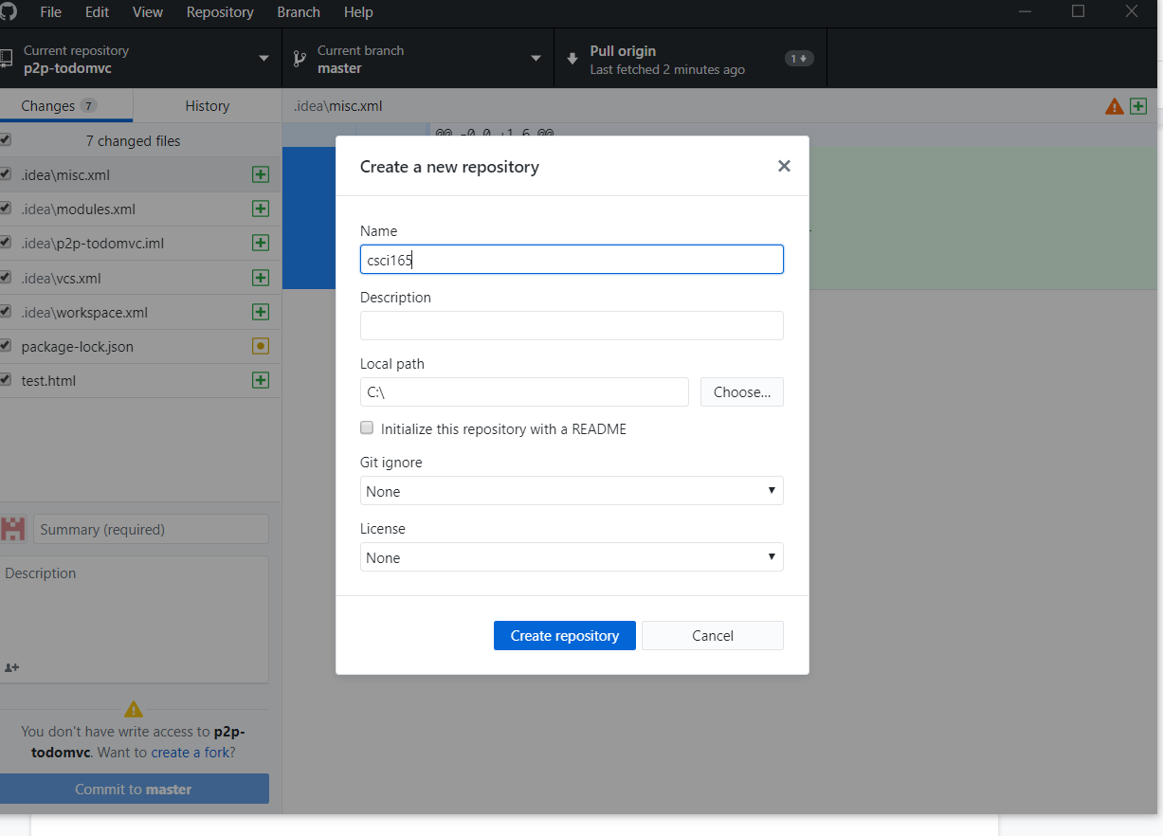
4. Create *index.html* inside the home directory of your repo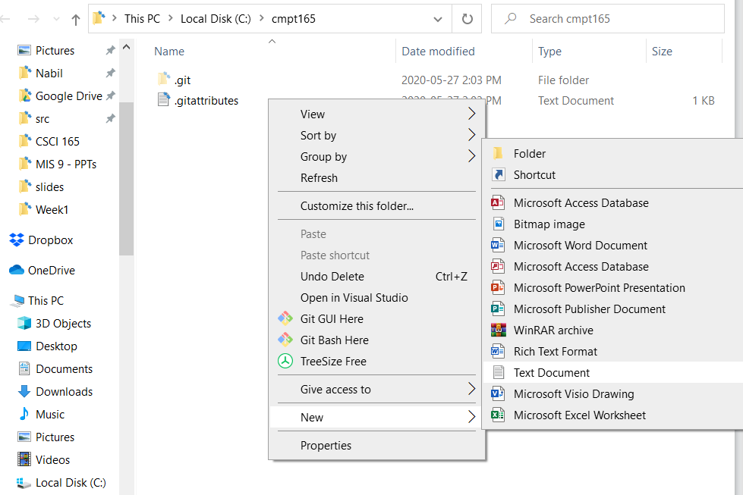
5. Open *index.html* and fill with this content

<html>

<head>

<title>Home</title>

</head>

<body>

Hi, this is my first website.

</body>

</html>

1. Save the file.
2. Commit and Push in GitHub Desktop
3. Review your changes in Github.com
4. Create <https://app.netlify.com/> account and link it to your GitHub account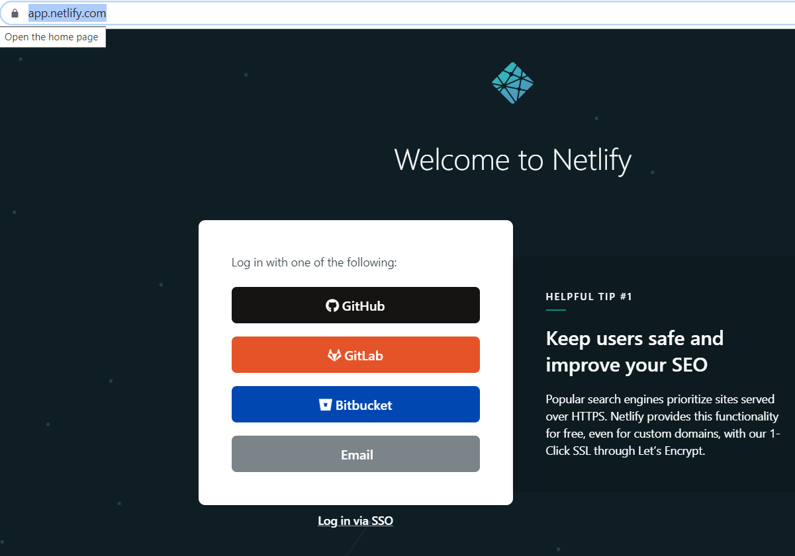
5. Create a new site in Netlify 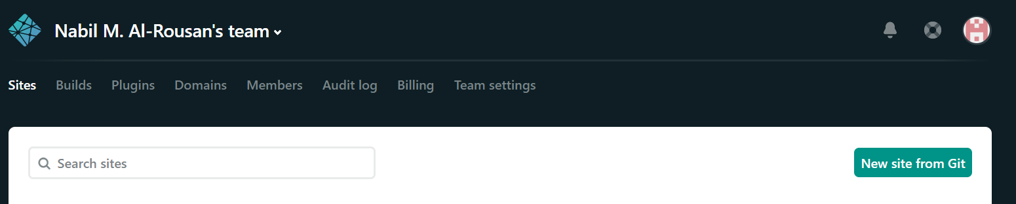
6. Link Netlify site to GitHub repo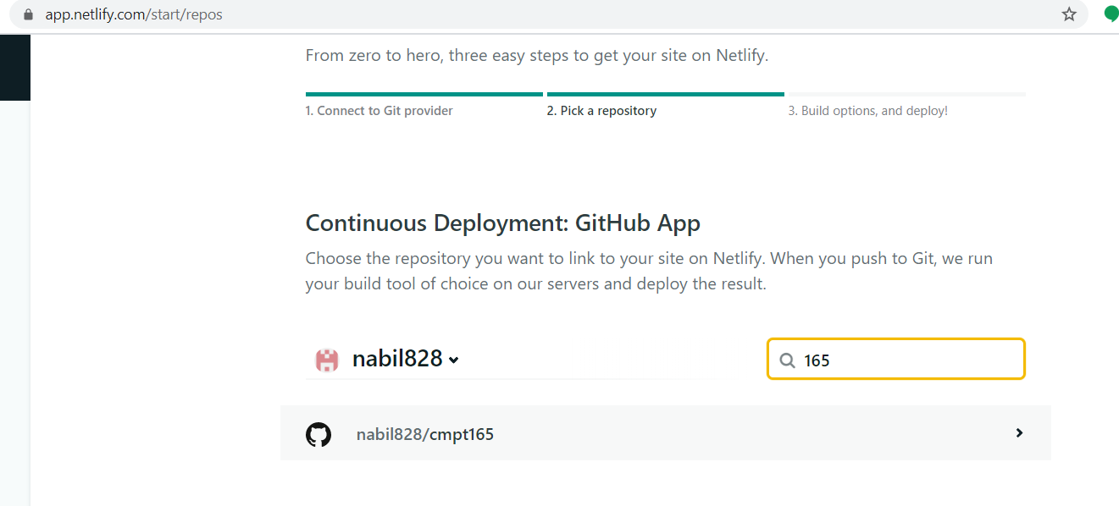
7. Deploy!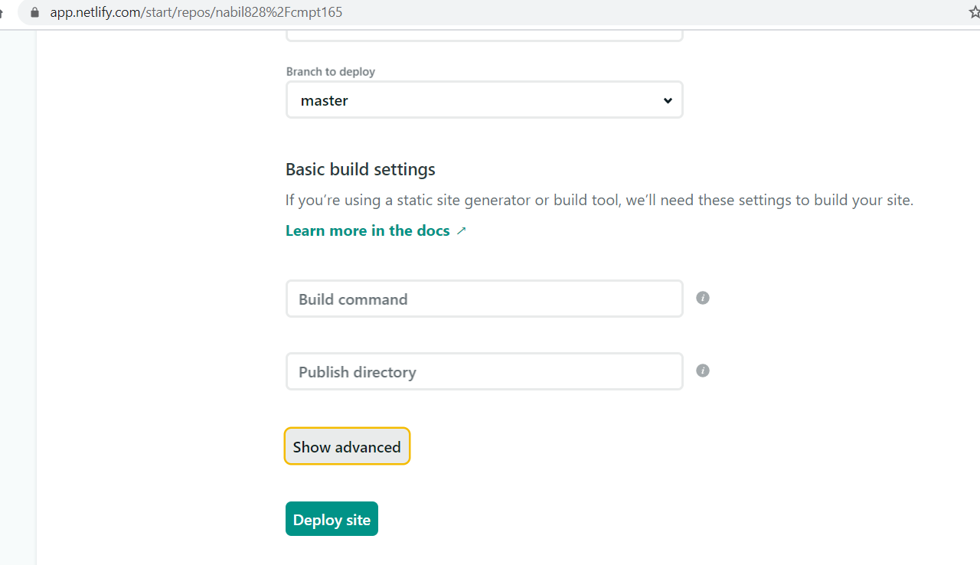
8. Wait a few seconds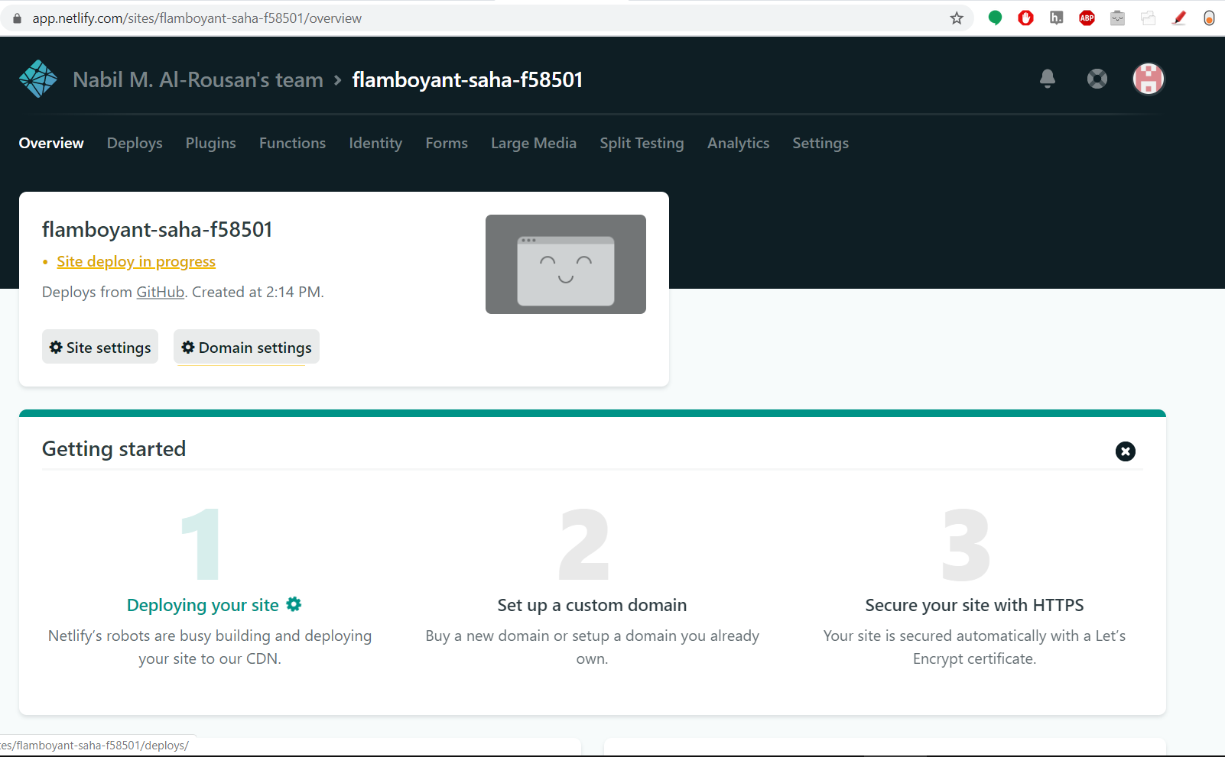
9. Voilà .. deployed!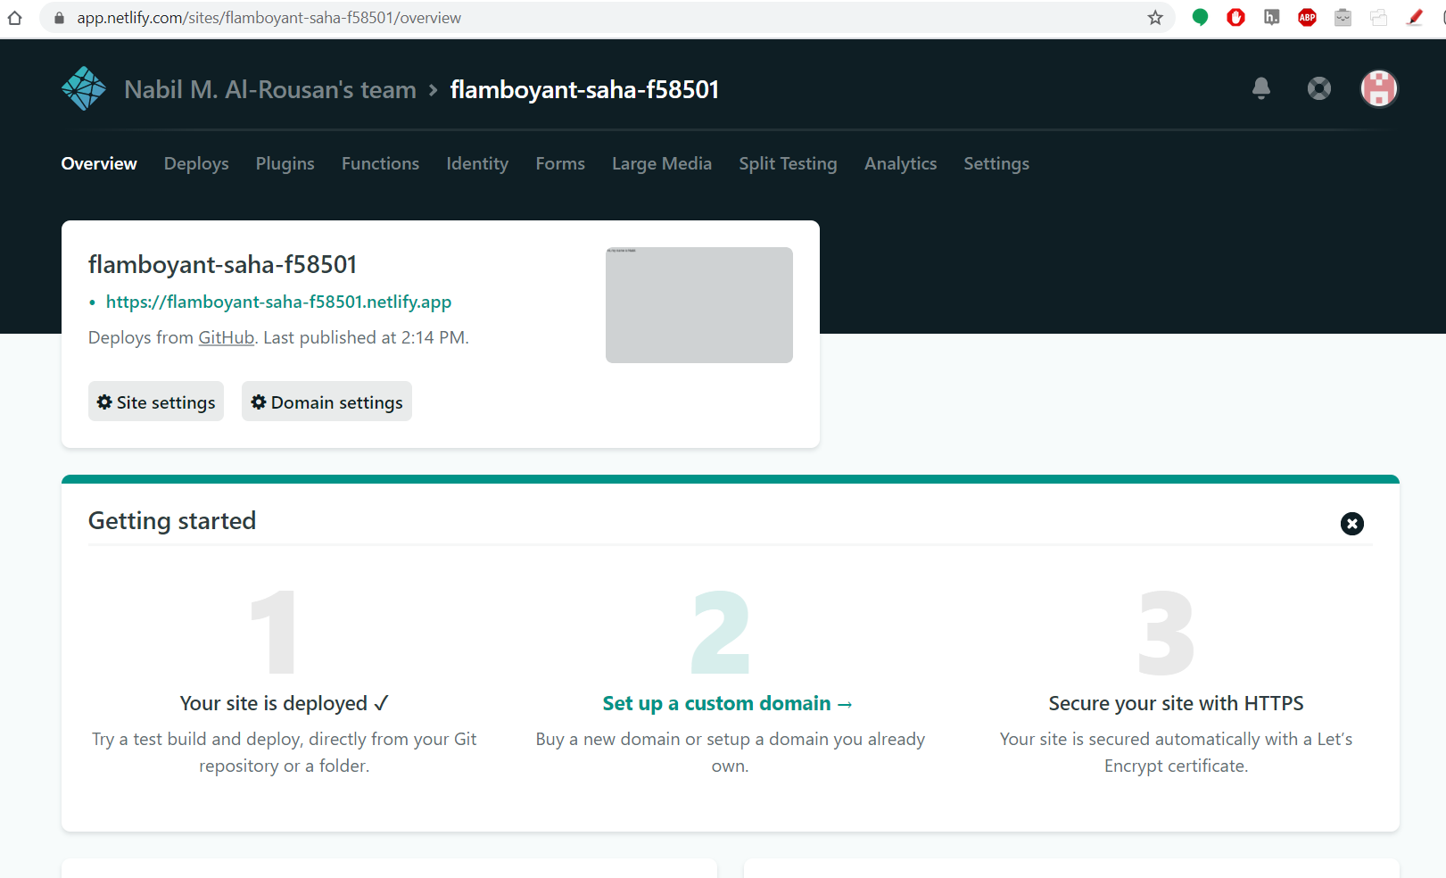

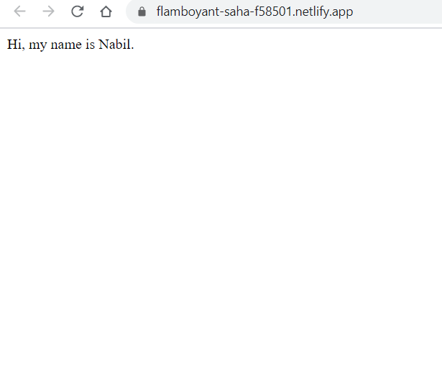

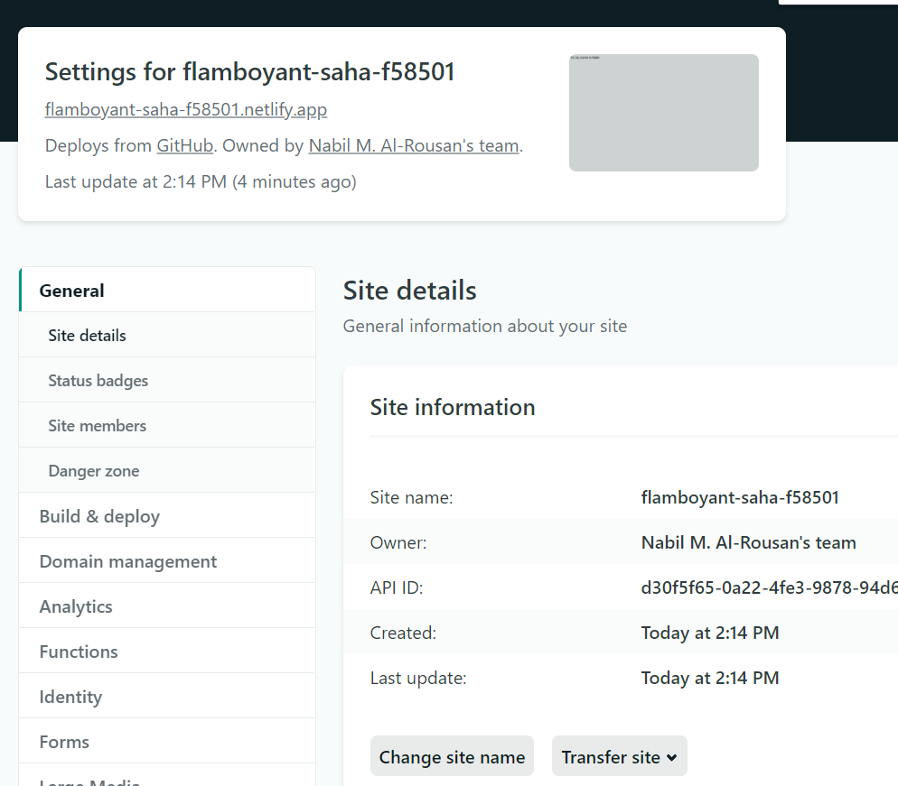

Phew! That is it!