Today we will be playing designing a responsive web gallery

## Part I

Solution - <https://comp1537-nabil.netlify.app/lab4/>

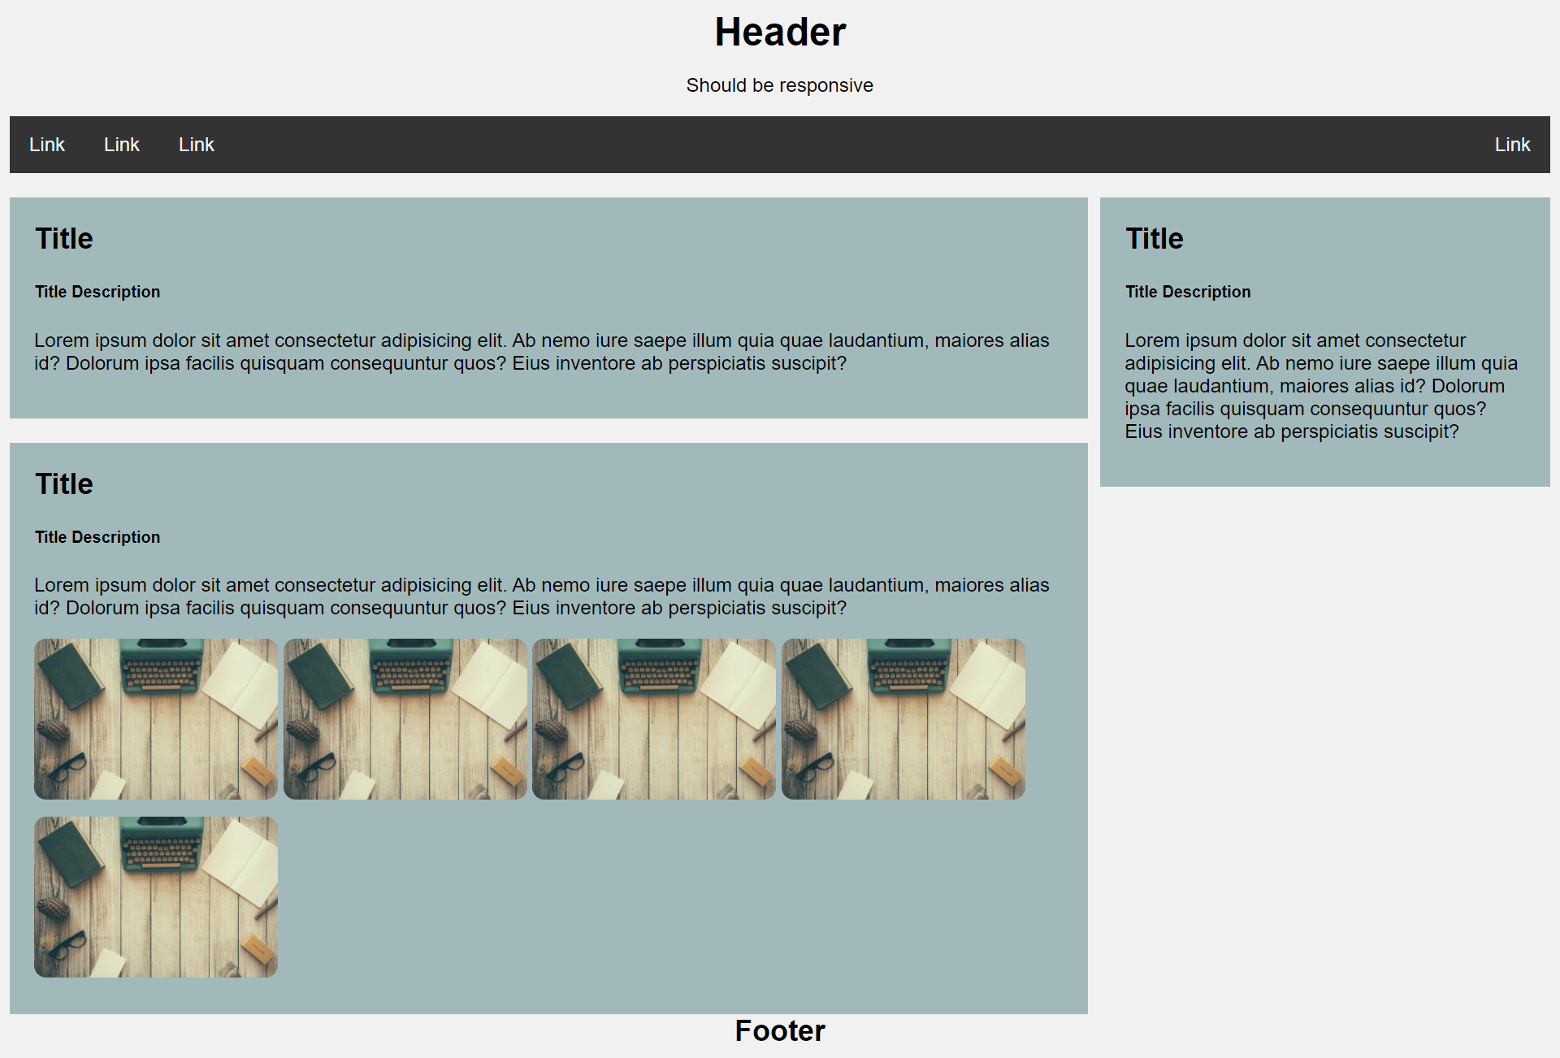

You may find the following references useful –

## Part II

On small screens

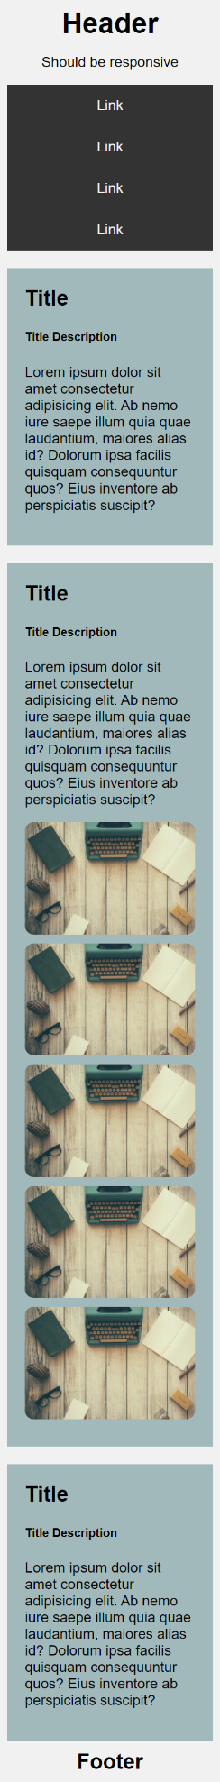

You may find the following references useful –

## Part III

These references might help:

<https://www.w3schools.com/css/css3_mediaqueries.asp>

# Deliverables

Link all your pages from your site’s home page. Submit one link in Learning hub.

Due date – Friday the 11th of February.