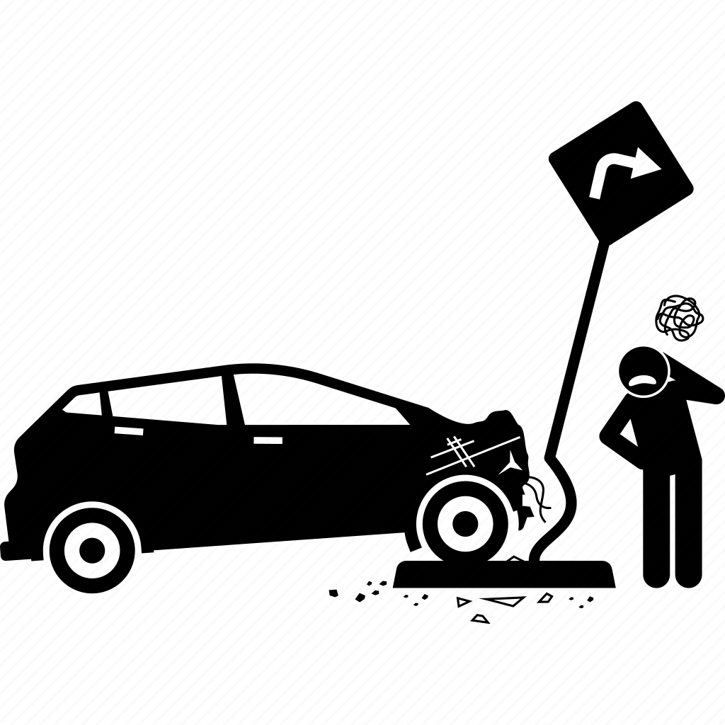

Title: collisions

Student Name: Nabil Raad

Instructor Name: Mr. Abd AL Rahman Jaber

Date: 10/4/2023

About: Proposal for the mid project

# Introduction

So, our task will focus on specific objectives and research questions. By analysing this dataset, we aim to provide valuable insights.

* With the increasing volume of vehicles on road networks, it has become priority for urban planners, transportation agencies, policymakers, business companies to analyse and understand transportation systems, enhancing mobility and optimizing traffic management strategies, intelligent transportation systems, self-driving cars development... to enhance road safety for safer environment.
* Of course, millions of studies, tasks, sources, analytics needed with data from many locations to contribute and each party will take a specific task.
* So, our task will focus on specific objectives and research questions. By analysing this dataset, we aim to provide valuable insights.

### Data

### Data source: <https://data.cityofnewyork.us/Public-Safety/Motor-Vehicle-Collisions-Crashes/h9gi-nx95/explore>

## Data info: Range Index: 2030510 entries, 0 to 2030509 Data columns (total 29 columns) some of columns:

***CRASH DATE (Occurrence date of collision, Date & Time)***

***CRASH TIME (Occurrence time of collision, Plain Text)***

***BOROUGH (Borough where collision occurred, Plain Text)***

***ZIP CODE (Postal code of incident occurrence, Plain Text)***

***LATITUDE (Latitude coordinate for Global Coordinate System, WGS 1984, decimal degrees (EPSG 4326), Number)***

***LONGITUDE (Longitude coordinate for Global Coordinate System, WGS 1984, decimal degrees (EPSG 4326), Number)***

***LOCATION (Latitude, Longitude pair, Location)***

***ON STREET NAME (Street on which the collision occurred, Plain Text)***

***CROSS STREET NAME (Nearest cross street to the collision, Plain Text)***

***Some of the questions about***

***Collisions accurse during given days.***

***Vehicles collisions between specific hours***

***Variant's locations of collision to study***

***Most dangerous streets***

***Brake down collisions by minutes***

***Highest collision areas***

***Most contributing factors***

***Crash frequency***