We used this application to have one min only for make handshake between target and attacker for make copy files and remodel target computer.
Notes . this is demo .

To run app open CMD and copy
*** java -jar 112.jar******
This app open source host helping to save time when you use Linux or windows to copy and past any code you need to add
All what you need is rename boxes and copy and past code what you need. that will make you don’t have to remember codes or write
Pic for the Application
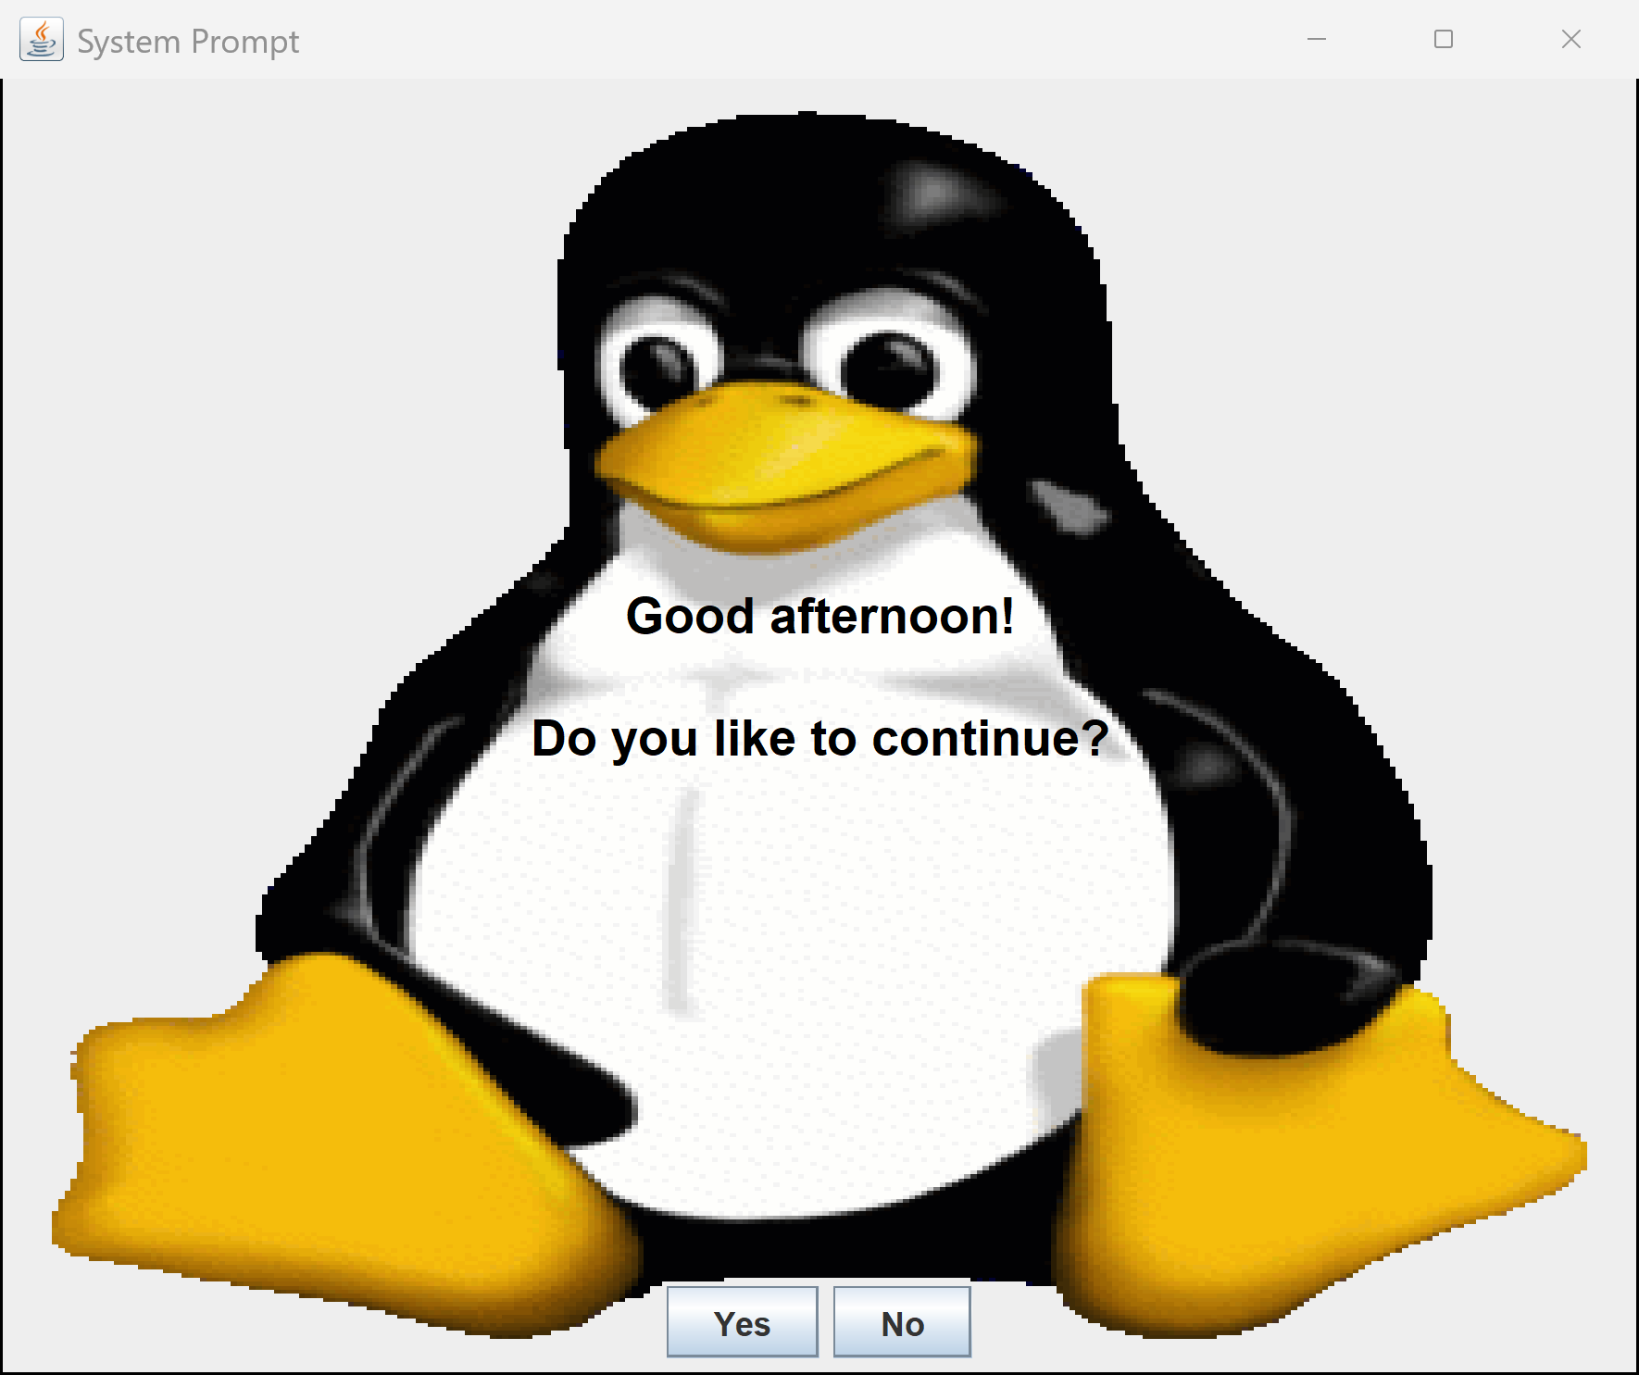

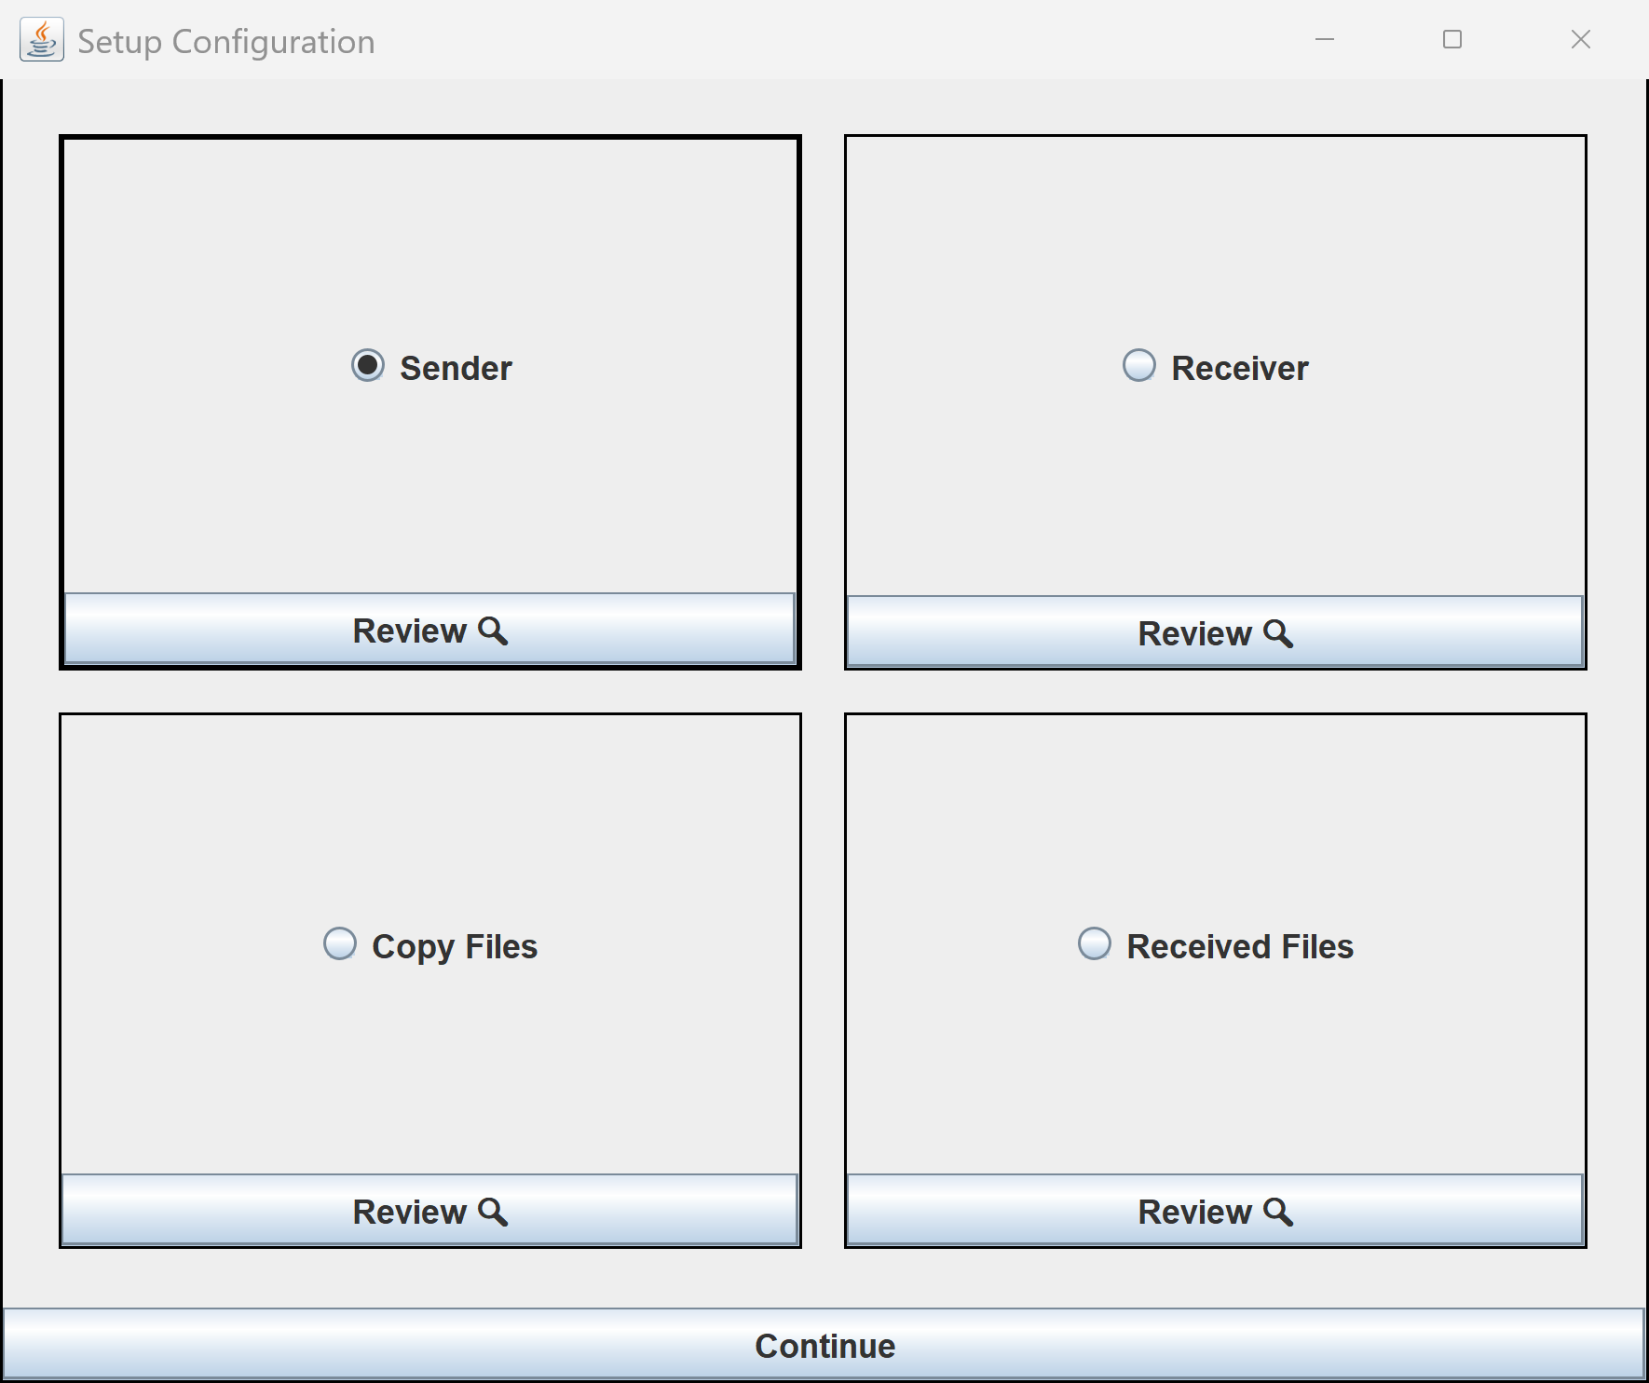
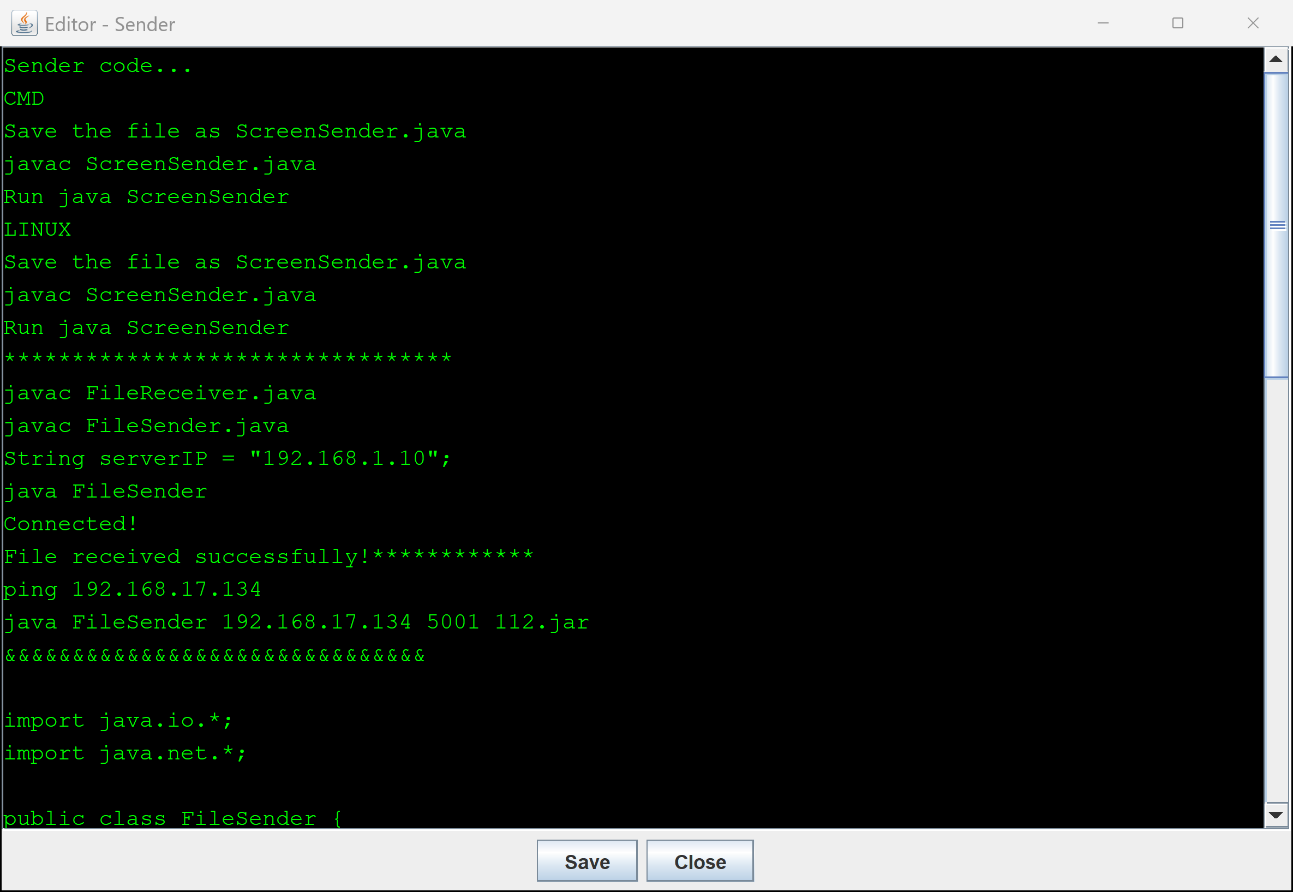
All wat you need copy or past or update the code .the code have all information to use in widows or Linux.
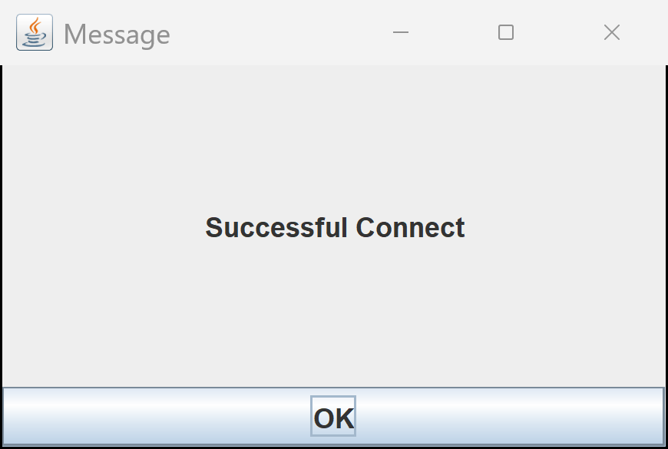

Will back to front page and if you choose No
