

AMERICAN INTERNATIONAL UNIVERSITY–BANGLADESH (AIUB)

Faculty of Science and Technology

Dept. of Computer Science

COURSE: SOFTWARE ENGINEERING

Spring 2025-2026

Section:

Group No: 03

Software Requirement Specification [SRS] Document On

Online Quiz Management System

Supervised By:

Submitted By

Name |  | ID
1. | Sheikh Mahfuzur Rahman | 24-55917-1
2. | Mohammed Ali Khorasani | 24-55920-1
3. | Ashiful Islam Nabil | 24-55928-1
4. | Jakaria Islam Raad | 24-55949-1
5. | Fahmida Faiza | 24-56431-1

Table of Contents

1. INTRODUCTION 3
2. SCOPES & FEATURES 4
2.1 Scope 1 4
2.2 Scope 2 4
2.3 Scope 3 4
3. USE CASE DIAGRAM 5
4. USER STORY TABLE 6
5. REQUIREMENT TRACEABILITY MATRIX 7
5.1 Functional Requirements 7
5.2 Non-Functional Requirements 7

INTRODUCTION

1.1 Background to the Problem

The rapid growth of online education and digital learning platforms has increased the demand for efficient and reliable online assessment systems. Traditional quiz and examination methods, such as paper-based tests or manual evaluations, are time-consuming, error-prone, and difficult to manage for large numbers of participants. These limitations often lead to delayed results, lack of transparency, and increased administrative workload.
Existing online quiz systems provide basic functionalities such as quiz creation and participation, but many lack advanced features like real-time result processing, secure authentication, anti-cheating mechanisms, and user role management. Issues such as tab switching, impersonation, and unfair practices reduce the credibility of online assessments.
To address these challenges, the proposed Online Quiz Competition System aims to develop a secure, automated, and user-friendly platform that supports multiple users simultaneously. The system introduces features such as role-based access control (Admin, Examiner, Participant), instant result generation, leaderboard ranking, facecam verification, and tab-switch prevention.
This project improves upon existing systems by enhancing security, automation, and user experience, ensuring fair evaluation and efficient quiz management in educational institutions and organizations.

1.2 Selection of Process Model
For developing the Online Quiz Competition System, the Agile Software Development Model is selected as the most suitable approach.
Agile is an iterative and incremental development model where the project is divided into small modules called sprints. Each sprint focuses on developing and delivering a specific feature of the system. This approach allows continuous testing, feedback, and improvement throughout the development lifecycle.
The Agile model is appropriate for this project because the system includes multiple modules such as user management, quiz management, participation, result processing, and security features like facecam verification and anti-cheating mechanisms. These features may require updates and improvements based on testing and user feedback.
In Agile, requirements can evolve over time, which is beneficial for this system as new features or enhancements can be added without affecting the entire project structure. It also ensures faster delivery of working components and better collaboration among team members.

Agile Process in This Project
Sprint 1: User Registration, Login & Authentication
Sprint 2: Quiz Creation & Management
Sprint 3: Quiz Participation & Timer System
Sprint 4: Result Generation & Leaderboard
Sprint 5: Security Features (Facecam & Anti-cheating)
Each sprint includes requirement analysis, design, implementation, testing, and feedback.

2.1: Scope 1: User Management
- User registration and login system
- Secure authentication (email & password)
- Profile management (update name, password, etc.)
- Role-based access control (Admin, Examiner & Participant)
- Logout functionality
- Password validation and basic security features

2.2: Scope 2: Quiz Management
- Admin can create, update, and delete quizzes
- Add, edit, and remove multiple-choice questions (MCQ)
- Set quiz duration and total marks
- Define correct answers for automatic evaluation
- Organize quizzes by category or topic
- Control quiz availability (start/end time)
· Examiner can create questions and evaluate results

2.3: Scope 3: Participation & Result
- Users can view available quizzes
- Users can join and attempt quizzes
- Timer-based quiz execution
- Auto submission when time ends
- Instant result generation after submission
- Display score and correct answers
- Leaderboard/ranking system based on performance
· Facecam verification required before quiz
· User cannot switch tab during quiz

2.4: Scope 4: System & Performance
- System supports multiple users at the same time
- Fast response and smooth performance
- Data security and user authentication
- Simple and user-friendly interface
- Accessible from web browsers (PC/mobile)

USE CASE DIAGRAM
- Actors:
- Admin
- · Admin
· Examiner
· Participant
- Description:
The admin controls the system by managing quizzes and users. Participants register, log in, take quizzes, and view results.

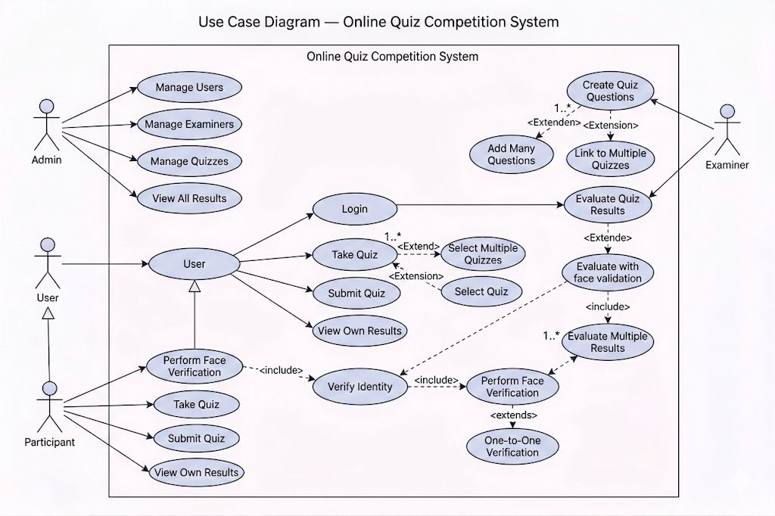
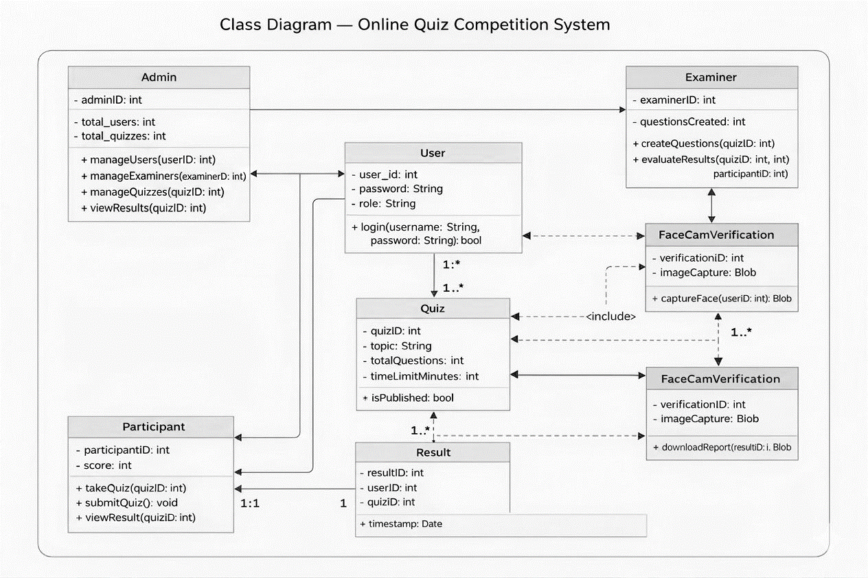

USER STORY TABLE
ID | User Story
US1 | As a user, I want to register so that I can participate in quizzes
US2 | As a user, I want to log in to access quizzes
US3 | As a user, I want to attempt quizzes
US4 | As a user, I want to see my results
US4 | As an admin, I want to create quizzes
US5 | As an admin, I want to add questions
US6 | As an admin, I want to manage users
US7 | As an admin, I want to view results
US8 | As an examiner, I want to create questions
US9 | As an examiner, I want to evaluate results
US10 | System verifies facecam
US11 | System prevents tab switching

REQUIREMENT TRACEABILITY MATRIX
Functional Requirements

Sl No | Module | Screen Definition | User Story | Acceptance Criteria
1 | SIGNUP | Name, Email, Password | User registers | Email unique, password ≥4
2 | LOGIN | Email, Password | User logs in | Valid credentials
3 | ADMIN | Quiz fields | Admin manages quiz | CRUD operations
4 | QUESTION | MCQ fields | Add questions | 4 options + correct answer
5 | QUIZ | Quiz list | Attempt quiz | Timer works
6 | RESULT | Score | View result | Auto evaluation

Non-Functional Requirements

Sl No | Specification | User Story | Acceptance Criteria
1 | Performance | Fast system | ≤3 sec
2 | Security | Secure system | Encryption
3 | Usability | Easy UI | Simple interface

