**Android**

1. **Theory**
2. **practical**

theory:

1. What is Android?
2. Why we use Android?
3. How to make an Android App?

**What is Android?**

an·droid

ˈanˌdroid/

*noun*

noun: **android**; plural noun: **androids**; noun: **Android**

1. **1**.

(in science fiction) a robot with a human appearance.

|  |  |
| --- | --- |
| synonyms: | robot, automaton, cyborg, droid, bot  "a space station run by androids" |

1. **2**.

*trademark*

an open-source operating system used for smartphones and tablet computers.

"I have an Android phone and I like it a lot"

Define android: a mobile robot usually with a human form — android in a sentence.

**Android** is a mobile operating system developed by Google, based on the Linux kernel and designed primarily for touchscreen mobile devices such as smartphones and tablets.

It launched in 2003 and is the world’s most popular mobile operating system (OS).

Android is an open source project (led by Google but it doesn't belong to them) called AOSP (Android Open Source Project). Google uses this project as a base to create its version of Android, which is then used by the other manufacturers.

As an OS, Android's job is to act as a translator between you and your gadget. When you take a photo, Android provides the button you tap and tells the phone what to do when you tap it. When you make or receive a call, Android tells your phone how to do that. When you play a game, Android tells the game what movements you’re making and what buttons you’re pressing. It’s like Windows, but for mobile devices.

Manufacturers which run Android on their phones include Samsung, Huawei, Sony, Lenovo, HTC, LG and many others; it's currently operational on more than one billion devices.

The Android mascot is a green robot: you might have seen it around.

Android is basically a piece of software which allows your hardware to function. The Android OS gives you access to apps, including many of Google's own creation. These allow you to look for information on the web, play music and videos, and check your location on a map, take photos using your device's camera and plenty more besides.

### Does Google make any Android phones?

Although Google owns the OS (Android), the company has not made any of the smartphones on which it runs in-house (it did make the Android-powered [Pixel C](https://recombu.com/mobile/article/google-pixel-c-review) tablet in 2015). However, it has partnered with various handset manufacturers over the years to make its own-brand smartphones under the 'Nexus' name.

### Who actually makes Android phones?

Any handset maker is free to make an Android phone if they want to. The likes of Motorola, HTC, Samsung and Sony, Acer, Alcatel, Asus, Huawei, LG and ZTE have all made Android phones (and tablets). Blackberry has put out several Android phones since 2015, including the [Priv](https://recombu.com/mobile/article/blackberry-priv-review) and the [KEYOne](https://recombu.com/mobile/article/blackberry-keyone-phone-specs-uk-price-release-date). And Nokia is enjoying a resurgence in 2017, thanks in large part to its new [Nokia 3, 5 and 6 phones](https://recombu.com/mobile/article/nokia-6-vs-nokia-5-vs-nokia-3-what-s-the-difference) which run Android OS.

**Where does Android come from?**

It comes from Google, who actually acquired Android in 2005 (no, Google didn't invent it). The search giant performs regular updates along with an annual major update.

The operating system is based on the Linux kernel

This is the GNU / Linux operating system based structure, which is a unix type system (portable operating system, multitasking and multi-user). The Linux kernel is one of the most prominent examples of free software.

**Difference between android, ios, windows os**

To be…

## What are the advantages of Android?

Choice. For example, if you want iOS, you have a choice of iPhone, iPhone or iPhone. If you go for Android there are stacks of great devices to choose from, from cheap and cheerful handsets to really impressive flagships. Those flagships are often cheaper than the equivalent Apple devices, too.

Android’s choice isn’t just about hardware. It’s about everything else too. Android is incredibly easy to customize, both in terms of how it looks and how it works, and the various app stores aren’t as tightly controlled as its rivals’ stores, like Apple

## What’s with the candy names?

Each new version of Android gets a code name based on consecutive letters of the alphabet. The most recent version is known as [Marshmallow](https://www.androidpit.com/android-m-release-date-news-features-name) because it is the Android M release. Previous versions have included [Lollipop](https://www.androidpit.com/android-5-0-lollipop-tips), KitKat, Jelly Bean and Gingerbread.

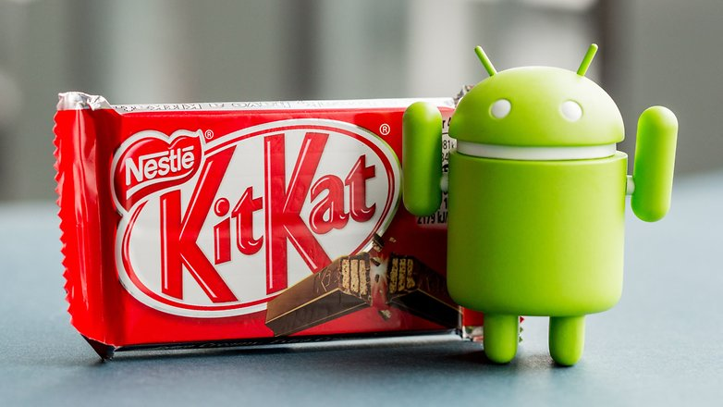

## What’s the best thing about Android?

Options, many options. With Android you have hundreds of gadgets at your disposal, the cheapest, the most expensive and innovative market. Android is also incredibly customizable, both in their roles, as in his appearance. You can really make a unique mobile experience for yourself with this OS.

## What’s the worst thing about Android?

Getting updates. In many cases manufacturers don’t seem to care about providing software updates for devices they’ve already sold you. Even when they do provide updates they take their sweet time about it. That’s why some [consider rooting](https://www.androidpit.com/how-to-root): you can download the updates yourself and apply them instead of waiting for the manufacturer to get around to it.

## What is Google Play / Play Store?

The Google Play Store is a digital marketplace where Android users can purchase apps, games, books, movies, music and more. And it's a big advantage to owning an Android device.

The purchased content is connected to your Google account – something you must have in order to make these purchases – and is available on any device where you log in with your Google account.

**Here are some Android terms you should know**

Here is a glossary of terms you can refer back to as you continue in our series. Have a read through them right now to get a brief overview. Click on one in the table to jump to the term.

|  |  |  |  |
| --- | --- | --- | --- |
| [ADB](https://www.androidpit.com/what-is-android#adb) | [Download Mode](https://www.androidpit.com/what-is-android#download) | [MicroSD](https://www.androidpit.com/what-is-android#microsd) | [ROM](https://www.androidpit.com/what-is-android#rom) |
| [APK](https://www.androidpit.com/what-is-android#apk) | [Factory Reset](https://www.androidpit.com/what-is-android#factory) | [ODIN](https://www.androidpit.com/what-is-android#odin) | [Root](https://www.androidpit.com/what-is-android#root) |
| [Application](https://www.androidpit.com/what-is-android#app) | [Firmware](https://www.androidpit.com/what-is-android#firmware) | [Open Source](https://www.androidpit.com/what-is-android#open) | [Soft Reset](https://www.androidpit.com/what-is-android#soft) |
| [Backup](https://www.androidpit.com/what-is-android#backup) | [Flash](https://www.androidpit.com/what-is-android#flash) | [Operating System](https://www.androidpit.com/what-is-android#OS) | [Unlock](https://www.androidpit.com/what-is-android#unlock) |
| [Bluetooth](https://www.androidpit.com/what-is-android#bluetooth) | [Kernel](https://www.androidpit.com/what-is-android#kernel) | [OTA](https://www.androidpit.com/what-is-android#ota) | [Widget](https://www.androidpit.com/what-is-android#widget) |
| [Bootloader](https://www.androidpit.com/what-is-android#bootloading) | [KIES](https://www.androidpit.com/what-is-android#kies) | [QR](https://www.androidpit.com/what-is-android#qr) | [Wipe](https://www.androidpit.com/what-is-android#wipe) |
| [Brick](https://www.androidpit.com/what-is-android#brick) | [Launcher](https://www.androidpit.com/what-is-android#launcher) | [Recovery Mode](https://www.androidpit.com/what-is-android#recovery) | [Window](https://www.androidpit.com/what-is-android#window) |

**Kernel: The core of the operating system. It's responsible for uniting the software functions and the hardware.**

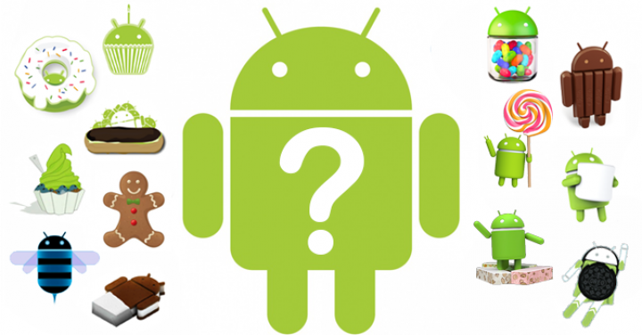

Versions usually come with a numerical code and a name that’s so far been themed after sweets and desserts, running in alphabetical order.

* Android 1.5 Cupcake
* Android 1.6 Donut
* Android 2.1 Eclair
* Android 2.2 Froyo
* Android 2.3 Gingerbread
* Android 3.2 Honeycomb - The first OS design specifically for tablets, launching on the Motorola Xoom
* Android 4.0 Ice Cream Sandwich: The first OS to run on smartphones and tablets, ending the 2.X naming convention.
* Android 4.1 Jelly Bean: Launched on the Google Nexus 7 tablet by Asus
* Android 4.2 Jelly Bean: Arrived on the LG Nexus 4
* Android 4.3 Jelly Bean
* Android 4.4 KitKat: Launched on the LG Nexus 5
* Android 5.0 Lollipop: Launched on the Motorola Nexus 6 and HTC Nexus 9
* Android 6.0 Marshmallow: Launched on the LG Nexus 5X and Huawei Nexus 6P
* Android 7.0 Nougat
* Android 7.1 Nougat: Launched on the HTC-made Google Pixel and Pixel XL
* Android 8.0 Oreo: Rumoured to be launching on the Google Pixel 2 and Pixel XL 2

The latest public version, [Android Nougat](https://recombu.com/mobile/article/best-new-features-in-android-7-nougat), makes the OS even faster than ever with a feature called 'instant apps'. It also offers improved battery life with Doze on-the-go and adds native VR support. [Here's what's changed between the different Android versions](https://recombu.com/mobile/article/android-versions).

<https://recombu.com/mobile/article/android-versions>

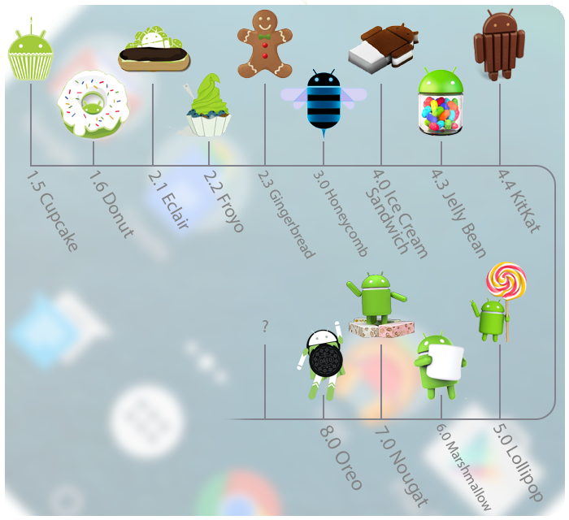

### When does Google announce new versions of Android?

As previously mentioned, Google tends to put out a fresh new version of Android once a year (although minor updates roll out constantly).

When it comes to Android, Google often releases a beta version in the first half of the year. This often coincides with Google I/O, a big developer event held annually around May. At Google I/O we usually find out more about the new Android update, including the best features and any UI improvements.

How to update android phone:

<https://recombu.com/mobile/article/how-to-update-your-android-phone>

more:

<https://link.springer.com/content/pdf/10.1007/978-1-4302-6131-5_1.pdf>

<https://www.skidmore.edu/academic-technologies/resources/7_things_android.pdf>

<http://www3.ul.ie/ictlc/Android.pdf>

<http://www.cs.columbia.edu/~coms6998-8/lectures/lec4-Android.pdf>

Android architecture

………………………….Lynda.com……………………………

Tutorial: [Android App Development Quick Start](https://www.lynda.com/Android-tutorials/Learning-Android-App-Development/471914-2.html)

##Introduction:

#Welcome:

Android is installed on more mobile devices than any other operating system. At last count, Android was installed on over 1.4 billion active monthly devices. With an install base that large, developing apps for Android is a very exciting and potentially lucrative opportunity. The Android ecosystem includes the Android OS for smartphones and tablets. It also includes Chrome OS devices that support Android apps and devices from Amazon, like the Fire tablet and other products. My name is Doug Winnie and in this course I'll introduce the basics of building apps for Android.

We'll cover the Android ecosystem, build a simple one-screen game and dive into XML and Java to build the game. After you're finished this course, you'll have a project that you can modify and expand upon, with some suggestions and ideas on where you can take it further. So with that, let's get started building our first app for Android.

Pic: android ecosystem

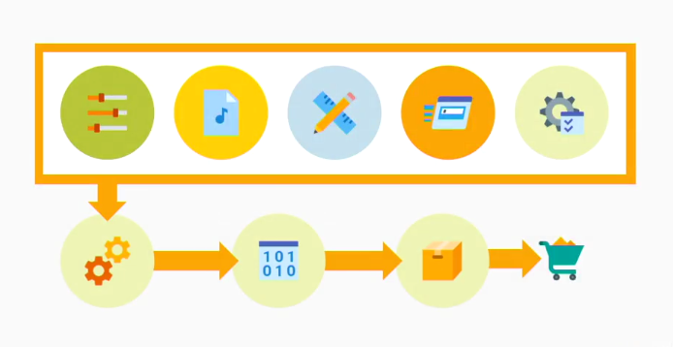

Pic: android ecosystem

#what you should know:

Making apps for Android is a lot of fun. The project we are going to work on is a simple game that will review the basics of programming as well as the tools and technologies you'll use to build Android apps. Before you get started, you should know the basics of how to program in Java and build XML. You don't have to be an expert programmer, but knowing the basics of Java is very helpful. We'll cover things like loops, conditionals, collections using the array list, and building methods, and working with fields and classes. In terms of what you need to have to complete this course, you'll need a 64-bit Windows 10 computer or a Mac to install the software that we will need.

I'll cover the detailed system requirements for Android Studio later in this course. You can watch the videos without working on the exercise files themselves, but working alongside me is recommended. This course is designed for anyone that is learning programming and wants to make their first Android app. I have designed this course so I can update it and revise it frequently based on your feedback, changes with the Android SDK, and new topics that can make the course better.

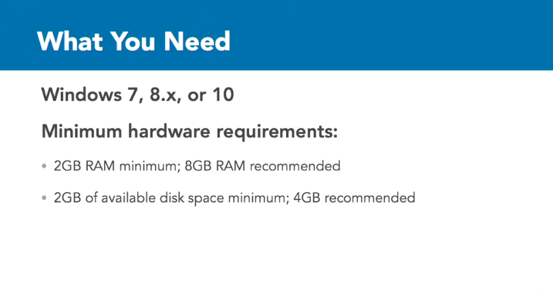

####Android basics####

#Android app basics

Let's take a step back and look at Android apps in general first before we go into the details of the tools you're going to work with. Android apps are apps that you can purchase through the Google Play store, or through Amazon if you publish for Fire devices. You can build apps for multiple devices. These apps all run Android include tablets, smartphones, supported Chrome OS devices, Android TV, Android Auto, and Android Wear. The app that we are going to build will work on Android-powered smartphones, tablets, and supported Chrome OS devices.

It'll share our common interface, so we can interact with on all of these various devices. I say can work, because we won't customize the interface to work uniquely for each device, but the app will work and run on each of these devices. The version of Android we will target in this course is Ice Cream Sandwich. Android versions are named after desserts. The newest version of Android currently available is Nougat. Each version starts with the next letter in the alphabet. So, after Ice Cream Sandwich is Jelly Bean, then KitKat, then Lollipop, then Marshmallow, and then finally, Nougat.

We are targeting Ice Cream Sandwich, because it will work with a wide variety of devices. Android versions can take time to proliferate on devices throughout the world, and Ice Cream Sandwich, or ICS, is compatible with almost 97% of Android devices worldwide. The exercise files are already configured to work with the Android SDK for Ice Cream Sandwich called API level 15, but if you create the exercise files from scratch, you can work with newer APIs if you wish. But if you're using your own hardware to test your app, make sure you have the right version installed to support the API level you select.

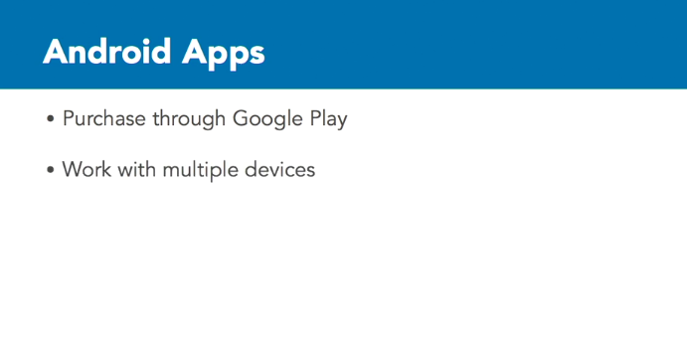

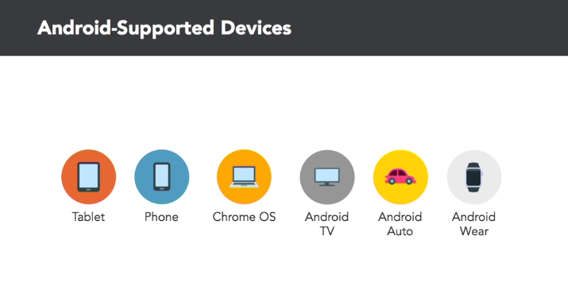

##App development overview:

Developing an app for Android requires a few basic steps. Using the tools and technologies in this course, we will first start with a project. Think of a project as a container. Inside of that container are files, assets and settings that are all the pieces that are used together to create your app. Your project has a few basic components that are inside. You have the settings for the project. These are the settings that define how the app works, what are requires of the device, how it should look in Google Play, and other things like the app icon, version number and more.

You have the assets of the project. For instance, you might have an app that has a sound effect for notification or an action that takes place. That sound file is part of the assets of the project. You have the layout and design of the app. This is a collection of files that lay out the screens for your app. For instance, test boxes, buttons, scrollable areas, menus, and where they appear on the screen, are all part of the layout component of your project. You have the behavior of the app. This is the code where you tell the app what to do and how the user can work with the app.

So if the app needs to access data, files in the device, respond to a button press by the user, or process information, this is one of the key areas. For all these earlier four areas, you, as the developer, are able to define all of them. The fifth area is a key component of the project, but you don't build it. It's called the SDK or framework. This critical component is all the software that Google, and others, have provided to allow your app to work on Android, access system system resources, render things on the screen, and pretty much make everything work the way you want to.

Without this, you have tons of code and assets, but there's no way for Android to understand and work with your instructions. When you have all five of these in your project, you're able to use them to build your app. To do this, your computer needs to analyze all the things you have in your project, and find a way to convert it to natively work with the device. This is called compiling, or building the app. The compiler, or build engine, takes the five components to your project and converts them into a format that the device can run. This is the app or application.

When you have the app, you can install on your own device but you need to find a way for others to download it as well. When you have the finished app, you then need to upload it and submit it to Google Play to allow others to find it, purchase it, or charge for it, and download it to use on their own devices. When you upload your app, Google will analyze and make sure that it doesn't do anything that could be harmful and then list it in Google Play. If you make updates to your app, like add new features or fix a bug, you would modify one or more of the primary components of the project, rebuild and upload the changes to Google, to update the version that is listed in the Store.

This is the essential process for how app development works. So from the five components of the app, to compiling and distributing to Google Play, this is the basic process you will take when you build your app for Android.

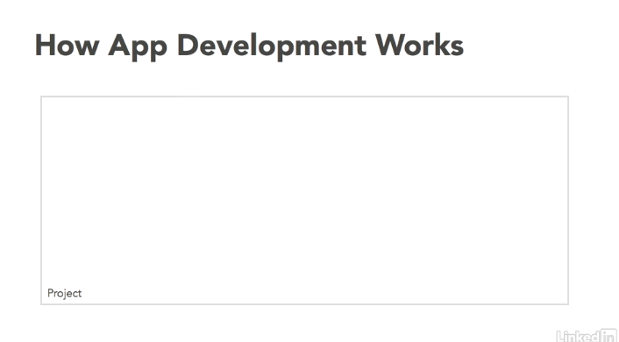

Pic: think of a project as a container

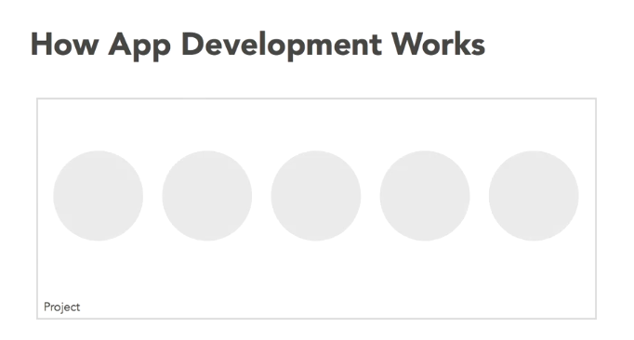

Pic: a project has a few basic components that are inside

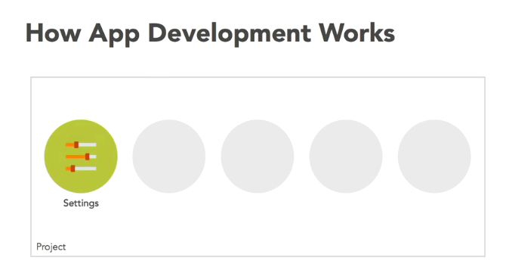

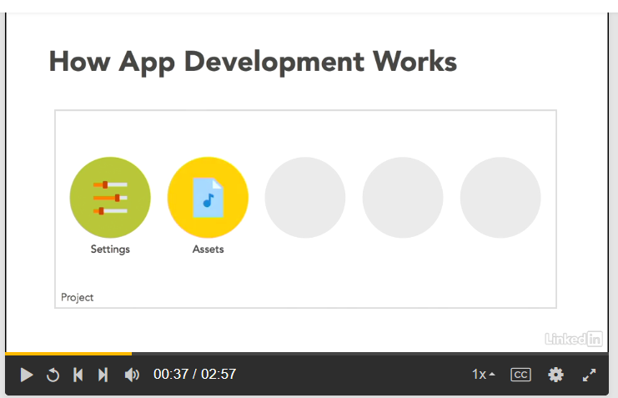

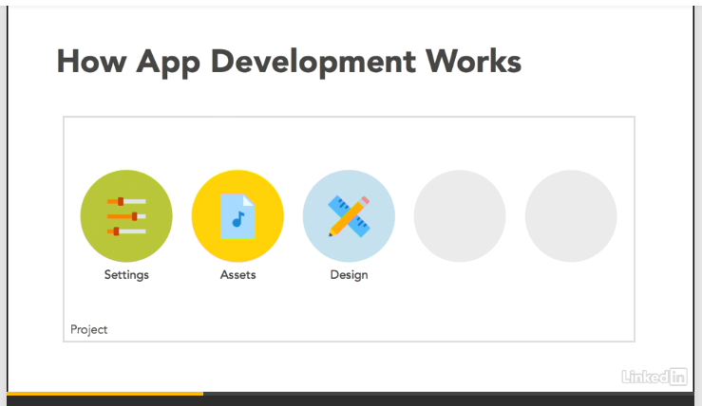

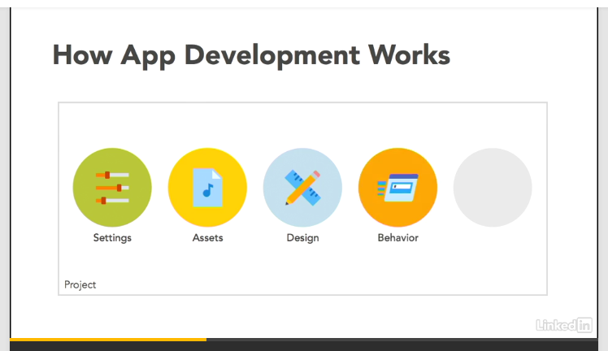

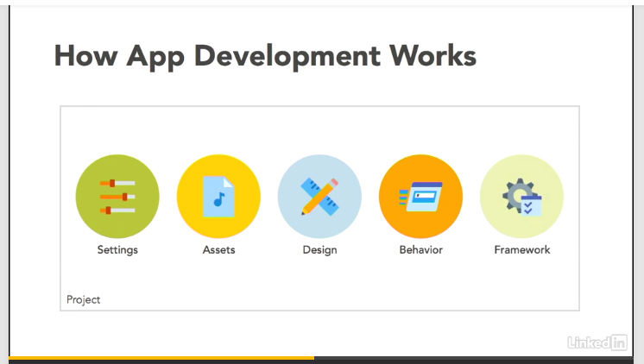

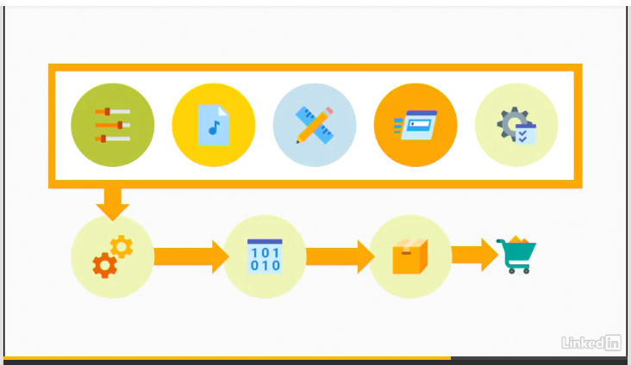

Pic: 5, u can make them 4

##Tools for android app development: