Roshen KSA Sales Dashboard — Trade Spend Native Module
Authenticated Production Verification Report
Date: 18 July 2026 · Method: a real sign-in through the production login form (Supabase password authentication) at https://roshen-ksa-dashboard.vercel.app, driving the real activities table, the real photos and the real active sales dataset. No mocked data. A dedicated verification account (ts.v2.verify@roshen.trade, role Admin) was created for this purpose and disabled afterwards.

1. Verification checklist — all passed in the live authenticated session
Requested check | Observed in the authenticated session | Result
New Activity page uses the V2 UI | 4 numbered sections, new layout | PASS
Engine V2 badge visible | “Engine V2 · 2026-07-17” on the form header and the Activity Log KPI | PASS
SKU picker is the new component | Search box + grouped panel with select-all and chips | PASS
Before/During/After preview works with live data | 418 / 17,974 / 5,016 SAR for the TS-2026-009 scenario — matches the audited reference figures exactly (ROI 134.3%, ROTS 2.34×, Successful) | PASS
Existing attachments available | TS-2026-009's two real execution photos render (after fix — §2) | PASS
Existing categories migrated | Real categories (e.g. Johnny Krocker 1KG) shown on records (after data repair — §3) | PASS
Existing photos displayed | Both photos fully decoded (naturalWidth verified) | PASS
Existing activities render correctly | All 49 production activities with live figures | PASS
Activity Log uses the new layout | New column set including Incremental | PASS

2. Two code defects found ONLY by the authenticated session — fixed
- Photos did not render: the legacy application stores execution photos as {name, data} objects; the module rendered the object itself (src="[object Object]"), so all 12 real production photos were invisible. Earlier automated tests used string-format photos and passed. The module now renders both shapes and saves in the legacy shape so the parallel-run application stays compatible.
- Login-time race: after sign-in the app swaps the embedded dataset for the downloaded active version; the sales index cached by array lengths only, so an index built mid-swap survived the swap and every activity computed wrong or zero figures for the whole session. The cache key is now a content fingerprint.
Both fixes are live in production (commit 279a4d9), with regression tests added — 71/71 passing.

3. The data root cause — active dataset had lost its category taxonomy
The active dataset version 22, created 16 July 2026 by an automated “bulk-reimport@system” job that is NOT part of this codebase, shipped with every SKU mapped to a single “—” category. Because the categories your activities reference did not exist in the data, Sales Before / During / After computed ZERO for every category-scoped activity — on any UI version. This was the real cause of the numbers you saw.
Repair: published version 23 through the application's own audited import mechanism — identical sales rows to v22, with the taxonomy restored (74 SKUs from the validated mapping, 2 new July SKUs classified by name: ROS44061 → Choclate Bar, ROS18710 → Konafetto Roll). All 20 categories are back; every connected user was refreshed automatically; the change is reversible from the Data & Versions dialog.

4. Findings for the business (decisions needed)
- Data regression: v22 also REGRESSED the data: it has 1,278 fewer rows and ends 16 July → 11 July (5 days of sales missing) compared to the humanly-uploaded v21. The repair (v23) deliberately preserved v22's rows exactly — please decide whether the missing 12–16 July sales should be restored (rollback to a v21-based repair is a one-step operation).
- Pipeline: the external bulk-reimport job must be fixed to carry the category taxonomy, otherwise its next run will wipe the categories again.
- Housekeeping: the verification account ts.v2.verify@roshen.trade is disabled but retained so the v23 import's audit-log entry stays traceable — delete it whenever you wish.

5. Screenshots from the authenticated production session
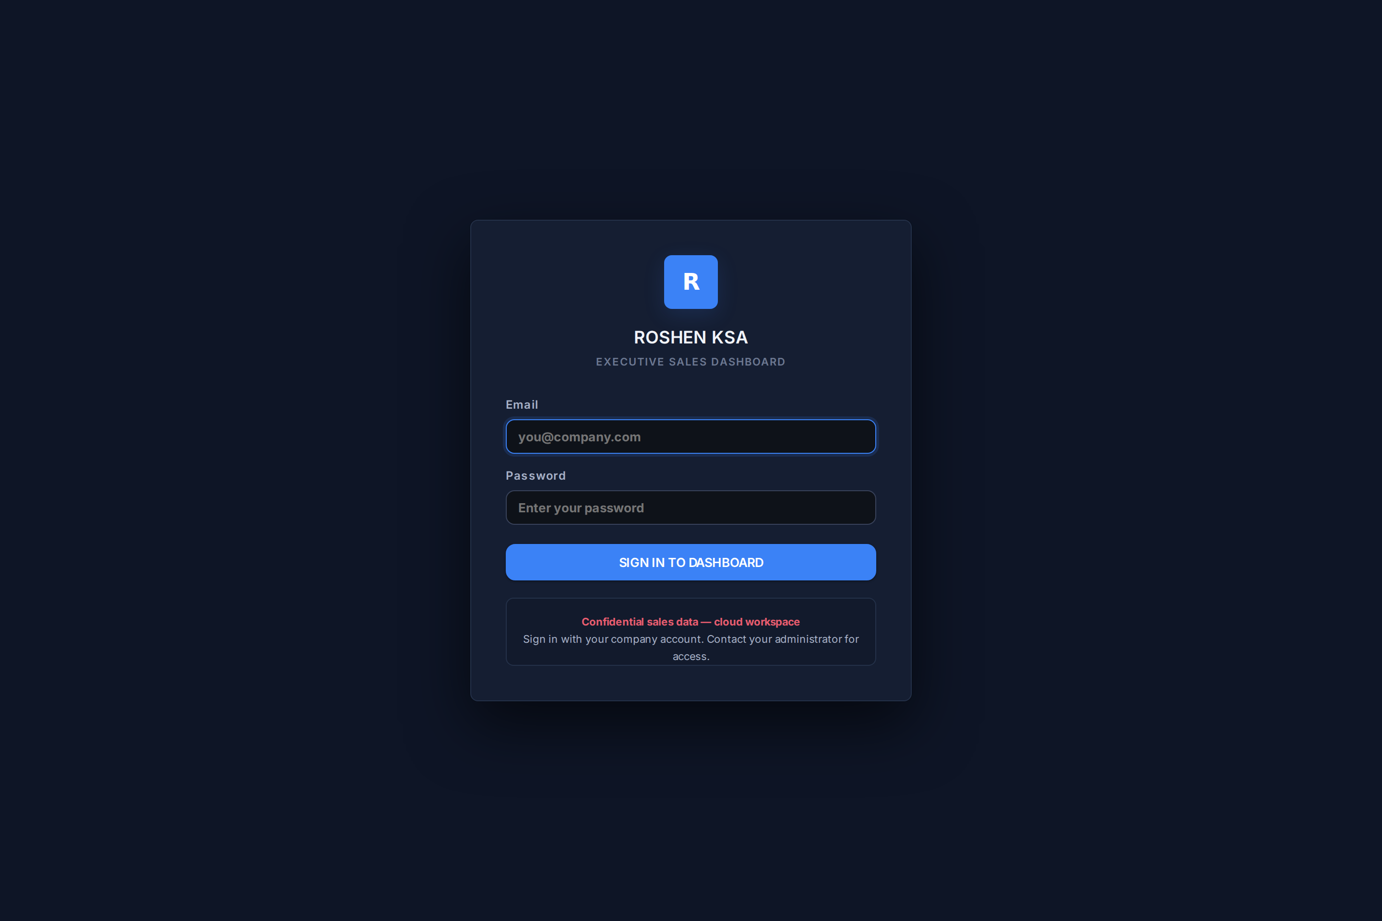
Fig. 1 — The real production login page (before sign-in).
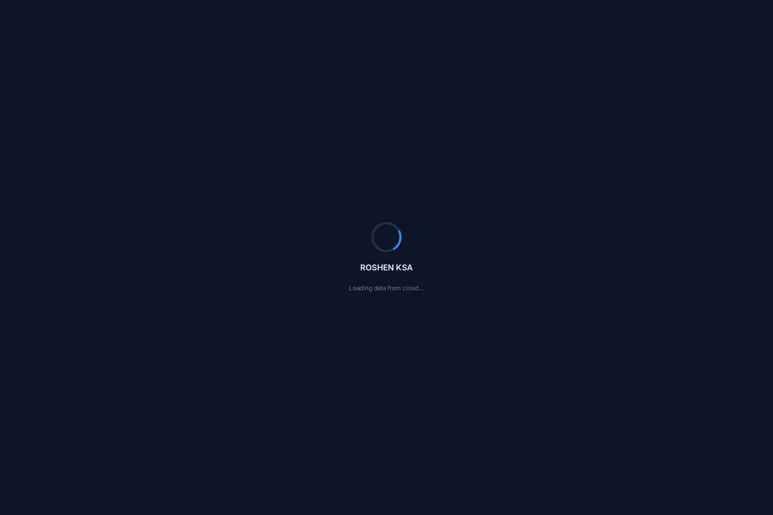
Fig. 2 — Activity Log after sign-in: 49 real activities, new layout with the Incremental column, “Live from cloud · Engine V2 · 2026-07-17” badge.

Fig. 3 — Real record TS-2026-009 (ALBSHAYAH TRADING): Before/Baseline/During/After panel, ROTS, Trade Spend %, and the two real execution photos rendering.
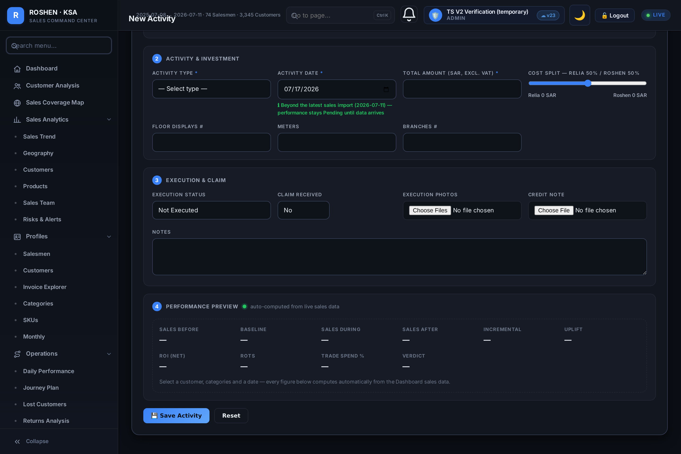
Fig. 4 — New Activity page: V2 sections, Engine V2 badge, category chips and the new SKU picker.
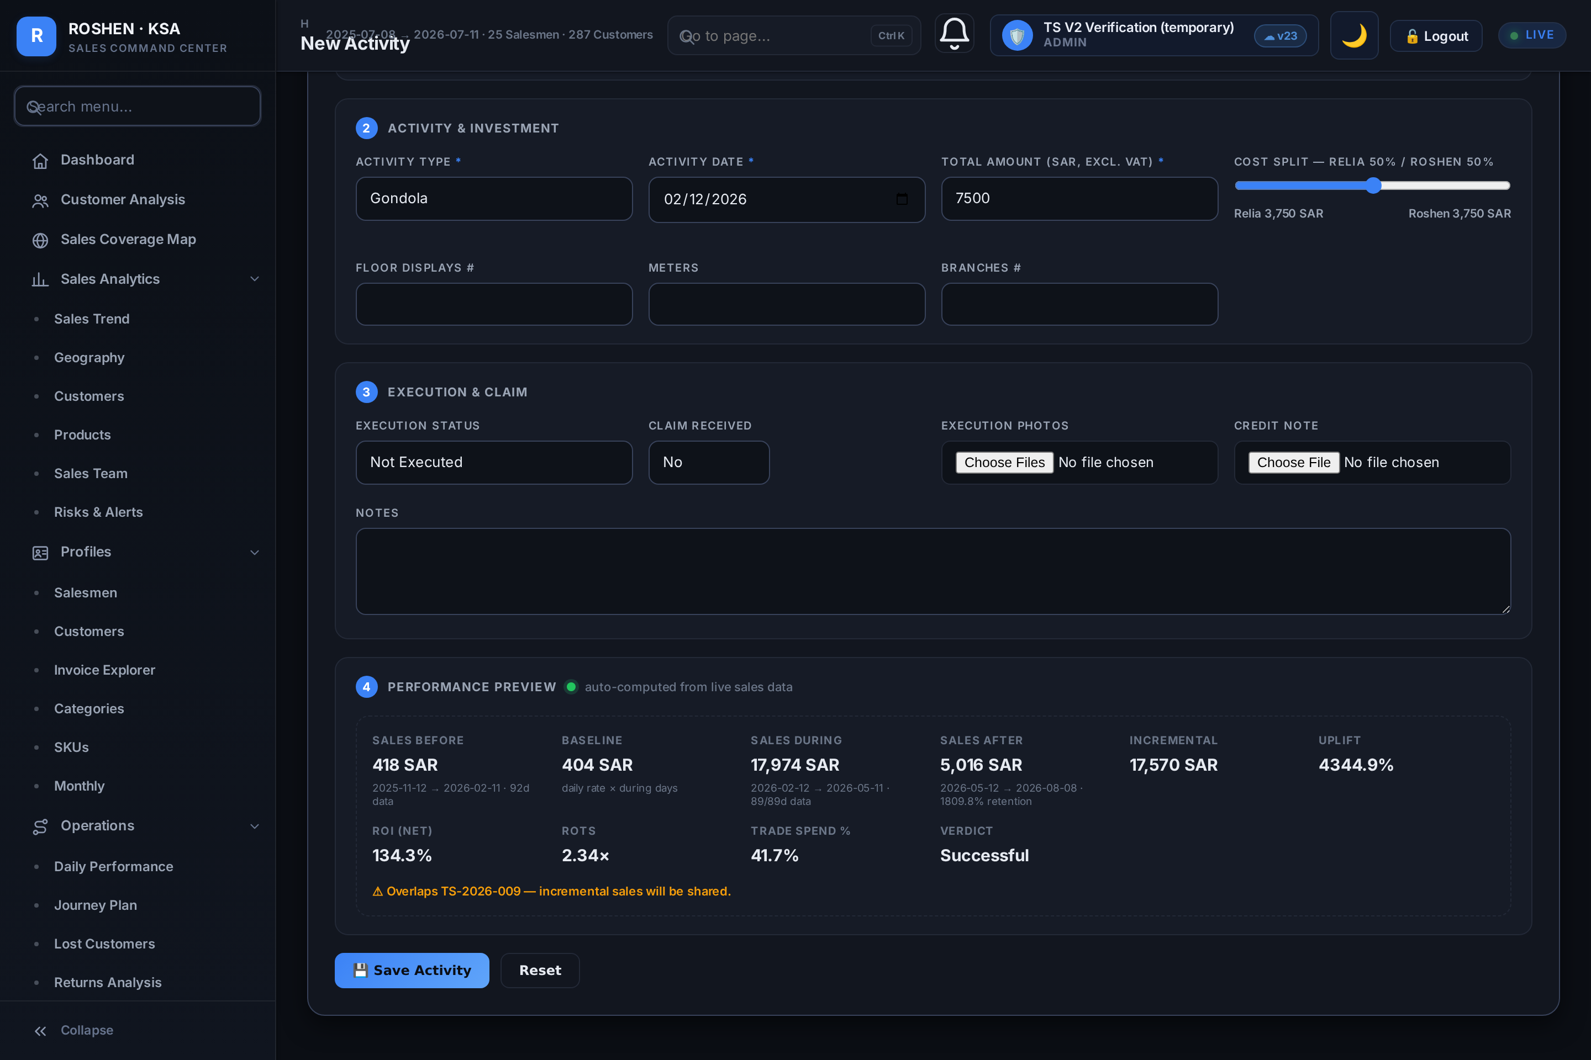
Fig. 5 — Live performance preview computed from the real active dataset: Before 418 · Baseline 404 · During 17,974 · After 5,016 SAR · ROI 134.3% · ROTS 2.34× · Successful.

6. Conclusion
The V2 build is serving and functioning in the real authenticated production application, with real records, categories, photos and live calculations verified end-to-end. The three defects this verification uncovered (photo rendering, login-time race, dataset taxonomy loss) are fixed and live.
Technical note: the verification browser ran inside a sandboxed environment whose egress proxy rejects direct browser connections, so its network traffic was relayed byte-for-byte through an approved channel to the production servers. Every request and response was genuine — the relay changes transport, not content.

