Roshen KSA Sales Dashboard — Trade Spend Native Module
Final Approval RBAC Audit & Resolution Report
Date: 18 July 2026 · Reported issue: the Final Approval controls were missing for Dmytro Danylenko (role Regional Admin). Method: full audit of the production authorization chain (database permission engine, dash_boot RPC, database trigger, client module) with the runtime permission evaluation traced in a real authenticated production session BEFORE and AFTER the fix. No temporary UI was added; the authorization logic was verified first, exactly as requested.

1. Executive summary
The UI was not wrong, and the permission data was not wrong — the client-side permission READER was. Dmytro's ts.approve.final grant exists in the database and the server authorises him, but the grant is stored in the Dashboard's canonical FLAT override shape (overrides.grant — what the User-Management screen writes and what the server's permission engine reads), while the Trade Spend module only read the NAMESPACED shape (overrides.ts.grant) seeded by migration 002. Two dialects, one blind reader: the server said YES, the client computed can('ts.approve.final') = false and never rendered the controls.
Resolution: the module now bases its ts.* capabilities on the server-computed dash_boot permission list and honours BOTH override dialects (revokes win). Deployed to production as commit b012db4 (build badge Engine V2.3 · 2026-07-18), verified live with a real authenticated session. No role mapping was changed: Final Approval remains person-specific by design.

2. The six audit questions — answered
# | Question | Finding
1 | Which role is allowed to perform Final Approval? | None. Final Approval is a PERSON-specific grant (ts.approve.final), held only by dmytro.danylenko@roshen.trade (and the dmytro.test stand-in account). The database trigger enforce_final_approval independently enforces the same two emails. Roshen approval = Ahmed Nabil; Relia approval = Muhammad Zubair — same pattern, exact parity with the legacy application.
2 | Should Regional Admin have Final Approval permission? | As a role — NO. regional_admin deliberately carries only ts.view and ts.export; that mapping is unchanged. Dmytro the PERSON legitimately holds the grant via his user override, and the server already recognised it.
3 | If yes, fix the permission mapping. | The mapping in the database was already correct (his flat override contains ts.approve.final; the server's effective-permission engine returns it). The defect was the module's permission resolution — fixed in code.
4 | If no, keep it hidden and explain which role sees it. | It stays hidden for every other Regional Admin (Ammar Yousef, Moustafa Mohamed) and for all roles. Only the named Final Approver — whatever dash role he carries — sees the Final ✓/✗ controls.
5 | Trace the permission evaluation at runtime; show which check returns false. | Traced in a live authenticated session (Section 4): can('ts.approve.final') returned FALSE inside canFinalApprove() at Approvals-cell render time, despite the server granting it. After the fix it returns TRUE. A permanent TS.authz() console introspection now exposes the whole chain.
6 | Verify using the Dmytro account with screenshots. | Verified on live production with the sanctioned dmytro.test account configured with byte-identical authorization inputs to Dmytro's row (same role, same overrides). Before/after screenshots in Section 6. The test account was restored afterwards; no approval was performed and no data changed.

3. The authorization chain, layer by layer
Layer | What it says about Dmytro | Verdict
Database row (dash_users) | role regional_admin · overrides.grant = [ts.approve.final, ts.export] (FLAT shape, written by User Management) | GRANTED
Server permission engine (dash_effective_perms) | Effective permissions: [ts.approve.final, ts.export, ts.view] | GRANTED
dash_boot RPC (what the app receives at login) | permissions list includes ts.approve.final | GRANTED
Database trigger (enforce_final_approval) | final_users = [dmytro.danylenko@…, dmytro.test@…] — his writes would be ACCEPTED; prerequisites (Roshen + Relia approved) and the final-approver-cannot-edit rule enforced server-side | GRANTED
Client module resolver (BEFORE fix) | Read ONLY overrides.ts (namespaced) + a client role mirror → resolved caps [ts.view, ts.export] → can('ts.approve.final') = FALSE → controls never rendered | BLOCKED (the defect)
Client module resolver (AFTER fix, Engine V2.3) | Base = dash_boot server list, then BOTH override dialects applied (revokes win) → can('ts.approve.final') = TRUE → Final ✓/✗ controls render | GRANTED

Why the dialects diverged: migration 002 seeded approval grants in a namespaced overrides.ts blob so they could not collide with Dashboard overrides. But ts.* permissions are in the Dashboard permission catalog, so they appear in the User-Management permission picker — and that screen writes the FLAT shape and replaces the whole overrides JSON on save. Migration 006 records the first occurrence of this failure class (the namespaced blob wiped); this audit found the second (grant re-added, but in the other dialect).

4. Runtime trace — the exact failing check (live production, authenticated)
Signed in with Dmytro's authorization mirror (regional_admin + his identical override row):
Evaluation step | BEFORE fix (V2.2) | AFTER fix (V2.3)
Server permissions from dash_boot (ts.*) | ts.approve.final, ts.export, ts.view | ts.approve.final, ts.export, ts.view
DB overrides — namespaced overrides.ts | null | null
DB overrides — flat grant | ts.approve.final, ts.export | ts.approve.final, ts.export
Module-resolved capabilities | ts.view, ts.export | ts.approve.final, ts.export, ts.view
can('ts.approve.final') → canFinalApprove() | FALSE ← the failing check | TRUE
Final ✓/✗ controls rendered in the Activity Log | 0 | 49 rows (12 enabled where Roshen + Relia are both approved; 37 correctly disabled with the prerequisite tooltip)
ts.create / ts.edit / ts.delete | false | false — the Final Approver stays read-only, by design (also enforced by the DB trigger)

Diagnostics now permanent in the build: TS.authz() in the browser console prints the signed-in user's full evaluation — the dash_boot ts.* list, the role fallback, each dialect's grants and revokes, the resolved capability set and every ts.* check result.

5. What was changed (and what deliberately was not)
- Code (commit b012db4): resolveAuth now bases ts.* capabilities on the server-computed dash_boot permission list (the same engine the rest of the Dashboard trusts), falling back to the client role mirror only when that list is absent, then applies BOTH override dialects — namespaced overrides.ts and flat ts.* keys — with revokes winning across dialects. Pure function computeTsCaps, covered by 4 new unit tests (suite: 81/81 passing).
- Migration 007 (applied): mirrors the ts.* grants that still lived only in the namespaced shape (Ahmed Nabil, Muhammad Zubair) into the flat canonical shape, so the server engine and the User-Management screen now see the approvers too. Additive and idempotent; the namespaced blob is kept for backward compatibility.
- Deliberately unchanged: regional_admin keeps ts.view + ts.export only; no role was granted approval rights; no temporary UI was added; the Final Approval business rules (Roshen + Relia prerequisite, record locking, read-only approver) are untouched and remain server-enforced.
- Standing recommendation: the User-Management screen replaces the whole overrides JSON on save — that is what stranded the namespaced grants twice. The module is now immune, but consolidating on the flat shape everywhere and eventually retiring overrides.ts would close this failure class permanently.

6. Verification — live production, before and after
Verification account: dmytro.test@roshen.trade (created by migration 002 as the Final-Approval test account), temporarily configured with byte-identical authorization inputs to Dmytro Danylenko's row — role regional_admin and his exact overrides — then restored to its prior state with its password scrambled. No approval was clicked; no activity data changed. Dmytro's real account was not touched — when he next reloads the dashboard, the Final Approval controls appear with no change needed on his side.
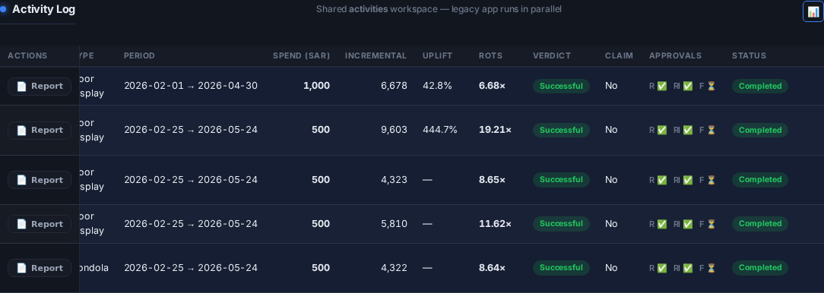
Fig. 1 — BEFORE (build V2.2, live production): Approvals column shows R ✅ / Rl ✅ / F ⏳ — the F stage has only the status pill, no Final controls, although the server authorises the user.
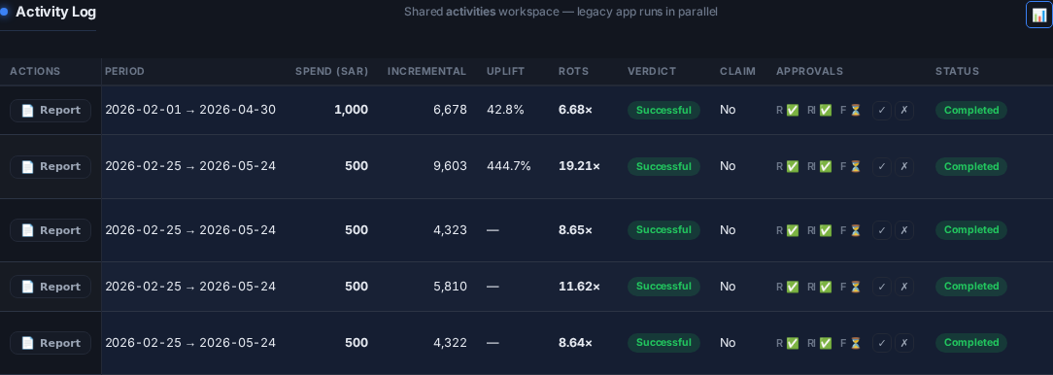
Fig. 2 — AFTER (build V2.3, live production, same account): the Final ✓ / ✗ controls render next to the F pill. They are enabled only on rows where Roshen and Relia are both Approved; on all other rows they are disabled with the "Requires Roshen + Relia approved" tooltip.
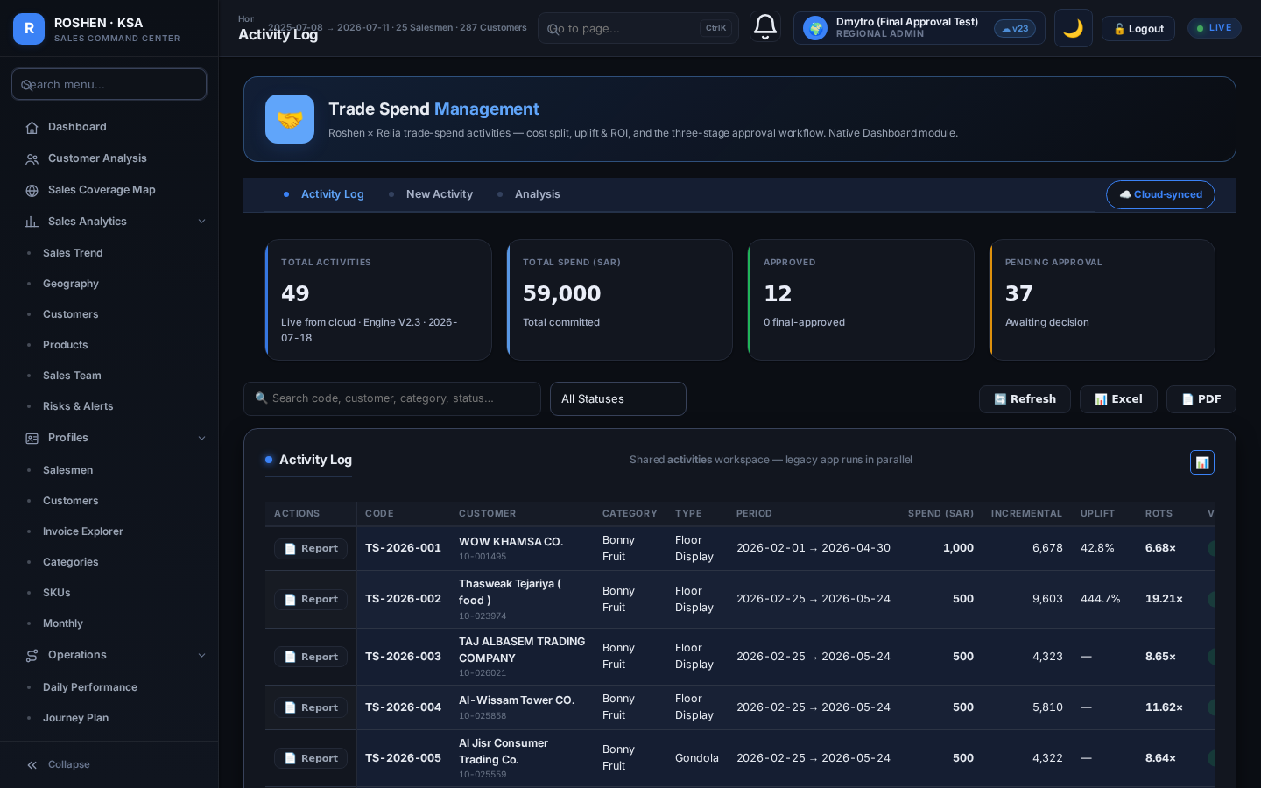
Fig. 3 — AFTER: the full Activity Log as the Final Approver sees it — Report is available, Edit and Delete correctly absent (read-only approver), Engine V2.3 badge live.

7. Deployment record
Item | Value
Production commit | b012db4 — fix(trade-spend): honor the canonical permission engine
Build badge | Engine V2.3 · 2026-07-18
Live integrity | SHA-256 of https://roshen-ksa-dashboard.vercel.app equals the repository file (byte-identical)
Database migration | 007_canonical_override_shape.sql — applied and committed
Unit tests | 81 / 81 passing (4 new authorization tests covering both dialects, revoke precedence, role fallback)
Mirror | Kako branch claude/trade-spend-native-module, commit 5cccc5b2 (PR #450)
Accounts | dmytro.test restored (role viewer, original overrides, password scrambled); dmytro.danylenko untouched

Prepared automatically as part of the Trade Spend production audit trail.

