VANTORA
FMCG Distribution Enterprise Pack
Architecture & Design Document
Distribution-first · Saudi Arabia · Route-to-Market / DMS · Design for implementation review
Aligned to Nestlé · PepsiCo · Coca-Cola · Mondelez · Unilever · P&G best practices

Contents
0. Scope & Reuse
Part II — Enterprise RTM: Distributor Model & DSD
Part II — Executive Dashboards (C-level)
1. Sales Hierarchy (7 roles)
2. Customer Structure
3. Route Execution
4. Perfect Store (RED)
5. Trade Marketing (TPM)
6. Van Sales
7. Distribution KPIs
8. Near-Expiry & Returns
9. Customer Data Governance (KSA)
10. Security & Permissions
11. Database Design
12. Mobile-First Field App
13. Saudi Arabia Localization
14. Enterprise Best-Practice Alignment
15. Governance Compliance
16. Implementation Roadmap
17. Open Decisions & Risks
Appendix — Architecture, ERD & Workflow Diagrams

0. Scope & Reuse
A distribution-first FMCG platform (Route-to-Market / Distributor Management System) delivered as a first-class industry pack on VANTORA — the plan-gated `distribution` module (+ `field_ops` for the mobile field app) over shared sales, inventory, accounting, pricing, CRM, analytics, and workflow. Targeted at Saudi Arabia (Arabic-first, VAT 15%, ZATCA e-invoicing, Commercial Registration, National Address) and aligned to global FMCG best practice.
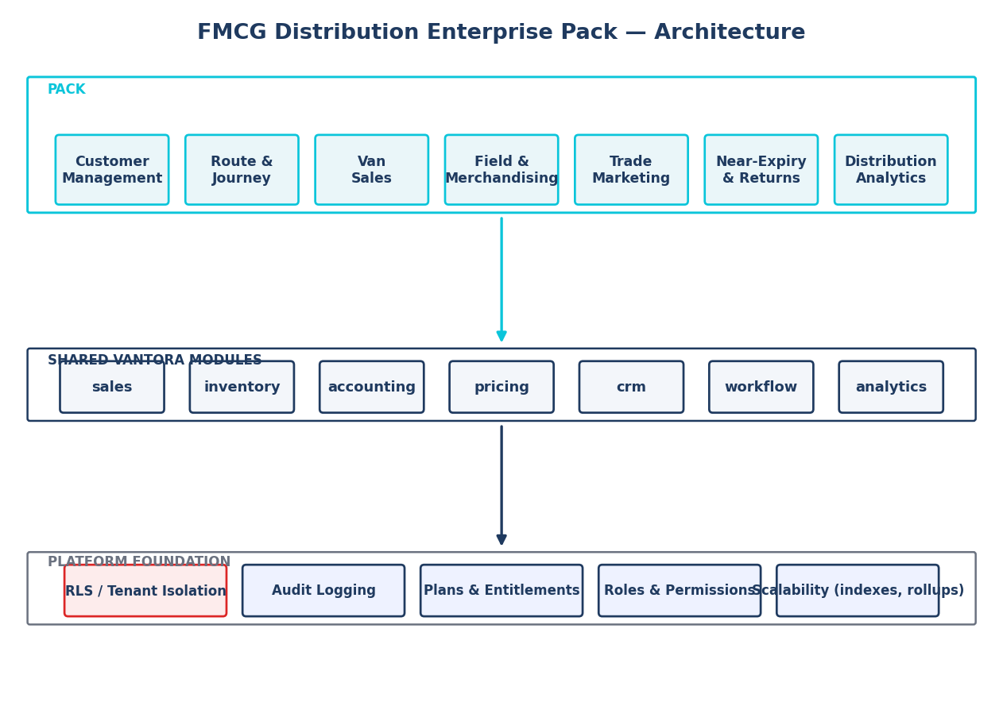
Figure 1 — FMCG pack architecture: pack capabilities over shared VANTORA modules over the platform foundation.

Capability | In VANTORA today | This pack adds
Customer master + approval + DFG | yes | channel/sub-channel, classification, GPS, payment terms, frequency, CDG change-requests
Routes / regions / scoped roles | partial | route master + territory + PJP + beat + route riding/accompaniment
Visits / GPS / day-close / settlement | yes | GPS validation, structured outcomes, Perfect-Store capture
Van sales | partial | load sheet, van ledger, mobile sell/return/collect, near/old expiry, reconciled day-close
Merchandising / MSL / Perfect-Store / OOS | dashboards | audit capture: OSA, SOS, planogram, competitor, photos
Trade marketing | — | NEW: spend, listing fees, displays, promos, claims, ROI/ROTS, activity calendar
Near/old expiry & returns | partial | NEW workflows + claims + warehouse processing
Mobile-first field apps | responsive web | role-specific, field-optimized, offline-capable apps
Saudi localization | bilingual | VAT 15%, ZATCA/Fatoora, CR, VAT no., National Address

Part II — Enterprise Route-to-Market: Distributor Model & DSD
A dual-model RTM platform: the same tenant can run Direct Store Delivery (DSD), the Distributor (indirect) model, or a Hybrid — across multiple brands, principals, and distributors by region — for all field-force types (distributor sales force, company sales force, van sales, merchandisers, Key Accounts).
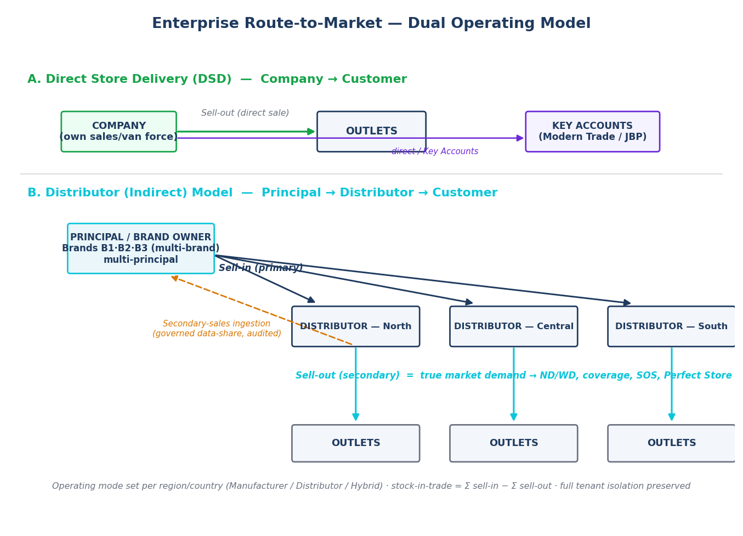
Figure 2 — Dual operating model: DSD (direct) and Distributor (indirect), with sell-in (primary) vs sell-out (secondary).

Company mode (role in the value chain): Manufacturer / Brand-Owner (owns brands → direct and/or via distributors), Distributor (represents principals → sells to outlets), or Hybrid (both). Per-region / per-country go-to-market is set independently, so the same company can run direct sales in one region and distributor sales in another:
GTM (per region) | Chain | Sell-in (primary) | Sell-out (secondary) | Example
Direct (DSD) | Company → Outlet | — (direct) | Company → Outlet (the sale) | Riyadh: own van/sales force; Key Accounts
Distributor | Principal → Distributor → Outlet | Principal → Distributor | Distributor → Outlet | Eastern Province: appointed distributor
Hybrid | both | both | both | Modern Trade direct + Traditional Trade via distributor

Principals, Brands & Distributors (multi-brand / multi-principal / multi-distributor):
- Principal — a brand owner; the tenant may OWN brands (acts as principal) and/or REPRESENT principals (acts as distributor) → multi-principal.
- Brand — belongs to a principal; products map brand → principal → multi-brand. All sales/targets/spend/KPIs slice by brand & principal.
- Distributor — a partner with contract, credit, assigned territories/regions/channels, price list, optional linked tenant; multiple distributors by region with exclusivity rules.
Sell-in vs Sell-out & Secondary Sales (core measurement):
- Sell-in (primary): Principal → Distributor — depletion into channel; basis for distributor targets, rebates, trade-spend funding.
- Sell-out (secondary): Distributor → Outlet — true market demand; basis for ND/WD, coverage, availability, SOS, Perfect Store.
- Stock-in-trade = Σ sell-in − Σ sell-out per distributor/SKU → prevents channel loading; feeds forecasting.
- Secondary capture: (a) distributor runs the same pack; (b) secondary-sales ingestion (governed data-share); (c) principal’s own merchandisers capture availability/SOS.
Distributor management, targets, rebates & trade spend:
- Distributor management — onboarding, contracts, price lists, credit, performance scorecards, status (audited).
- Distributor targets — primary (sell-in) & secondary (sell-out) per distributor × brand × SKU × period; cascaded; rolled up.
- Rebate programs — volume / value / growth / mix / slab / display-linked; accrued on qualifying sales; approval + credit-note settlement; audited.
- Trade spend allocated & tracked per distributor (and brand/channel/principal); ROI/ROTS by distributor.
- Key Account Management (KAM) — Modern Trade / national chains managed direct (banner→chain→store, JBP, listing, planograms), parallel to distributors for Traditional Trade.
Multi-tenant linkage & isolation:
- Single-tenant — one company runs DSD and/or models distributors as partner entities + ingested secondary data; all rows scoped by company_id (standard RLS).
- Connected tenants (enterprise) — principal and distributor are separate VANTORA tenants linked by a consented, scoped, audited data-share over the integrations/sync layer. No cross-tenant RLS is opened; full tenant isolation preserved.
Distributor inventory, coverage, scorecards & profitability:
- Distributor inventory — stock-on-hand per distributor/SKU → days-of-cover, OOS, stock-in-trade.
- Distributor coverage — outlets covered ÷ universe in territory; productive coverage.
- Distributor scorecard — periodic composite (sell-in vs sell-out, coverage, ND/WD, target %, OTIF/fill-rate, claim & rebate status, Perfect-Store, receivables ageing) → ranked league table.
- Distributor profitability — gross-to-net: revenue (sell-in) − COGS − trade spend − rebates − logistics → margin & ROI by distributor/brand/region.
Strategic planning — JBP, agreements, budgets, growth & market share:
- Annual Joint Business Plans (JBP) — per distributor/key account: volume & value targets, growth, trade-spend envelope, activity calendar, agreed KPIs; reviewed quarterly.
- Distributor agreements — terms, exclusivity, margins, payment terms, SLAs, period.
- Trade-spend budgets — annual by brand/channel/distributor/region, phased to the activity calendar; commitments vs actuals; ROI/ROTS.
- Growth targets — YoY by brand/region/distributor. Market-share tracking — share % & trend (panel import or estimated from ND/WD & SOS).
- Regional performance — consolidated region/country P&L, coverage, growth, share, target attainment.
KPIs roll up: outlet (secondary) → distributor → territory → channel → brand → principal → national, with sell-in vs sell-out reconciliation.

Part II — Executive Dashboards (C-level)
Role-scoped, read-only strategic dashboards over the rollups — no live heavy scans; drill-down respects role scope. Built for enterprise FMCG operating across multiple regions and countries (region → country → area → territory → route; per-region mode & GTM; per-country localization; currency-normalized group consolidation).
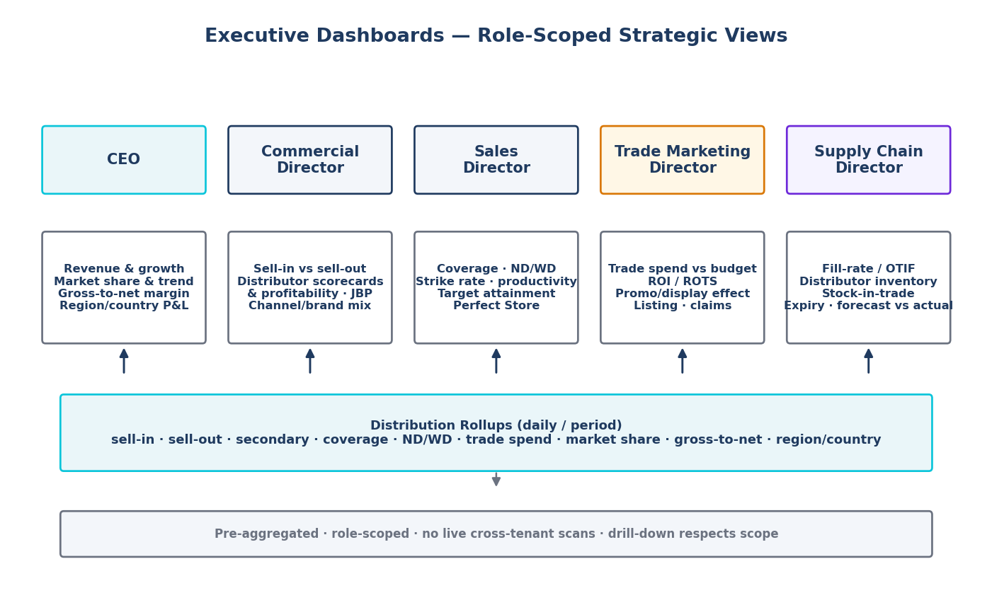
Figure 3 — C-level executive dashboards fed by the distribution rollup layer.

Persona | Focus KPIs
CEO | Revenue & growth (vs target/LY), market share & trend, gross-to-net margin, region/country performance, top risks
Commercial Director | Sell-in vs sell-out, distributor scorecards & profitability, JBP attainment, channel & brand mix, receivables
Sales Director | Coverage, ND/WD, strike rate, productivity, target attainment by region/area/rep, Perfect-Store
Trade Marketing Director | Trade-spend vs budget, ROI/ROTS, promotion & display effectiveness, listing, claims, activity calendar
Supply Chain Director | Fill-rate / OTIF, distributor inventory & days-of-cover, stock-in-trade, near/old expiry & write-offs, forecast vs actual

1. Sales Hierarchy (7 roles)
Reuses VANTORA roles + per-branch reporting lines and region/area/route scope. Targets cascade down; achievement and approvals roll up. Scope determines data visibility and approval authority.
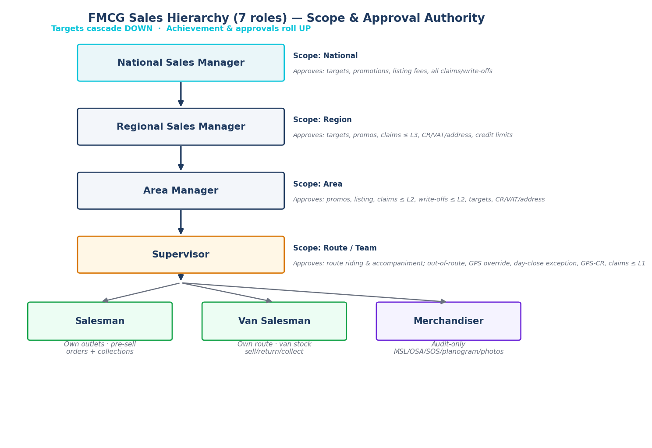
Figure 4 — FMCG sales hierarchy: scope & approval authority.

2. Customer Structure
Extends erp_customers via a 1–1 FMCG profile.
Attribute | Notes
Channel / Sub-channel | Traditional Trade (grocery/kiosk/wholesaler), Modern Trade (hyper/super/mini), HoReCa, Pharmacy, B2B
Territory / Route | region → area → territory → route (beat)
Classification | outlet grade A/B/C/D, size band, Perfect-Store tier
GPS location | validated lat-long + geofence radius
Credit limit / Payment terms | credit limit + balance + hold; cash / on-account; terms (days)
Visit frequency | F1/F2/F4 + preferred day(s) → PJP
KSA compliance | CR number, VAT no. (15-digit), National Address

3. Route Execution
- Permanent Journey Plan (PJP): scheduled outlet/date list per rep from route + frequency.
- Beat plan: the day’s ordered outlets with time windows.
- Route compliance: on-route vs off-route (off-route needs approval).
- Coverage = visited ÷ planned outlets; Strike rate = productive ÷ total visits; Call productivity = drop size, lines/SKUs per call.
- Route riding & supervisor accompaniment: structured field-coaching evaluation during a ride-along.

4. Perfect Store (RED / Picture of Success)
- MSL compliance — audit vs each outlet’s Must-Stock List.
- OSA (On-Shelf Availability) → OOS list.
- Shelf Share (SOS) — our facings ÷ category facings.
- Display compliance — contracted displays present & correct (photo-backed).
- Planogram compliance — shelf layout vs planogram.
- Competitor visibility — SKU/price/promo/share-of-shelf.
- Photo evidence — before/after shelf photos (object storage).
- Perfect-Store score — weighted availability + facings + planogram + display + price.

5. Trade Marketing (TPM)
- Trade spend & budget by customer/channel/promo (commitments + actuals).
- Listing fees — per-SKU per-outlet/chain listing payments (Modern Trade).
- Displays — types/contracts per outlet + compliance.
- Promotions — price-off / BOGO / bundle / slab + eligibility + budget → pricing engine at sale.
- Activity calendar — time-phased plan of promos/displays/listings.
- Claims — submit (evidence) → validate → tiered approve → settle (credit note) → audited.
- ROI / ROTS (Return on Trade Spend) — incremental value vs spend per promo/display/listing.

6. Van Sales
- Van inventory — van warehouse (is_van) stock ledger.
- Load sheet — stock issued to the van for a beat day (draft→loaded→reconciled).
- Sales — mobile cash/credit invoices vs van stock, priced incl. promotions, ZATCA-compliant.
- Collections — on-account vs customer balance + cash session.
- Returns — good (restock) vs damaged vs near/old expiry (segregate → claims).
- Day close — reconcile van (load ± sales/returns = closing) + cash; variance → supervisor approval.

7. Distribution KPIs
Pre-aggregated rollups (no live cross-tenant scans).
KPI | Definition
Numeric Distribution (ND) | outlets stocking SKU ÷ total outlets
Weighted Distribution (WD) | ND weighted by outlet sales importance
Coverage | visited ÷ planned outlets
Productivity / Strike rate | productive visits ÷ total visits
SKU per outlet | avg distinct SKUs per productive call
Average invoice (drop size) | avg invoice value per productive call
MSL compliance / OSA / OOS | must-stock adherence; on-shelf availability; out-of-stock
Perfect-Store score | weighted RED score

8. Near-Expiry & Returns (two workflows)
- Near-Expiry: batch/expiry tracking → near-expiry threshold → flag → action (sell-through promo / pull-back) before expiry.
- Old/Expired: expired stock → segregate (block) → expiry claim → approval → warehouse processing (destroy / return-to-supplier) → credit note + write-off.
- Approvals tiered by value (supervisor → area → region); fully audited.

9. Customer Data Governance (KSA)
Master-data changes affecting tax/legal/financial integrity are approval-gated change-requests, built on VANTORA’s customer-approval + Dynamic Field Governance + audit.
Change request | Why governed | Flow
GPS Change Request | outlet location / fencing integrity | field captures new GPS + photo → supervisor/area approve → apply
CR Update Request | Commercial Registration (السجل التجاري) | requestor → compliance review → approve → apply
VAT Update Request | VAT no. (15-digit) — affects e-invoicing | requestor → finance/compliance approve → apply
National Address Update | العنوان الوطني (unified address) | requestor → review → approve → apply

10. Security & Permissions
Group | Permission keys
Customers / CDG | customers.manage/approve, customer.classify, credit.request.create/approve, cdg.request.create, cdg.gps/cr/vat/address.approve
Route / Journey | route.create/import, journey.create/import, beat.plan, accompaniment.record
Van sales | vansales.load, sales.sell/return/collect, day.close, day.approve_close_exception
Perfect Store | field.sales, visit.override_gps, visit.approve_out_of_route, audit.capture, assortment.manage, grade.manage, planogram.manage
Trade marketing | trade.promo/display/listing/budget.manage, trade.claim.create/approve
Near/old expiry | expiry.manage, returns.claim.create/approve, inventory.adjustment.approve
Targets / analytics | target.view/manage, reports.view, report.aggregate.view, reconciliation.view/manage/approve
Distributor / RTM | principal.manage, brand.manage, distributor.manage, distributor.target.manage, secondary.ingest, rebate.scheme.manage, rebate.accrual.approve, keyaccount.manage
Strategy / Executive | exec.dashboard.view, jbp.manage, agreement.manage, growth.target.manage, market.share.manage, distributor.scorecard.view

Role × approval authority (key):
Capability | Merch | Sales/Van | Supervisor | Area | Regional | NSM
Audit capture | ✔ | ✔ | ✔ | view | view | view
Sell/return/collect/day-close submit | — | ✔ | ✔ | view | view | view
Out-of-route / GPS override / day-close exception | — | — | ✔ | ✔ | ✔ | ✔
Accompaniment (route riding) | — | — | ✔ | ✔ | ✔ | —
GPS change-request approve | — | — | ✔ | ✔ | ✔ | ✔
CR / VAT / National Address approve | — | — | — | ✔ | ✔ | ✔
Promotions / displays / listing | — | — | — | ✔ | ✔ | ✔
Trade claim approve (tiered) | — | — | ≤L1 | ≤L2 | ≤L3 | all
Expiry / write-off approve | — | — | ≤L1 | ≤L2 | ✔ | ✔
Targets / credit-limit approve | — | — | — | ✔ | ✔ | ✔

All approvals + sensitive mutations are written to erp_audit_logs via erp_log_audit.

11. Database Design
All new tables company_id-scoped; RLS company_id = erp_user_company_id() OR erp_is_platform_owner(); created_by/updated_by/created_at; audited mutations.
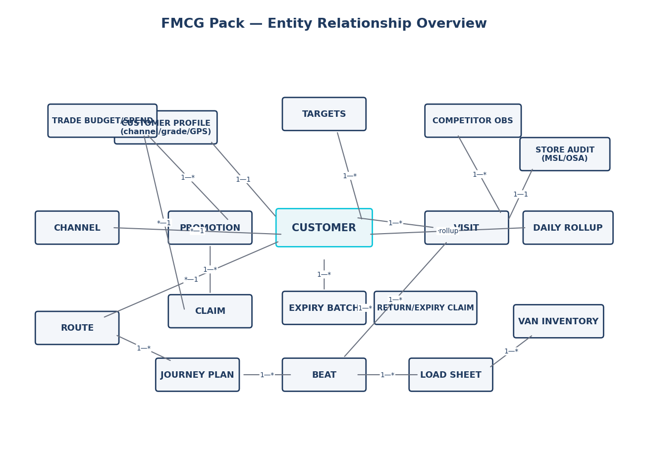
Figure 5 — FMCG pack entity-relationship overview.

Table group | Purpose
channels / customer_profile / customer_change_requests | channel master, FMCG+KSA attributes, CDG governance
journey_plans / journey_stops / beats / accompaniments | PJP, planned visits, day beat, route-riding evals
load_sheets / load_sheet_lines / van_reconciliations | van load + day-close variance
store_audits / audit_lines / planograms / competitor_obs / visit_photos | Perfect-Store capture + evidence
promotions / promo_lines / listing_fees / displays / display_contracts | trade mechanics
trade_budgets / trade_spend / activity_calendar / claims / claim_lines | spend + claims lifecycle
expiry_batches / return_claims / return_claim_lines | near/old expiry + returns
targets / daily_rollup | targets + pre-aggregated KPIs (by brand/principal/distributor/territory)
principals / brands / distributors / distributor_territories | RTM master: multi-brand, multi-principal, multi-distributor by region
distributor_targets / secondary_sales / channel_stock | sell-in & sell-out targets; secondary transactions; stock-in-trade
rebate_schemes / _accruals / _settlements / key_accounts | rebate programs lifecycle; Key Account Management
operating_modes / distributor_inventory / distributor_scorecards | company mode + per-region GTM; distributor stock; scorecards
distributor_agreements / jbp / growth_targets / market_share | contracts; Joint Business Plans; growth & market share

Index strategy: every FK indexed; composite (company_id, created_at DESC) and (route_id/salesman, date) on high-volume tables; partial indexes for hot predicates; RLS auth wrapped in (SELECT …). Scalability: monthly range-partition high-volume tables; analytics via rollups; photos to object storage.

12. Mobile-First Field App
Field reps work in low-connectivity outlets — mobile-first, fast, offline-capable (queue + sync), Arabic/RTL, GPS-aware.
App | User | Core screens
Salesman app | Salesman / Van Salesman | My Day/beat; check-in (GPS); order or van-sell; collect; audit; photos; day-close
Supervisor app | Supervisor | route riding / accompaniment; approvals (out-of-route, GPS override, day-close exception, CDG GPS); live coverage/strike
Merchandiser app | Merchandiser | store audit (MSL/OSA/SOS/planogram); competitor; photos — no selling

13. Saudi Arabia Localization
- VAT 15% standard rate (inclusive/exclusive handling).
- ZATCA e-invoicing (Fatoora) Phase 2 — compliant e-invoices, QR, clearance/reporting (via the integrations module; mirrors the existing ETA pattern).
- Commercial Registration (CR) + VAT number (15-digit) on customer master, governed via CDG.
- National Address (العنوان الوطني): building/street/district/city/postal/additional no.
- Arabic-first, RTL; Hijri date optional; currency SAR.

14. Enterprise Best-Practice Alignment
Practice | Source | In this pack
Route-to-Market / DMS | all | distribution module; van/pre-sell; routes
PJP + beat planning | Nestlé / Unilever | journey plans, beats, coverage
Perfect Store / RED / Picture of Success | Coca-Cola / PepsiCo | store audits; MSL/OSA/SOS/planogram; Perfect-Store score
Numeric & Weighted Distribution | Nielsen / all | ND/WD KPIs
Trade Promotion Management + ROTS | P&G / Mondelez | spend, promos, listing fees, claims, ROI
Route riding / field coaching | Unilever / PepsiCo | accompaniments
Master-data governance | all | CDG change-requests + approvals + audit

15. Governance Compliance
- Plan-gated distribution + field_ops; distribution/general business-type templates.
- Company-scoped RLS on all new tables; sensitive tables tightly scoped; reads/writes verified.
- Audit on all approvals + sensitive mutations (erp_log_audit).
- Role hierarchy + region/area/route scope reuse platform mechanisms.
- Permissions registered (labels + groups + danger flags); managed via Global Roles & Plans editors.
- FK index coverage + per-query RLS + rollups/partitioning plan; files in object storage.

16. Implementation Roadmap
Phase | Scope
F1 — Foundation | Customer profile/classification/channel/KSA fields; route master; PJP & beats; Customer Data Governance; permissions + RLS + audit
F2 — Mobile field & Perfect Store | Salesman/Supervisor/Merchandiser apps; visits + GPS validation; store audits (MSL/OSA/SOS/planogram); competitor; photos; coverage
F3 — Van sales | Load sheet; van inventory; mobile sell/return/collect; near-expiry; day-close reconciliation
F4 — Trade marketing (TPM) | Promotions (pricing); displays; listing fees; budgets/spend; activity calendar; claims + approvals; ROI/ROTS
F5 — Near/old expiry & returns | Batch/expiry; near + expired workflows; claims; warehouse processing + accounting
F6 — Distribution analytics | Daily rollups; ND/WD/coverage/strike/SKU-per-outlet/avg-invoice/Perfect-Store; partitioning
F7 — KSA compliance & hardening | ZATCA/Fatoora; VAT; approval-threshold matrix; targets cascade; offline-sync hardening; load test; retention

17. Open Decisions & Risks
- Pre-sell vs van-sell (or hybrid) default per channel — model supports both.
- ZATCA Phase-2 clearance integration scope & certified solution provider.
- Trade-spend ↔ accounting posting (accrual vs claim-time) — finance sign-off.
- Offline-first sync/conflict strategy for the mobile apps (separate mobile design doc).
- Promotion-engine depth (slab/bundle) — extend the existing pricing engine vs a new TPM engine.

Appendix — Workflow Diagrams
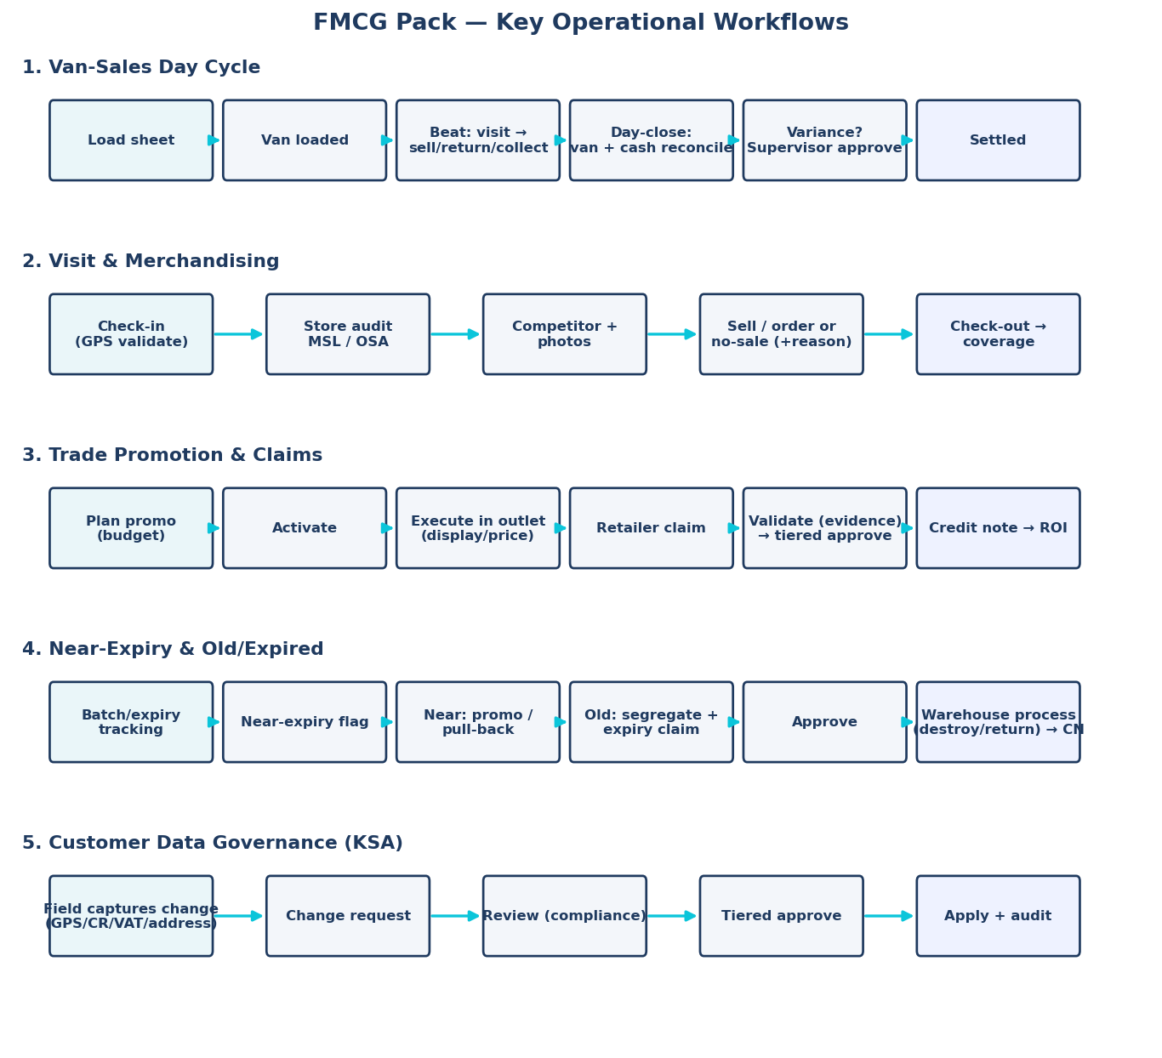
Figure 6 — Key FMCG operational workflows (van-sales day cycle, visit & merchandising, trade promotion & claims, near/old expiry, customer data governance).

— End of design document —

