VANTORA
Multi-Tenant SaaS ERP Platform
Full Platform Documentation
Version 1.0 · June 2026 · Generated for engineering & product handoff
Stack: Next.js (App Router, RSC) · Supabase (Postgres + RLS + Auth + Storage) · TypeScript

Contents
1. Executive Summary
2. Platform Purpose
3. Full System Architecture
4. Modules
5. Platform Owner Area
6. Company Admin Area
7. Roles & Permissions Hierarchy
8. Plans, Modules, Entitlements & Industry Packs
9. Multi-Tenant Structure & Tenant Isolation
10. Database Structure Overview
11. RLS / Security Model
12. Audit Logging System
13. Navigation & UI Structure
14. Existing Pages / Routes
15. Migrations Applied
16. Tests & Verification Status
17. Scalability Review Summary
18. PR / Branch Structure
19. Remaining Technical Debt
20. Recommended Next Development Phase
21. Architecture Diagram
22. Database ERD Overview
23. Workflow Maps
24. Module Dependency Map
25. Future Industry Packs
26. Final Architecture Readiness Assessment
27. Executive CTO Summary

1. Executive Summary
VANTORA is a production-grade, multi-tenant SaaS ERP platform that serves many independent businesses ("companies"/"tenants") of different industries from a single application and database. Each tenant operates in strict isolation, sees only the modules its subscription plan and business type unlock, and is governed by a role-and-permission model. A separate vendor ("Platform Owner") tier administers the entire platform: companies, plans, modules, roles, billing, audit, and support.
The platform is built on Next.js (App Router, React Server Components + Server Actions) and Supabase (Postgres with Row-Level Security, Auth, and Storage). Authorization is enforced in five consistent layers — Plan entitlement → Company module → Role permission → UI visibility → Route/API guard — with the database (RLS) as the hard isolation boundary.
Current status (production-grade checklist):
- Clean platform governance and a unified authorization model.
- Tenant isolation verified across all 129 database tables (reads and writes).
- All sensitive mutations are audit-logged; tenants and the vendor can each review their audit trail.
- Consistent entitlement chain; every licensable module has a navigation surface.
- Database performance hygiene: 100% foreign-key index coverage; no per-row RLS auth evaluation.
- Continuous-integration guards for architecture, navigation, authorization, and schema health.
- A documented, trigger-based scalability plan for growth to 10,000+ companies.

2. Platform Purpose
VANTORA lets a vendor operate one ERP product that adapts to many industries instead of building a separate system per vertical. A company signs up, picks a business type (e.g. clothing, clinic, restaurant, FMCG distribution, pharmacy, supermarket), and immediately gets a tailored experience: only the relevant modules, navigation, roles, and screens — no irrelevant complexity.
Goals:
- One codebase, many industries — industry "packs" layer on shared commerce/accounting foundations.
- Strong multi-tenant isolation so one company can never see or affect another.
- A powerful but safe Platform Owner control center for onboarding and administering tenants.
- A clean, role-appropriate experience for every end user (owner, manager, cashier, accountant, …).
- Scalable foundations ready for large-scale customer onboarding.

3. Full System Architecture
VANTORA has two authorization tiers and a layered request path:
Two tiers
- Platform (vendor) tier — the operator and its internal staff. Identified by the is_platform_owner flag on a profile, or membership in erp_platform_staff. They see only the vendor control center (/platform/*) and never tenant operational screens.
- Tenant (company) tier — a customer company’s own users, identified by branch membership (erp_user_branches). Scoped to exactly one company.
Request path
- UI: Next.js App Router — React Server Components, Server Actions, i18n (Arabic/English, RTL).
- Authorization core (src/lib/erp): guards, permissions, capabilities, navigation/visibility, home routing, plan/role admin logic.
- Auth context: getUserContext() / getPlatformContext() resolve identity, company, modules, and permissions — now request-memoized (React cache()) so each request resolves once.
- Data: Supabase Postgres with Row-Level Security. Reads use the user’s JWT (RLS-enforced); mutations go through guarded, audited Server Actions; multi-write operations use SECURITY DEFINER RPCs (e.g. invoice issue, fashion checkout) for atomicity.
- Files: Supabase Storage (object store); the database holds metadata + storage paths only.
The five-layer entitlement chain
Plan entitlement (erp_plan_modules) → Company module (erp_company_modules) → Role permission (erp_company_role_permissions / erp_role_permissions) → UI visibility (visibleSections) → Route/API guard (requireModule / requirePermission). The apex tiers (Platform Owner, Super Admin) bypass layers 1–3.

4. Modules
A "module" is a licensable capability. Effective modules for a tenant = the modules its company has enabled ∩ the modules its plan unlocks. The 20 plan-gateable modules split into core capabilities and industry verticals; three additional "item-level" modules refine screens inside core sections.
Module | Type | What it does
sales | Core | Quotes, orders, invoices, customers, collections.
inventory | Core | Products, stock levels, movements, low-stock/expiry.
purchasing | Core | Suppliers, purchase orders, supplier returns/payments.
accounting | Core | Chart of accounts, journals, double-entry posting, finance reports.
pos | Core | Generic counter Point-of-Sale (quick sale).
crm | Core | Customer relationship management surface (any-of with sales).
workflow | Core | Approvals & workflow engine (approval center, tasks).
analytics | Core | Analytics/reporting surface (sales report, dashboards).
field_ops | Core | Field/van sales: journeys, GPS visits, day-close, settlements.
integrations | Core | Integration hub, API keys, connectors, data import/export, onboarding.
hotel | Vertical | Rooms and bookings.
clinic | Vertical | Reception, doctor queue, appointments, patients, visits, services.
restaurant | Vertical | Tables, orders, kitchen.
salon | Vertical | Appointments, tickets, services.
pharmacy | Vertical | Dispensing + near-expiry tracking.
laundry | Vertical | Laundry orders and services.
market | Vertical | Supermarket POS.
wholesale | Vertical | Price levels/tiers, wholesale orders.
distribution | Vertical | FMCG distribution: routes, journey compliance, MSL, perfect-store.
fashion | Vertical | Clothing store pack: variants, POS, installments, cash box, reports.
sales_orders | Item-level | Sales-order screen inside Sales (business-type gated).
returns | Item-level | Sales-returns screen inside Sales.
warehousing | Item-level | Transfers, stock requests, counts, multi-warehouse.

Abstract packs: "retail" and "electrical" have no standalone database module — "electrical" is permission-gated (electrical.rma); "retail" preselects core modules. A continuous-integration test guarantees every real module has a navigation surface (no "orphan" modules).

5. Platform Owner Area
The vendor control center lives under /platform/* and is owner/staff-gated. It is organized into SaaS-style groups: Overview, Tenants, Catalog, Billing, Team & Access, Reference Data.
- Overview / Activity / Analytics — platform-wide KPIs, activity feed, cross-tenant analytics.
- Companies (Company 360) — per-company profile: information, business type, plan, subscription, enabled modules, roles & permissions, users, integrations, usage, audit; actions to suspend/activate, renew, change plan, grant/clear trial, toggle modules, onboard admins, reset passwords, and View As Company (read-only per-role tenant preview).
- Plans & Modules editor — create/edit/clone/archive/reorder plans, set per-plan module entitlements with a live impact preview, and edit business-type templates.
- Global Roles & Permissions — manage the default role catalog: create/rename/clone/delete roles, grouped permission editor with search, dangerous-permission warnings, and role comparison.
- Billing — subscriptions, invoices, unpaid totals, price book.
- Team & Access — internal platform staff (roles + granular permissions, escalation-guarded) and the forensic Audit Log.
- Reference Data — e.g. the clinic drug list importer.
The Platform Owner never sees an "Out of Plan" / upgrade screen and bypasses tenant gates by design.

6. Company Admin Area
A Company Admin (the tenant "admin" role) administers their own company only. Capabilities include:
- Staff & organization — invite users, assign roles, manage departments/teams/job titles and reporting lines (audited).
- Branches & regions — manage branches, regions, and areas (within plan limits).
- Roles & permissions — per-company role configuration and the Authorization Console (capabilities, scopes, limits).
- Data & fields — custom fields, customer data, units of measure, field governance.
- Integrations (plan-gated) — integration hub, API keys, connectors, import/export, onboarding.
- Audit Log — a new tenant-facing viewer: the company’s own audit trail (who did what, when).
- Operational modules — everything the company’s business type and plan enable (sales, inventory, the relevant vertical, etc.).

7. Roles & Permissions Hierarchy
Two role tiers. Platform roles govern the vendor control center; tenant roles govern a company. Tenant permissions resolve per company (company-scoped config if present, else global defaults). A role’s rank is used only to pick the "top role" for navigation display — it does not grant permissions.
Platform roles & permissions
Platform role | Default platform permissions
Owner (flag) | All — apex; also bypasses all tenant gates
admin | view_companies, create_companies, manage_billing, export_data, manage_users, access_support_tickets, access_audit_logs
sales | view_companies, create_companies
support | view_companies, access_support_tickets
implementation | view_companies, create_companies, export_data, access_support_tickets
finance | view_companies, manage_billing, export_data, access_audit_logs

Tenant roles (by rank)
Rank | Role | Summary
8 | admin | Company Owner/Admin — all sales/inventory/purchasing/accounting + every vertical *.manage + settings.users/branches
7 | manager | Full operational control (no granular fashion split)
7 | sales_director / national_sales_manager | FMCG commercial leadership
6 | branch_manager / regional_manager / supervisor / it_admin | Branch ops / scoped management / IT & integrations
5 | accountant / area_manager / doctor | Finance / scoped commercial / clinical
4 | warehouse_keeper | Inventory & purchasing
3 | cashier / technician / stylist | POS & service front-desk
2 | salesman / driver / receptionist | Field/sales/reception
1 | staff / housekeeping | Limited operational
0 | viewer | Read-only

Permission groups (16): sales, inventory, purchasing, accounting, settings, field_ops, hotel, clinic, restaurant, salon, pharmacy, market, wholesale, electrical, fashion (plus the fashion.manage owner umbrella). There are 79 tenant permissions and 7 platform permissions. System roles (21) are protected from deletion; custom roles are owner-managed.
Representative permissions
Group | Example permissions
sales | sales.sell, sales.discount, sales.collect, sales.return, customers.manage, customers.approve
inventory | inventory.view/adjust/transfer/count, stock_request.create/approve, product.create/import
purchasing | purchasing.manage, purchasing.return, suppliers.manage
accounting | accounting.view, accounting.post, reports.view, credit.request.approve
settings | settings.users, settings.branches, settings.custom_fields, integrations.manage, workflow.manage
field_ops | field.sales, visit.override_gps, day.close, target.manage, reconciliation.approve
fashion | fashion.manage (umbrella) → fashion.sell/inventory/purchase/installments/cashbox/reports
verticals | hotel.manage, clinic.manage/reception/doctor, restaurant.manage, salon.manage, pharmacy.dispense, laundry.manage, market.pos, wholesale.pricing, electrical.rma

8. Plans, Modules, Entitlements & Industry Packs
A subscription plan unlocks a set of modules and sets limits (users, branches, products, storage, trial days). A company’s effective modules are the intersection of its enabled company-modules and its plan’s modules. Business-type templates seed which modules a new company starts with; industry packs preselect bundles for a vertical.
Plan | Rank | Max users | Modules unlocked
free | 0 | 1 | Sales, inventory, and the vertical modules (no accounting/purchasing/analytics/integrations/pos)
standard | 1 | 15 | + accounting, purchasing, analytics, integrations, pos
pro | 2 | 50 | + workflow, field_ops (full set)
unlimited | 3 | ∞ | All modules

Industry packs: clinic, pharmacy, distribution, retail, electrical, restaurant, hotel, salon, laundry, fashion. The Plans & Modules editor lets the Platform Owner manage plans, entitlements, and business-type templates with a live impact preview (which companies gain/lose which modules before saving). Clothing companies are normalized to a fashion-only module set.

9. Multi-Tenant Structure & Tenant Isolation
VANTORA uses a shared-database, shared-schema, row-level-isolation model. Every tenant table carries a company_id (or scopes via branch_id → company). Row-Level Security policies enforce that a user reads/writes only rows belonging to their company; the vendor tier (erp_is_platform_owner()) has cross-tenant access by design.
Isolation was verified across all 129 tables for both reads and writes: a tenant user sees only their company’s rows, while the platform owner sees all. One historical cross-tenant gap (erp_supplier_payments) was found and fixed; the table was empty so no data was exposed.

10. Database Structure Overview
The schema has ~129 erp_* tables. Representative groups:
Area | Key tables
Tenancy & identity | erp_companies, erp_branches, erp_profiles, erp_user_branches, erp_departments, erp_teams, erp_job_titles
Roles & permissions | erp_roles, erp_role_permissions, erp_company_roles, erp_company_role_permissions
Plans & modules | erp_plans, erp_plan_modules, erp_company_modules, erp_business_type_modules, erp_business_type_roles
Platform / vendor | erp_platform_staff, erp_platform_staff_permissions, erp_platform_role_permissions
Commerce | erp_customers, erp_suppliers, erp_products_catalog, erp_invoices, erp_invoice_lines, erp_sales_orders, erp_sales_returns
Inventory | erp_inventory_stock, erp_stock_movements, erp_stock_requests, erp_warehouses
Accounting | erp_chart_of_accounts, erp_journal_entries, erp_journal_lines
Fashion pack | erp_fashion_styles/variants/colors/sizes, erp_installment_plans/schedule/payments, erp_cash_sessions/movements, erp_expenses
Verticals | erp_clinic_*, erp_restaurant_*, erp_salon_*, erp_laundry_*, erp_pharmacy_*, erp_rooms/bookings, erp_wholesale_*
Governance | erp_audit_logs, erp_custom_fields, erp_entity_notes/attachments, erp_workflow_instances/tasks, erp_notifications
Billing | erp_billing_subscriptions, erp_billing_invoices, erp_billing_payments, erp_billing_plan_prices

11. RLS / Security Model
- Every erp_* table has Row-Level Security enabled with at least one policy (129/129).
- Tenant tables: read/write only where company_id = erp_user_company_id() (or via a parent join), OR erp_is_platform_owner().
- Global reference tables (plans, roles, role permissions, business-type templates, clinic reference) are readable by any authenticated user but writable only by the owner/super-admin.
- Sensitive cross-cutting tables are tightly scoped: audit logs (vendor + own-company-admin), billing (own company for tenants; owner writes), platform staff (owner/self/manage_users).
- Apex consistency: the Platform Owner is authoritative on profiles and the global role catalog (RLS updated for this). Guards (requireModule/requirePermission/capabilities) bypass for owner/super-admin.
- Performance hygiene: all 112 unindexed foreign keys were indexed; 6 RLS policies that re-evaluated auth.uid() per row were fixed to evaluate once per query.

12. Audit Logging System
All sensitive mutations are recorded in erp_audit_logs via the SECURITY DEFINER function erp_log_audit(action, entity, entity_id, details, company_id), which stamps the actor from the session (the actor cannot be forged). Columns: actor_id, actor_email, company_id, action, entity, entity_id, details (JSONB), created_at.
- Covered actions: create/update/delete, enable/disable, grant/revoke, activate/deactivate, plan change, role & permission changes, module/plan/business-type changes, user assignment, view-as, etc.
- A bilingual describeAuditEvent() renders human-readable sentences.
- Vendor forensic viewer at /platform/audit; tenant self-audit viewer at /settings/audit-log (company-admin, own company only).

13. Navigation & UI Structure
Navigation is computed by visibleSections() from the user’s permissions, effective modules, business type, and tier. A single shared helper (isModuleGateOpen) drives both the sidebar and the mobile bottom navigation, so gating is consistent.
- Platform Owner: sees only the grouped vendor panel (Overview, Tenants, Catalog, Billing, Team & Access, Reference Data).
- Tenant users: see only the sections their modules + permissions allow; vertical businesses get a clean, focused experience (e.g. a clothing store sees only its Fashion store, not generic ERP).
- Mobile: a bottom navigation bar with mutually-exclusive groups (e.g. Sell = Fashion POS or generic Sales, never both).
- Home routing: each business type lands on its own home (clothing → /fashion, clinic → role screen, etc.); the platform owner lands on /platform; no-company users land on /dashboard.
- Guards: vendor items never leak to tenants (regression-tested); no dead navigation links (regression-tested).

14. Existing Pages / Routes
Area | Representative routes
Platform | /platform, /platform/activity, /platform/analytics, /platform/audit, /platform/billing, /platform/staff, /platform/companies, /platform/companies/[id] (+ /analytics, /view-as), /platform/plans, /platform/roles, /platform/drugs
Dashboard/home | /dashboard, /today, /manager, /territory, /attention, /notifications, /account
Sales | /sales/invoices, /sales/pos, /sales/orders, /sales/returns, /sales/pricing, /sales/report, /customers, /customers/[id]
Inventory | /products, /inventory, /inventory/low-stock, /inventory/expiry, /inventory/transfers, /warehouses, /suppliers
Purchasing/Accounting | /purchases/orders, /purchases/returns, /accounting, /exports
Verticals | /fashion (+ sell/products/inventory/customers/installments/suppliers/cashbox/reports), /clinic*, /restaurant*, /salon*, /laundry*, /pharmacy*, /hotel*, /wholesale*, /distribution*
Field ops | /rep, /field/route, /field/stock, /sales/journey, /sales/settlement
Settings | /settings/staff, /settings/organization, /settings/branches, /settings/users, /settings/permissions, /settings/authz, /settings/audit-log, /settings/integration-hub, /settings/integrations, /settings/import, /settings/export, /settings/custom-fields, /settings/marketplace
Upgrade/auth | /upgrade, /login, /register, /setup

15. Migrations Applied
The schema is managed by sequential SQL migrations (0001–0158). The most recent program (Fashion pack + Platform Governance + Scalability) is summarized below; all are additive and reversible with documented rollbacks.
Migration | Purpose
0146 | Fashion Store pack — tables, RPCs, clothing module/role/permission seeding
0147 | Fashion clothing role cleanup — curated per-role fashion permissions
0148 | New-clothing-company trigger also enforces fashion-only modules
0149 | Platform owner is apex authority on erp_profiles (RLS)
0150 | Plan storage-limit entitlement (erp_plans.storage_limit_mb)
0151 | SECURITY: fix cross-tenant leak on erp_supplier_payments (RLS scope)
0152 | Platform owner may manage the global role catalog (RLS)
0153 | Tenant Audit Viewer — company-admin read of own audit log (RLS)
0154 | Integrations becomes a real plan-gated capability + backfill
0155 | Normalize clothing business-type template to fashion-only
0156 | Close the POS plan gap — POS grantable + enabled for general retail
0157 | Scalability: covering indexes for all 112 unindexed foreign keys
0158 | Scalability: fix 6 per-row auth.uid() RLS policies (initplan)

16. Tests & Verification Status
- 661 unit tests pass; typecheck and production build are green.
- Architecture-integrity tests: no dead permissions/modules in nav; catalog completeness; orphan-module guard (allowlist now empty).
- Navigation-routes tests: no dead sidebar links; vendor items never leak to tenants.
- Authorization tests: apex-tier bypass; fashion umbrella; home routing (no redirect loops).
- Plan-admin / role-admin tests: validation, impact preview, diff, role compare, danger flags.
- Schema-health integration test (DB): fails CI if a migration introduces an unindexed FK or a per-row auth.uid().
- Domain integration tests (DB): accounting balance, invoice/payment idempotency, customer scope, etc.
- CI on the governance PR applied migrations 0149–0158 cleanly to a staging database.

17. Scalability Review Summary
A full capacity review (docs/SCALABILITY-REVIEW.md) covers the multi-tenant model, indexing, high-volume tables, attachment storage, reporting/analytics patterns, caching, retention, partitioning, and bottleneck projections.
Scale | Primary bottleneck | Mitigation
100 companies | Per-request auth queries | Request memoization (done); transaction pooler
1,000 companies | Platform analytics over capped sets; audit/notification growth | Pre-aggregated rollup tables; retention; catalog caching
10,000 companies | Total write volume + single-primary ceiling | Monthly range-partitioning; read replica; evaluate sharding

Applied now: 100% FK index coverage, per-query RLS auth, request-memoized auth context, and a CI schema-health guard. Deferred (trigger-based, when data justifies): (company_id, created_at) composite indexes, retention policies, partitioning, analytics rollups, read replica, sharding.

18. PR / Branch Structure
The work is split into two clean, independently-reviewable pull requests (stacked), preserving all commit history, migrations, audit trail, and documentation links.
PR | Branch → Base | Scope
#121 | claude/fashion-store-pack → main | Fashion Store Industry Pack (clothing vertical)
#122 | claude/platform-governance → claude/fashion-store-pack | Governance, authorization, module architecture, scalability (migrations 0149–0158)

Land order: review/merge #121, then #122. CI on #122 applied all migrations to staging successfully.

19. Remaining Technical Debt
Item | Severity | Notes
Naming divergence (finance↔accounting; market="Supermarket") | Low | Bridged in code; a deliberate reviewed rename pass is recommended (high blast-radius across seeds/tests/i18n).
field_ops over-provisioned on many companies | Low | Not a live leak (perm-gated); re-scope as a product decision.
Code↔DB role-map divergence (ROLE_PERMISSIONS vs DB) | Low | Runtime uses DB; code map only feeds a hint/tests. Harmless, documented.
/platform/copilot-analytics namespace | Low | Shared with company admins but under vendor namespace; move to /insights/*.
Multiple permissive RLS policies (advisor) | Low | Minor planner overhead from OR’d SELECT policies; consolidate opportunistically.
Trigger-based scalability work | Planned | Composite indexes, retention, partitioning, rollups, replica — when data justifies.

No correctness or security debt is outstanding: tenant isolation verified, the one real leak fixed, all sensitive mutations audited, FK coverage complete, and no per-row RLS auth.

20. Recommended Next Development Phase
Phase | Action
A. Land & stabilize | Merge #121 → #122 → main; confirm Supabase transaction pooler for serverless.
B. Onboarding readiness | Catalog (plans/roles/modules) short-TTL caching; the reviewed naming reconciliation; finalize field_ops/POS-per-vertical defaults; move copilot-analytics out of /platform.
C. Scale-readiness (trigger-based) | (company_id, created_at) composite indexes; retention + monthly range-partitioning of high-volume tables; platform-analytics rollup tables; read replica for reporting.
D. Customer-facing product | Self-serve plan/upgrade flows on the entitlement model; tenant-facing dashboards & reporting on the rollup foundation.

21. Architecture Diagram
The diagram below shows VANTORA’s governance-to-runtime control flow. The Platform Owner defines plans, modules, roles, and permissions (governance); companies and their users then operate strictly within those entitlements (runtime); and Row-Level Security enforces tenant isolation at the database — the hard boundary that one tenant can never cross into another.
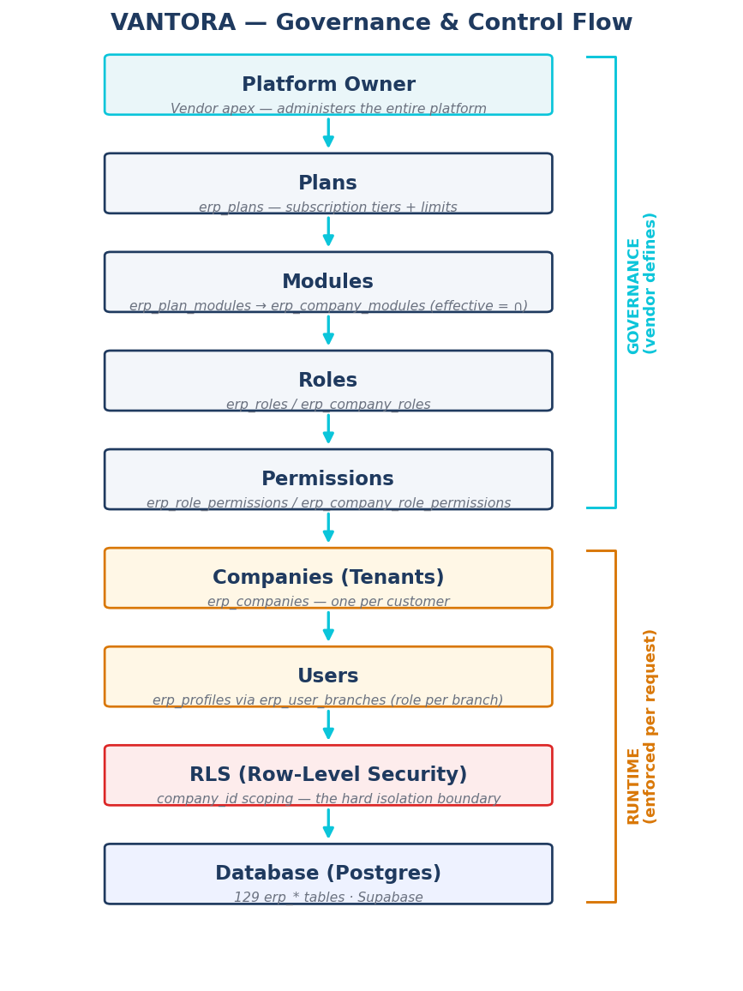
Figure 1 — Governance & control flow: vendor defines → runtime enforces.

22. Database ERD Overview
A high-level view of the core entities and their ownership chains. COMPANIES is the tenancy hub: every operational record ultimately traces back to a company, which is the basis for Row-Level Security. Cardinalities use 1—* (one-to-many) and *—* (many-to-many via a link table).
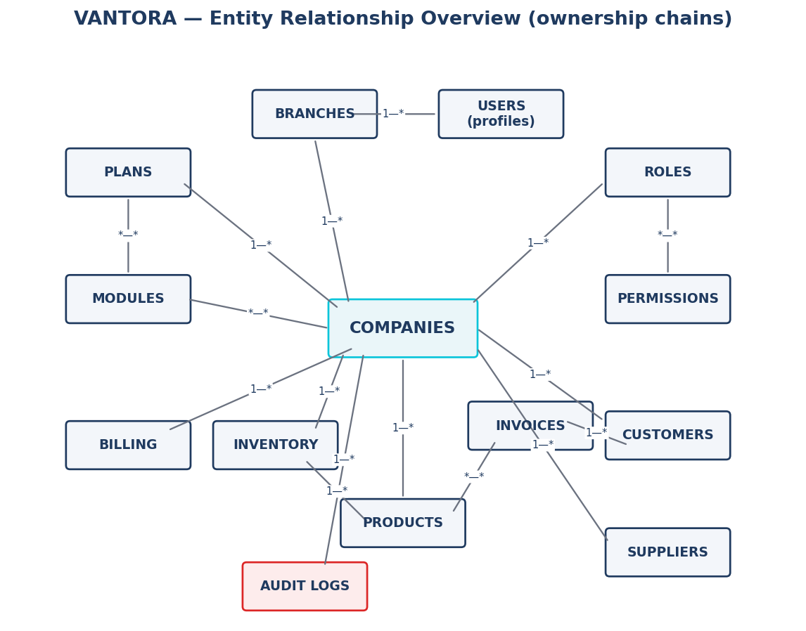
Figure 2 — Entity relationship overview (ownership chains).

Primary ownership chains:
- Company → Branches → Users (a user’s role is assigned per branch via erp_user_branches).
- Plan → Company; Plan ⇄ Modules and Company ⇄ Modules → effective modules = the intersection.
- Company → Roles ⇄ Permissions (company-scoped config, falling back to global defaults).
- Company → Customers / Suppliers / Products; Customer → Invoices; Product ⇄ Invoice lines; Product → Inventory.
- Company → Audit Logs; Company → Billing (subscriptions, invoices, payments).

23. Workflow Maps
Operational flows for the platform’s most important processes — onboarding, identity, entitlement, and governance.
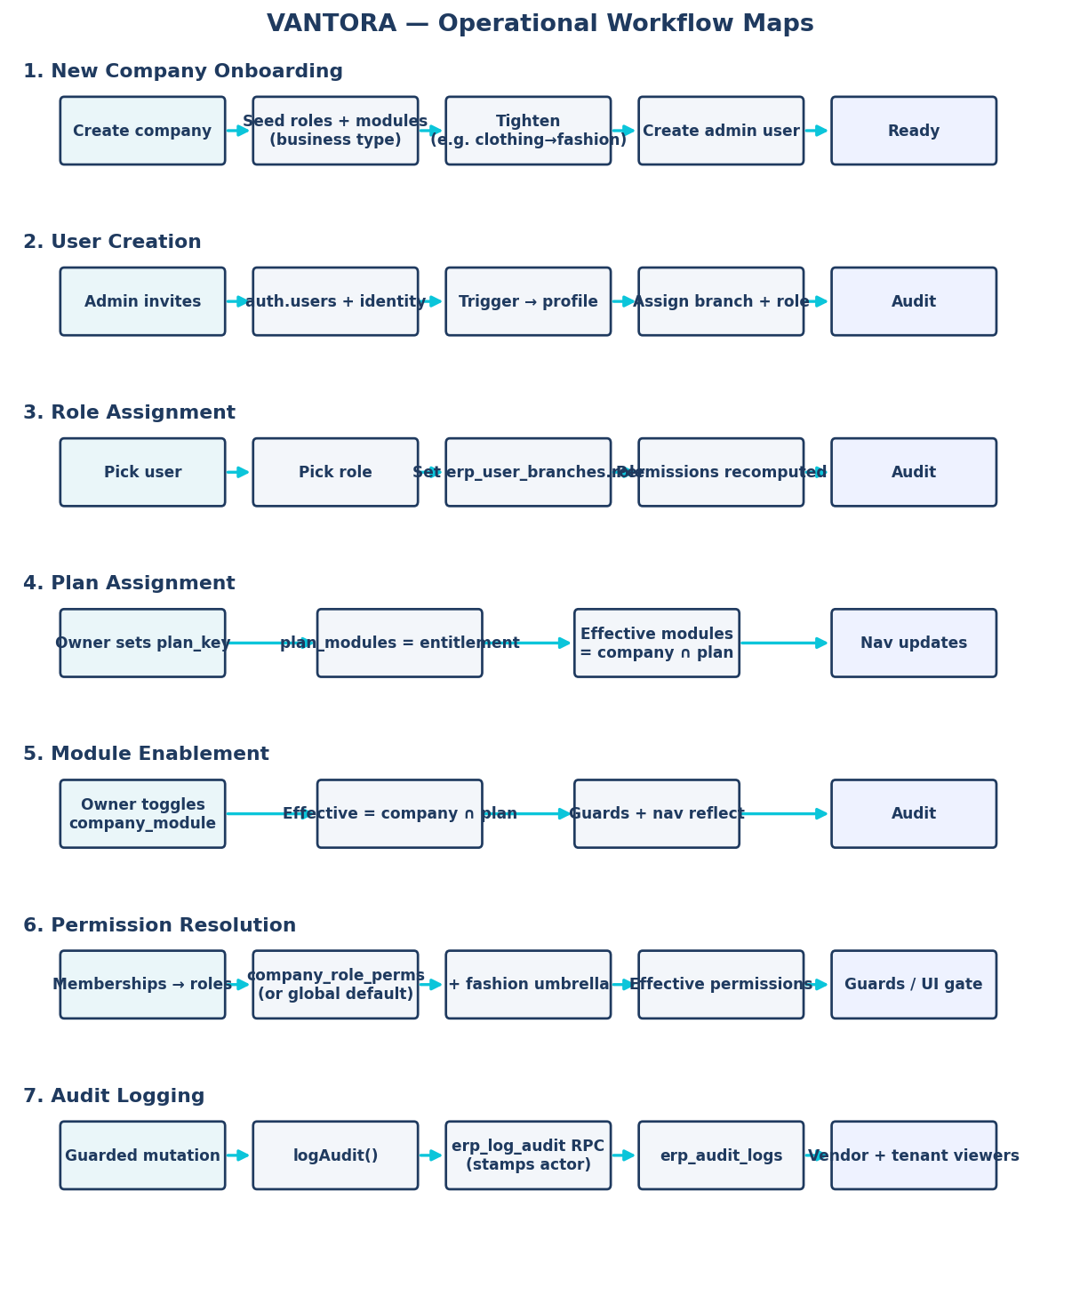
Figure 3 — Operational workflow maps (seven flows).

24. Module Dependency Map
Modules build on shared capabilities. "Depends on" means a module needs — or works best alongside — another to function. Core capabilities (shown in cyan) are the foundation; industry verticals and item-level refinements layer on top. The advisory dependency hints also drive UI warnings before a depended-on module is disabled.
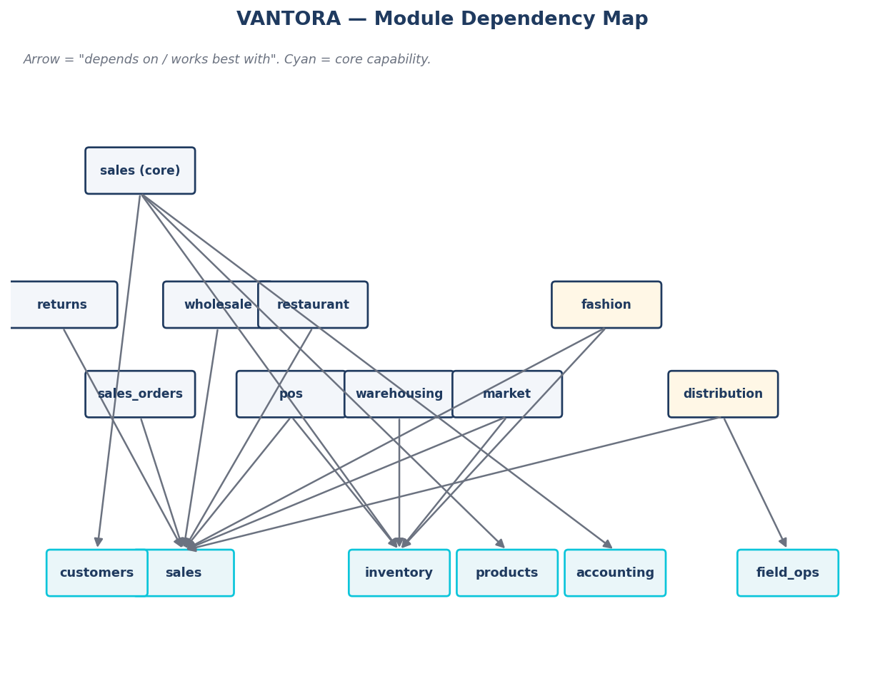
Figure 4 — Module dependency map.

Module | Depends on / works best with
sales (core) | customers, products, inventory, accounting (revenue posting)
pos | sales, inventory
sales_orders / returns | sales
warehousing | inventory
market (supermarket) | sales, inventory
wholesale | sales (price tiers)
restaurant | sales
distribution | sales, field_ops (journey planning, MSL / trade-marketing, perfect-store)
fashion | sales, inventory (+ installments & cash box as built-in sub-features)

25. Future Industry Packs
VANTORA’s pack model layers industry-specific modules on the shared commerce/accounting foundation. The packs below are built or planned; each lists the core modules it reuses, the modules/features unique to it, and its target customer profile.
Pack | Core modules used | Unique modules / features | Target customer
FMCG Distribution | sales, inventory, accounting, field_ops | routes, journey compliance, MSL matrix, perfect-store, outlet grading | Distributors / wholesalers with van sales & retail execution
Clinic | crm, sales, accounting | reception, doctor queue, appointments, patients, visits, services, drug reference | Clinics & polyclinics
Pharmacy | sales, inventory, purchasing, accounting, pos | dispensing, near-expiry tracking | Pharmacies / drugstores
Restaurant | sales, inventory, accounting | tables, orders, kitchen display | Restaurants & cafés
Hotel | accounting | rooms, bookings | Hotels / guesthouses
Salon | sales, accounting | appointments, tickets, services | Salons & spas
Laundry | sales, accounting | orders, services | Laundries / dry cleaners
Fashion | sales, inventory | variants, fashion POS, installments, cash box, store reports | Clothing & footwear retail
Retail (general) | sales, inventory, accounting, pos | generic counter POS | General retail shops
Wholesale | sales, inventory | price tiers, wholesale orders | Wholesalers / B2B sellers

26. Final Architecture Readiness Assessment
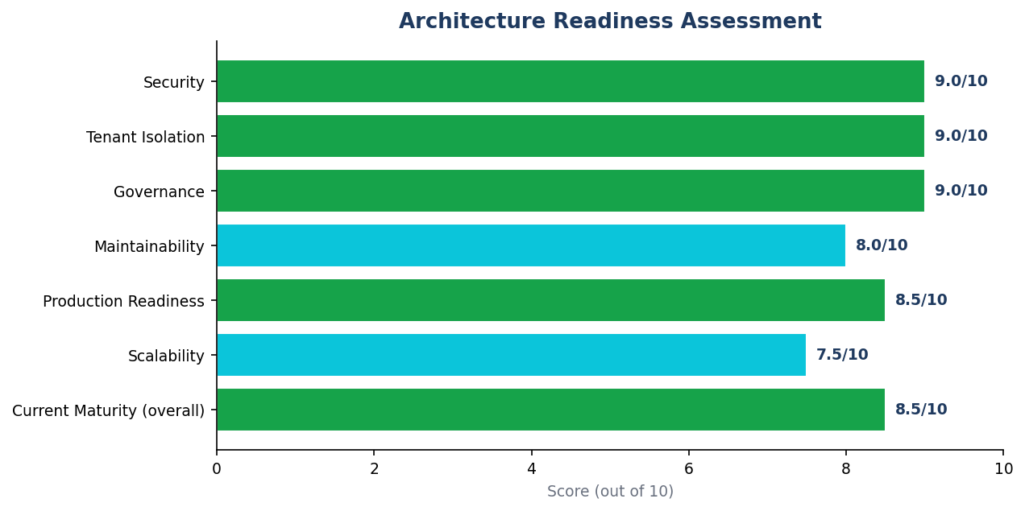
Figure 5 — Architecture readiness scores (out of 10).

Dimension | Score | Basis
Security | 9.0 / 10 | RLS on all 129 tables; isolation verified (reads + writes); one historical leak fixed; guards consistent across the apex tier.
Tenant Isolation | 9.0 / 10 | company_id scoping everywhere; no permissive tenant policies; sensitive tables (audit/billing/staff) tightly scoped.
Governance | 9.0 / 10 | Unified authorization; all sensitive mutations audited; tenant + vendor audit viewers; CI architecture/authz/schema guards.
Maintainability | 8.0 / 10 | Shared gating helpers; typed catalogs; thorough docs; minor naming debt remains.
Production Readiness | 8.5 / 10 | Green CI; migrations apply cleanly to staging; clean two-PR split; reversible migrations.
Scalability | 7.5 / 10 | FK coverage 100%, per-query RLS, request memoization done; partitioning/rollups/replica deferred (trigger-based).
Current Maturity (overall) | 8.5 / 10 | Production-grade core; remaining work is the customer-facing product surface + trigger-based scale.

27. Executive CTO Summary
What VANTORA is.
A production-grade, multi-tenant SaaS ERP that runs many businesses of different industries from a single codebase and database, with strict per-tenant isolation, a five-layer entitlement model (Plan → Module → Permission → UI → Guard), and a vendor control center for administering the whole platform. Built on Next.js (App Router) and Supabase (Postgres + RLS + Auth + Storage).
What is already complete.
- Authorization & isolation: RLS on all 129 tables, verified for reads and writes; consistent apex tier; every sensitive mutation audited; tenant and vendor audit viewers.
- Platform control center: company 360 (suspend/activate, plan/trial, modules, users), Plans & Modules editor (with impact preview), Global Roles & Permissions, View-As-Company, billing, staff, audit.
- Tenant experiences: clean, business-type-specific navigation for fashion, clinic, restaurant, pharmacy, salon, laundry, hotel, wholesale, FMCG distribution, and general retail.
- Entitlement consistency: every licensable module has a navigation surface; integrations and POS are real plan-gated capabilities; clothing normalized to fashion-only.
- Scalability foundations: 100% FK index coverage, per-query RLS auth, request-memoized auth context, and a CI schema-health guard.
- Documentation + a clean two-PR split (#121 Fashion, #122 Governance) that preserves all history.
What remains.
- Trigger-based scale work: (company_id, created_at) composite indexes, retention policies, monthly range-partitioning of high-volume tables, platform-analytics rollups, and a read replica.
- A deliberate naming-reconciliation pass (finance↔accounting; market labeled "Supermarket").
- Minor cleanups: move copilot-analytics out of the vendor namespace; finalize field_ops / POS defaults per business type.
- Customer-facing product surface: self-serve plan/upgrade flows and tenant dashboards.
What should be built next.
- Land #121 then #122 to main; confirm the Supabase transaction pooler for serverless connections.
- Catalog (plans/roles/modules) short-TTL caching; the naming pass; per-vertical default finalization.
- Begin the customer-facing self-serve plan/upgrade experience on top of the entitlement model.
Required before onboarding paying customers.
- Confirm production connection pooling (transaction pooler) and backup/PITR posture.
- Define and enable retention for audit logs and notifications (legal + growth).
- End-to-end validation of billing/subscription flows.
- A final security pass and a load smoke-test at expected pilot volume.
- Support and incident runbooks; on-call and monitoring in place.

— End of document —

