https://github.com/nabiljaber/EECE435L-435L

first GET request showing that the database is empty.

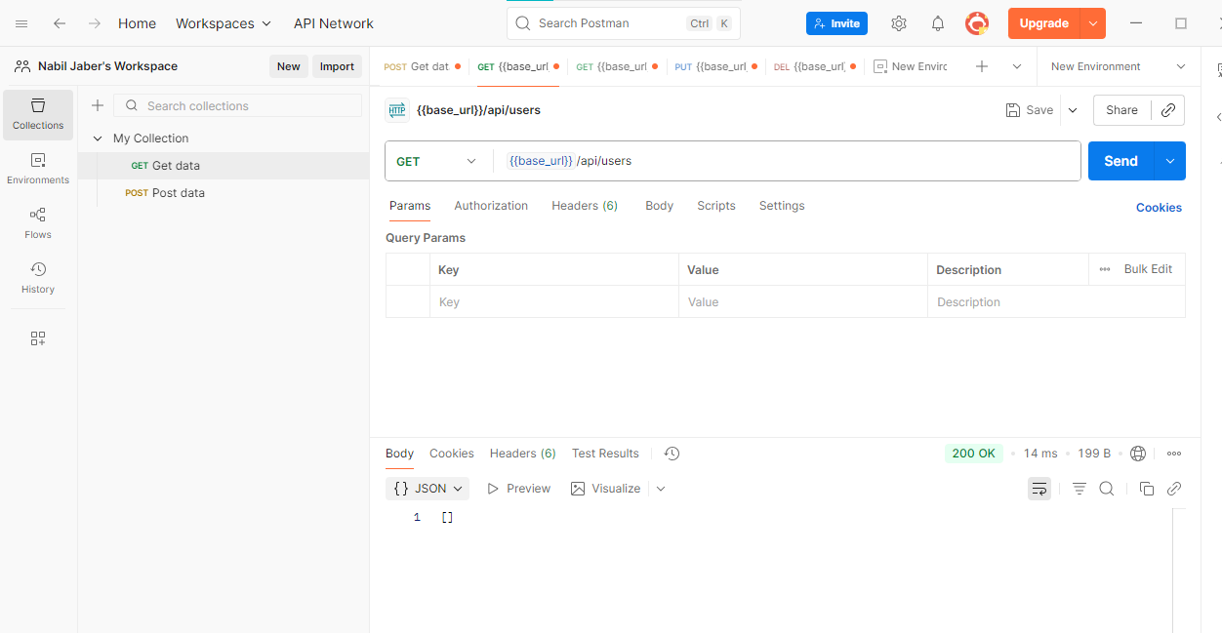

First POST request to add an entry into the database

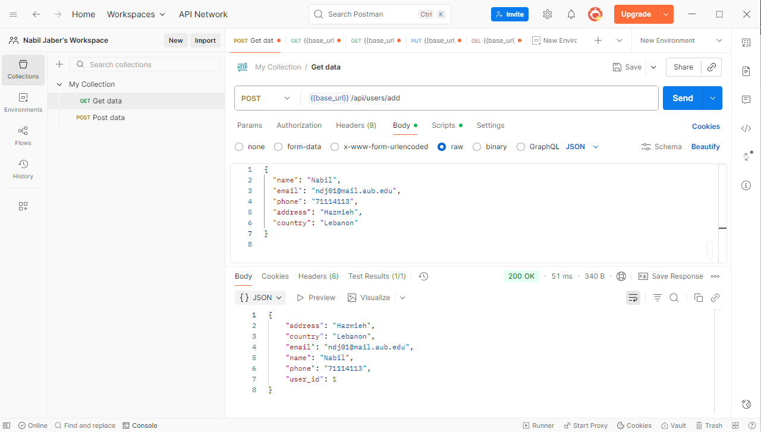

Second GET request to check if the entry has been added to the database.

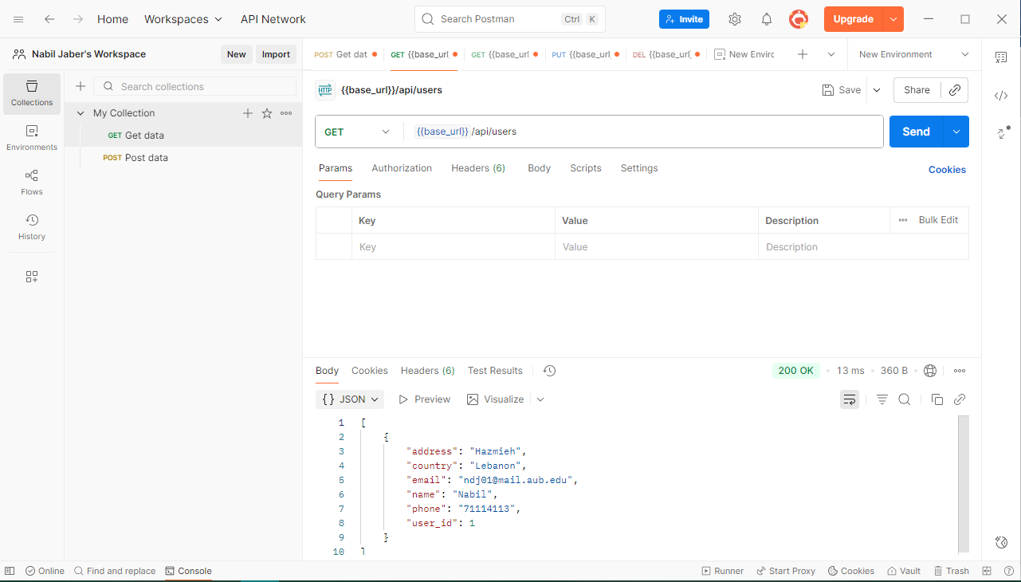

GET request to show the entry number 1.

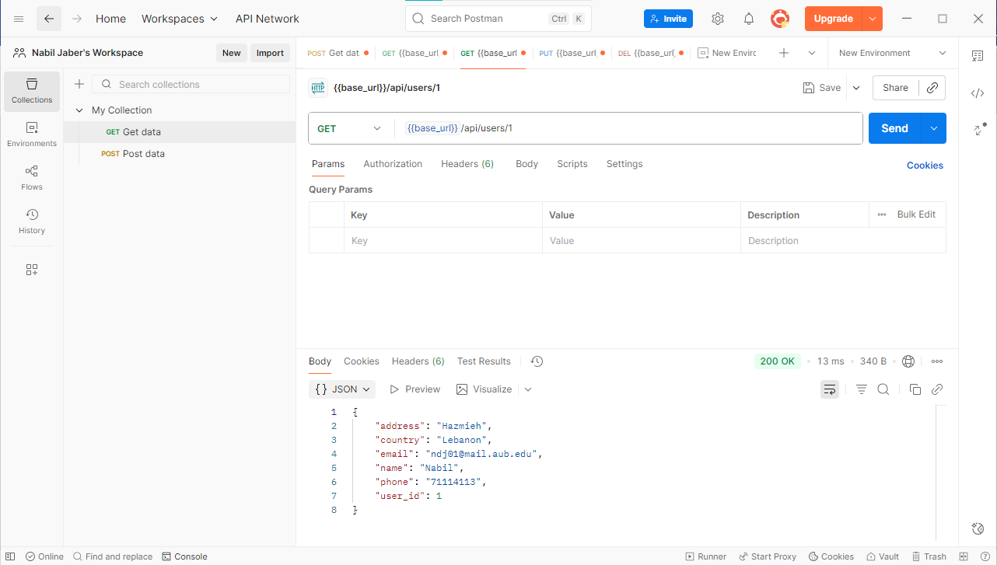

PUT request to modify our #1 entry.

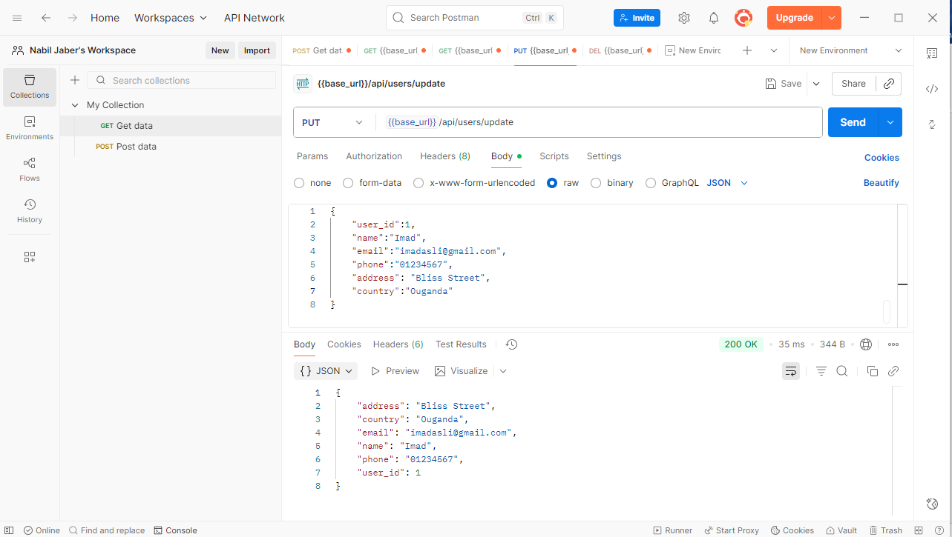

GET request to check if it’s been modified successfully

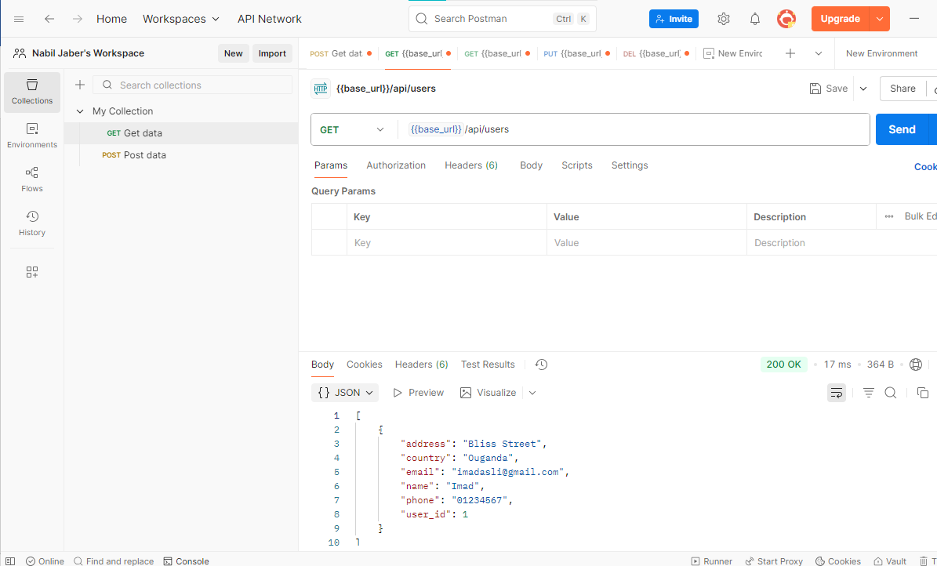

DELETE request to remove the #1 user.

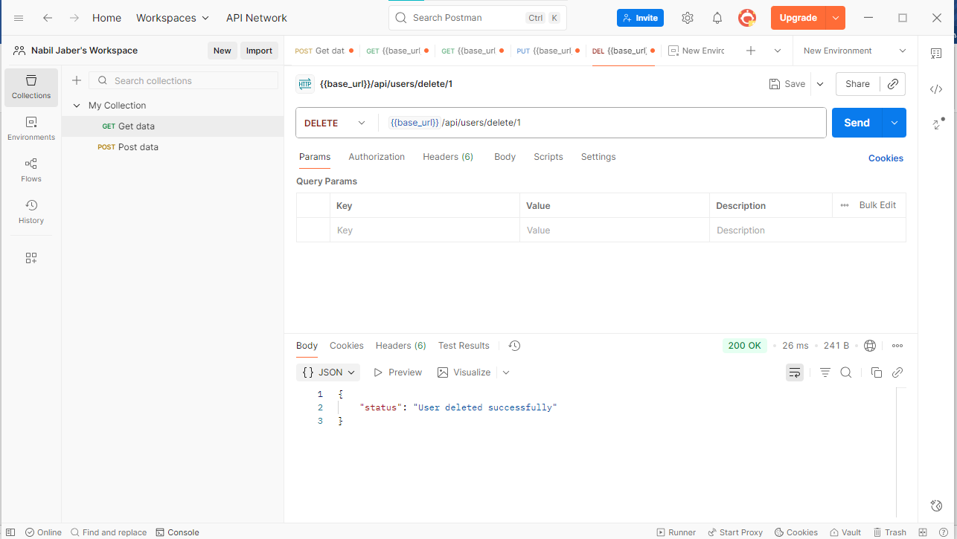

Final GET request to show that the database is now empty.

