FLINT QUIZ
Comprehensive Architecture Document

Multilingual Conversational Quiz System
Built on Microsoft Agent Framework (MAF) & Azure AI Foundry

Version 1.0
May 2026
Classification: Internal / Confidential

Table of Contents

1. Executive Summary
Flint Quiz is a production-grade, multilingual conversational quiz and examination system built on Microsoft Agent Framework (MAF) and deployed through Azure AI Foundry. The system delivers curated quiz experiences across three initial languages (English, French, and Spanish) through both text-based (Foundry Playground) and voice-based (Foundry Realtime API with WebRTC) interaction channels.
The architecture follows a single-agent, multi-channel design pattern where one MAF agent instance serves both text and voice channels with portable session state. This decision, documented in ADR-002, simplifies operational complexity while maintaining channel-specific optimizations for voice latency and text formatting.
Key architectural principles include security-first design with three layers of answer-leakage prevention, managed identity everywhere with zero connection strings in code, per-resource RBAC enforcement, deterministic question shuffling for auditability, and production-hardened observability from day one.

1.1 Document Purpose and Audience
This document serves as the authoritative architecture reference for the Flint Quiz system. It is intended for solution architects, software developers, DevOps engineers, security reviewers, and operations teams who need to understand, deploy, maintain, or extend the system.

1.2 Technology Stack Summary
Category | Technology
Runtime Language | Python 3.11+
Agent Framework | Microsoft Agent Framework (MAF) v1.x (GA 2026-04-03)
Deployment Target | Azure AI Foundry Agent Service (Hosted Agent)
State Store | Azure Cosmos DB NoSQL
Question Bank | Azure AI Search (multilingual indexing with synonyms)
Object Storage | Azure Blob Storage (authoring source for questions)
Identity | Microsoft Entra ID + User-Assigned Managed Identities
Secrets Management | Azure Key Vault (Managed Identity access only)
Configuration | Azure App Configuration (feature flags, voice mapping)
Observability | Application Insights + Foundry Tracing (thread/tool spans)
Voice Channel | Foundry Realtime API (WebRTC, streaming STT/TTS)
AI Models | Azure OpenAI: gpt-4o-mini (text), gpt-realtime (voice)
Infrastructure as Code | Azure Bicep (subscription-scoped)
CI/CD | GitHub Actions (3-tier: PR, Merge, Release)
Data Models | Pydantic v2.5+ with strict validation (extra="forbid")
Testing | pytest v8.2+ with async support, Cosmos emulator
Container Runtime | Azure Container Apps Environment
API Gateway (Optional) | Azure API Management (rate limiting, quotas)

2. High-Level Architecture Overview
The Flint Quiz system is organized into six primary modules, each with clearly defined responsibilities and bounded interfaces. The architecture follows a layered design where user interactions flow through the agent layer, are dispatched to the tool layer, which in turn communicates with the data plane. Background jobs handle operational concerns such as session cleanup, while the observability layer provides end-to-end visibility across all components.

2.1 Solution Architecture Diagram
The following diagram illustrates the complete solution architecture, showing all major components, their relationships, and the security layers that protect the system:
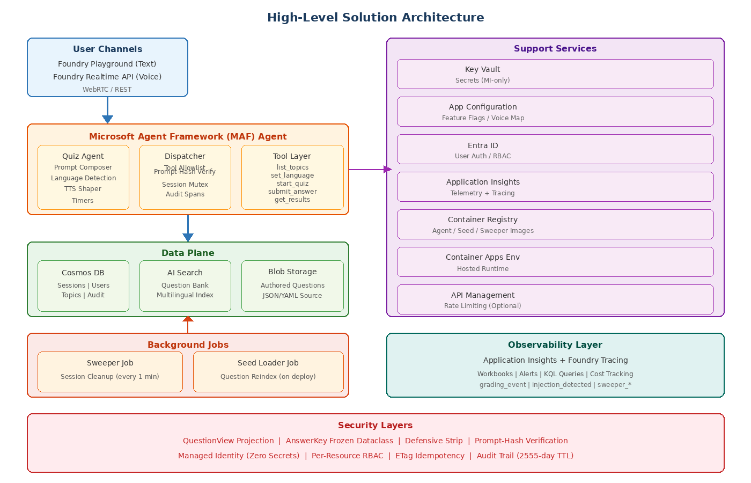

2.2 Component Roles and Responsibilities
Each component in the system has a well-defined role within the overall architecture:
Component | Role | Key Responsibilities
MAF Agent | Conversational orchestrator serving both text and voice channels through a single agent instance | Prompt composition, language detection, tool dispatch, TTS shaping, session resumption, timer enforcement
Dispatcher | Security-critical bridge between MAF runtime and tool implementations | Tool allowlist validation, prompt-hash verification, per-session mutex, audit span emission
Tool Layer | Five registered tools implementing all quiz business logic | list_topics, set_language, start_quiz, submit_answer, get_results with defensive answer stripping
Data Layer | Unified async interface to all persistent storage | Cosmos CRUD with etag idempotency, AI Search queries with QuestionView projection, shuffle persistence
Voice Module | Realtime API adapter for voice-based quiz interactions | WebRTC session management, STT/TTS pipelines, idle detection, session cap enforcement, voice selection
Seed Module | Question bank authoring pipeline and indexing | Topic reconciliation across languages, AI Search index population, Foundry Evaluations gate
Sweeper | Background cleanup job running every minute | Expire paused sessions, release stranded mutexes, emit sweeper events
Observability | End-to-end telemetry and monitoring | Typed event emission with dimension policy, Foundry tracing spans, cost tracking
Infrastructure | Bicep IaC for all Azure resources | Subscription-scoped deployment, per-resource RBAC, deployment hooks, smoke tests

2.3 Component Diagram
The following diagram shows the internal structure of each module and the dependency relationships between them:
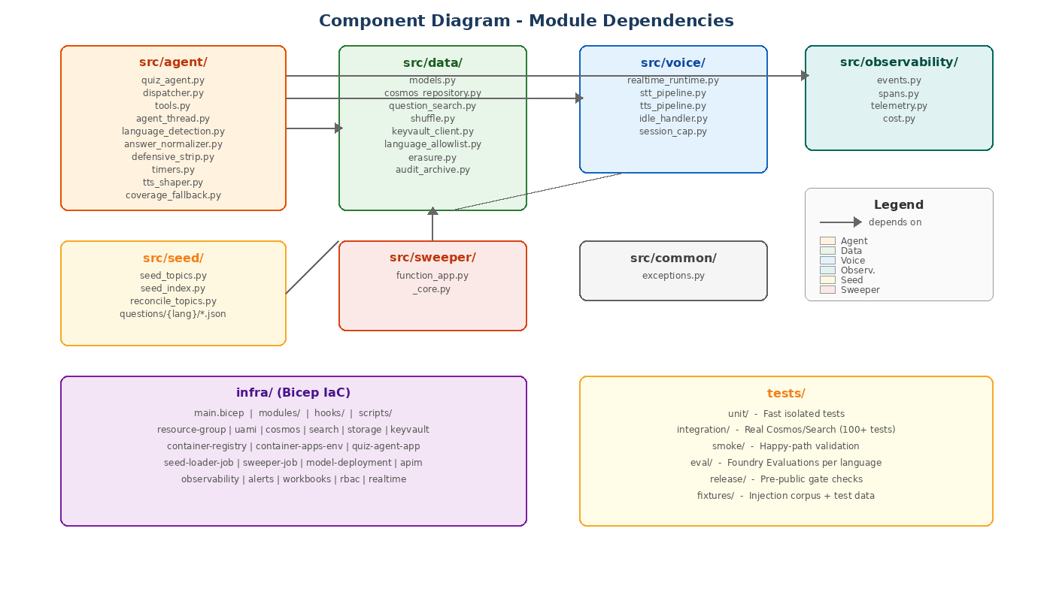

2.4 Design Principles
- Single Agent, Multiple Channels: One MAF agent instance serves both text and voice channels. Session state is portable across channels, enabling users to start a quiz in voice and finish in text (ADR-002).
- Security-First Design: Answer leakage is prevented at three layers: QuestionView projection (no correct_answer field), AnswerKey frozen dataclass (no JSON serializer), and defensive_strip() on every tool return. Prompt-hash verification prevents injection attacks.
- Multilingual by Design: The question bank stores (logical_id, language) pairs separately. Per-language Foundry Evaluations gate all publishes. Fallback language auto-selection notifies users explicitly when their preferred language is unavailable for a topic.
- Production Hardening from Day One: RBAC enforced per-resource (never RG-wide). Observability wired from boot. Audit trail immutable with 2555-day TTL. Cost budgets and alerts configured. Deterministic shuffle with persisted seed for auditability.
- Testability: Real Cosmos emulator in CI with 100+ integration tests covering idempotency, state machine transitions, timers, channel switching, and GDPR erasure. Smoke tests validate end-to-end happy paths. Per-language evaluations gate releases.

3. Detailed Module Breakdown

3.1 Agent Module (src/agent/)

3.1.1 Functional Responsibilities
The Agent module is the core runtime component responsible for managing conversational interactions with users across both text and voice channels. It initializes the MAF agent with verified prompt composition, registers exactly five tools, enforces a 600-token output cap per turn, and instruments per-turn spans for observability.

3.1.2 Internal Architecture
The agent module comprises ten source files, each with a single well-defined responsibility:
- quiz_agent.py: Factory that creates the MAF agent instance. Verifies prompt composition integrity at boot time, registers all five tools, enforces the output token cap, and initializes per-turn span instrumentation.
- dispatcher.py: Security-critical MAF-to-tool bridge. Enforces tool allowlist validation (rejects unknown tools), prompt-hash verification (prevents prompt injection), per-session mutex on (session_id, question_id) for idempotency with 60-second TTL, and audit-grade span emission for every dispatch.
- tools.py: Implements five registered tools: list_topics, set_language, start_quiz, submit_answer, and get_results. All tools use Pydantic request models with extra="forbid" for strict input validation. Answer keys are defensively stripped after every tool return.
- agent_thread.py: Manages session resumption by session_id after network disconnections. Supports channel-switch tolerance, allowing users to start in voice and finish in text.
- language_detection.py: Auto-detects language from the first user message. Falls back to the closest available language if a topic is not covered in the detected language. Emits coverage_gap events.
- answer_normalizer.py: Normalizes user answers to canonical form before grading. Handles case folding, whitespace normalization, punctuation stripping, and synonym matching.
- defensive_strip.py: Recursive strip_answer_key() function that scrubs answer keys from all tool responses. This is the third line of defense after QuestionView projection and AnswerKey frozen dataclass.
- timers.py: Server-side enforcement of per-question and per-quiz timers. The model is never trusted for time enforcement. Auto-grades unanswered questions on expiry.
- tts_shaper.py: Formats output for the voice channel. Expands numerals, handles URLs, avoids markdown and code blocks, and speaks options as full phrases rather than single letters.
- coverage_fallback.py: Suggests a fallback language when the user's topic is unavailable in their preferred language. Provides explicit notification in the fallback language.

3.1.3 Key Services and Dependencies
The Agent module depends on the Data module for Cosmos DB operations and AI Search queries, the Voice module for Realtime API integration, and the Observability module for event emission and span creation. It uses Azure App Configuration for runtime feature flags and voice mapping, and Azure Key Vault for secrets retrieval via managed identity.

3.1.4 APIs and Integrations
The agent exposes five tools to the MAF runtime, each with strictly typed Pydantic request and response models:
Tool | Input | Output
list_topics | language (optional, auto-detected) | Array of TopicDoc with id, name, description, question_count per language
set_language | language_code (en, fr, es) | Confirmation with available topics in selected language
start_quiz | topic_id, session config (optional) | SessionDoc (ACTIVE state) + first QuestionView (no correct_answer)
submit_answer | session_id, question_id, user_answer | Verdict (correct/incorrect/partial/unanswered) + next QuestionView
get_results | session_id | Final score breakdown with per-question verdicts, session status SCORED

3.1.5 Security Considerations
- Answer Leakage Prevention: Three-layer defense: QuestionView projection excludes correct_answer, AnswerKey is a frozen dataclass with no JSON serializer and masked __repr__, and defensive_strip() recursively scrubs all tool returns.
- Prompt Injection Prevention: Prompt-hash computed at boot time and verified on every dispatch. Hash mismatch halts the session immediately and emits an agent.prompt_hash_mismatch event.
- Idempotency: submit_answer uses Cosmos etag conditional writes with ifMatch. Duplicate calls return existing state without re-grading. Bounded to 1 retry maximum.
- Tool Allowlist: The dispatcher rejects any tool not in the registered set of five. Unknown tool invocations are logged and blocked.

3.2 Data Module (src/data/)

3.2.1 Functional Responsibilities
The Data module provides the unified data access layer for all persistent storage operations. It defines domain models using Pydantic v2.5+ with strict validation, implements the Cosmos DB repository with partition-aware reads and etag-based idempotent writes, wraps AI Search for question retrieval with QuestionView projection, and manages deterministic question shuffling with persisted seeds.

3.2.2 Internal Architecture
- models.py: Domain model definitions including Question (source-of-truth shape with correct_answer for authoring), QuestionView (LLM-safe projection without correct_answer, frozen, extra="forbid"), AnswerKey (frozen dataclass, never JSON-serializable, masked __repr__), SessionDoc (state machine: ACTIVE, PAUSED, EXPIRED, COMPLETED, SCORED), UserDoc, TopicDoc, and AuditEvent.
- cosmos_repository.py: Single async interface to all Cosmos operations. Partition-aware reads only (tool path never cross-partition queries). Idempotent submit_answer via etag + if_match with 1 retry bound. State-machine validation rejects illegal transitions with SessionStateError. Session TTL applied (30 days per ADR-006).
- question_search.py: AI Search client wrapper that fetches QuestionView projections with deliberately allowlisted fields only. Supports synonym expansion for English, French, and Spanish queries.
- shuffle.py: Deterministic shuffle via seed = hash(session_id). Both the seed and the shuffled ID list are persisted in the session row for full auditability.
- erasure.py / erasure_cli.py: GDPR right-to-be-forgotten implementation. Pseudonymizes user data in the audit container (server-only storage) and emits a USER_ERASED event.
- audit_archive.py: Long-retention archive for the audit trail with 2555-day TTL per ADR-006. Records are immutable after initial write.

3.2.3 Data Flows
All data flows through the tool layer, never directly from the agent to data stores. Write operations use optimistic concurrency control via Cosmos DB etags. The question search path returns only QuestionView projections, ensuring the correct_answer field never reaches the agent or user. Audit events are emitted synchronously with the grading operation and archived to the long-retention container.

3.2.4 Scalability and Resiliency
- Cosmos DB: Partition-aware reads avoid cross-partition fan-out. Session documents are partitioned by session_id for even distribution. TTL-based automatic cleanup reduces storage costs.
- AI Search: Faceted indexing by topic and language enables efficient filtered queries. Synonym expansion improves recall without sacrificing precision.
- Idempotent Writes: Etag-based conditional writes ensure that concurrent submit_answer calls for the same question serialize correctly, with the first write winning and subsequent calls returning the existing state.

3.3 Voice Module (src/voice/)

3.3.1 Functional Responsibilities
The Voice module adapts the Foundry Realtime API for voice-based quiz interactions. It manages WebRTC sessions, implements speech-to-text and text-to-speech pipelines, handles idle detection with configurable timeouts, enforces maximum session duration caps to prevent runaway billing, and selects per-language voice profiles from App Configuration.

3.3.2 Internal Architecture
- realtime_runtime.py: WebRTC/Realtime SDK adapter. Manages per-language voice selection from App Configuration (default mapping: alloy for English, shimmer for French, verse for Spanish). Propagates the "voice" channel tag in all dispatcher calls. Supports channel-switch tolerance for session resumption across channels.
- stt_pipeline.py: Speech-to-text processing with configurable confidence floor (default 0.5). Low-confidence transcriptions trigger re-prompt rather than incorrect grading.
- tts_pipeline.py: Text-to-speech processing with per-language voice selection. Integrates with tts_shaper for voice-friendly formatting.
- idle_handler.py: Auto-disconnect on idle with configurable timeout (default 30 seconds). Sends a warning prompt before disconnecting.
- session_cap.py: Maximum session length enforcement (default 20 minutes). Prevents runaway billing on the Realtime API, which is billed per audio minute.

3.3.3 Security Considerations
Voice sessions carry the same security properties as text sessions. The "voice" channel tag is propagated through the dispatcher to ensure audit events correctly attribute the interaction channel. Session caps prevent denial-of-wallet attacks through prolonged voice sessions.

3.4 Seed Module (src/seed/)

3.4.1 Functional Responsibilities
The Seed module manages the question bank authoring pipeline. It loads topic catalogs, indexes authored question files from Blob Storage into AI Search, reconciles topic consistency across languages, and gates question publication behind Foundry Evaluations per language.

3.4.2 Internal Architecture
- seed_topics.py: Loads the topic catalog from Cosmos DB. Topics define available quiz categories with metadata per language.
- seed_index.py: Indexes questions from authored JSON files into AI Search. Applies the full-text search schema with facets by topic and language, and configures synonym expansion maps.
- reconcile_topics.py: Validates topic consistency across languages. Ensures that topic IDs referenced in questions exist in the topic catalog and that question logical_ids are unique within each language.
Questions are authored as JSON files following the Question model schema, stored in the questions/{lang}/{topic}/{logical_id}.json directory structure.

3.5 Sweeper Module (src/sweeper/)

3.5.1 Functional Responsibilities
The Sweeper is a scheduled Container Apps Job that runs every minute to perform operational cleanup. It expires paused sessions that have exceeded their TTL, releases stranded dispatcher mutexes, and emits sweeper events for operational visibility.

3.5.2 Internal Architecture
- function_app.py: Entry point for the scheduled job. Orchestrates cleanup operations in sequence.
- _core.py: Core cleanup logic including conditional session expiration (only sessions past TTL), stranded mutex release, and event emission.
The sweeper reuses the agent identity (Cosmos Data Contributor on sessions container only), following the principle of least privilege. It emits sweeper_stranded_released, sweeper_expired_swept, and sweeper_paused_swept events for operational monitoring.

3.6 Observability Module (src/observability/)

3.6.1 Functional Responsibilities
The Observability module provides end-to-end telemetry across all system components. It defines typed event emitters with a strict dimension policy enforced at emit time, integrates with Foundry tracing for thread and tool spans, and tracks per-operation costs.

3.6.2 Internal Architecture
- events.py: Typed event emitters with dimension policy enforcement. The grading_event carries: session_id, question_id, user_id, language, received, verdict, channel, score_delta, latency_ms, and timestamp. Forbidden dimensions (correct_answer, answer_key, expected, received_raw) are never emitted, preventing answer leakage through telemetry.
- spans.py: Foundry tracing integration creating thread-level and tool-level spans. Each span carries channel and language dimensions for cross-cutting analysis.
- telemetry.py: Application Insights sink wiring for structured log ingestion.
- cost.py: Per-operation cost tracking including token count, model call costs, and cumulative session costs.

3.6.3 Custom Events Taxonomy
Event | Description
grading_event | Emitted on every answer submission with verdict, score delta, and latency
injection_detected | Prompt-hash mismatch or suspicious input pattern detected
coverage_gap | User requested topic/language combination not available
refusal_loop | Agent entered refusal loop (repeated inability to fulfill request)
prompt_hash_mismatch | Computed prompt hash differs from boot-time hash (security event)
auth_mismatch | Identity verification discrepancy detected
user_erased | GDPR erasure completed for a user (pseudonymization applied)
sweeper_expired_swept | Sweeper expired a session past its TTL
sweeper_stranded_released | Sweeper released a stranded dispatcher mutex
sweeper_paused_swept | Sweeper cleaned up a paused session

3.6.4 Monitoring and Alerting
The system includes pre-configured Azure Monitor workbooks and alert rules:
- Grading Correctness Workbook: Per-language correctness rates with trend analysis and baseline comparison.
- Cost Tracking Workbook: Token consumption, model call costs, and per-session cost breakdown.
- Security Governance Workbook: Injection attempts, prompt-hash mismatches, auth anomalies.
- Voice Latency Workbook: End-to-end voice latency including STT, tool execution, and TTS.
Alert rules fire on per-language correctness drops below baseline, P95 latency threshold breaches, voice latency exceeding 300ms, and governance events (injection, refusal loops, auth mismatches).

4. Workflow and Sequence Diagrams

4.1 Quiz Session Workflow
The following diagram illustrates the complete lifecycle of a quiz session, from user channel entry through language detection, topic selection, quiz progression, and final scoring. It also shows the session state machine that governs valid transitions:
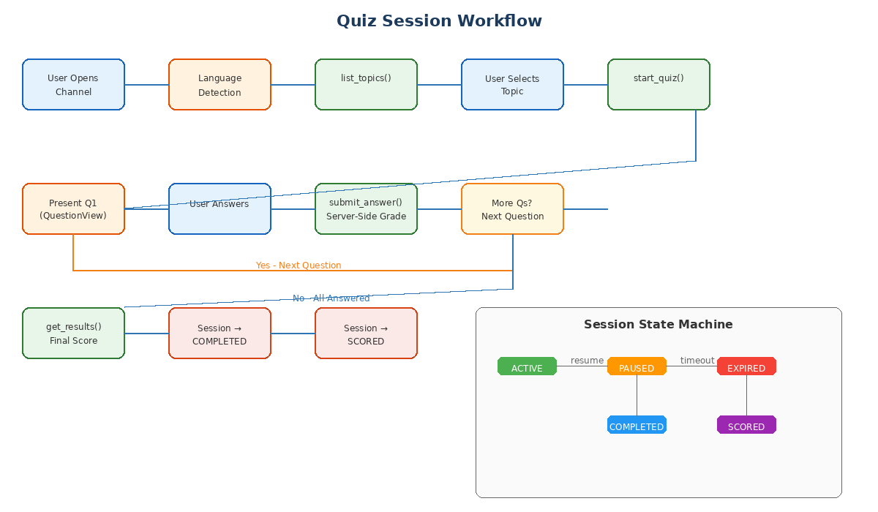

4.2 Answer Submission Sequence
The answer submission flow is the most security-critical path in the system. This sequence diagram shows how an answer traverses from user input through the dispatcher (with prompt-hash verification and mutex acquisition), to the tool layer (with server-side grading and defensive stripping), and back to the user:
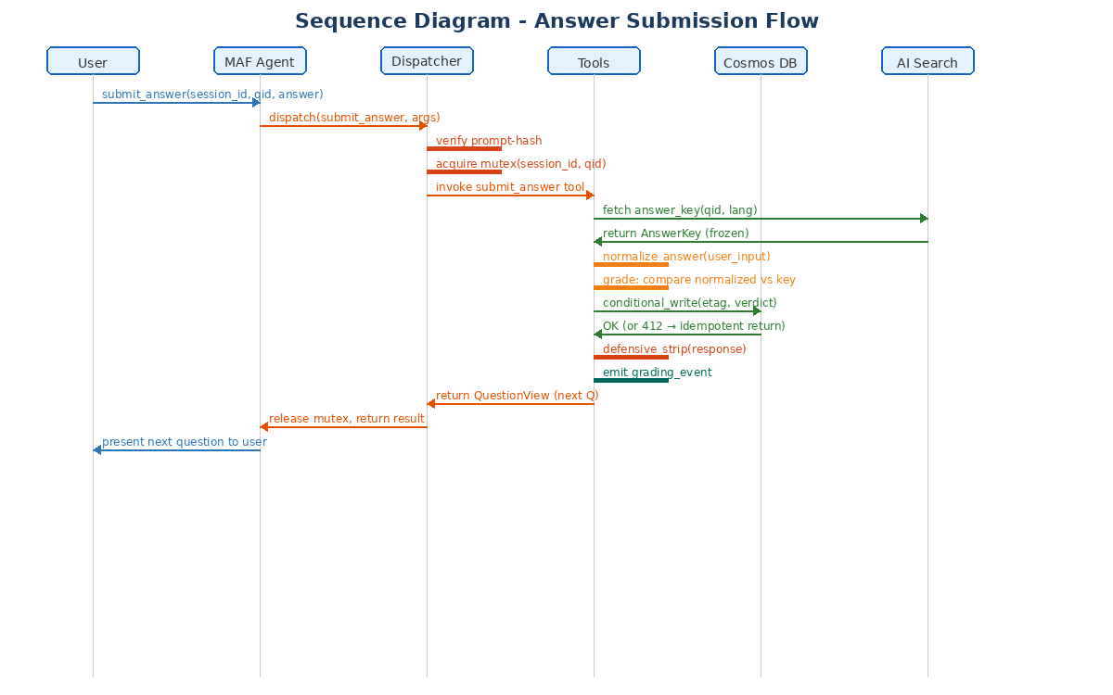
Key security checkpoints in this flow include prompt-hash verification (step 3), mutex acquisition to prevent concurrent grading of the same question (step 4), AnswerKey retrieval via frozen dataclass (step 6), Cosmos etag conditional write for idempotency (step 10), and defensive stripping of the response before returning to the agent (step 12).

4.3 Data Flow Diagram
This diagram shows both the authoring/indexing data flow (how questions move from authored JSON files through Blob Storage, the Seed Loader, and into AI Search) and the runtime data flow (how user interactions flow through the agent, dispatcher, and tool layers to the various data stores):
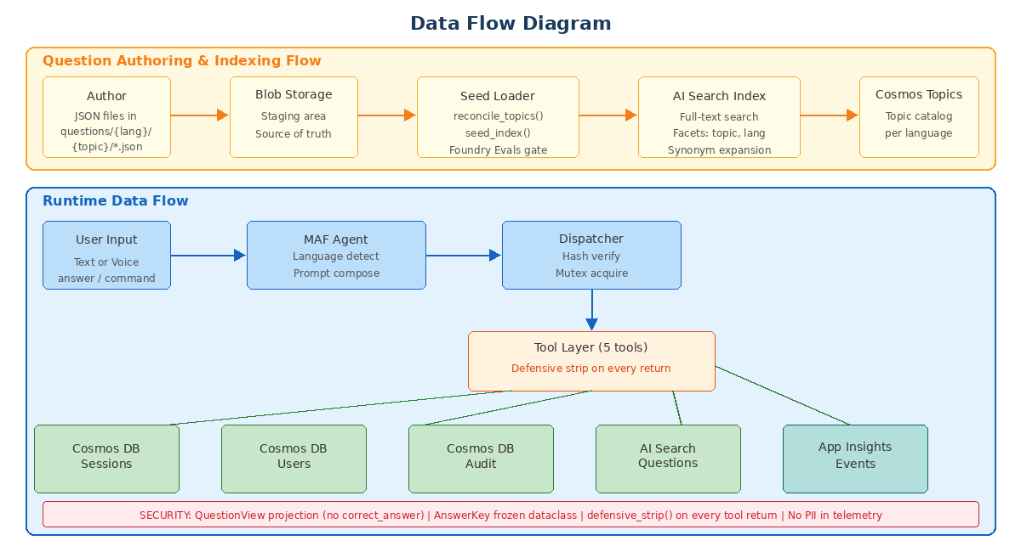

4.4 Session State Machine
Sessions follow a strict state machine with the following valid transitions:
From State | To State | Trigger | Notes
(new) | ACTIVE | start_quiz() called | Session created with shuffled question order
ACTIVE | PAUSED | Network disconnection or explicit pause | Resumable via agent_thread.py
PAUSED | ACTIVE | Session resumed (any channel) | Channel-switch tolerance
ACTIVE | EXPIRED | Per-quiz timer exceeded | Unanswered questions auto-graded
PAUSED | EXPIRED | Sweeper TTL exceeded | Cleaned up by sweeper job
ACTIVE | COMPLETED | All questions answered | Transitions to SCORED after get_results()
COMPLETED | SCORED | get_results() called | Final score computed and persisted
EXPIRED | SCORED | get_results() called | Partial score for answered questions
Any transition not listed above raises a SessionStateError and is rejected by the Cosmos repository. This enforcement is tested in the integration test suite (test_state_machine.py).

5. Deployment Architecture

5.1 Azure Deployment Topology
The following diagram shows the complete Azure deployment architecture, including all provisioned resources, their relationships, identity assignments, and the CI/CD pipeline:
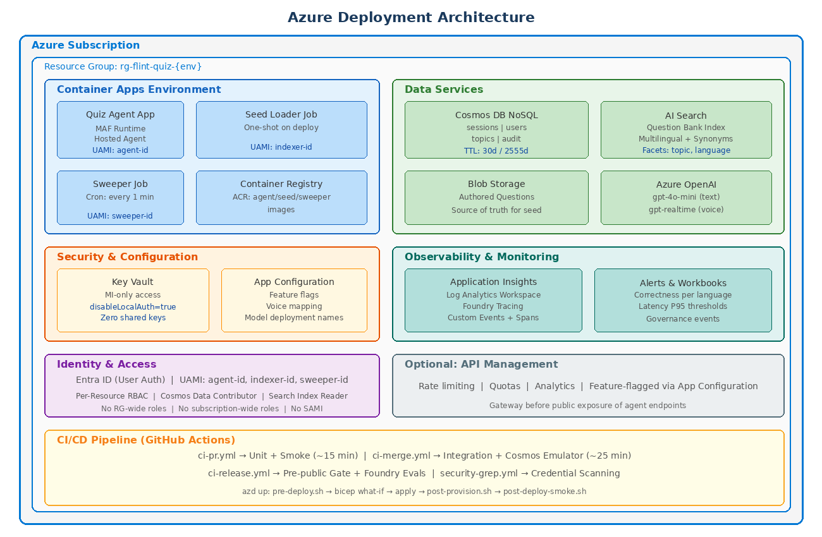

5.2 Infrastructure Topology
All infrastructure is defined as Bicep templates in the infra/ directory, with a subscription-scoped entry point (main.bicep) that composes reusable modules in dependency order. The deployment creates a single resource group per environment containing all required Azure services.

5.2.1 Resource Inventory
Resource | Azure Service | SKU/Tier | Purpose
rg-flint-quiz-{env} | Resource Group | N/A | Environment boundary
cosmos-flint-{env} | Cosmos DB NoSQL | Serverless / Provisioned | Session state, users, topics, audit
search-flint-{env} | AI Search | Basic / Standard | Question bank index
st-flint-{env} | Storage Account | Standard LRS | Authored questions (Blob)
kv-flint-{env} | Key Vault | Standard | Secrets (MI-only)
appconfig-flint-{env} | App Configuration | Standard | Feature flags, voice mapping
acr-flint-{env} | Container Registry | Basic / Standard | Container images
cae-flint-{env} | Container Apps Env | Consumption | Agent + jobs runtime
ai-flint-{env} | Azure OpenAI | S0 | LLM inference
appi-flint-{env} | Application Insights | Standard | Telemetry + tracing
law-flint-{env} | Log Analytics | Per-GB | Log retention + queries
apim-flint-{env} (optional) | API Management | Consumption / Developer | Rate limiting, quotas

5.2.2 Identity Architecture
The system uses three User-Assigned Managed Identities (UAMI) following the principle of least privilege:
Identity | Assigned To | RBAC Roles (Per-Resource)
agent-id | Quiz Agent Container App | Cosmos DB Data Contributor (sessions, users, topics), AI Search Index Reader, Key Vault Secrets User, App Config Data Reader
indexer-id | Seed Loader Job | AI Search Index Contributor, Cosmos DB Data Contributor (topics), Storage Blob Data Reader
sweeper-id | Sweeper Job | Cosmos DB Data Contributor (sessions only)
All roles are assigned per-resource, never at the resource group or subscription level. No System-Assigned Managed Identities (SAMI) are used. Local authentication is disabled on all services (disableLocalAuth=true, allowSharedKeyAccess=false).

5.3 CI/CD Pipeline Architecture
The CI/CD pipeline is implemented as GitHub Actions workflows organized in three tiers:
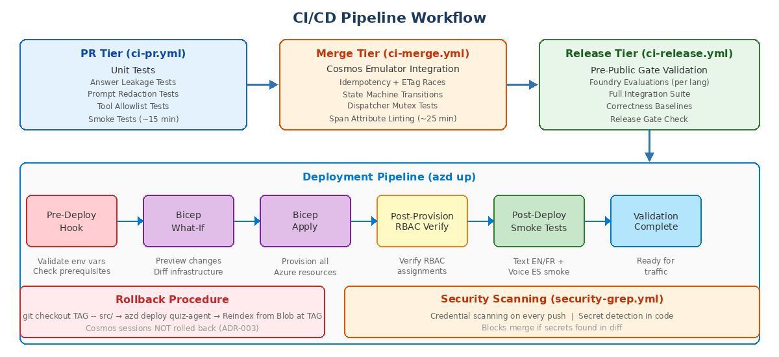

5.3.1 Pipeline Tiers
Tier | Workflow | Trigger | Duration
PR | ci-pr.yml | Pull request opened/updated | ~15 minutes
Merge | ci-merge.yml | PR merged to main | ~25 minutes
Release | ci-release.yml | Git tag pushed | ~45 minutes
Security | security-grep.yml | Every push | ~2 minutes

6. Security Architecture

6.1 Threat Model Overview
The Flint Quiz system addresses several key threat vectors specific to AI-powered quiz applications. The primary threat is answer leakage, where correct answers could be exposed to users through the LLM response, telemetry data, or API responses. Secondary threats include prompt injection attacks, session tampering, and data exfiltration.

6.2 Answer Leakage Prevention (SEC-001/002/005)
Answer leakage prevention is implemented as a defense-in-depth strategy with three independent layers:
- QuestionView Projection (First Layer): The QuestionView Pydantic model deliberately excludes the correct_answer field and is configured with extra="forbid" to reject any unexpected fields. This ensures the LLM never sees the correct answer in its context.
- AnswerKey Frozen Dataclass (Second Layer): The AnswerKey is implemented as a frozen Python dataclass with no JSON serializer and a masked __repr__. Even if the AnswerKey object is inadvertently included in a response, it cannot be serialized to text.
- Defensive Strip (Third Layer): The defensive_strip() function in defensive_strip.py recursively traverses every tool response and removes any field containing answer-related keywords. This catches edge cases that the first two layers might miss.

6.3 Prompt Injection Prevention (SEC-003)
A SHA-256 hash of the composed prompt is computed at agent boot time and stored in memory. On every tool dispatch, the dispatcher recomputes the hash and compares it against the stored value. Any mismatch immediately halts the session, emits a prompt_hash_mismatch security event, and returns an error to the user. The injection corpus in tests/fixtures/injection_corpus.yaml validates this defense against known attack patterns.

6.4 Idempotency and Race Conditions (SEC-006, NFR-002)
The submit_answer tool uses Cosmos DB etag conditional writes (ifMatch) to ensure that concurrent submissions for the same question are serialized correctly. The first write wins, and subsequent calls return the existing verdict without re-grading. This is bounded to 1 retry maximum; beyond that, the conflict is surfaced to the caller. The per-session mutex in the dispatcher provides an additional layer of protection with a 60-second TTL that self-heals stuck entries.

6.5 Identity and Access Control (SEC-004/007/013)
All service-to-service communication uses User-Assigned Managed Identities. Zero connection strings exist in code or configuration. Local authentication is disabled on all Azure services. RBAC roles are assigned per-resource (never at the resource group or subscription level). Entra ID provides user authentication through the Foundry Playground.

6.6 Data Protection and Compliance
- Audit Trail: Immutable audit events with 2555-day TTL (approximately 7 years) for compliance requirements.
- GDPR Right-to-Erasure: The erasure module pseudonymizes user data in the audit container and emits USER_ERASED events. The erasure CLI provides operational tooling for data protection officers.
- No PII in Telemetry: The grading_event dimension policy explicitly forbids correct_answer, answer_key, expected, and received_raw from appearing in telemetry. This is validated by test_no_pii_in_telemetry.py.
- Session TTL: Active sessions expire after 30 days (ADR-006). The sweeper job enforces this by cleaning up expired sessions.

7. Deployment Guide: New Azure Tenant
This section provides a complete guide for deploying the Flint Quiz system into a new Azure tenant. It covers all prerequisites, provisioning steps, configuration, verification, and troubleshooting procedures.

7.1 Prerequisite Tools and Software
Tool | Minimum Version | Purpose
Azure CLI (az) | 2.60+ | Azure resource management and authentication
Azure Developer CLI (azd) | 1.9+ | Template-based deployment orchestration
Python | 3.11+ | Agent runtime, seed loader, sweeper, and tests
Docker | 24.0+ | Container image builds (local) and Cosmos emulator (tests)
Git | 2.40+ | Source code management
Node.js (optional) | 18+ | Only for infrastructure tooling scripts
Make | 4.0+ | Operator surface for deployment commands

7.2 Required Azure Services and Permissions

7.2.1 Subscription Requirements
- An active Azure subscription with billing enabled.
- The subscription must have the following resource providers registered: Microsoft.DocumentDB, Microsoft.Search, Microsoft.Storage, Microsoft.KeyVault, Microsoft.AppConfiguration, Microsoft.ContainerRegistry, Microsoft.App, Microsoft.CognitiveServices, Microsoft.Insights, Microsoft.OperationalInsights.
- Sufficient quota for Azure OpenAI models (gpt-4o-mini, gpt-realtime) in the target region.

7.2.2 Deployer Permissions
The person or service principal performing the deployment needs the following permissions:
- Contributor role on the target subscription (for resource creation).
- User Access Administrator role on the target subscription (for RBAC role assignments).
- Application Administrator role in Entra ID (for managed identity creation).
For CI/CD-based deployment, a service principal with these roles should be configured as a GitHub Actions secret.

7.3 Environment Preparation

7.3.1 Clone the Repository
Clone the Flint Quiz repository and install Python dependencies:
git clone <repository-url> flint-quiz && cd flint-quiz
python -m venv .venv && source .venv/bin/activate
pip install -e ".[dev]"

7.3.2 Authenticate with Azure
az login --tenant <YOUR_TENANT_ID>
az account set --subscription <YOUR_SUBSCRIPTION_ID>
azd auth login

7.3.3 Initialize the Environment
Create a new AZD environment for your tenant:
azd env new <env-name> # e.g., azd env new prod-contoso
Configure the required environment variables:
azd env set AZURE_SUBSCRIPTION_ID <your-subscription-id>
azd env set AZURE_LOCATION <your-region> # e.g., westeurope
azd env set AZURE_RESOURCE_GROUP rg-flint-quiz-<env>

7.4 Infrastructure Provisioning

7.4.1 Pre-Deployment Validation
Run the pre-deployment checks to validate your environment:
make pre-deploy
This executes infra/hooks/pre-deploy.sh, which validates that all required environment variables are set, prerequisite tools are installed, and Azure provider registrations are in place.

7.4.2 Provision Infrastructure
Deploy all Azure resources using the Azure Developer CLI:
azd up
This command executes the following steps in sequence:
- Pre-deploy hook validates prerequisites and parameters.
- Bicep what-if preview shows planned resource changes.
- Bicep apply provisions all Azure resources (Cosmos DB, AI Search, Storage, Key Vault, App Configuration, Container Registry, Container Apps, OpenAI, Application Insights, Log Analytics).
- Container images are built and pushed to ACR (remote build).
- Container Apps are deployed with the latest images.
- Post-provision hook verifies RBAC assignments.
- Post-deploy smoke tests validate the deployment.

7.4.3 Parameter Customization
For production deployments, create a parameter file at infra/main.parameters.prod.json:
cp infra/main.parameters.dev.json infra/main.parameters.prod.json
Key parameters to customize:
Parameter | Default | Description
environmentName | dev | Environment identifier (dev, qa, prod)
location | westeurope | Primary Azure region
supportedLanguages | ["en","fr","es"] | Languages to enable
modelDeploymentName | gpt-4o-mini | OpenAI model deployment name
cosmosSessionsTtlDays | 30 | Session TTL in days
voiceMaxSessionMinutes | 20 | Max voice session duration
voiceIdleSeconds | 30 | Voice idle disconnect timeout

7.5 CI/CD Configuration

7.5.1 GitHub Actions Setup
Configure the following GitHub repository secrets for automated deployment:
Secret Name | Value
AZURE_CREDENTIALS | Service principal credentials JSON (az ad sp create-for-rbac output)
AZURE_SUBSCRIPTION_ID | Target subscription ID
AZURE_TENANT_ID | Entra ID tenant ID
AZD_ENV_NAME | Environment name matching your azd env

7.5.2 Branch Protection Rules
Configure branch protection on the main branch to require all three CI pipeline tiers to pass before merge. The ci-pr.yml workflow should be required for all pull requests. The ci-merge.yml workflow runs automatically after merge. The ci-release.yml workflow triggers on version tag pushes (v*.*.* pattern).

7.6 Secrets and Configuration Management

7.6.1 Key Vault Initialization
After provisioning, Key Vault is empty. Secrets are populated automatically by the Bicep templates for service-to-service communication (via managed identity, no secrets needed). For any additional secrets required by custom extensions:
az keyvault secret set --vault-name kv-flint-<env> --name <secret-name> --value <secret-value>

7.6.2 App Configuration Setup
App Configuration is populated by the Bicep template with default values. To customize runtime configuration:
az appconfig kv set --name appconfig-flint-<env> --key model:deploymentName --value gpt-4o-mini
az appconfig kv set --name appconfig-flint-<env> --key voices:en --value alloy
az appconfig kv set --name appconfig-flint-<env> --key voices:fr --value shimmer
az appconfig kv set --name appconfig-flint-<env> --key voices:es --value verse

7.7 Verification and Validation

7.7.1 Post-Provisioning RBAC Verification
make rbac
This runs infra/hooks/post-provision-rbac.sh which verifies that all three managed identities (agent-id, indexer-id, sweeper-id) have exactly the RBAC roles specified in the architecture, no more and no less.

7.7.2 Smoke Test Matrix
make smoke
The smoke test matrix validates the following scenarios:
Test | Channel | Language | Validates
test_text_en.py | Text | English | Full quiz flow, grading, scoring
test_text_fr.py | Text | French | Multilingual support, prompt composition
test_voice_es.py | Voice | Spanish | Realtime API, STT/TTS, voice selection

7.7.3 End-to-End Validation
After smoke tests pass, perform manual validation:
- Open the Foundry Playground and start a text-based quiz in English.
- Complete the quiz and verify the final score is computed correctly.
- Start a voice-based quiz in Spanish and verify STT/TTS functionality.
- Verify that Application Insights is receiving grading_event telemetry.
- Check Azure Monitor workbooks for initial data population.
- Verify the sweeper job is running (check Container Apps job logs).

7.8 Post-Deployment Retention Verification
make retention-check
This runs infra/scripts/post-deploy-retention-check.sh which verifies that Cosmos DB TTL policies are correctly applied: 30-day TTL on the sessions container and 2555-day TTL on the audit container.

7.9 Rollback and Recovery Procedures

7.9.1 Application Rollback
To roll back the agent application to a previous version:
make rollback TAG=v1.2.3
This performs the following steps:
- Checks out the source code at the specified tag: git checkout TAG -- src/
- Redeploys the agent container: azd deploy quiz-agent
- Rebuilds the AI Search index from the Blob Storage source at the tag version.
- Runs smoke tests to validate the rollback.
Important: Cosmos DB session data is NOT rolled back (per ADR-003). Existing sessions continue with their current state, and the rolled-back agent handles them gracefully.

7.9.2 Infrastructure Rollback
For infrastructure rollback, the Bicep templates are idempotent. Redeploy from the previous known-good commit:
git checkout <known-good-commit> -- infra/
azd up

7.9.3 Data Recovery
Cosmos DB point-in-time restore is available for the sessions and users containers. Azure AI Search indexes can be fully rebuilt from the Blob Storage source using:
python -m src.seed.reconcile_topics && python -m src.seed.seed_index

7.10 Common Deployment Issues and Troubleshooting
Issue | Likely Cause | Resolution
azd up fails at RBAC step | Deployer lacks User Access Administrator role | Grant User Access Administrator on the subscription to the deployer
Agent fails to start (prompt hash) | Prompt YAML files modified without updating MANIFEST.json | Run prompt composition verification: python -m src.agent.prompts.compose --verify
AI Search returns empty results | Seed loader job did not run or failed | Check seed-loader job logs. Re-run: python -m src.seed.seed_index
Voice sessions fail to connect | OpenAI gpt-realtime model not deployed or quota exhausted | Verify model deployment: az cognitiveservices account deployment list
Cosmos 412 Precondition Failed | Normal idempotency behavior on concurrent writes | No action needed. Idempotent retry returns existing state
Sweeper not running | Container Apps Job schedule misconfigured | Verify cron expression in sweeper-job.bicep. Check CAE job logs
Missing telemetry in App Insights | Application Insights connection string not set | Verify observability.bicep output. Check APPLICATIONINSIGHTS_CONNECTION_STRING env var
RBAC verification fails post-deploy | Role propagation delay (Azure eventual consistency) | Wait 5 minutes and retry: make rbac. Azure RBAC can take up to 5 min to propagate
Resource provider not registered | New subscription without provider registration | Register manually: az provider register --namespace Microsoft.DocumentDB (repeat for each provider)
Container image build fails | ACR not accessible or Docker not configured | Verify ACR login: az acr login --name acr-flint-<env>. Check Docker daemon status

8. Configuration and Environment Management

8.1 Environment Strategy
The system supports three environments (dev, qa, prod) with separate Azure subscriptions and Foundry projects per environment. The environment name parameterizes all resource names, ensuring complete isolation between environments.
Env | Region | Purpose | Access
dev | West Europe | Development and local testing | Development team
qa | West Europe | Integration testing and staging | QA team + CI/CD
prod | West Europe (primary) / North Europe (DR) | Production workload | Operations team + CI/CD

8.2 Runtime Configuration (App Configuration)
Runtime configuration is managed through Azure App Configuration, allowing changes without redeployment:
Key | Default Value | Description
model:deploymentName | gpt-4o-mini | Agent reads at runtime; flip model without redeploy
features:apim | false | Enable/disable API Management gateway
voices:en | alloy | TTS voice for English
voices:fr | shimmer | TTS voice for French
voices:es | verse | TTS voice for Spanish
session-cap-minutes | 20 | Maximum voice session length in minutes
idle-reprompt-seconds | 15 | Seconds before idle warning prompt
idle-close-seconds | 30 | Seconds before idle disconnect
stt-confidence-floor | 0.5 | Minimum STT confidence for accepted transcription

8.3 Secrets Management
All secrets are stored in Azure Key Vault with Managed Identity access only. No connection strings, account keys, or shared secrets exist in code, configuration files, or environment variables. The security-grep.yml CI workflow scans every push for accidentally committed credentials and blocks the merge if any are found.

9. Architecture Decision Records
The following Architecture Decision Records (ADRs) document the key design decisions made during the system architecture. Each ADR captures the context, decision, and consequences of a significant architectural choice.
ADR | Title | Summary
001 | Use Microsoft Agent Framework | MAF chosen as strategic successor to retiring Prompt Flow. Provides hosted agent runtime, Foundry integration, built-in tool dispatch, and Realtime API support. LangGraph and Semantic Kernel evaluated but lacked equivalent Foundry integration.
002 | Single Agent Architecture | Single MAF agent serves both text and voice channels. Multi-agent pattern rejected to reduce operational complexity, simplify session state management, and avoid inter-agent coordination overhead for a bounded-scope quiz application.
003 | Cosmos DB for Session State | Cosmos DB NoSQL chosen for session persistence over in-memory state. Enables session resumption after disconnects, channel switching, and auditable state machine transitions. Partition key on session_id ensures even distribution.
004 | AI Search for Question Bank | Azure AI Search chosen over embedding-based vector search. Curated question bank benefits from full-text search with synonym expansion rather than semantic similarity. Faceted indexing by topic and language enables efficient filtered queries.
005 | Tool-Boundary Answer Leakage Prevention | Answer leakage prevented at the tool boundary through three layers (QuestionView projection, AnswerKey frozen dataclass, defensive strip) rather than prompt-based prevention. Tool boundary provides deterministic security guarantees.
006 | Retention Policy | 30-day TTL on active sessions (sufficient for quiz completion). 2555-day TTL on audit trail (approximately 7 years for compliance). GDPR erasure pseudonymizes rather than deletes audit records to maintain trail integrity.

10. Appendices

10.1 Specification Documents Reference
Spec | Title | Scope
001 | Product Requirements | Functional requirements, non-functional requirements, risks, and constraints
002 | System Architecture | High-level system design and component relationships
003 | Data Contracts | API request/response shapes and data model definitions
004 | Agent Behavior | Conversation flow rules, refusal behaviors, and language handling
005 | Security Model | Threat model, mitigation strategies, and security controls
006 | Testing Strategy | Test tier definitions, coverage targets, and gate criteria
007 | Operational Runbook | Incident response procedures, operational playbooks
008 | API Contracts (Authoritative) | Tool signatures, data models, dimension policy (1326 lines)
009 | Agent Governance | Prompt management, model update procedures, consent flows

10.2 Makefile Operator Surface
The Makefile provides the primary operator interface for deployment and operations:
Command | Description
make deploy | Full deployment pipeline (pre-deploy, azd up, post-deploy smoke)
make smoke | Run smoke test matrix only
make rbac | Verify RBAC assignments match architecture specification
make rollback TAG=x | Roll back agent to specified version tag
make test-pr | Run PR-tier tests (unit + smoke, ~15 min)
make ci-merge | Run merge-tier tests (integration + Cosmos emulator, ~25 min)
make ci-release | Run release-tier tests (pre-public gate + evals)
make pre-public-check | Validate pre-public gate checklist
make retention-check | Verify Cosmos DB TTL policies
make pre-deploy | Run pre-deployment prerequisite validation

10.3 Glossary
Term | Definition
MAF | Microsoft Agent Framework - the agent runtime SDK (GA 2026-04-03)
Foundry | Azure AI Foundry - the platform for deploying and managing AI agents
QuestionView | LLM-safe projection of Question that excludes the correct_answer field
AnswerKey | Frozen dataclass holding the correct answer, never JSON-serializable
UAMI | User-Assigned Managed Identity - Azure identity for service-to-service auth
etag | Entity tag for optimistic concurrency control in Cosmos DB writes
AZD | Azure Developer CLI - template-based deployment orchestration tool
Sweeper | Background job that cleans up expired/paused sessions every minute
Seed Loader | One-shot job that indexes questions from Blob Storage into AI Search
ADR | Architecture Decision Record - documents a significant design decision

