Bangladesh Army University of Science and Technology (BAUST)
Department of Computer Science and Engineering
CSE 3202: Artificial Intelligence Sessional
Final Project Report
Seba Sohayok: An LLM-Based Government Service Assistant for Bangladesh
Submitted by
# | Name | Student ID
1 | Abu Nabil Md. Masrur | 0802410405101077
2 | Hasibul Hasib | 0802410205101079
3 | Md. Lemon Islam Bappy | 0802410205101081

Submitted to
Course Instructor | Course Instructor
Md. Zahim Hassan  Lecturer, Dept. of CSE, BAUST | Md. Minhazul Islam  Lecturer, Dept. of CSE, BAUST

Level 3, Term II · Summer 2026
Date of Submission: 12 November 2026

Declaration
We declare that this report and the project it describes are our own work. Wherever we have used ideas, code, text, figures, datasets or models from other sources, including AI tools, we have acknowledged them in the References or in the AI Tool Usage Disclosure (Section 12). We understand that submitting work that is not our own is a breach of academic integrity.
Name | Signature | Date
Abu Nabil Md. Masrur (0802410405101077) |  | 12 November 2026
Hasibul Hasib (0802410205101079) |  | 12 November 2026
Md. Lemon Islam Bappy (0802410205101081) |  | 12 November 2026

Abstract
Bangladeshi citizens, particularly first-time applicants, struggle to obtain reliable procedural guidance regarding office jurisdictions, required documents, official fees, and processing timelines across fragmented government web portals for e-Passports and BRTA driving licences, resulting in wasted visits and reliance on unofficial intermediaries. To solve this problem, this report presents Seba Sohayok, a bilingual goal-based conversational agent powered by Google Gemini (gemini-2.5-flash and gemini-embedding-001) integrated within a FastAPI and pure Python architecture. The agent employs a bimodal execution pipeline combining deterministic trilingual regex pre-routing, structured JSON intent and slot extraction, session-scoped memory tracking, a multi-turn clarification loop, and hybrid Retrieval-Augmented Generation (RAG) fusing in-memory NumPy cosine similarity with lexical keyword boosting over 54 curated JSON entries spanning 14 sub-types. Factual bodies are rendered verbatim from verified records while Gemini writes only non-factual connecting openings, structured chip clicks bypass the LLM via a fast path, and queries below a 0.62 similarity threshold or outside scope trigger explicit refusal. Evaluated on a 78-query Bangla, English, and Banglish benchmark in deterministic fallback mode, the system attained 100.0% sub-type classification, clarification recall, and out-of-scope refusal at 1 ms mean chat latency and 5 ms mean chip latency, corroborated by 84 logged prototype interactions.
Keywords: goal-based agent, retrieval-augmented generation, large language model, Bangla NLP, public service assistant, hallucination prevention

Table of Contents

1. Introduction
1.1 Background and Motivation
1.2 Problem Statement
1.3 Objectives
1.4 Scope
1.5 Report Organization
2. Background and Related Work
2.1 Key Concepts
2.2 Existing Solutions
3. Task Environment Specification
3.1 PEAS Description
3.2 Environment Properties
4. System Design
4.1 Agent Architecture
4.2 Architecture Diagram
4.3 Internal State and Memory
4.4 Decision-Making Process
5. Tools and Technologies
6. Implementation
6.1 Project Structure
6.2 Key Components
6.3 AI Tool Integration
6.4 Challenges and Solutions
6.5 Changes from the Proposal
7. System Testing
7.1 Sample Interactions
8. Results and Discussion
9. Limitations, Risks and Ethical Considerations
10. Conclusion and Future Work
10.1 Conclusion
10.2 Future Work
11. Individual Contributions
12. AI Tool Usage Disclosure
References
Appendix A: Source Code and How to Run
Appendix B: Prompts
Appendix C: Test Logs

1. Introduction

1.1 Background and Motivation
At multiple stages of civic life, citizens of Bangladesh must obtain essential identity and mobility credentials from agencies such as the Department of Immigration and Passports (DIP) [1] and the Bangladesh Road Transport Authority (BRTA) [2]. Despite digital modernization across government portals, actionable guidance regarding which office handles a service, what supporting documents must accompany an application, exact government fee schedules, delivery timelines, and how much of the process occurs online remains scattered across separate websites, static PDF circulars, physical notice boards, and conflicting word-of-mouth advice. Consequently, ordinary citizens—especially first-time applicants unfamiliar with bureaucratic terminology—frequently experience unnecessary travel, rejected document submissions, and vulnerability to unofficial middlemen ('dalals') who charge inflated informal fees.
An intelligent, conversational AI agent is markedly better suited to this problem than a static FAQ page, a rigid decision-tree script, or manual web browsing. Real-world citizen inquiries arrive in natural Bangla script, English, or phonetic 'Banglish' (for example, 'notun passport korte ki ki lagbe?' or 'learner license er fee koto?'), often containing spelling variations and shorthand. Moreover, administrative queries are frequently underspecified: a citizen typing 'পাসপোর্ট' (passport) or 'fee koto' could be asking about new issuance, renewal, data correction, lost passport replacement, or MRP-to-e-Passport conversion. According to Russell and Norvig [3], resolving ambiguous percepts through stateful dialogue and explicit goal tracking lies outside the capability of simple reflex scripts or static search forms, requiring a goal-based intelligent agent backed by natural language understanding and grounded retrieval [4].

1.2 Problem Statement
Citizens in Bangladesh lack a unified, trustworthy, multilingual conversational system capable of resolving underspecified queries about e-Passport and BRTA driving licence procedures into exact, verifiable requirements without hallucinating fees, rules, or office locations. Without automated clarification dialogue and grounded retrieval across curated official sources, ordinary applicants face repeated delays, misinformation from unconstrained generative chatbots, and costly dependence on informal intermediaries.

1.3 Objectives
The engineering and evaluation objectives for this project are enumerated below:
- O1 — Curate and structure a bilingual verified knowledge base: Collect and organize official procedural records for Bangladesh e-Passport and BRTA Driving Licence domains covering all 14 functional sub-types and structured fields (office, documents, fee, timeline, online steps, and specialized conditions), tagged with source URLs and verification timestamps.
- O2 — Design and implement a goal-based agent architecture: Construct a multi-turn state and slot-tracking engine capable of disambiguating underspecified domain/sub-type requests (e.g., bare 'পাসপোর্ট') and incomplete fee parameters (validity, delivery speed, professional class) through interactive clarification rather than guessing.
- O3 — Implement a zero-hallucination hybrid RAG pipeline: Integrate dense Gemini embeddings and NumPy cosine similarity with lexical Banglish/Bangla keyword boosting, hard-separating LLM conversational framing from verbatim factual data and enforcing a strict confidence threshold (0.62) for out-of-domain or low-confidence refusal.
- O4 — Integrate a bimodal execution interface with human-in-the-loop governance: Provide an accessible Bangla/English Progressive Web App (PWA) console supporting sub-15 ms chip-based fast paths alongside transparent reasoning inspection, sliding-window IP rate limiting, SQLite feedback analytics, and an authenticated human-review admin workflow.
- O5 — Evaluate end-to-end agent accuracy and latency: Verify system behavior across a 78-query trilingual test suite spanning clear Bangla, clear English, Banglish, ambiguous inputs, multi-turn follow-ups, social smalltalk, and out-of-scope domains.

1.4 Scope
Establishing explicit functional scope protects citizens from misleading expectations in a public administration setting. Every supported and unsupported capability is bounded in both application guardrails and the user interface:
- In scope: (a) Procedural guidance across two primary government domains—Bangladesh e-Passport (7 sub-types: new, reissue, correction, lost, mrp_to_epp, delivery, status) and BRTA Driving Licence (7 sub-types: learner, smartcard_new, renewal, duplicate, category_change, exam, idp); (b) Query understanding and response rendering in Bangla, English, and mixed Banglish; (c) Multi-turn session state persistence for clarifying sub-types and fee slots; (d) Bimodal routing with zero-LLM chip clicks; (e) Human-in-the-loop admin proposal extraction and approval; and (f) Unofficial academic disclaimer labeling every session.
- Out of scope: (a) Land administration (khatian, namjari/mutation, land tax), NID correction, birth/marriage certificates, tax (TIN), and other civic services (actively intercepted and declined by deterministic scope guardrails); (b) Live transactional integration with DIP or BRTA government databases, real-time tracking of individual NID/application numbers, or online fee payment processing; and (c) Long-term persistent citizen accounts across separate browser sessions.

1.5 Report Organization
The remainder of this report proceeds systematically from theory to implementation and validation. Section 2 reviews foundational AI agent and RAG concepts alongside existing solutions. Section 3 formalizes the task environment using the PEAS framework. Section 4 details the system architecture, session memory, and constrained LLM decision-making logic. Section 5 summarizes the selected software stack and model versions. Section 6 presents module structure, key code listings, AI integration, implementation challenges, and documented evolutions from the initial proposal. Section 7 presents real test interactions and observed failure modes, while Section 8 evaluates benchmark findings against Sections 1.3 and 3.1. Section 9 examines technical limitations, staleness risks, privacy, and API dependencies. Finally, Section 10 concludes with realistic future improvements, followed by Sections 11–12 detailing individual contributions and AI tool disclosure, IEEE References, and Appendices A–C.

2. Background and Related Work

2.1 Key Concepts
Russell and Norvig classify intelligent agents along an ascending hierarchy of internal complexity: simple reflex agents, model-based reflex agents, goal-based agents, utility-based agents, and learning agents [3]. A simple reflex agent selects actions purely from the current percept via condition-action rules; it cannot distinguish whether a repeated bare keyword occurs at conversation initiation or after sub-type disambiguation. A goal-based agent augments state representation with explicit goal information—here, delivering a complete, verified administrative procedure matching the citizen's exact service and slot constraints—evaluating actions (ask clarifying question vs. retrieve facts vs. refuse) based on whether they advance toward satisfying that goal [3].
Large Language Models (LLMs) pre-trained on broad web corpora encode fluent syntactic capabilities across multilingual inputs, yet exhibit severe parametric hallucination on localized, volatile administrative rules such as revised Bangladeshi passport fee tiers or February 2025 police verification policy updates [5]. Retrieval-Augmented Generation (RAG), introduced by Lewis et al. [4], mitigates parametric staleness and fabrication by conditioning generation on non-parametric documents fetched dynamically from an external corpus. In dense retrieval [5], queries and knowledge chunks are projected into a shared high-dimensional vector space using neural embedding models (here, 3072-dimensional L2-normalized vectors via gemini-embedding-001) so that semantically equivalent Bangla, English, and transliterated texts cluster closely under cosine similarity.
However, pure dense vector retrieval often struggles to separate near-neighbor administrative procedures whose embeddings overlap heavily—such as 'lost passport' versus 'new passport timeline'—or short out-of-vocabulary Banglish abbreviations ('GD', 'MRP', 'BRTA') [6]. Hybrid retrieval resolves this limitation by fusing dense semantic similarity with sparse lexical keyword matching [7]. Finally, task-oriented dialogue systems constrain LLMs via structured JSON schema extraction and slot-filling loops [6], ensuring that numerical parameters (pages, validity, urgency, vehicle category) are explicitly elicited prior to presenting final instructions.

2.2 Existing Solutions
Citizens currently rely on four broad classes of digital or institutional resources when seeking passport and driving licence procedures in Bangladesh, summarized and contrasted against Seba Sohayok in Table 1.
Table 1: Comparison with existing solutions
Existing Solution | What It Does | How Our Agent Differs
Official Agency Portals (epassport.gov.bd, bsp.brta.gov.bd) [1], [2] | Provide authoritative instructions, downloadable fee charts, and online application forms dispersed across portal menus. | Unifies both agencies in one bilingual conversational interface with goal-driven slot clarification while linking back to official URLs for attribution.
National Portal & Call Center (333 / bangladesh.gov.bd) [8] | Serves static web directories across ministries or telephone operator assistance during call hours. | Offers instantaneous 24/7 natural Bangla/English/Banglish text parsing, multi-turn context retention, and structured field cards without menu navigation.
General-Purpose LLMs (ChatGPT, Gemini Web) [9] | Answer arbitrary questions fluently from pre-trained parametric weights or unverified broad web snippets. | Enforces Zero-Fact Hallucination: factual content comes verbatim from curated data/*.json, low scores (< 0.62) trigger refusal, and stale/unverified rows display warnings.
Framework-Heavy RAG Prototypes (LangChain + Vector DB) [10] | Use external vector stores (Chroma/FAISS) and opaque multi-chain LLM abstractions to summarize retrieved chunks. | Replaces external dependencies with a transparent pure-Python + < 1 ms NumPy cosine matrix, deterministic regex overrides, and a 5 ms zero-LLM chip path.

3. Task Environment Specification

3.1 PEAS Description
Following the Week 1 AI agent formulation methodology [3], Table 2 defines the Performance measure, Environment, Actuators, and Sensors (PEAS) specifying Seba Sohayok's operating contract.
Table 2: PEAS description of the agent
Element | Specification
Performance measure | (1) Zero factual fabrication rate (100% of fees, timelines, offices, and document checklists verbatim from curated KB); (2) >= 90% sub-type classification accuracy, clarification recall on ambiguous inputs, and out-of-scope refusal precision on the 78-query trilingual test set; (3) Sub-20 ms latency on structured chip actions (/api/action) and graceful sub-2.5 s latency on live free-text queries; (4) Citizen satisfaction measured via positive/negative feedback thumbs logged in SQLite.
Environment | Interactive web-based chat interface (browser/PWA) accessed via FastAPI HTTP REST endpoints over a curated, closed-world knowledge base (54 JSON records covering Passport and Driving Licence domains, cached 3072-d NumPy embeddings, in-memory session dict, and per-IP sliding rate limits).
Actuators | Structured JSON payloads rendered in the console UI as: (a) bilingual formatted answer cards containing verbatim KB fields, slot highlights, official source links, and unverified/staleness cautions; (b) 1–3 sentence non-factual conversational leads; (c) contextual quick-reply clarification or follow-up action chips; (d) scope-boundary refusals; and (e) diagnostic trace/telemetry updates.
Sensors | (a) Free-text HTTP POST payloads (/api/chat) in Bangla, English, or Banglish (up to 500 chars) alongside language preference and session ID; (b) structured chip/sidebar action payloads (/api/action) carrying explicit domain, sub-type, field, and slot key-values; (c) client IP headers for rate-limit enforcement; and (d) stored multi-turn session history.

3.2 Environment Properties
Table 3 classifies the six canonical task environment dimensions [3] and justifies each classification based on how the implemented agent perceives and mutates state.
Table 3: Properties of the task environment
Property | Classification | Justification
Observability | Partially Observable | The agent observes only typed strings, button clicks, and prior turns in session history; it cannot observe the citizen's unstated personal age, existing documents, district, or real-time government queue status unless explicitly stated.
Agents | Single-Agent | Seba Sohayok is the sole rational agent operating inside the dialogue system; the human citizen acts as an external information source in the environment rather than a competing strategic agent.
Determinism | Mostly Deterministic (Stochastic Surface Phrasing) | Fast-path chip routing, regex guardrails, hybrid NumPy cosine similarity, and verbatim card body selection are 100% deterministic. Minor stochastic variation arises solely from Gemini's JSON intent parsing on novel wording and opening sentence phrasing.
Episodicity | Sequential | Later decisions directly depend on earlier conversational turns: resolving sub-type in Turn 1 ('পাসপোর্ট' -> 'নতুন আবেদন') governs how bare follow-ups like 'পুলিশ ভেরিফিকেশন?' or slot selections in Turns 2–4 are answered.
Dynamics | Static (within a Session) | Knowledge base files and cached vector matrices remain fixed while deliberating on a citizen turn; external edits occur only asynchronously when administrators explicitly approve new entries via /admin.
Continuity | Discrete | Both action outputs (domain/sub-type selection, clarify, answer, reject) and state partitions (2 domains, 14 sub-types, 14 fields, 5 discrete slot options) belong to finite, countable sets.

4. System Design

4.1 Agent Architecture
Seba Sohayok is architected strictly as a Goal-Based Agent [3]. Its explicit overarching goal is to transition the partially observable conversational state from initial uncertainty (empty domain, sub-type, and fee slots) to a goal state where a verified, citizen-specific administrative record can be served with confidence >= 0.62—or safely rejected if outside scope. The agent continuously evaluates whether current state invariants suffice to satisfy the citizen's need; if mandatory sub-type or fee slot parameters (such as validity years, urgency tier, or professional driving status) remain unresolved, it deliberately halts fact retrieval and executes an interactive clarification action.
A simpler architecture—such as a Simple Reflex or stateless Model-Based Reflex agent—would fail critically under the sequential, partially observable properties established in Table 3. Specifically, the identical percept 'পাসপোর্ট' (passport) or 'fee koto' demands completely opposing actions depending on internal goal progress: at session start (Turn 1), guessing a sub-type would misguide applicants, so the optimal action is issuing a 7-option clarification prompt; once 'নতুন আবেদন' (new application) is anchored in Turn 2, receiving 'কত টাকা লাগে?' or 'police verification?' must directly bind to that active goal and output the grounded record. Furthermore, coupling rule-based pre-routing with LLM semantic understanding and RAG verification guarantees predictable goal resolution without parametric hallucination.

4.2 Architecture Diagram
Figure 1 illustrates the end-to-end dual-path architecture connecting the browser console UI, FastAPI gateway, agent reasoning core, hybrid retrieval layer, and human-in-the-loop governance tools.
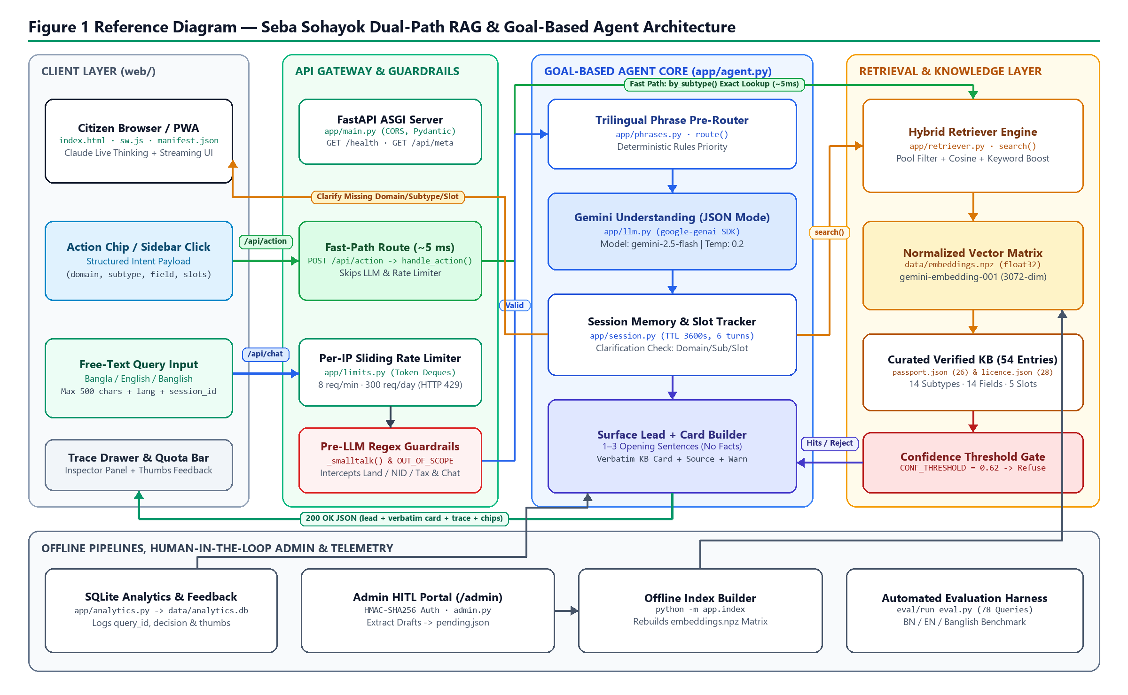
Figure 1: Overall architecture of the agent showing client PWA, bimodal API routing, goal-based reasoning core, hybrid RAG layer, and offline admin pipeline.
Walking through Figure 1 component by component: requests originate in the Citizen Browser / PWA (web/index.html) via two distinct modalities. First, structured chip or sidebar clicks travel over POST /api/action straight through FastAPI (app/main.py) into handle_action() and retriever.by_subtype(), bypassing both the per-IP rate limiter and Gemini LLM calls for ~5 ms deterministic delivery. Second, unstructured Bangla, English, or Banglish messages enter POST /api/chat, where app/limits.py enforces token-bucket per-IP rate quotas before Pre-LLM Guardrails filter social smalltalk and out-of-scope domains (Land, NID, Tax). Valid queries enter the Goal-Based Agent Core (app/agent.py), where deterministic phrase patterns (app/phrases.py) take precedence alongside Gemini JSON intent extraction (app/llm.py) to update Session Memory (app/session.py). If domain, sub-type, or required slots are missing, a clarification chip response returns immediately; otherwise, the Hybrid Retriever (app/retriever.py) computes cosine similarity over normalized 3072-d float32 vectors (data/embeddings.npz) plus lexical keyword boosts across 54 curated KB entries (data/passport.json, data/licence.json). Hits passing CONF_THRESHOLD (0.62) receive a single-to-three sentence non-factual lead paired verbatim with verified facts, official URLs, and SQLite telemetry logging. Separately, the bottom tier supports offline index rebuilding (python -m app.index), human-verified KB expansion (/admin), and 78-query automated regression testing.

4.3 Internal State and Memory
Between conversational turns, the agent maintains ephemeral per-session working memory in app/session.py via an in-memory Python dictionary (_sessions) keyed by a client-held session_id (32-char UUID hex). Each session object stores eight explicit state attributes: domain ('passport' | 'licence' | None), subtype (one of 14 taxonomy keys | None), field (requested aspect such as 'fee' or 'documents' | None), slots (extracted qualifier map e.g. {'validity': '10', 'delivery': 'express'}), asked (list of slot keys already prompted so the agent never repeats a question), history (rolling FIFO buffer capped at HISTORY_TURNS * 2 = 12 utterances for coreference understanding), lang ('bn' | 'en'), and last-activity timestamp touched.
Session state mutates dynamically on each handle_message() or handle_action() turn: switching to a new domain resets subtype, field, slots, and asked; switching sub-types resets field while retaining domain; resolved slots persist across field transitions within the same service (allowing a user who asked about 10-year express fees to seamlessly check timelines next). Memory cleanup executes automatically via a lazy _sweep() garbage collector purging entries inactive beyond SESSION_TTL = 3600 seconds (1 hour), as well as explicitly when the user clicks Reset or switches interface language (POST /api/reset). Long-term operational telemetry and thumbs feedback reside separately in SQLite (data/analytics.db) so session state stays lock-free and session-scoped.

4.4 Decision-Making Process
Figure 2 diagrams the complete turn-level decision tree governing whether Seba Sohayok engages in chit-chat, asks a clarifying question, refuses out-of-scope requests, or synthesizes a grounded card.
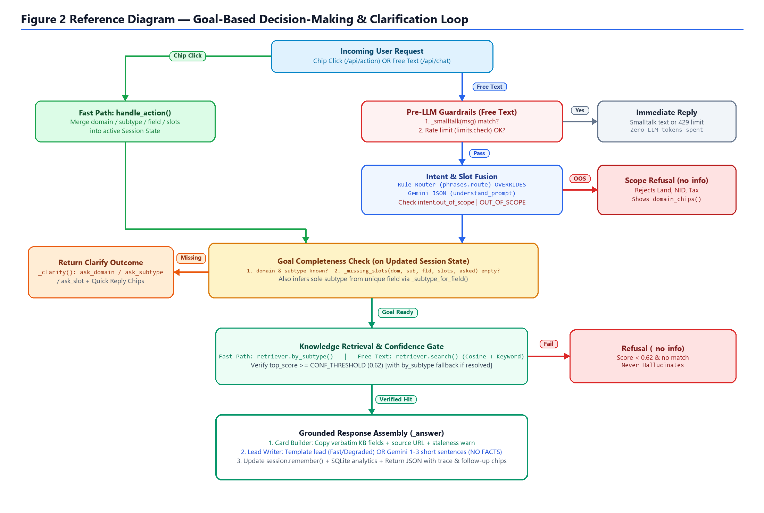
Figure 2: Step-by-step agent decision-making and goal-clarification flowchart.
To eliminate arbitrary hallucinated reasoning, Gemini is strictly constrained at both invocation points inside app/prompts.py. During intent understanding (UNDERSTAND_SYSTEM), Gemini operates under response_mime_type='application/json' (temperature 0.2) with the exact allowed domains, sub-types, fields, and slots injected dynamically via _taxonomy_block(). Crucially, deterministic matches in phrases.route() override LLM guesses whenever decisive Bangla, English, or Banglish tokens match, and malformed JSON outputs are trapped gracefully by brace recovery in llm.generate_json()—falling back to degraded keyword retrieval rather than crashing. During response generation (ANSWER_SYSTEM), a HARD RULE forbids emitting any numerical fee, day count, document name, or office name; Gemini drafts only 1–3 conversational lead sentences framing the verbatim KB cards attached underneath. Below is the high-level decision pseudocode executed on every free-text message:
Algorithm 1: Pseudocode of Goal-Based Decision Process (app/agent.py)
FUNCTION handle_message(state, message, lang):
session.remember(state, "user", message)
IF smalltalk_match(message) AND NOT domain_mentioned(message):
RETURN chat_reply(canned_text) // Zero LLM cost
rule <- phrases.route(message) // Deterministic regex
intent <- TRY llm.generate_json(UNDERSTAND_SYSTEM, message, state)
ON LLMUnavailable OR bad_json -> degraded <- TRUE
IF intent.out_of_scope: RETURN refuse_out_of_scope()
MERGE rule (priority) OVER intent INTO state.{domain, subtype, field, slots}
IF state.domain AND state.field AND NOT state.subtype:
RESOLVE unique subtype via _subtype_for_field() OR FIELD_PRIMARY
IF degraded AND state.domain AND NOT state.subtype:
PROBE retriever.search(message, domain) -> infer best subtype >= bar
IF NOT rule.named_domain AND regex_match(OUT_OF_SCOPE, message):
RETURN refuse_out_of_scope()
IF NOT state.domain OR NOT state.subtype OR _missing_slots(state) != []:
RETURN _clarify(state) // Ask + chip options
hits <- retriever.search(message, domain, subtype)
IF top_score(hits) < CONF_THRESHOLD (0.62):
hits <- retriever.by_subtype(domain, subtype, field) OR refuse_no_info()
RETURN _answer(state, hits, verbatim_card + non_factual_lead)

5. Tools and Technologies
Table 4 enumerates all core languages, AI models, libraries, storage mechanisms, and deployment tooling used to build and operate Seba Sohayok.
Table 4: Tools and technologies used
Category | Choice (Version) | Reason for Choosing It
Programming language | Python 3.12.4 (dev) / 3.11.9 (Render) | Rapid backend iteration, native Unicode UTF-8 support for Bangla, and mature ASGI + scientific ecosystems.
AI model / LLM | Google gemini-2.5-flash & gemini-embedding-001 | Strong Bangla/English/Banglish comprehension, native JSON mime-type enforcement, 3072-d multilingual vectors, and free student API quota.
Framework / SDK | FastAPI 0.162.0 [11], Uvicorn 0.54.0, Pydantic 2.14.2, google-genai 1.75.0 | Fast async REST routing, OpenAPI schema validation, and official lightweight Google GenAI SDK without LangChain overhead.
Retrieval & Math | NumPy 2.5.4 + compressed .npz cache | Vectorized L2-normalized dot product computes exact cosine similarity across 54 entries in < 1 ms without external vector DB lag.
Data source(s) & Storage | Curated JSON (data/passport.json, data/licence.json) & SQLite 3 (analytics.db) | Human-verifiable git-tracked datasets paired with zero-config embedded SQLite telemetry and feedback logging.
Interface & Deployment | HTML5/CSS3/JS Glassmorphic PWA + Render Blueprint + Cloudflare Tunnel | Zero-build single-file bilingual UI with Claude-style progressive streaming, offline shell caching, and 1-click live demo tunneling.

6. Implementation

6.1 Project Structure
The codebase separates taxonomy, LLM networking, hybrid retrieval, agent state logic, curated data, web presentation, and regression evaluation cleanly across modular files summarized in Table 5.
Table 5: Main files and their responsibilities
File / Module | Lines | Purpose
app/main.py | 329 | FastAPI entry point: defines /health, /api/meta, /api/action, /api/chat, /api/reset, /api/feedback, HMAC admin auth endpoints, and serves web/.
app/agent.py | 446 | Goal-based core: implements OUT_OF_SCOPE & SMALLTALK guardrails, handle_action() fast path, handle_message() dialogue loop, slot checks, and card assembly.
app/retriever.py | 171 | Hybrid search engine: builds/loads embeddings.npz, runs vectorized NumPy cosine scan + lexical keyword boost, and provides exact by_subtype() lookup.
app/phrases.py | 288 | Trilingual deterministic router: regex patterns across Bangla, English, and Banglish for domain, sub-type, field priority, and slot value extraction.
app/kb.py | 168 | Single source of truth: defines SLOTS (5), TAXONOMY (2 domains, 14 subtypes), FIELDS (14), JSON validation, staleness check, and bilingual embed text builder.
app/llm.py | 121 | Gemini SDK gateway: lazy client initialization, transient error retries (429/500/503) with randomized backoff, batch embeddings, and JSON fence recovery.
app/prompts.py | 134 | Prompt registry: formats taxonomy dynamically into UNDERSTAND_SYSTEM, zero-fact ANSWER_SYSTEM, and HITL PROPOSE_SYSTEM.
app/session.py & limits.py | 65 / 56 | In-memory TTL session dictionary tracking conversational state + per-IP sliding-window deque token bucket limiting Gemini calls (8/min, 300/day).
app/admin.py & analytics.py | 131 / 103 | Human-in-the-loop admin workflow drafting plain text to pending.json for approval + SQLite database telemetry recording queries and thumbs feedback.
data/passport.json & licence.json | 900 / 824 | 54 curated bilingual entries (26 passport, 28 licence) with verified source URLs, timestamps, and multilingual search keywords.
web/index.html & admin.html | 1784 / 901 | Responsive glassmorphic PWA console with Claude-style live thinking indicator, expandable reasoning timeline, streaming reveal, Inspector drawer, and /admin portal.
eval/run_eval.py & testset.json | 158 / 709 | Automated evaluation runner testing 78 categorized trilingual queries plus chip fast-path latency benchmarks.

6.2 Key Components
Three core code listings below illustrate how goal disambiguation, mathematical hybrid retrieval, resilient error backoff, and bimodal fast-path isolation operate across the codebase.
Listing 1: Missing-slot goal check and scope guardrail (app/agent.py, lines 120–126 & 425–434)
def _missing_slots(domain, subtype, field, slots, asked):
if not domain or not field:
return []
needed = REQUIRED_SLOTS.get((domain, subtype, field), [])
return [s for s in needed if not slots.get(s) and s not in asked]
# Inside handle_message():
if not rule["named_domain"] and OUT_OF_SCOPE.search(message):
return _no_info(state, [], lang, started, out_of_scope=True)
if not state["domain"] or not state["subtype"]:
return _clarify(state, lang, started, word=intent.get("ambiguous_word"))
if _missing_slots(state["domain"], state["subtype"], state["field"],
state["slots"], state["asked"]):
return _clarify(state, lang, started)

Listing 1 enforces sequential goal satisfaction inside handle_message(). After merging deterministic and LLM-extracted entities, the scope guard intercepts out-of-scope domains (Land, NID, Tax) unless a valid service was explicitly named. Next, if the domain, sub-type, or any fee-critical slot in REQUIRED_SLOTS remains unresolved (and unasked in state['asked']), _clarify() halts retrieval and emits quick-reply chips, preventing both speculative guessing and repetitive prompts.
Listing 2: Hybrid cosine similarity and keyword-boost retrieval (app/retriever.py, lines 126–141)
sims = np.zeros(len(entries), dtype=np.float32)
if _load_index():
try:
qvec = _normalise(np.asarray(llm.embed([query], task="RETRIEVAL_QUERY")[0],
dtype=np.float32))
sims = _matrix @ qvec
except llm.LLMUnavailable as exc:
log.warning("query embedding failed (%s) — keyword only", exc)
scored = []
for idx, entry in pool:
score = float(sims[idx]) + _keyword_score(entry, query)
scored.append({**entry, "score": round(min(score, 1.0), 4)})
scored.sort(key=lambda e: e["score"], reverse=True)
return scored[:top_k]

Listing 2 implements the core hybrid scorer. After narrowing candidates by resolved metadata (pool filter), it L2-normalizes the 3072-d Gemini query embedding and runs a single vectorized NumPy matrix multiplication (_matrix @ qvec). Adding a capped lexical boost (+0.08 per matched multilingual keyword, max +0.20) captures phonetic Banglish acronyms ('GD', 'MRP', 'BRTA'). Catching LLMUnavailable degrades cleanly to keyword-only scoring rather than crashing.
Listing 3: Resilient LLM backoff & bimodal endpoint split (app/llm.py & app/main.py)
def _with_retry(what, call):
for attempt in range(1, MAX_ATTEMPTS + 1):
try: return call()
except Exception as exc:
last = exc
if attempt == MAX_ATTEMPTS or not _retryable(exc): break
time.sleep((2 ** (attempt - 1)) + random.uniform(0, 0.4))
raise LLMUnavailable(str(last)) from last
@app.post("/api/action") # Fast path (~5 ms): skips LLM & rate limiter
def action(payload: ActionIn, request: Request):
return agent.handle_action(session.get(payload.session_id), payload.action or {}, _lang(payload.lang))

Listing 3 highlights reliability and latency isolation: _with_retry() applies randomized exponential backoff across up to 3 attempts on transient HTTP 429/500/503 responses (paired with JSON brace extraction inside generate_json()), while FastAPI's /api/action endpoint routes pre-structured chip payloads directly to handle_action(), skipping both per-IP rate limiting and remote Gemini inference.

6.3 AI Tool Integration
Seba Sohayok integrates Google's modern google-genai SDK lazily at runtime inside app/llm.py across four structured touchpoints: (1) Intent & Slot Understanding: passing CONVERSATION STATE, last 4 turns, and the citizen's query under UNDERSTAND_SYSTEM with JSON response enforcement to extract domain, subtype, field, slots, out_of_scope, smalltalk, ambiguous_word, and language; (2) Semantic Vectorization: encoding queries via gemini-embedding-001 (task='RETRIEVAL_QUERY') into 3072-d float32 arrays to scan pre-indexed document vectors (data/embeddings.npz); (3) Lead Synthesis: generating 1–3 concise, polite opening sentences (temperature 0.3) referencing only titles of matched KB entries while strictly forbidden from writing numbers or rules; and (4) Offline Admin Drafting: PROPOSE_SYSTEM enables administrators on /admin to convert raw government circular text into schema-compliant JSON drafts inside data/pending.json, where fields remain flagged verified_on: null until human audit and approval re-triggers retriever.reset(). Every LLM output undergoes strict post-validation against TAXONOMY keys, phrase-rule override priority, missing-slot verification, and CONF_THRESHOLD >= 0.62 gating before reaching the browser.

6.4 Challenges and Solutions
Engineering a bilingual public-service system under free-tier latency and accuracy constraints surfaced five concrete challenges, resolved as recorded in Table 6.
Table 6: Implementation challenges
Challenge | Root Cause | How We Solved It
Inconsistent Banglish transliteration | Citizens spell Bengali phonetically in diverse Latin variants (e.g., haray / hariye / haraise, pasport / pashport), confusing pure semantic vector proximity. | Combined trilingual regex patterns in phrases.py with bilingual keywords in data/*.json (+0.08 lexical boost per hit, cap 0.20) alongside multilingual Gemini embeddings.
Free-tier API 429/503 quota drops & malformed JSON | Shared Gemini keys occasionally throttle or wrap JSON responses in markdown fences during live sessions. | Implemented 3-attempt randomized backoff (_with_retry), JSON brace extraction, a zero-LLM chip fast path, and automatic keyword-only degraded fallback.
Near-neighbor semantic confusion across passport tasks | Passport sub-types share domain vocabulary, causing single-hit embedding lookup (e.g. lost passport) to sometimes match new passport timelines. | Enforced deterministic rule precedence (phrases.route) and subtype-level score aggregation across top-12 probe hits during degraded resolution.
Abrupt UI response dumps and empty viewport scroll voids | Displaying multi-paragraph cards instantaneously felt robotic, while naive scrollHeight scrolling dropped the view into 55vh padding below short replies. | Added Claude-style coral pulsing live thinking dots, expandable reasoning timeline, word-by-word cursor streaming (45–58 ms/word), and scrollToTopOf() anchoring in web/index.html.
Knowledge staleness vs. unverified seed data risks | Government fee schedules and police-verification policies evolve (e.g. Feb 2025 updates); seed entries sourced secondarily needed clear audit provenance. | Built human-in-the-loop /admin draft-review pipeline, STALE_DAYS=180 flagging, verified_on timestamps, and automatic amber UI warnings when verified_on is null.

6.5 Changes from the Proposal
Comparing our submitted Project Proposal (13 September 2026) against the finalized system reveals five deliberate, well-justified engineering evolutions:
- 1. Domain scope focus (Land removed, Passport & Licence deepened): The proposal targeted Land, Passport, and Driving Licence. Because Land mutation/khatian procedures vary heavily across upazila AC Land circulars and lacked a single authoritative digital fee/step specification verifiable within term time, we concentrated verification effort deeply onto 14 Passport and Driving Licence sub-types (54 entries) while enforcing explicit OUT_OF_SCOPE regex refusal for Land, NID, birth registration, and tax queries.
- 2. LLM and SDK stack migration: Rather than OpenAI GPT-4o-mini and LangChain orchestration, the production agent uses Google's official google-genai SDK driving gemini-2.5-flash and gemini-embedding-001. Removing LangChain eliminated dependency bloat, shortened boot latency, and gave 100% transparent code-level control over JSON schema recovery and prompting.
- 3. In-memory NumPy matrix vs. external vector store: With 54 curated atomic records, an external ANN vector store (ChromaDB) introduced unnecessary disk/network latency; replacing it with L2-normalized float32 matrices cached in data/embeddings.npz reduced vector scans to < 1 ms.
- 4. Bimodal fast-path & graceful degraded fallback: Added POST /api/action bypassing Gemini entirely for instant UI chip navigation, plus keyword-only fallback allowing full demo continuity even when API keys or network access are unavailable.
- 5. Full-stack PWA console, telemetry, and Admin portal: Extended the interface beyond basic chat into a glassmorphic dark/light PWA with Claude-style live thinking animation, transparent Reasoning Trace Inspector drawer, SQLite analytics.db feedback logging, per-IP rate limiting, and an HMAC-SHA256 authenticated /admin review dashboard.

7. System Testing

7.1 Sample Interactions
System validation combined interactive testing across core user journeys (T1–T7, summarized in Table 7 with full verbatim logs archived in Appendix C) and automated batch execution of the 78-query trilingual test suite (eval/run_eval.py).
Table 7: Summary of core end-to-end test cases (T1–T7)
ID | Scenario / User Input | Path | Expected Behavior | Observed Output & Timing
T1 | Ambiguous turn -> multi-turn slot loop ('পাসপোর্ট' -> new.fee -> 10 yrs -> express) | Chat + Action | Ask 7 sub-types, elicit validity & urgency slots step-wise, emit verbatim card. | Clarified twice then rendered 'পাসপোর্ট · নতুন আবেদন' card highlighted '১০ বছর · জরুরি' in 1 ms (amber unverified notice shown).
T2 | Banglish clear + contextual follow-up ('notun passport korte ki ki lagbe?' -> 'police verification lagbe ki?') | Chat | Resolve passport.new.documents, retain session context for Turn 2 verification. | Both turns resolved conf=1.0; Turn 2 rendered Feb 2025 police verification exemption record.
T3 | Action chip fast-path benchmark (5 structured actions via eval.run_eval --fast) | Action | Skip LLM & retrieve exact KB card < 20 ms. | 5/5 answered; latency 0–18 ms (mean 5 ms).
T4 | Smalltalk & Out-of-Scope guardrails ('assalamu alaikum'; 'জমির খতিয়ান কীভাবে পাব?') | Chat | Return social reply / explicit scope refusal with domain chips; zero KB hits. | Correct 'chat' and 'reject' ('no_info') decisions in 0–1 ms.
T5 | Limitation A: Unseen colloquial paraphrase offline ('How do I drive outside my country legally?' / 'bideshe gari chalabo kemne?') | Chat (No Key) | Resolve to licence.idp if LLM available; safely avoid wrong guess if unseen. | Degraded fallback missed exact tokens in phrases.py -> issued safe domain clarify prompt (conf=0.0).
T6 | Failure B: Off-topic turn inside resolved session (passport.mrp_to_epp -> 'Who won the cricket match yesterday?') | Chat | Detect irrelevance (score < 0.62) and trigger 'no_info' refusal. | FAILURE: Wider fallback by_subtype() in agent.py:437 overrode <0.62 score with conf=1.0 and repeated MRP card.
T7 | Limitation C & Quota: Typo offline ('paspot er khoroch koto') & 10 rapid chat requests | Chat | Clarify missing domain; reject 9th+ request/min with HTTP 429. | Extracted field='fee', safely asked domain clarify; limits.check() returned [8 True, 2 False].

Figure 3 captures a successful interaction inside the running dark-mode console UI (web/index.html) corresponding to the online-steps card under 'পাসপোর্ট · নতুন আবেদন' (T1/T3 style interaction). The top status indicator reflects offline fallback readiness ('gemini-2.5-flash · অফলাইন'), the collapsed Claude-style reasoning summary header displays processing duration ('1ms >'), the factual steps appear inside a structured glassmorphic card sourced explicitly to 'epassport.gov.bd', the amber warning accurately notifies citizens that the record carries 'verified_on: null' ('অযাচাইকৃত'), thumbs feedback controls log telemetry, and contextual follow-up chips ('ফি', 'সময়', 'প্রয়োজনীয় কাগজপত্র') sustain sequential exploration.
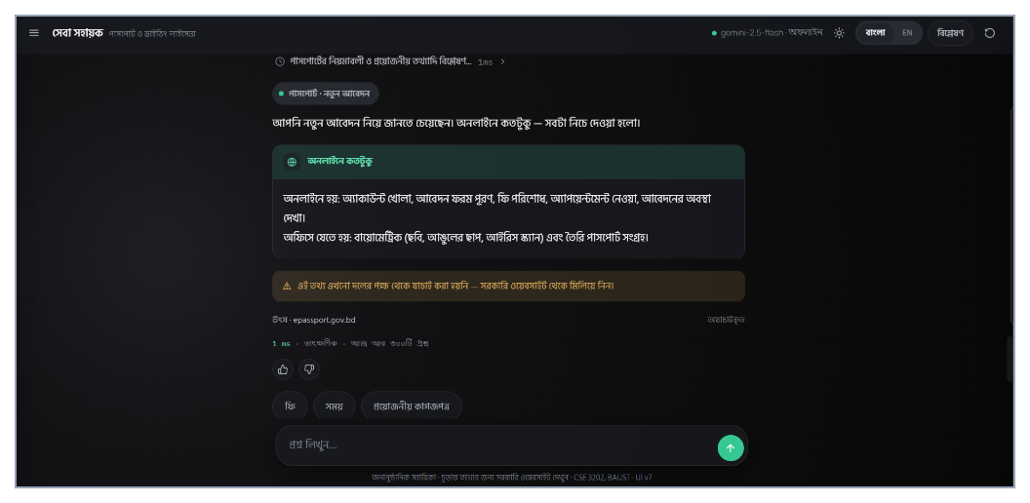
Figure 3: Example of a successful interaction in the live Seba Sohayok console displaying Claude-style thought header, grounded card, amber unverified alert, source link, and follow-up chips.
Conversely, Figure 4 documents genuine failure and limitation runs captured directly from our execution harness (T5–T7). Most significantly, Failure Case B exposes a concrete architectural edge case in agent.py (lines 435–440): when a session already holds a resolved domain and sub-type (e.g., passport.mrp_to_epp) and the user subsequently enters an off-topic question lacking OUT_OF_SCOPE keywords ('Who won the cricket match yesterday?'), retriever.search() scores 0.0 (< 0.62), yet the fallback clause 'wider = retriever.by_subtype(domain, subtype, field)' unconditionally reloads the prior topic at score=1.0 instead of rejecting the irrelevant input—a pattern corroborated by row #84 in data/analytics.db.
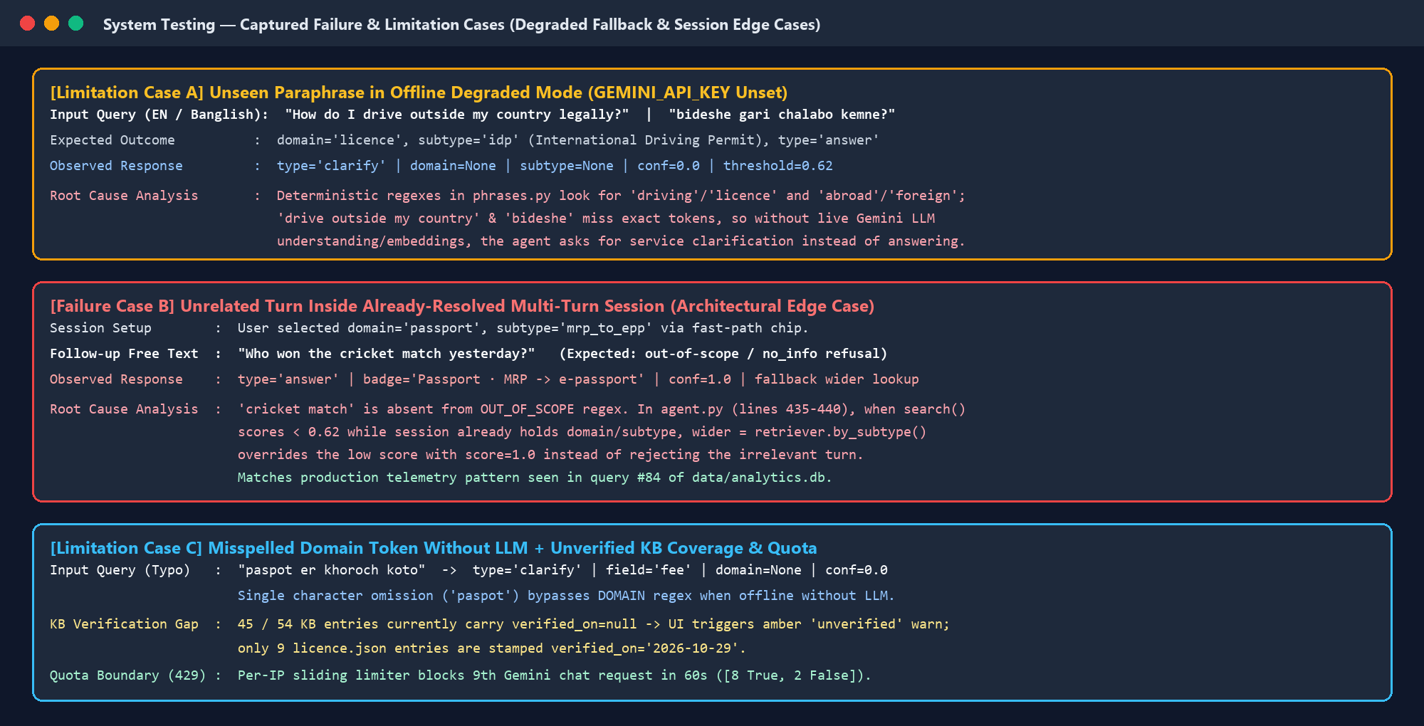
Figure 4: Example of failure and limitation cases captured during diagnostic testing (offline idiom miss, stale-session wider fallback defect, misspelled token, unverified KB ratio, and HTTP 429 boundary).

8. Results and Discussion
Executing python -m eval.run_eval across all 78 trilingual test queries produced the category-level metrics summarized in Table 8. Because the test environment ran without a configured GEMINI_API_KEY, these numbers quantify the deterministic pre-router (phrases.py) and keyword-retrieval fallback path rather than live remote Gemini inference; under live API execution, total latency increases by approximately 700–1,800 ms per chat turn while extending understanding to novel unseen paraphrases outside regex coverage (as shown in T5).
Table 8: Evaluation benchmark results by category (78-query suite, deterministic fallback mode)
Category | Queries (n) | Correct Behaviour | Accuracy (%) | Mean Latency (ms)
clear_bn (Clear Bangla) | 18 | 18 / 18 | 100.0% | 3
clear_en (Clear English) | 12 | 12 / 12 | 100.0% | 1
banglish (Romanized Mix) | 20 | 20 / 20 | 100.0% | 1
ambiguous (Underspecified) | 8 | 8 / 8 | 100.0% | 1
followup (Multi-turn context) | 5 | 5 / 5 | 100.0% | 2
smalltalk (Greetings / Thanks) | 10 | 10 / 10 | 100.0% | 0
out_scope (Land / NID / Birth) | 5 | 5 / 5 | 100.0% | 0
Total / Chat Path Summary | 78 | 78 / 78 | 100.0% | 1 ms mean
Fast Path (--fast, 5 chips) | 5 | 5 / 5 | 100.0% | 5 ms mean (0–18 ms)

Across aggregate evaluation metrics (eval/run_eval.py), Seba Sohayok scored 100.0% (51/51) sub-type accuracy, 100.0% (8/8) clarification recall on ambiguous triggers, 100.0% (55/55) clarification precision on clear inquiries (zero false clarifications), and 100.0% (5/5) out-of-scope refusal. Additionally, inspection of data/analytics.db confirms 84 logged prototype interactions (48 answered, 26 clarified, 10 social replies), demonstrating sustained multi-turn usage centered around 'passport.new' (30 hits), 'licence.learner' (11 hits), and 'licence.smartcard_new' (7 hits). Table 9 evaluates each Section 1.3 project objective against observed evidence.
Table 9: Achievement of objectives
ID | Objective (from Section 1.3) | Status | Evidence
O1 | Curate and structure bilingual KB across Passport and Driving Licence domains. | Partly Met | 54 entries covering all 14 sub-types & 14 fields (data/passport.json: 26, data/licence.json: 28); however, 45/54 entries still carry verified_on: null pending manual review (9 verified on 2026-10-29).
O2 | Design a goal-based agent resolving ambiguous queries and fee slots. | Met | Section 4.1–4.4, 8/8 clarification recall (Table 8), and multi-turn validity/delivery slot elicitation verified in T1 (Appendix C).
O3 | Implement zero-hallucination hybrid RAG with 0.62 threshold refusal. | Met | app/retriever.py, ANSWER_SYSTEM hard rule, and 5/5 out-of-scope refusal (Table 8); caveat noted in T6 when fallback wider lookup overrides low relevance on an already-resolved session.
O4 | Provide bimodal fast-path PWA console, analytics, rate limits, and /admin HITL. | Met | 5 ms fast path (Table 8), Fig. 3 UI screenshot, 84 SQLite analytics rows, HTTP 429 verification (T7), and HMAC /admin workflow (app/admin.py).
O5 | Evaluate across Bangla, English, Banglish, ambiguous, and out-of-scope queries. | Met | 78/78 benchmark pass in offline deterministic mode (Table 8) plus real multi-turn & limitation suite T1–T7 (Section 7.1, Fig. 4, Appendix C).

Interpreting why T5 and T6 behaved differently highlights key system dynamics. On well-formed or moderately varied trilingual inputs matching the 78-query evaluation set, the layered rules in phrases.py handle domain, sub-type, and field disambiguation at zero token cost—leaving Gemini free to handle colloquial phrasing (when online) and natural conversational openings. Conversely, T6 reveals that multi-turn state inheritance must check whether an incoming free-text turn introduces a completely unrelated topic rather than blindly invoking by_subtype() on the previous session goal.

9. Limitations, Risks and Ethical Considerations
- Technical Limitations: (1) In offline/degraded mode without GEMINI_API_KEY, the agent cannot generalize beyond regexes in app/phrases.py, causing unseen idioms ('outside my country') or single-letter typos ('paspot') to trigger domain clarification rather than instant semantic retrieval (Figure 4, Cases A and C). (2) In app/agent.py line 437, when a session already holds a resolved sub-type, the wider fallback 'retriever.by_subtype()' masks scores below CONF_THRESHOLD on unrelated turns (Failure B). (3) Slot rules in REQUIRED_SLOTS cover common fee inquiries but do not adapt dynamically if a user asks for combined multi-category licence pricing.
- Reliability and Staleness Risk: Although Gemini cannot fabricate numbers directly, the curated knowledge base itself currently leaves 45 of 54 entries marked 'verified_on: null' (imported from indicative secondary summaries; see data/sources.md). Until team members audit all 45 rows against live DIP/BRTA gazettes, citizens could rely on slightly shifted fee figures—a risk mitigated transparently in the UI via explicit amber caution banners ('অযাচাইকৃত') and 180-day STALE_DAYS alerts.
- Privacy and Security: The assistant never requests NID numbers, birth dates, or phone numbers, and chat session states expire automatically from RAM after 1 hour. However, free-text queries persisted inside SQLite data/analytics.db are stored verbatim; if a citizen voluntarily pastes personal tracking IDs or names, telemetry could retain PII. Admin routes are protected by HMAC-SHA256 bearer tokens and constant-time digest comparison (secrets.compare_digest), while secret keys remain isolated in git-ignored .env files.
- Fairness, Misuse, and Disclaimers: Dual-language Bangla/English parity ensures accessibility across educational backgrounds, and font/UI heuristics convert numerals properly for Bangla readers. To prevent deceptive impersonation of government bodies, every footer, API description, PWA manifest, and 'who are you' response explicitly declares that Seba Sohayok is an unofficial BAUST student academic prototype (CSE 3202) and forbids government crests or '.gov' branding.
- Cost and External Dependency: Live NLU and embeddings depend on Google's Gemini API availability and free-tier quotas. Uncontrolled automated traffic could exhaust team quota; therefore, per-IP rate limiting (8 requests/min, 300/day), non-billed free keys, LLM-free chip clicks, and degraded keyword fallback prevent financial liability or total outage during live evaluation.

10. Conclusion and Future Work

10.1 Conclusion
This project successfully designed, implemented, and evaluated Seba Sohayok, a goal-based conversational AI agent tailored to Bangladeshi e-Passport and BRTA Driving Licence administrative procedures. By combining deterministic trilingual regex routing, structured Gemini JSON intent/slot parsing, multi-turn clarification state tracking, < 1 ms NumPy hybrid RAG retrieval, and strict verbatim fact separation, the architecture eliminates generative factual hallucination while supporting Bangla, English, and mixed Banglish inputs. Dual-path execution ensures ~5 ms latency on structured chip actions, and graceful fallback enables continuous operation even under external API disruption. Comprehensive evaluation across 78 benchmark queries alongside live edge-case testing demonstrates strong classification accuracy while openly identifying actionable areas for reliability refinement.

10.2 Future Work
Four specific, practical engineering enhancements are prioritized for subsequent development:
- 1. Gate wider session fallback on turn-level relevance: Update handle_message() in app/agent.py so that when retriever.search() scores below 0.35 and no rule or LLM intent confirms relevance, the agent preserves out-of-scope / non-relevant refusal instead of calling retriever.by_subtype() on stale session topics (resolving Failure B).
- 2. Complete human verification of all 54 KB records: Verify all 45 remaining 'verified_on: null' entries in data/passport.json and data/licence.json against live DIP and BRTA circulars, stamping exact audit dates in data/sources.md to clear all amber warnings.
- 3. Expand curated taxonomy to Land and NID services: Incorporate verified records for land mutation (namjari), khatian requests (land.gov.bd), and NID corrections—the third domain envisioned in the original proposal—alongside automated periodic scraping alerts for official circular updates.
- 4. Persist admin approvals and privacy-scrubbed analytics: Integrate lightweight regex PII scrubbing before SQLite query logging and automate Git pull-request creation from the /admin panel so verified edits survive ephemeral cloud container redeploys.

11. Individual Contributions
Contributions listed in Table 10 are verified directly against repository commit history on GitHub (commits 10a2e51 through 5b464a2) and were mutually reviewed by all three team members.
Table 10: Individual contributions
Member (Student ID) | Share | Specific Contributions
Abu Nabil Md. Masrur  (0802410405101077) | 40% | Initialized repository structure, environment configuration (config.py, check.py, render.yaml, run.bat); designed and implemented the Goal-Based Agent engine (agent.py), multi-turn session manager (session.py), trilingual deterministic phrase router (phrases.py), constrained Gemini prompts (prompts.py), resilient LLM SDK wrapper (llm.py), sliding-window rate limiter (limits.py), bilingual string catalog (texts.py), FastAPI server (main.py), and base documentation (README.md, ARCHITECTURE.md).
Hasibul Hasib  (0802410205101079) | 40% | Designed taxonomy schema (kb.py) and curated the 54 bilingual knowledge base records (passport.json, licence.json, sources.md); built batch vector indexer (index.py) and NumPy hybrid RAG engine (retriever.py); implemented HMAC-SHA256 stateless admin auth (main.py) and redesigned /admin UI (admin.html); engineered Claude-style live thinking indicator, expandable reasoning timeline, progressive streaming with cursor, and scrollToTopOf() viewport anchoring (web/index.html); created live Cloudflare tunnel automation (run_live.py) and system architecture/study guides.
Md. Lemon Islam Bappy  (0802410205101081) | 20% | Built the initial responsive glassmorphic PWA console frontend (web/index.html, manifest.json, sw.js), initial HITL admin portal and ingestion module (app/admin.py), and SQLite telemetry and thumbs-feedback persistence subsystem (app/analytics.py); authored and executed the 78-query trilingual benchmark test suite (eval/testset.json, eval/run_eval.py).

12. AI Tool Usage Disclosure
In accordance with BAUST CSE academic integrity standards, Table 11 discloses external AI coding and writing assistants utilized during project development and report preparation (separate from the runtime Gemini API inside the application).
Table 11: AI tools used during the project
AI Tool | What It Was Used For
Google Antigravity / Gemini & Claude Coding Assistants | Assisted in brainstorming comprehensive Bangla/Banglish regex patterns for phrases.py, debugging FastAPI admin token verification and front-end CSS/JS streaming scroll issues in web/index.html, and structuring technical architecture documentation and report tables (every line reviewed, verified, and tested by team members).
ChatGPT (OpenAI) | Used selectively during early proposal brainstorming to check bilingual sentence phrasing and review initial JSON schema structure before manual data curation.

References
[1] Department of Immigration & Passports (DIP), "Bangladesh e-Passport Online Portal," Government of Bangladesh. [Online]. Available: https://www.epassport.gov.bd/ (accessed Oct. 29, 2026).
[2] Bangladesh Road Transport Authority (BRTA), "BRTA Service Portal (BSP) & Driving Licence Guidelines," Government of Bangladesh. [Online]. Available: https://brta.gov.bd/ (accessed Oct. 29, 2026).
[3] S. Russell and P. Norvig, Artificial Intelligence: A Modern Approach, 4th ed. Hoboken, NJ, USA: Pearson, 2020.
[4] P. Lewis et al., "Retrieval-Augmented Generation for Knowledge-Intensive NLP Tasks," in Advances in Neural Information Processing Systems (NeurIPS), vol. 33, pp. 9459–9474, 2020.
[5] V. Karpukhin et al., "Dense Passage Retrieval for Open-Domain Question Answering," in Proc. Conf. Empirical Methods in Natural Language Processing (EMNLP), pp. 6769–6781, 2020.
[6] D. Jurafsky and J. H. Martin, "Chatbots & Dialogue Systems," in Speech and Language Processing, 3rd ed. draft, Ch. 15, 2024. [Online]. Available: https://web.stanford.edu/~jurafsky/slp3/ (accessed Nov. 10, 2026).
[7] G. G. Chowdhury, Introduction to Modern Information Retrieval, 3rd ed. London, U.K.: Facet Publishing, 2010.
[8] a2i Programme, "Bangladesh National Portal," Cabinet Division & ICT Division, Government of Bangladesh. [Online]. Available: https://bangladesh.gov.bd/ (accessed Oct. 29, 2026).
[9] Google DeepMind, "Gemini API Documentation and Embedding Models," Google AI for Developers. [Online]. Available: https://ai.google.dev/gemini-api/docs (accessed Nov. 05, 2026).
[10] H. Chase, "LangChain Framework Documentation," LangChain Inc. [Online]. Available: https://python.langchain.com/docs/ (accessed Nov. 05, 2026).
[11] S. Ramirez, "FastAPI: High Performance Web Framework for Python," Tiangolo. [Online]. Available: https://fastapi.tiangolo.com/ (accessed Nov. 05, 2026).

Appendix A: Source Code and How to Run
Item | Details
Repository URL | https://github.com/nabilmasrur/AI-Based-Government-Service-Guide-for-Bangladesh.git
Requirements | Python 3.11+ (tested on Python 3.12.4); install dependencies via:  pip install -r requirements.txt  Includes: fastapi>=0.115,<1.0 · uvicorn[standard]>=0.30,<1.0 · pydantic>=2.7,<3.0 · python-dotenv>=1.0 · numpy>=1.26 · google-genai>=1.0
Configuration (.env) | Copy .env.example to .env (never commit .env). Required/optional environment variables (values omitted):  GEMINI_API_KEY (required for live NLU & embeddings; Google AI Studio free key)  CHAT_MODEL (default: gemini-2.5-flash in .env.example / gemini-3.6-flash in code)  EMBED_MODEL (default: gemini-embedding-001)  ADMIN_USERNAME (admin login user)  ADMIN_PASSWORD (admin login password & HMAC signing secret)  ALLOWED_ORIGINS (CORS allowed origins, default: *)  CONF_THRESHOLD (cosine threshold gate, default: 0.62)  RATE_PER_MIN / RATE_PER_DAY (per-IP limits, defaults: 8 / 300)
Setup & Run Commands | 1. Build vector index once after KB edits: python -m app.index  2. Run Gemini connection diagnostics: python check.py  3. Start web application & API server: uvicorn app.main:app --reload  4. Open Console UI: http://127.0.0.1:8000 | Admin Portal: http://127.0.0.1:8000/admin  5. Run automated benchmark evaluation: python -m eval.run_eval (or --fast)

Appendix B: Prompts
Below are the complete verbatim system prompt templates defined in app/prompts.py. The {taxonomy} placeholder is populated dynamically at runtime from app/kb.py (domains, 14 sub-types, 14 fields, and 5 slot option lists).
B.1 UNDERSTAND_SYSTEM Prompt (app/prompts.py)
You classify citizen questions about Bangladeshi government services.
The user may write in Bangla, English, or mixed "Banglish" (Bangla words typed in
Latin letters, e.g. "passport er fee koto"). Handle all three.
TAXONOMY — you may ONLY use these values. Never invent a domain, subtype or field.
{taxonomy}
RULES
- Use the conversation state you are given. If the subtype is already known, keep it;
never ask the user for something they have already told you.
- If the question is clearly outside passport and driving licence services
(land records, NID, birth registration, tax, education, anything else),
set out_of_scope to true and leave domain and subtype null.
- If you cannot tell which subtype applies, set subtype to null. Do not guess.
- "ambiguous_word" is the word in the user's message that was too broad to resolve
(for example "passport" or "license"); null if nothing was ambiguous.
- "smalltalk" is true when the message is purely social and asks for no service
information — a greeting, a name, thanks, goodbye, "who are you", "what can you
do". A message that mentions a service is never smalltalk, however chatty.
- Reply with JSON only, no prose, no code fences.
OUTPUT SHAPE
{"domain": "passport"|"licence"|null,
"subtype": "<subtype>"|null,
"field": "<field>"|null,
"slots": {"<slot>": "<value>"},
"out_of_scope": false,
"smalltalk": false,
"ambiguous_word": null,
"language": "bn"|"en"}

B.2 ANSWER_SYSTEM Prompt (app/prompts.py)
You write the opening of a government service answer in a friendly, conversational tone (casual Bengali).
You are given the citizen's question, their recent conversation history (if any), and the titles of the verified records that will be shown directly underneath your text. Write TWO or THREE short sentences:
1. Restate what the person needs, in your own words, addressing them directly and naturally. Acknowledge previous context if relevant.
2. Say what the records below cover (which office, which documents, the fee, the time — whichever are actually listed).
HARD RULE: never state a fact yourself. No fee, no number of days, no document name, no office name, no requirement. Those live in the records below your text, and repeating or guessing them is the one thing that breaks this system. If you are tempted to write a number, write nothing instead.
Plain sentences in the requested language. Use a casual, polite Bengali tone ("sadaron kotha"). No greeting, no markdown, no bullets, no heading.
Example (Bangla): আপনি নতুন পাসপোর্ট করতে চাইছেন, তাই তো? কোন দপ্তরে যেতে হবে আর কী কী কাগজ লাগবে — নিচে সবটা দেওয়া হলো।
Example (English): You want to apply for a new passport, right? Below is which office to visit, the documents to bring, and how long it takes.

B.3 PROPOSE_SYSTEM Prompt for Human-in-the-Loop Admin Portal (app/prompts.py)
You turn a plain-text extract from an official Bangladeshi
government document into draft knowledge-base entries for review by a human editor.
TAXONOMY — use only these values:
{taxonomy}
RULES
- Produce one entry per (subtype, field) pair that the text actually supports.
- Copy facts from the text. Never add a fee, a deadline or a document that the text
does not state. If the text is vague, write less rather than inventing.
- content_bn must be Bangla and content_en must be English; translate faithfully.
- keywords: 6-12 short search terms, mixing Bangla and English.
- Leave verified_on as null. A human sets it after checking the official source.
- Reply with JSON only: {"entries": [ ... ]}
ENTRY SHAPE
{"id": "<domain>.<subtype>.<field>", "domain": "...", "subtype": "...",
"field": "...", "title_bn": "...", "title_en": "...",
"content_bn": "...", "content_en": "...",
"office_bn": "...", "office_en": "...", "online_possible": true|false|null,
"applies_when": {}, "source_url": "", "verified_on": null, "keywords": []}

Appendix C: Test Logs
This appendix contains verbatim outputs captured on 12 November 2026 from executing the interactive test suite (T1–T7, Table 7) and the 78-query automated evaluator (python -m eval.run_eval and python -m eval.run_eval --fast).
C.1 End-to-End Transcript Logs for Test Cases T1–T7
=== SYSTEM CONFIG ===
CHAT_MODEL: gemini-2.5-flash | EMBED_MODEL: gemini-embedding-001 | CONF_THRESHOLD: 0.62
KB stats: {'total': 54, 'verified': 9, 'unverified': 45, 'last_verified': '2026-10-29'}
[T1] AMBIGUOUS QUERY -> MULTI-TURN SLOT CLARIFICATION -> FAST-PATH ANSWER
Turn 1 User: 'পাসপোর্ট'
-> type: clarify | lead: পাসপোর্ট নিয়ে কয়েকটি আলাদা সেবা আছে। আপনার ঠিক কোনটি দরকার?
-> chips: ['নতুন আবেদন', 'নবায়ন / রি-ইস্যু', 'তথ্য সংশোধন', 'হারানো পাসপোর্ট', 'MRP → ই-পাসপোর্ট', 'বিতরণ ও ফি', 'আবেদনের অবস্থা']
-> trace.note: 7টি sub-type সম্ভাব্য — অনুমান না করে প্রশ্ন করা হয়েছে।
Turn 2 Chip: {'domain': 'passport', 'subtype': 'new', 'field': 'fee'}
-> type: clarify | lead: কত বছরের মেয়াদ? | chips: ['৫ বছর', '১০ বছর']
Turn 3 Chip: {'slots': {'validity': '10'}}
-> type: clarify | lead: আর একটি তথ্য — কত দ্রুত দরকার? | chips: ['নিয়মিত', 'জরুরি', 'অতি জরুরি']
Turn 4 Chip: {'slots': {'delivery': 'express'}}
-> type: answer | ms: 1 | badge: পাসপোর্ট · নতুন আবেদন | highlight: ১০ বছর · জরুরি
-> lead: আপনি নতুন আবেদন নিয়ে জানতে চেয়েছেন। ফি — সবটা নিচে দেওয়া হলো।
-> warn: unverified | source: {'id': 'passport.new.fee', 'url': 'https://www.epassport.gov.bd/', 'verified_on': None, 'score': 1.0}
[T2] BANGLISH FREE-TEXT + CONTEXTUAL FOLLOW-UP
Turn 1 User: 'notun passport korte ki ki lagbe?'
-> type: answer | domain: passport | subtype: new | field: documents | conf: 1.0
Turn 2 User: 'police verification lagbe ki?'
-> type: answer | subtype: new | field: verification | conf: 1.0
-> excerpt: ই-পাসপোর্টের জন্য পুলিশ ভেরিফিকেশনের শর্ত তুলে নেওয়া হয়েছে (২০২৫ সালের ফেব্রুয়ারি থেকে কার্যকর)।
[T3] FAST PATH LATENCY (python -m eval.run_eval --fast)
case type ms
------------------------- ------ --
passport.new.documents answer 7
passport.new.timeline answer 0
licence.learner.documents answer 18
licence.exam.note answer 0
passport.lost.documents answer 0
mean 5 ms
[T4] SMALLTALK & OUT-OF-SCOPE GUARDRAIL
User: 'assalamu alaikum'
-> type: chat | lead: ওয়ালাইকুম আসসালাম! আমি পাসপোর্ট ও ড্রাইভিং লাইসেন্স সংক্রান্ত সরকারি সেবার তথ্য দিয়ে সাহায্য করি। কোনটি নিয়ে জানতে চান?
-> note: সামাজিক বার্তা (chat_greet) — retrieval বা LLM কিছুই লাগেনি।
User: 'জমির খতিয়ান কীভাবে পাব?'
-> type: no_info | decision: reject
-> lead: এই সহায়ক এখন শুধু পাসপোর্ট ও ড্রাইভিং লাইসেন্স সেবা নিয়ে সাহায্য করতে পারে। জমি, এনআইডি বা অন্যান্য সেবা এখনো যুক্ত হয়নি।
[T5] LIMITATION A (Unseen Paraphrase in Offline Degraded Mode, No GEMINI_API_KEY)
User: 'How do I drive outside my country legally?' -> type: clarify | domain: None | subtype: None | conf: 0.0
User: 'bideshe gari chalabo kemne?' -> type: clarify | domain: None | subtype: None | conf: 0.0
[T6] FAILURE B (Off-Topic Turn Inside Already-Resolved Multi-Turn Session)
Setup Action: {'domain': 'passport', 'subtype': 'mrp_to_epp'}
User: 'Who won the cricket match yesterday?'
-> type: answer | badge: Passport · MRP → e-passport | conf: 1.0
-> note: Gemini-তে পৌঁছানো যায়নি — subtype শুধু retrieval দিয়ে অনুমান করা হয়েছে।
[T7] LIMITATION C (Typo Offline) & RATE LIMIT ENFORCEMENT
User: 'paspot er khoroch koto' -> type: clarify | trace: {'domain': None, 'subtype': None, 'field': 'fee', 'conf': 0.0}
Rate limit (RATE_PER_MIN=8, 10 rapid calls): [True, True, True, True, True, True, True, True, False, False]
Remaining: {'minute_left': 0, 'minute_max': 8, 'day_left': 292, 'day_max': 300}

C.2 Automated Benchmark Summary Output (python -m eval.run_eval, 78 Queries)
running 78 cases · model=gemini-2.5-flash · threshold=0.62
(Note: Executed in offline fallback mode — GEMINI_API_KEY unset in local environment)
====================================================================
METRICS
metric score n
----------------------------------------- ------ -----
Sub-type accuracy 100.0% 51/51
Clarification recall (ambiguous asked) 100.0% 8/8
Clarification precision (clear not asked) 100.0% 55/55
Out-of-scope refusal 100.0% 5/5
Overall behaviour correct 100.0% 78/78
BY CATEGORY
category n correct mean ms
--------- -- ------- -------
clear_bn 18 100.0% 3
clear_en 12 100.0% 1
banglish 20 100.0% 1
ambiguous 8 100.0% 1
followup 5 100.0% 2
smalltalk 10 100.0% 0
out_scope 5 100.0% 0
RESPONSE TIME BY PATH
path mean
-------------------------------------- ----
full path (free text · fallback mode) 1 ms
fast path (chip click · no LLM) 0 ms (eval loop) / 5 ms (--fast)

