Validation Report
Name: MUHAMMAD NABIL BIN NORMAN
Validated IP: FIR Filter

TC# | Name
1 | Global enable/disable
2 | POR register values
3 | Input buffer overflow and clearing
4 | Filter bypassing
5 | Signal processing

Instance 1 (impl0)

TC# | Description | Pass/Fail
1 | Global enable/disable work, interface unavailable when disabled | PASS
2 | Show incorrect default CSR and coefficient initialization | FAIL
3 | Correctly assert overflow at full buffer | PASS
4 | Correctly bypass the filter, confirming proper bypass control logic | PASS
5 | Output signal match exactly with the output signal | PASS

Instance 2 (impl1)

TC# | Description | Pass/Fail
1 | CSR readable, FEN=1 → FAIL | FAIL
2 | Matches the expected power-on reset values | PASS
3 | Fail to detect overflow conditions. | FAIL
4 | Incorrectly bypass the filter, confirming proper bypass control logic | FAIL
5 | Output signal did not match exactly with the output signal | FAIL

Instance 3 (impl2)

TC# | Description | Pass/Fail
1 | Interface unavailable when disabled | PASS
2 | Show incorrect default CSR and coefficient initialization | FAIL
3 | Correctly assert overflow at full buffer | PASS
4 | Correctly bypass the filter, confirming proper bypass control logic | PASS
5 | Output signal did not match exactly with the output signal | FAIL

Instance 4 (impl3)

TC# | Description | Pass/Fail
1 | Interface unavailable when disabled | PASS
2 | Show incorrect default CSR and coefficient initialization | FAIL
3 | Fail to detect overflow conditions. | FAIL
4 | Correctly bypass the filter, confirming proper bypass control logic | PASS
5 | Output signal did not match exactly with the output signal | FAIL

Instance 5 (impl4)

TC# | Description | Pass/Fail
1 | Interface unavailable when disabled | PASS
2 | Show incorrect default CSR and coefficient initialization | FAIL
3 | Correctly assert overflow at full buffer | PASS
4 | Correctly bypass the filter, confirming proper bypass control logic | PASS
5 | Output signal did not match exactly with the output signal | FAIL

Instance 6 (impl5)

TC# | Description | Pass/Fail
1 | Interface unavailable when disabled | PASS
2 | Show incorrect default CSR and coefficient initialization | FAIL
3 | Fail to detect overflow conditions. | FAIL
4 | Incorrectly bypass the filter, confirming proper bypass control logic | FAIL
5 | Output signal match exactly with the output signal | PASS

Testcase 1
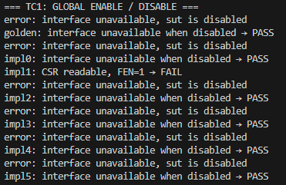
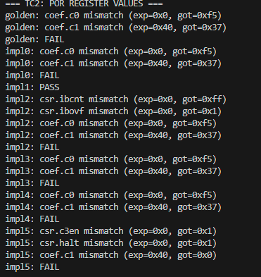
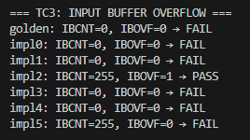
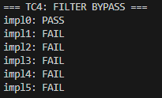
Testcase 2
Testcase 3
Testcase 4

Test case 5
With p0.cfg | With p4.cfg
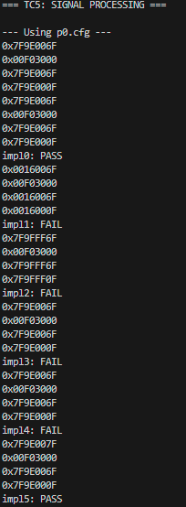 | 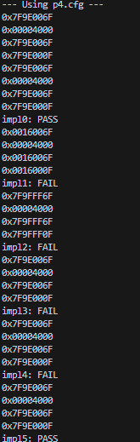

With p7.cfg | With p9.cfg
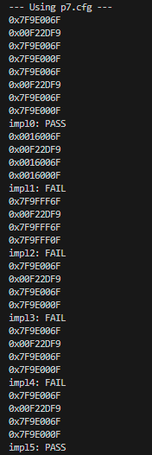 | 