
Misr International University
Course Code & Title: IS388 & SWE230 Web Development
Semester: Spring 2025

Lab 1
HTML
Example 1:
This example illustrates that the web page division will be as the following figure:
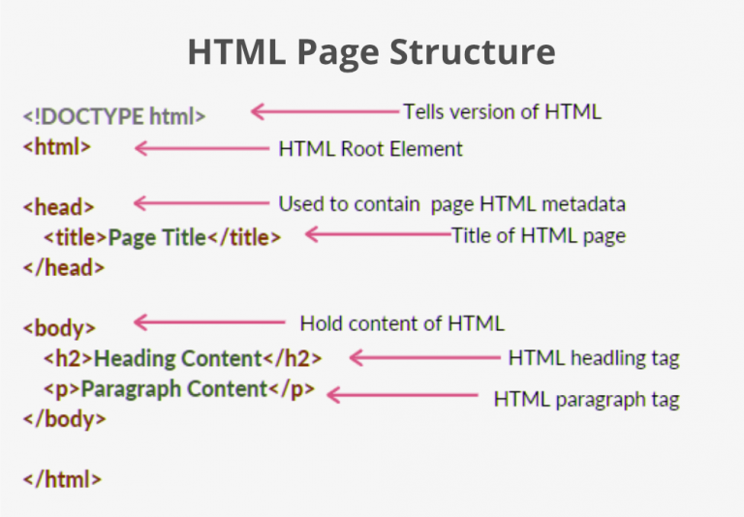

Tag Syntax:
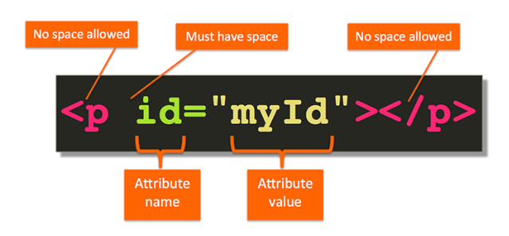
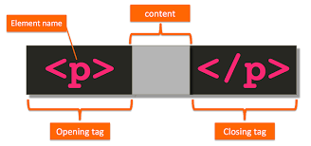
Code:
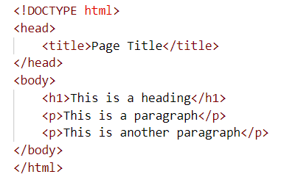

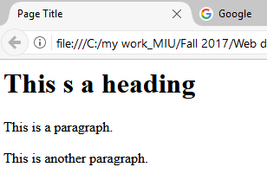
Output:

Example 2:
Headings: from h1 to h6:
Code:
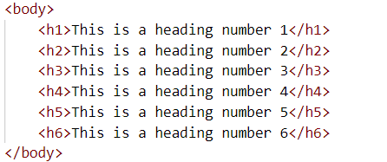

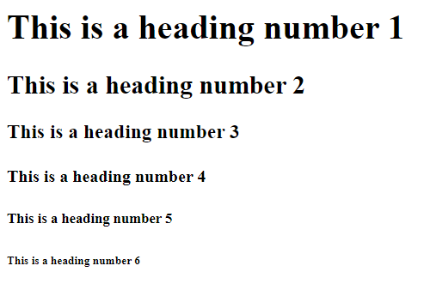
Output:

Example 3:
Paragraph and line break tags.
Code:
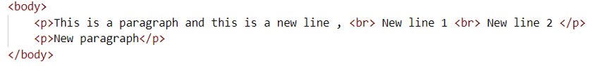
Output:


Example 4:
Horizontal tag
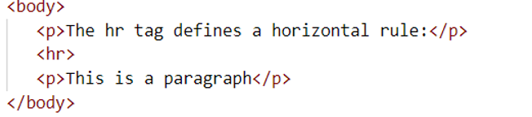
Code:

Output:
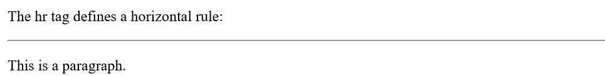

Example 5:
Adding a hyperlink
Code:
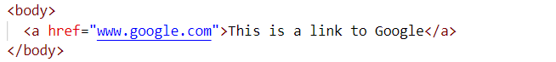

Output:


When you press the link it will go to the website.

Example 6:
Adding an image
Code:
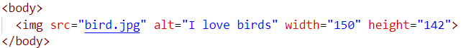

Adding an image with a caption:
Code:
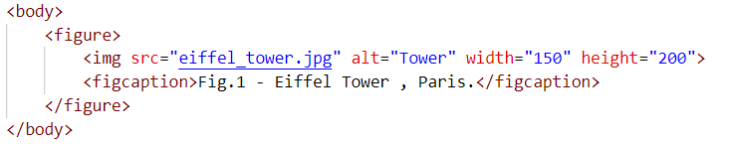

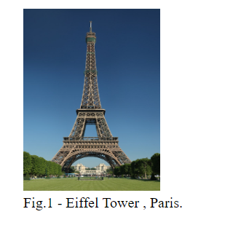
Output:

Example 7:
Adding a video
Example 1:
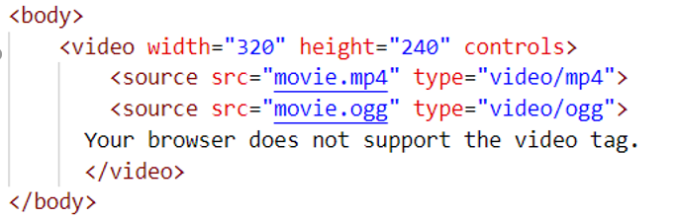

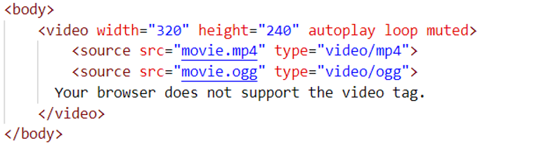
Example 2:

Example 8:
Ordered and unordered list
Code:
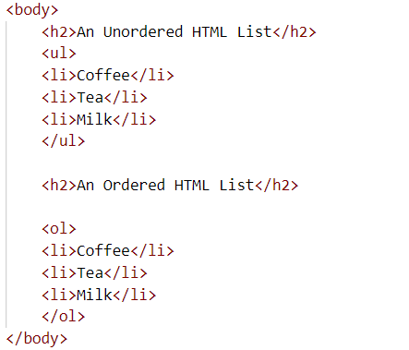

Output:

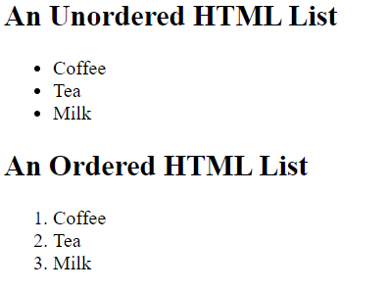

Note:
Bold and italic
Code:
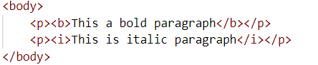

Output:
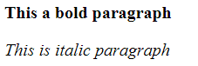

Example 9:
Forms
Code:
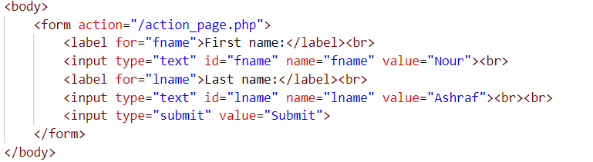
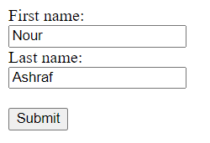
Output

Exercises
Exercise 1:
Create the following registeration form:
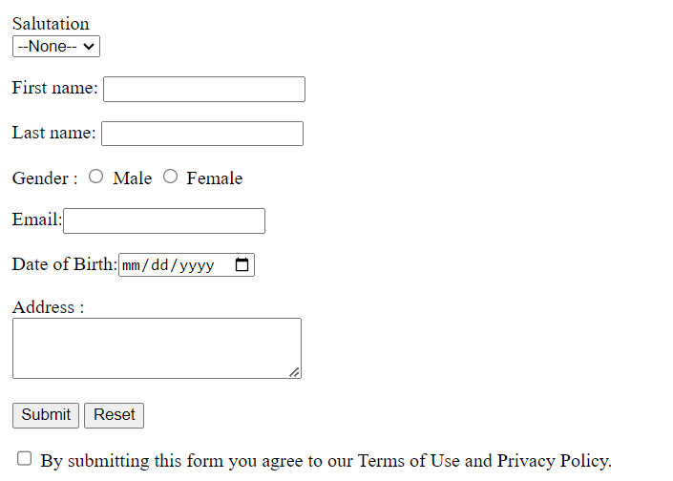

Notes:
1-The submitted data shouldn’t be shown in the URL and the response should be displayed in a new window.
2-Maximum length of first and last name is 10 characters .
3-Email field must be filled.
4-Set the height of the address field to 30 and the width to 50.
Exercise 2:
Create the following table:
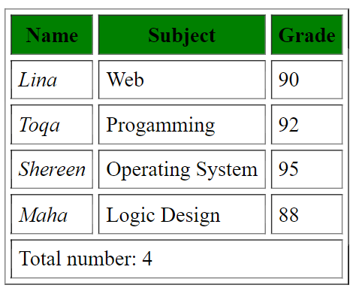
Note:
Set cellpadding to 5 and cellspacing to 4.

