**Nama : Nabil Sahsada Suratno**

**Nim : 202410370110357**

**Kelas : H**

**Bab 2 Latihan 1**

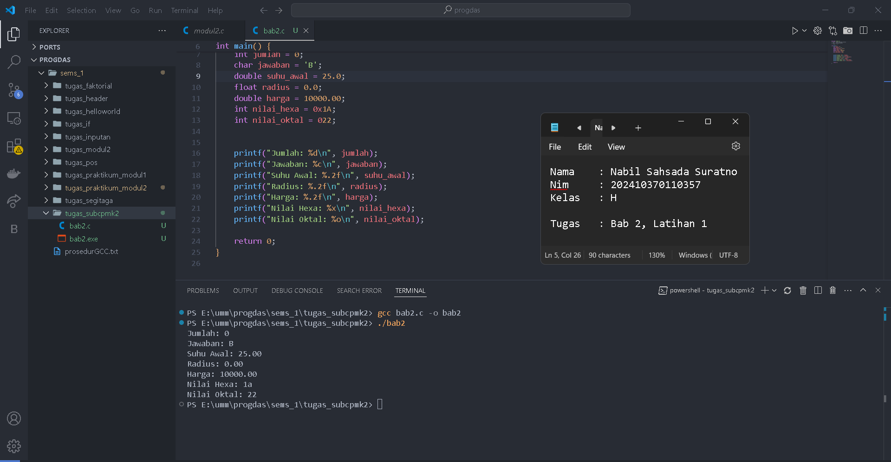

**Bab 2 Latihan 2**

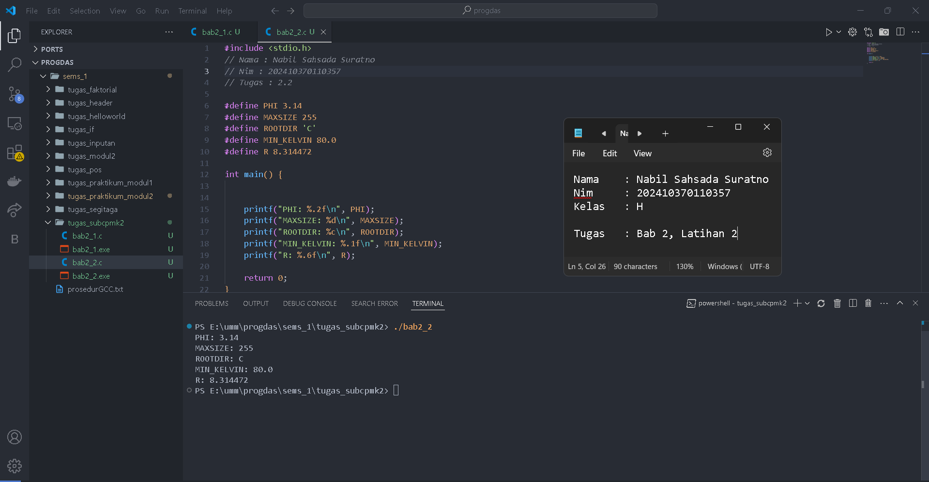

**Bab 3 Latihan 1**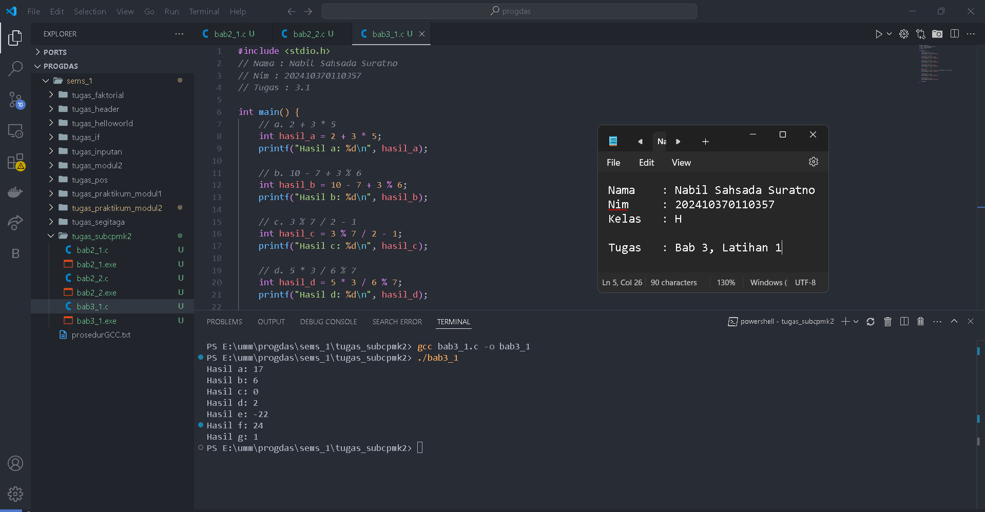

**Bab 4 Latihan 1**

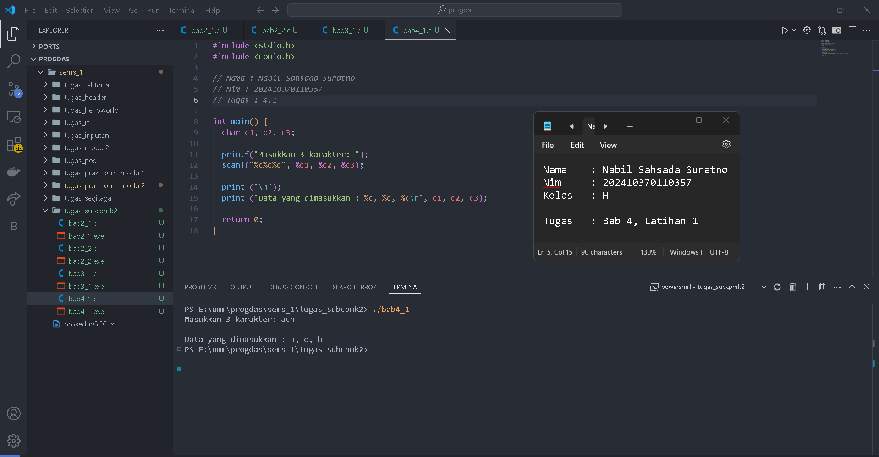

**Bab 4 Latihan 2**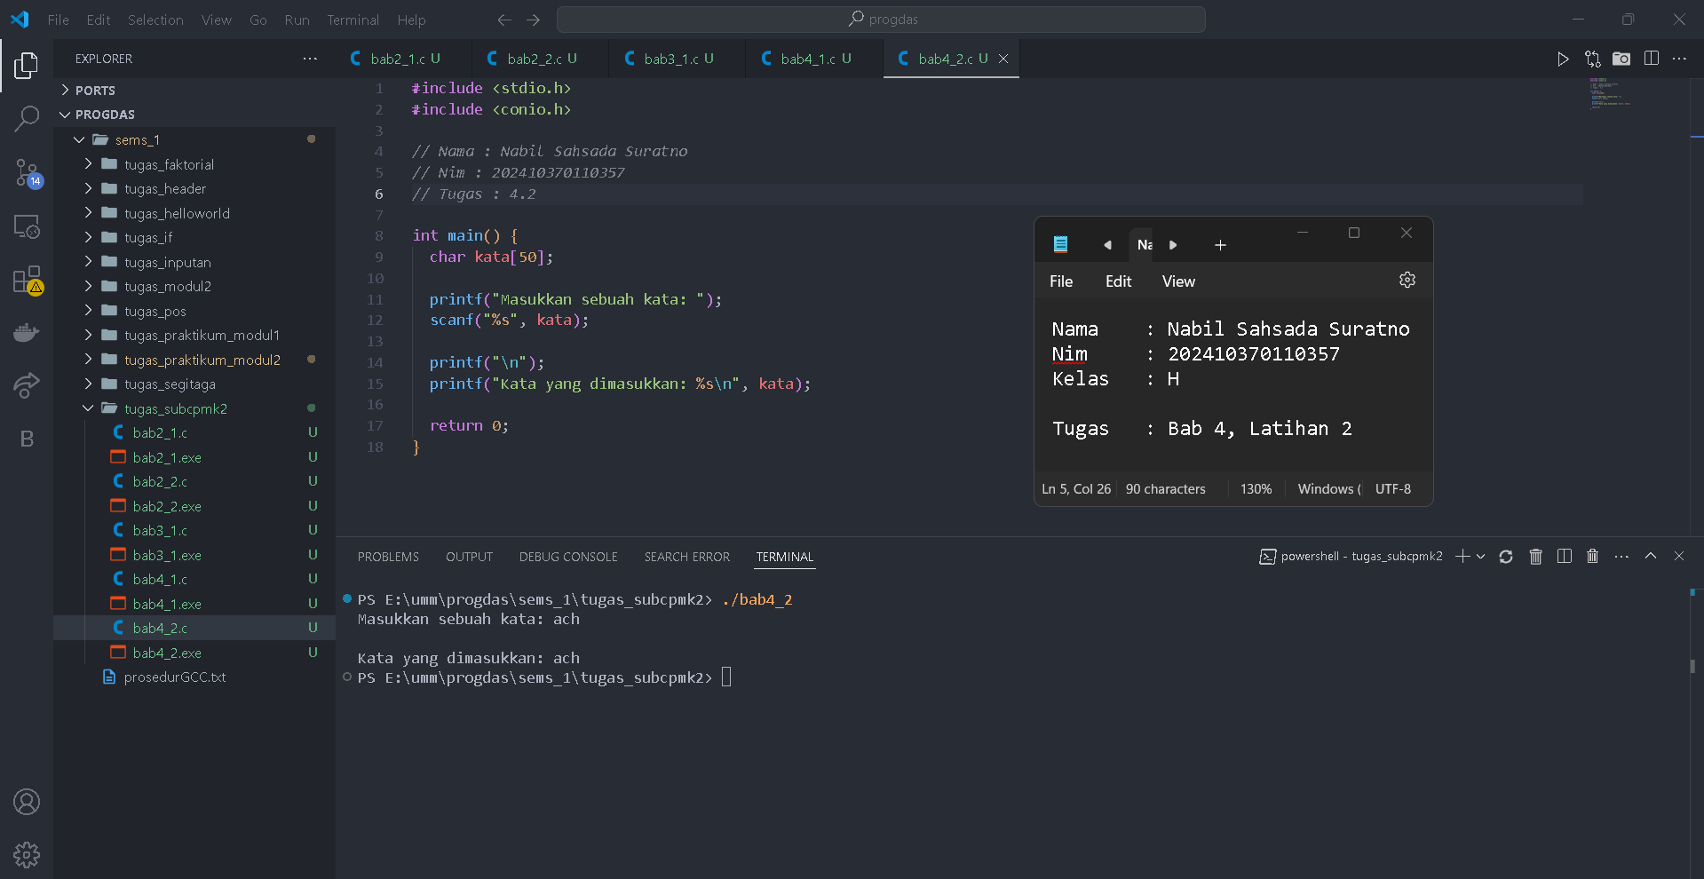

**Bab 4 Latihan 3**

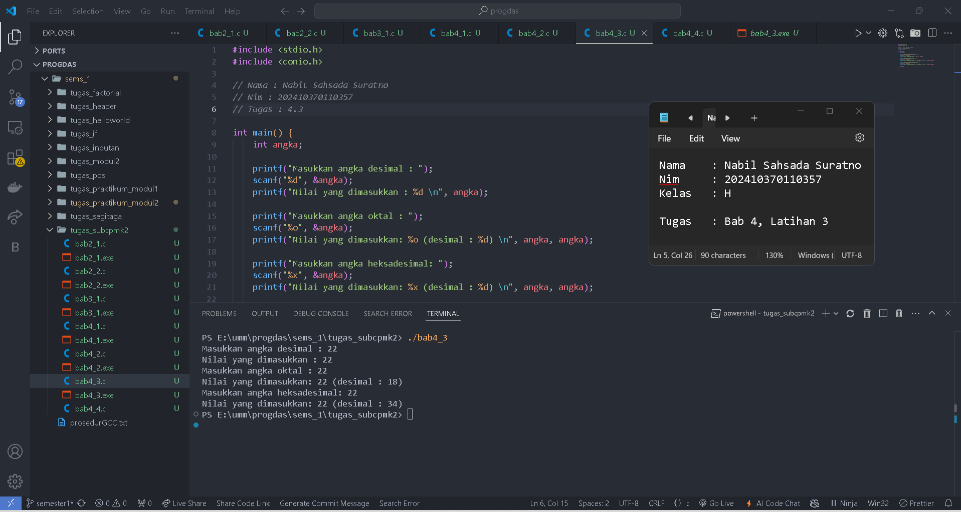

**Bab 4 Latihan 4**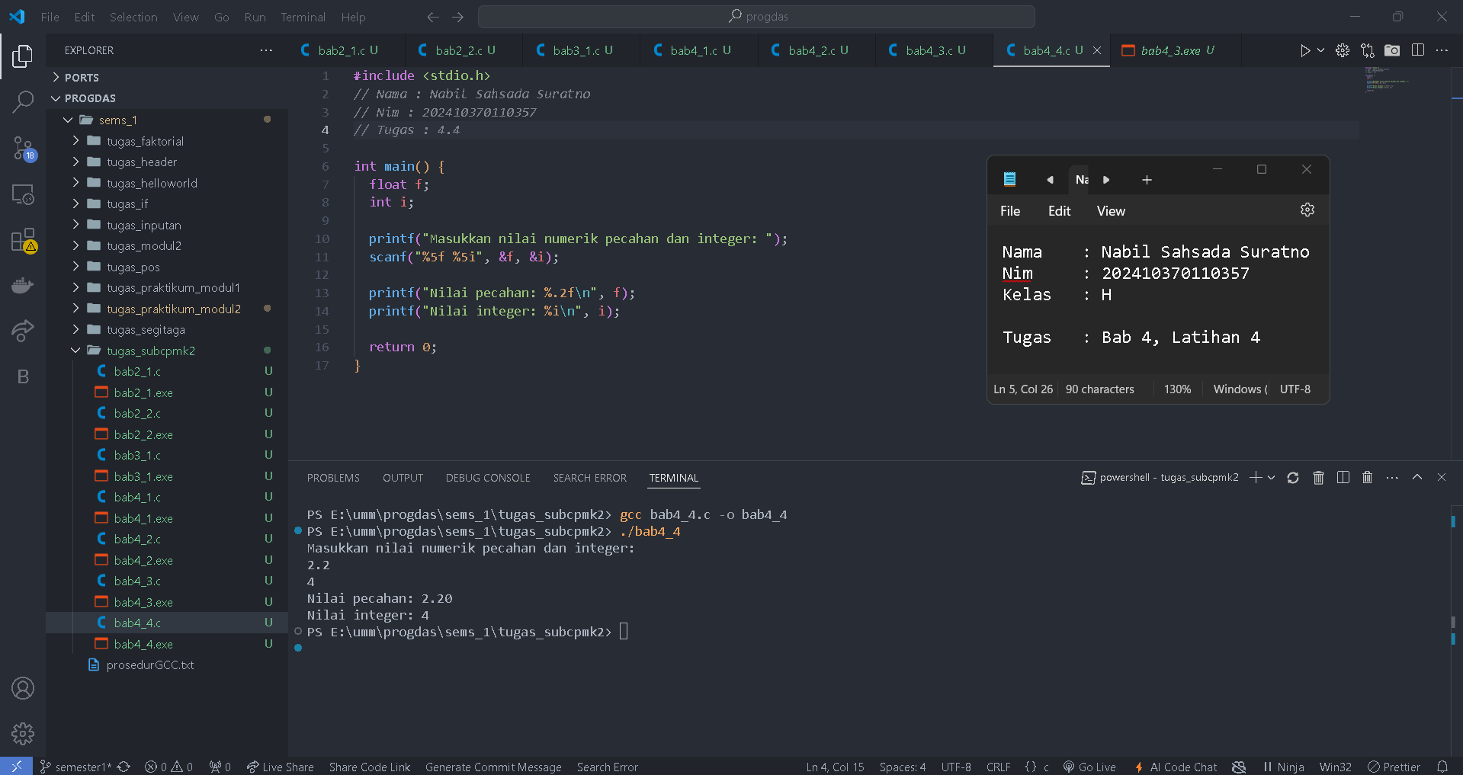

**Bab 5 Latihan 1**

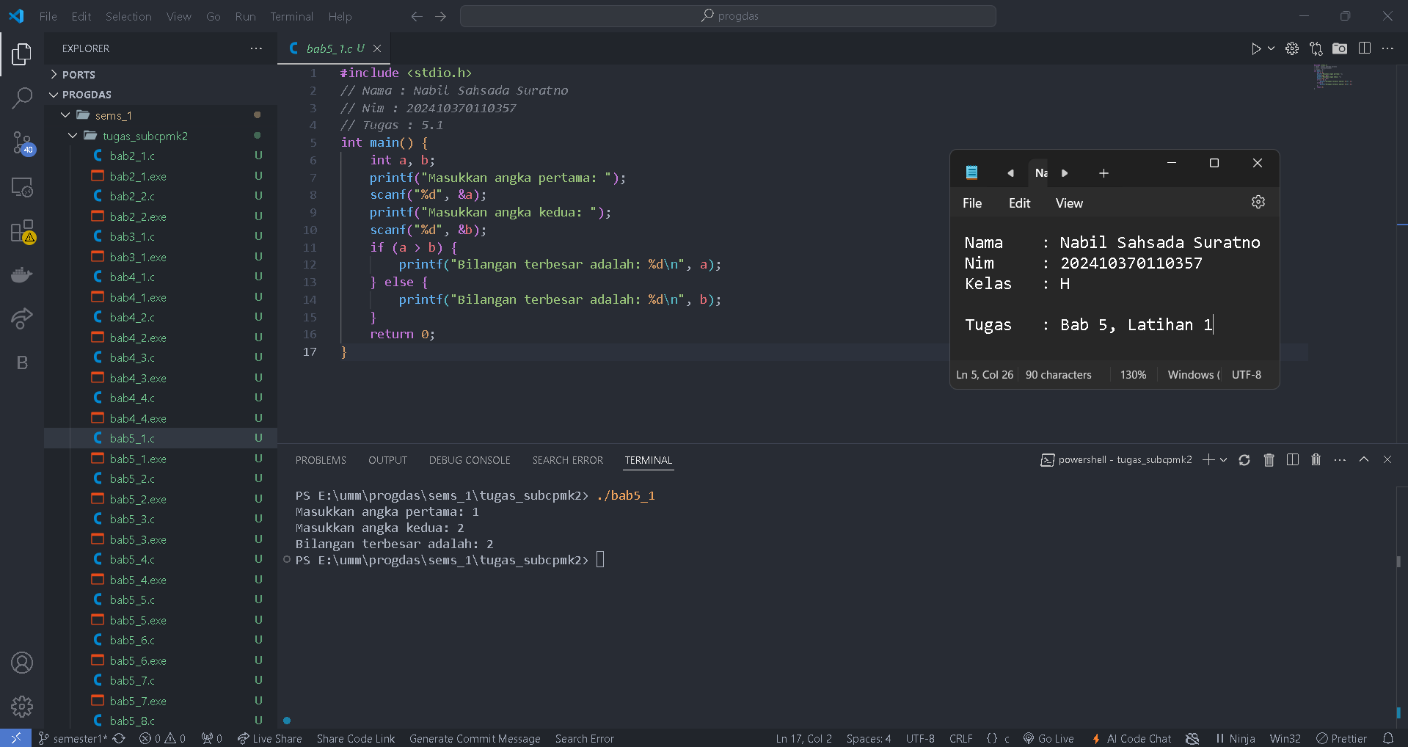

**Bab 5 Latihan 2**

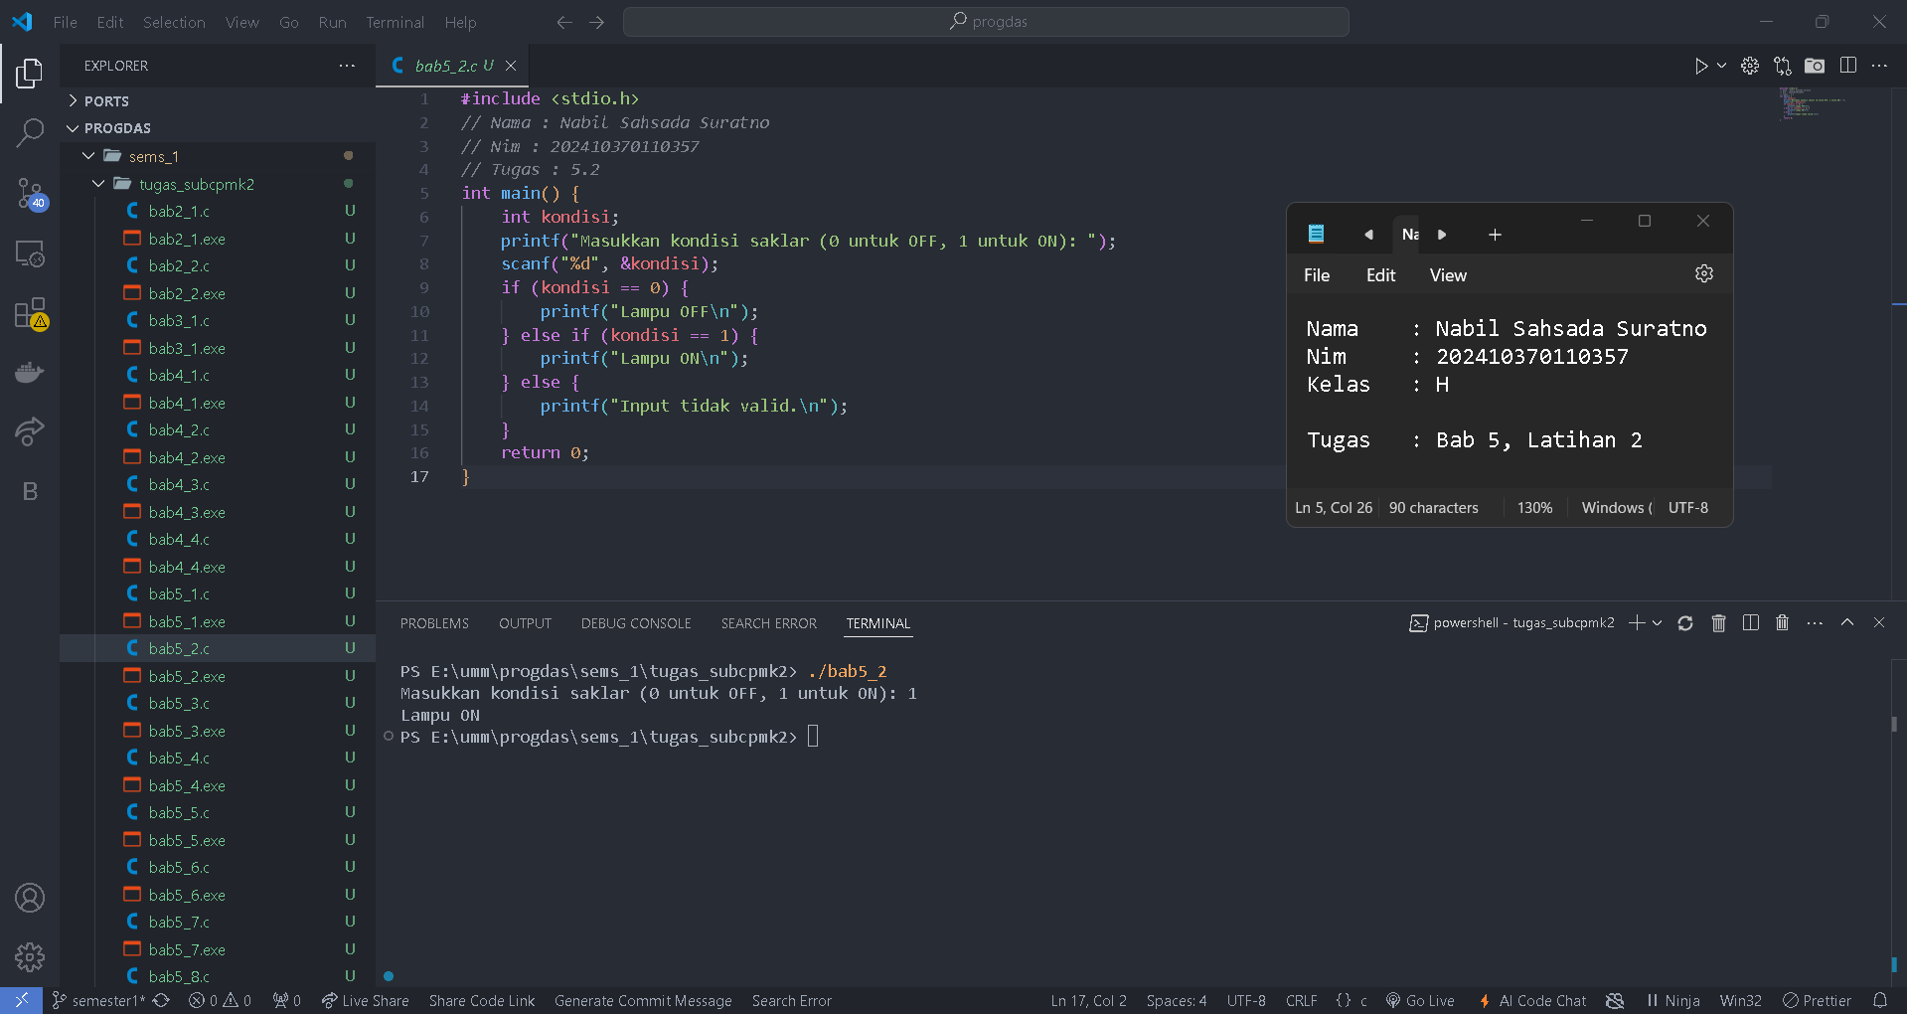

**Bab 5 Latihan 3**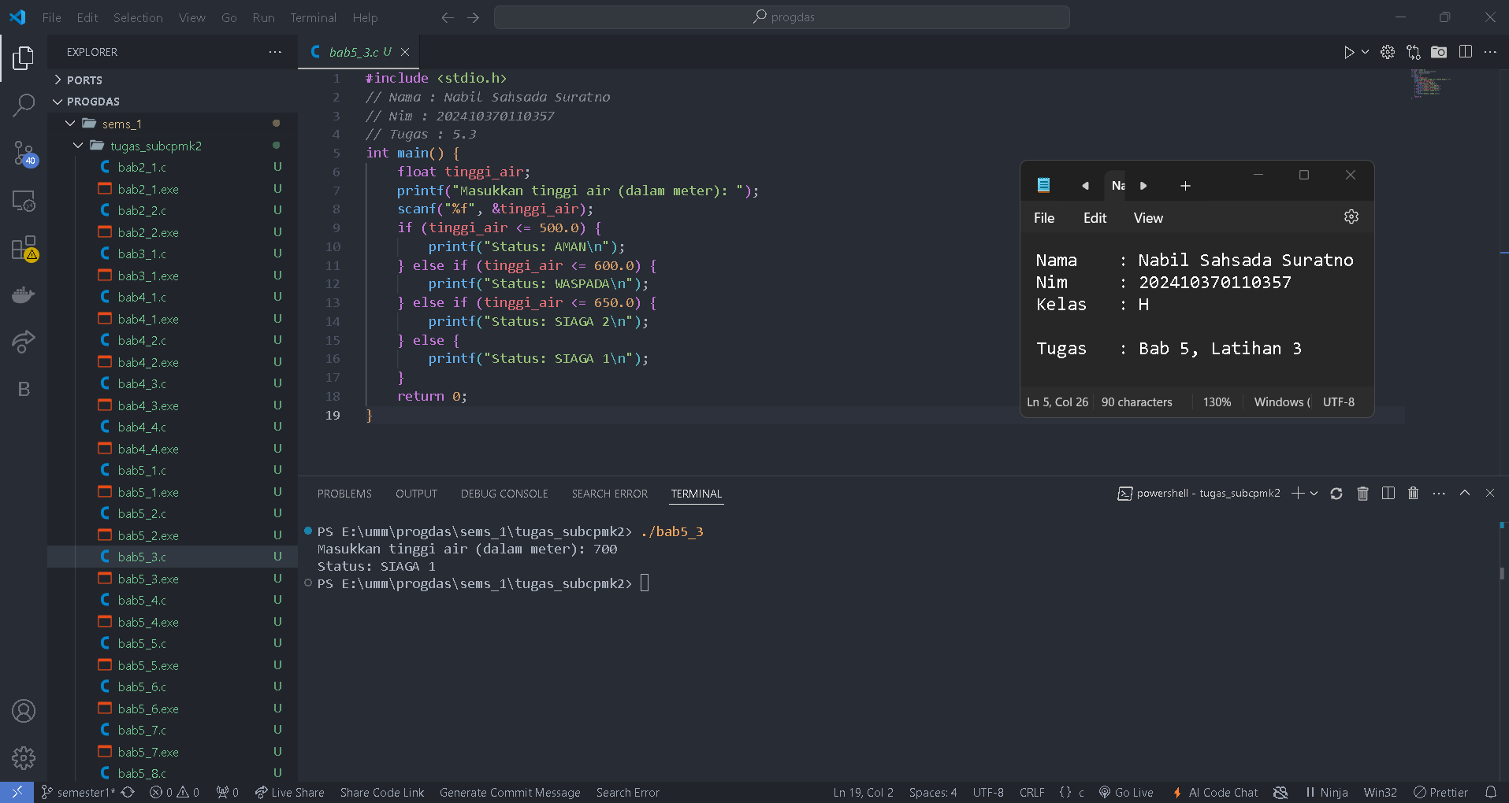

**Bab 5 Latihan 4**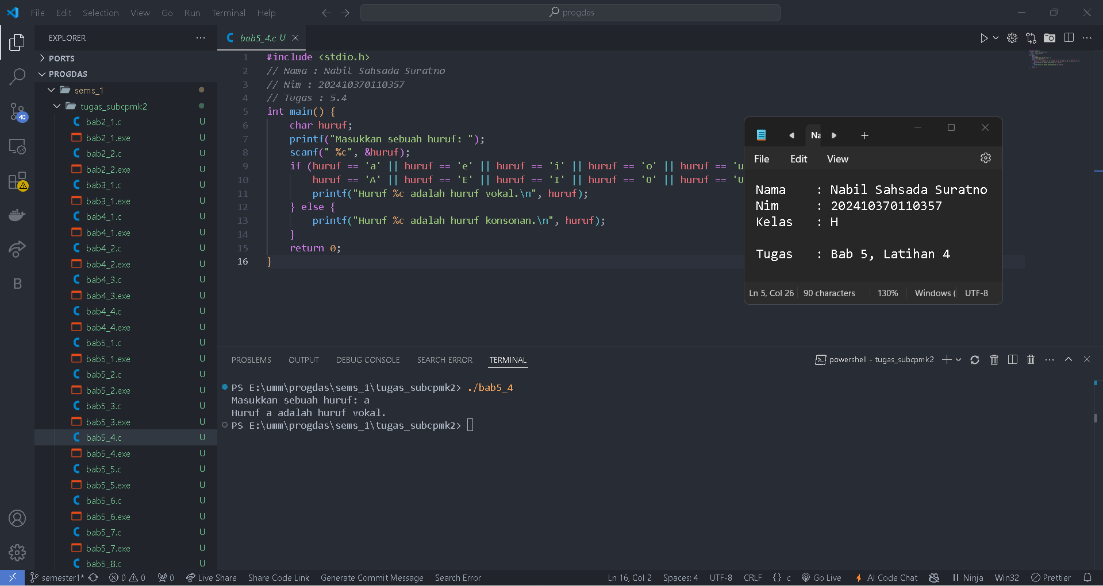

**Bab Latihan 5**

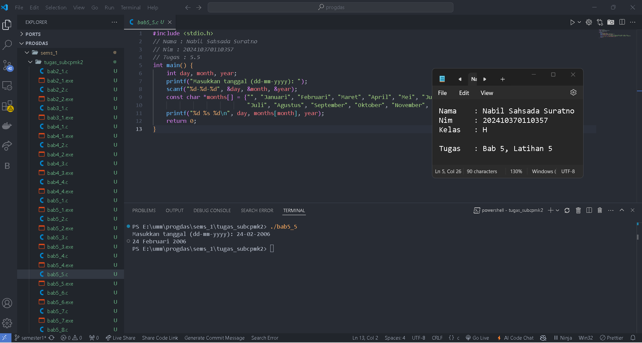

**Bab Latihan 6**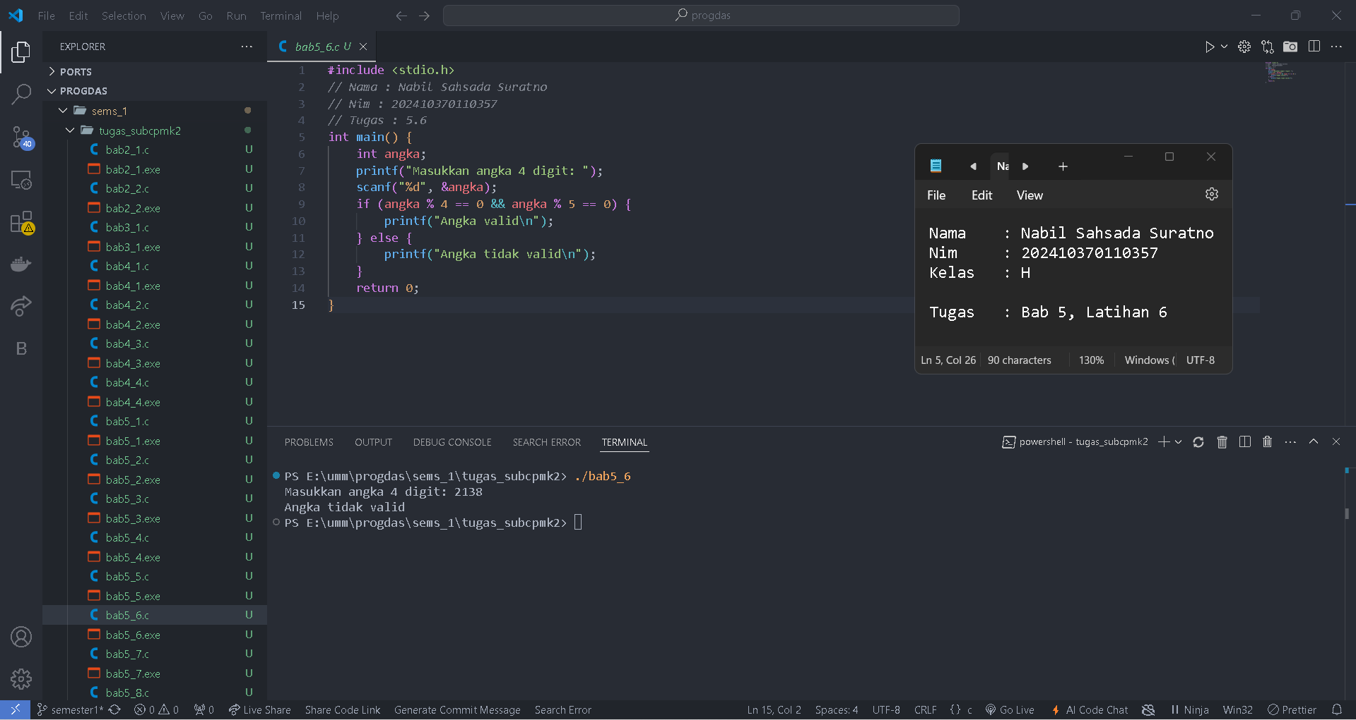

**Bab 5 Latihan 7**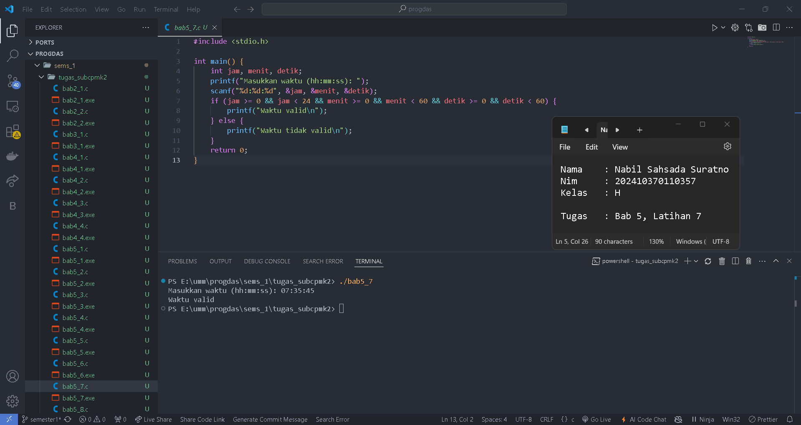

**Bab Latihan 8**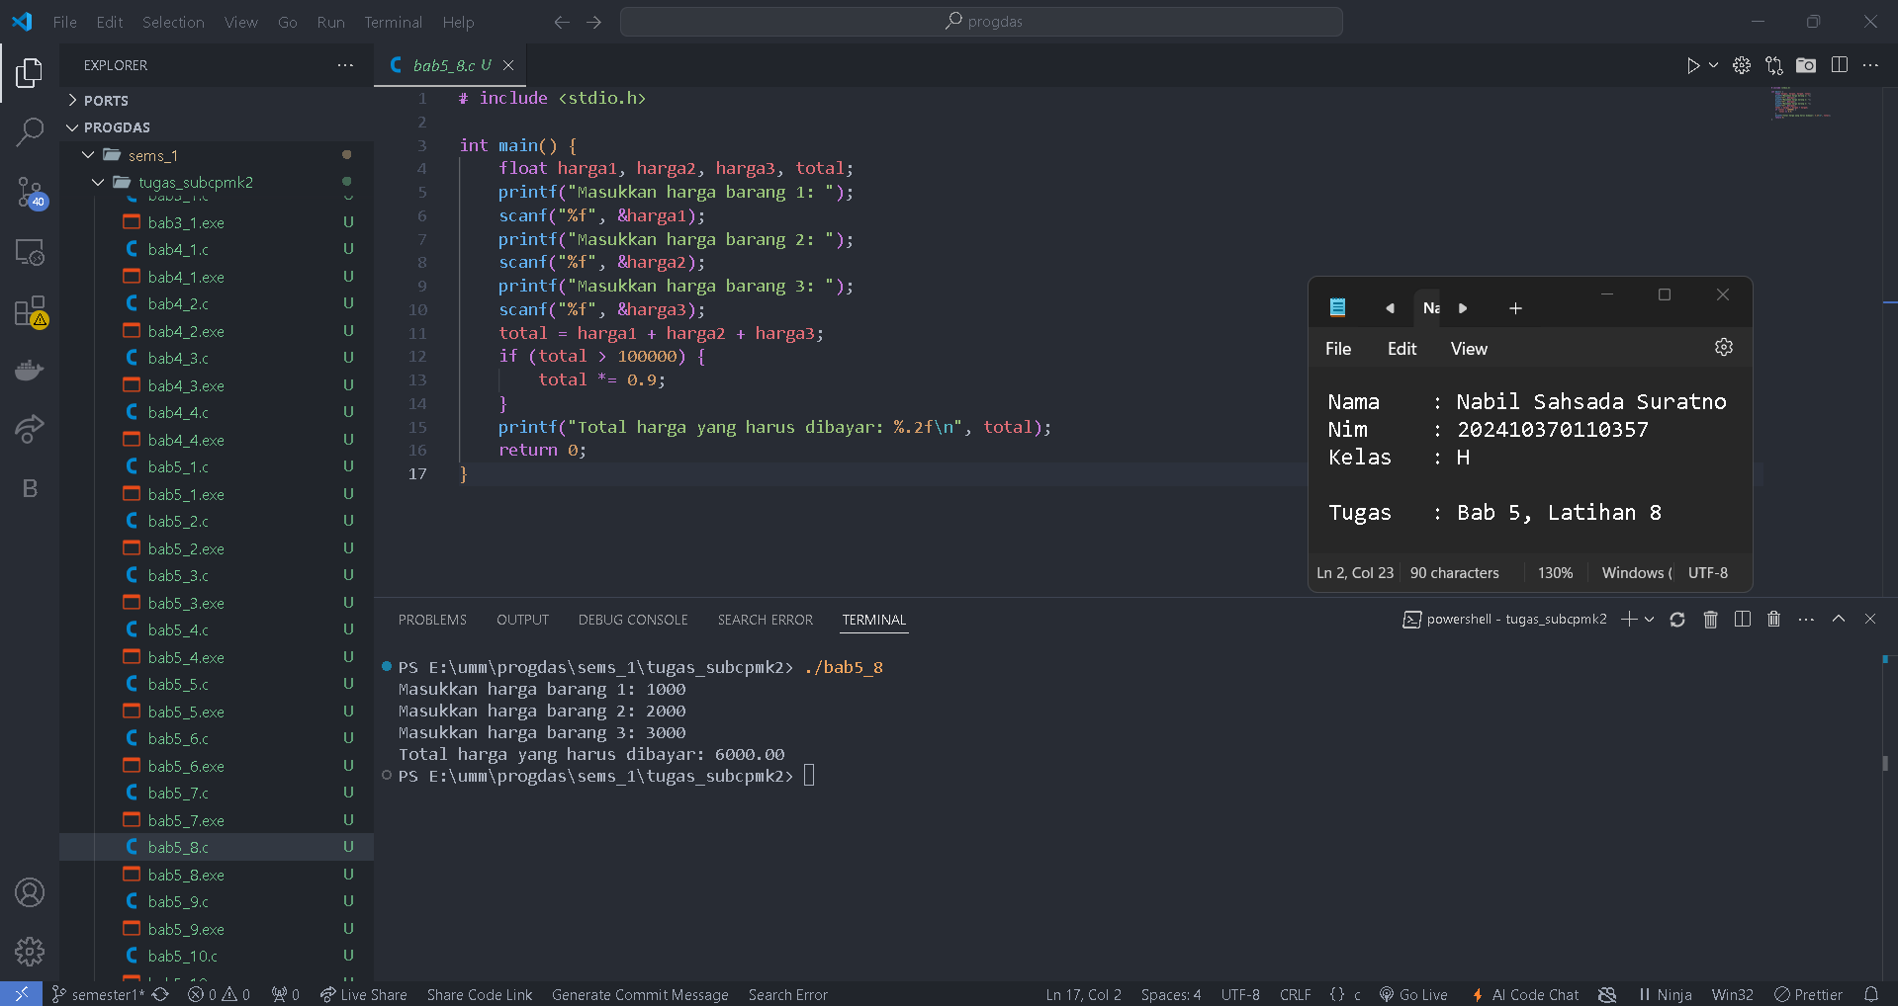

**Bab 5 Latihan 9**

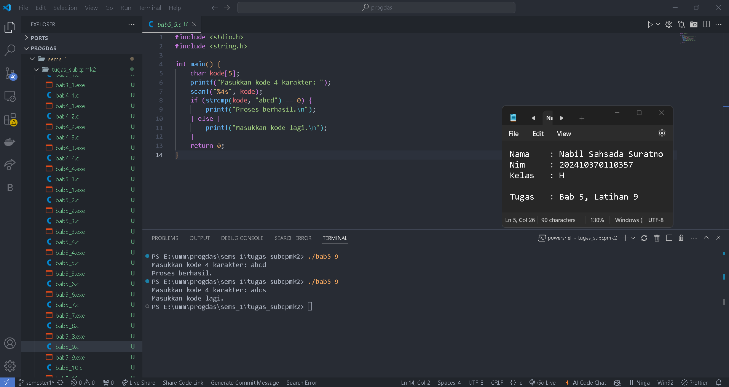

**Bab 5 Latihan 10**

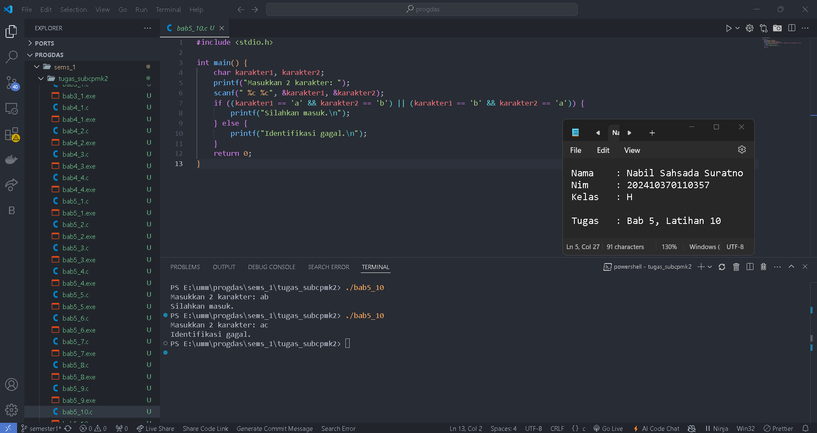

**Bab 5 Latihan 11**

