GameApps:

Here one screen to another screen is performed. Here consist of three files.

file name: game

Code in main.dart:

1. import 'package:game/home_page.dart';
2. import 'package:flutter/material.dart';
3. import 'package:game/game_page.dart';
4. void main() {
5. runApp(MaterialApp(
6. title: "Game App",
7. home: GamePage(),
8. ));
9. }

Code in game_page.dart

1. import 'package:flutter/material.dart';
2. import 'package:game/home_page.dart';
3. class GamePage extends StatelessWidget {
4. GamePage({Key? key}) : super(key: key);
5. TextEditingController cName = TextEditingController();
6. @override
7. Widget build(BuildContext context) {
8. return Scaffold(
9. appBar: AppBar(
10. title: Text("Game Page"),
11. ),
12. body: Center(
13. child: Padding(
14. padding: const EdgeInsets.all(20.0),
15. child: Column(
16. mainAxisAlignment: MainAxisAlignment.center,
17. children: [
18. TextField(
19. controller: cName,
20. decoration: const InputDecoration(
21. label: Center(child: Text("Enter your Data"))),
22. ),
23. SizedBox(
24. height: 20,
25. ),
26. ElevatedButton(
27. onPressed: () {
28. if (cName.text.isEmpty) return;
29. Navigator.push(
30. context,
31. MaterialPageRoute(
32. builder: (context) => HomePage(cName.text)),
33. );
34. },
35. child: Text("Continue"))
36. ],
37. ),
38. ),
39. ));
40. }
41. }

Code in home_page.dart

1. import 'package:flutter/material.dart';
2. class HomePage extends StatelessWidget {
3. final String name;
4. HomePage(this.name);
5. @override
6. Widget build(BuildContext context) {
7. return Scaffold(
8. body: Center(child: Text("Hello, $name")),
9. );
10. }
11. }

Output:

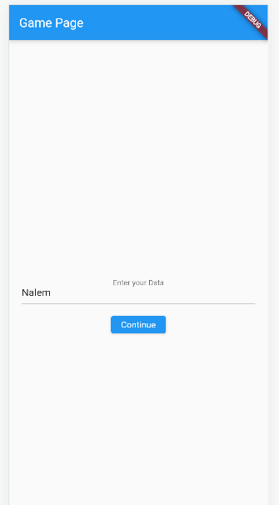 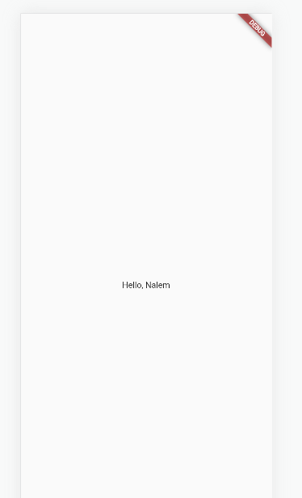

On tap continue the screen 1 to screen 2