**CSE 3330                                            Project 2 Phase 2                                                 Fall 2020**

**HONOR CODE**

I pledge, on my honor, to uphold UT Arlington's tradition of academic integrity, a tradition that values hard work and honest effort in the pursuit of academic excellence.

I promise that I will submit only work that I personally create or that I contribute to group collaborations, and I will appropriately reference any work from other sources. I will follow the highest standards of integrity and uphold the spirit of the Honor Code

I will not participate in any form of cheating/sharing the questions/solutions.



Aashis Adhikari Nabin Shrestha Santosh Pandey

1001752163 1001746226 1001744702

**Part 1**

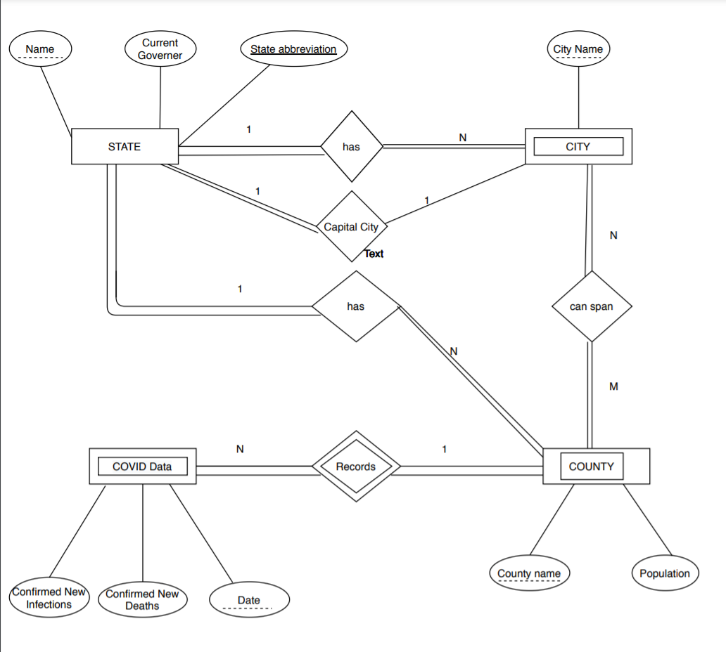

ER Diagram

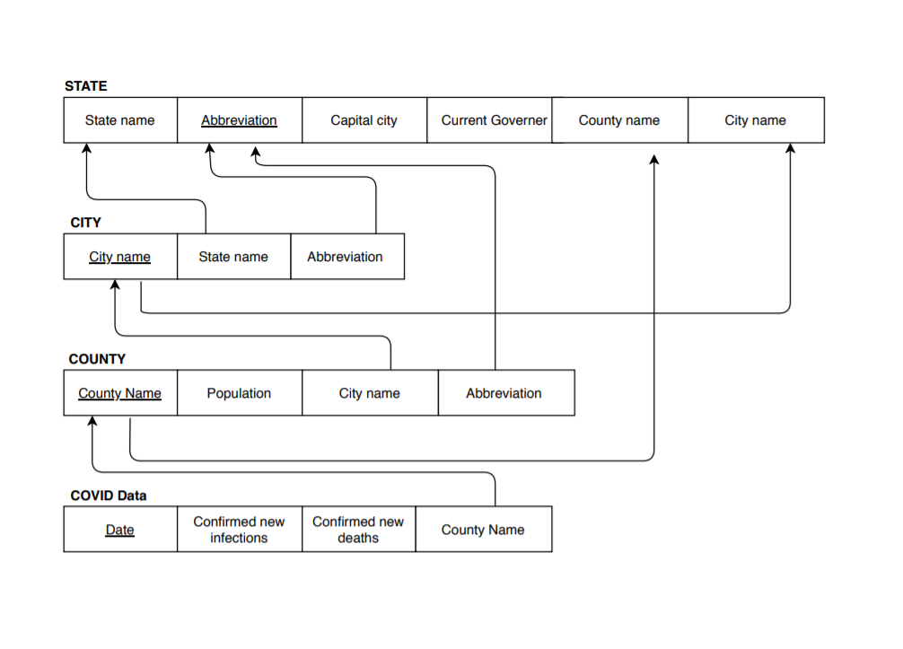

Fig: Schema

**CREATE TABLE statements**

CREATE TABLE STATES

(State_Name VARCHAR(15) NOT NULL,

State_Ab VARCHAR(5) NOT NULL,

Capital VARCHAR(15) NOT NULL,

Governor VARCHAR(15) NOT NULL,

PRIMARY KEY(State_Ab),

UNIQUE(State_Name)

);

CREATE TABLE COUNTIES

(County_Name VARCHAR(15),

State_Ab VARCHAR(5),

Population INT,

PRIMARY KEY (County_Name, State_Ab),

FOREIGN KEY(State_Ab) REFERENCES states(State_Ab)

);

CREATE TABLE CITIES

( State_Ab VARCHAR(15),

City_Name VARCHAR(15),

PRIMARY KEY(City_Name),

FOREIGN KEY(State_Ab) REFERENCES STATES(state_Ab)

);

CREATE TABLE City_County

(State_Ab VARCHAR(15),

City_Name VARCHAR(15),

County_Name VARCHAR(15),

PRIMARY KEY (State_Ab, City_Name, County_Name),

FOREIGN KEY (State_Ab) REFERENCES CITIES(State_Ab),

FOREIGN KEY (City_Name) REFERENCES CITIES(City_Name),

FOREIGN KEY (County_Name) REFERENCES COUNTIES(County_Name)

);

CREATE TABLE COVIDDATA

(CDate DATE,

County_Name VARCHAR(15),

State_Name CHAR(5),

Daily_Count_Cases INT,

Daily_Deaths INT,

PRIMARY KEY (CDate, State_Name, County_Name),

FOREIGN KEY(County_Name) REFERENCES COUNTIES(County_Name),

FOREIGN key(State_Name) REFERENCES COUNTIES(State_Name)

);

**Execution of Select query**

SELECT *

FROM ‘states’

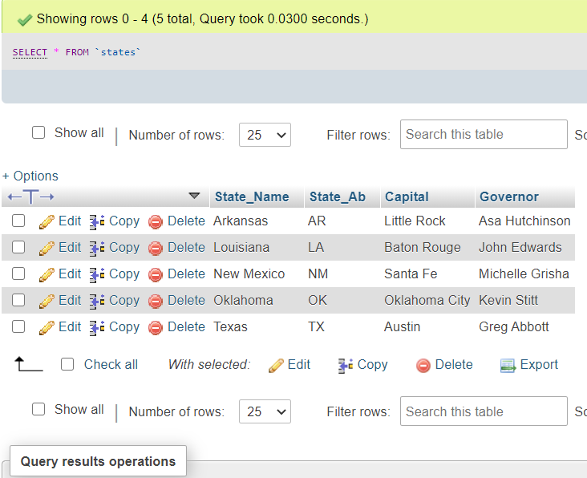

SELECT *

FROM ‘cities’

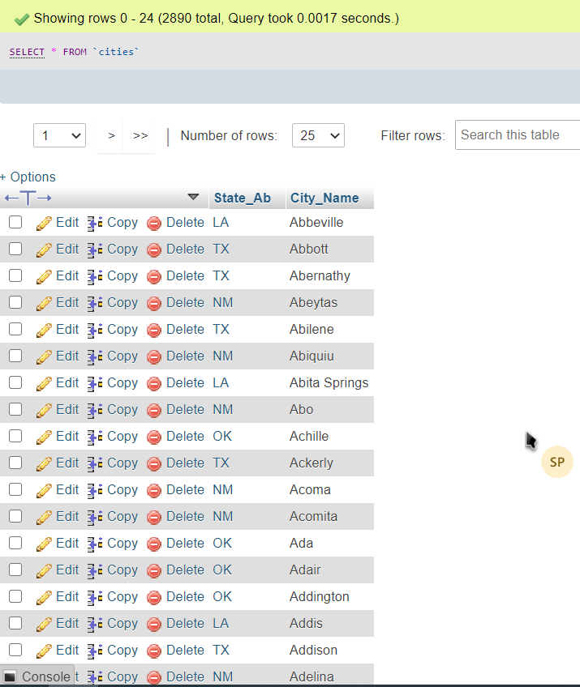

SELECT *

FROM ‘city_county’

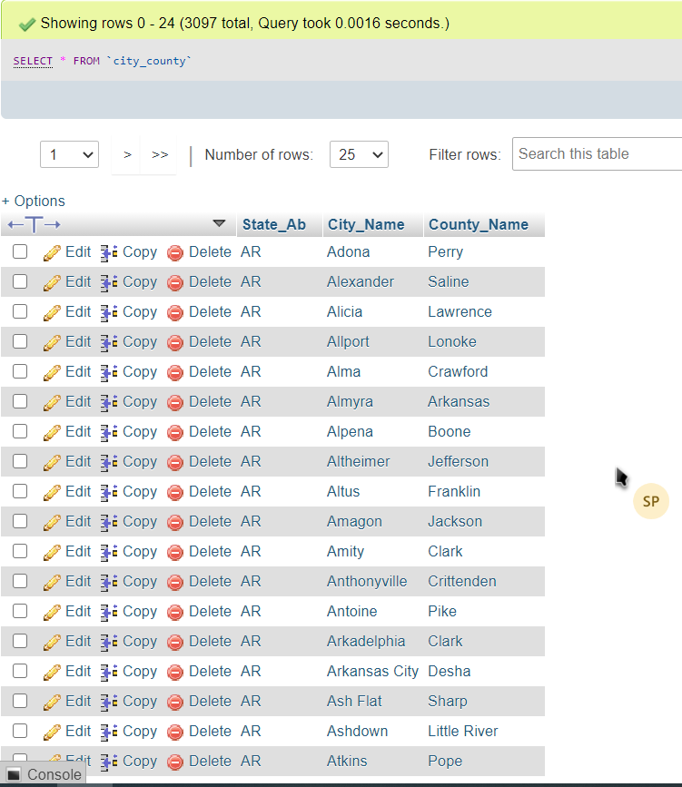

SELECT *

FROM ‘counties’

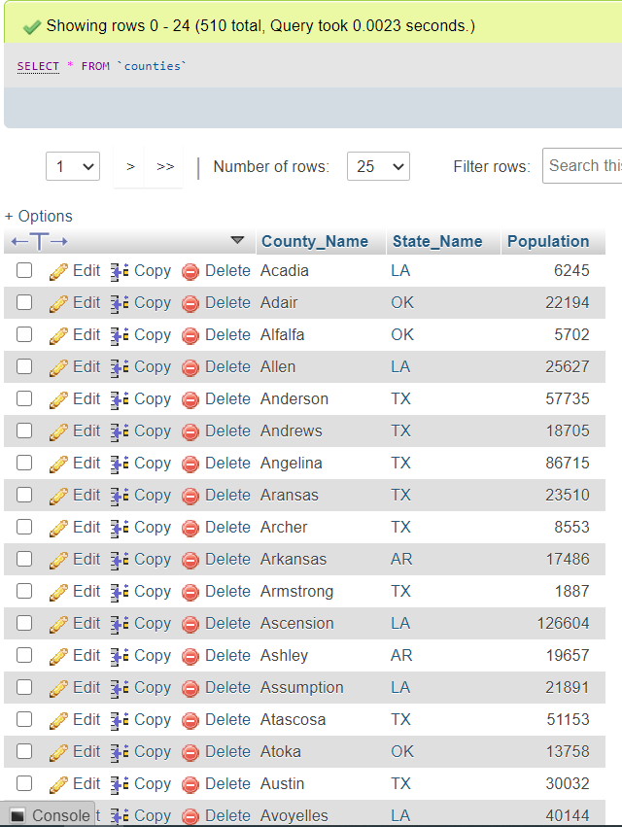

SELECT *

FROM ‘coviddata’

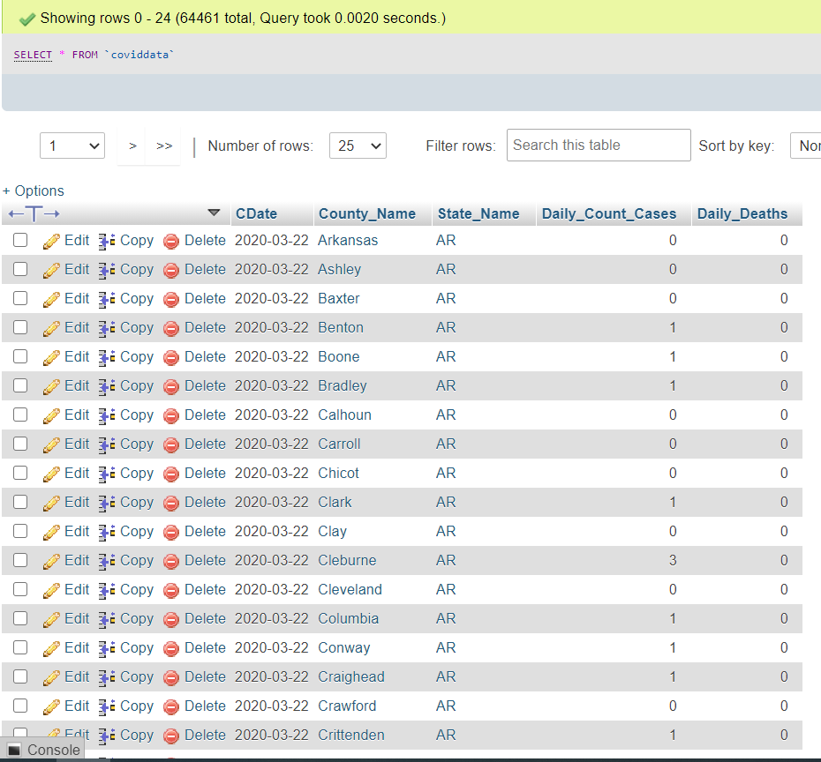

**Part 2**

**Q1. Retrieve the states, their capital cities and governor’s name for all the states whose data is in our COVID19 database.**

SELECT s.State_name, s.Capital, s.Governor

FROM states s;

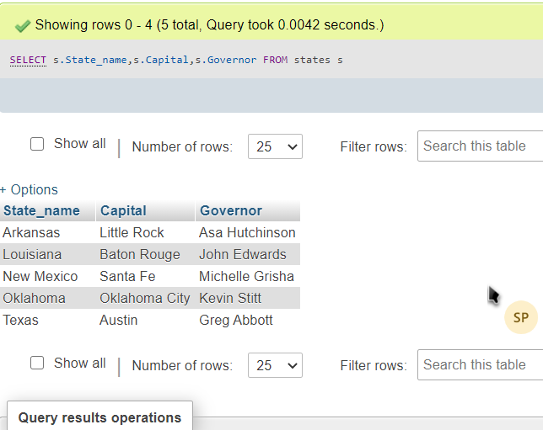

**Q2 Retrieve the names of counties in the state of ‘Texas’. It is sufficient to show the screen shot giving the total number of rows and the first set of counties. Your query should include ‘Texas’ and not ‘TX’.**

SELECT c.County_Name, s.State_Name

FROM states s, counties c

WHERE s.State_Name = "Texas" AND s.State_Ab=c.State_Name

GROUP BY c.County_Name;

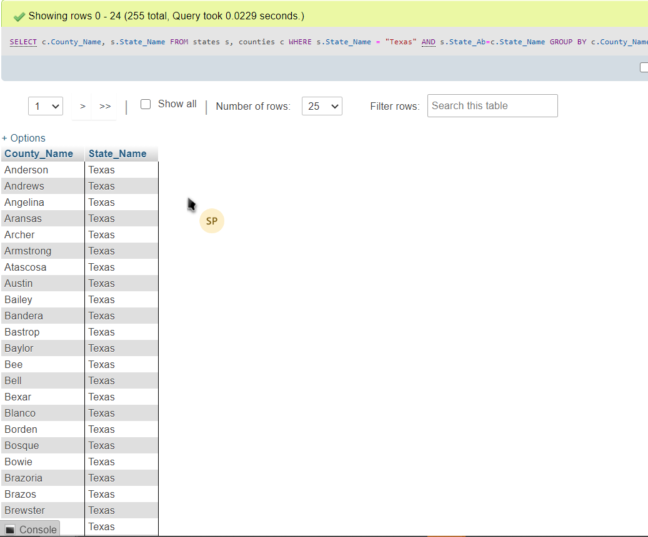

**Q3 Retrieve the total number of counties in each state along with the state name (for example Texas). (Your query will be considered incorrect if it returns the state abbreviation instead of the full state name)**

SELECT COUNT(*) AS "No. of Counties",S.State_Name

FROM states s, counties c

WHERE s.State_Ab=c.State_Name

GROUP BY S.State_Name

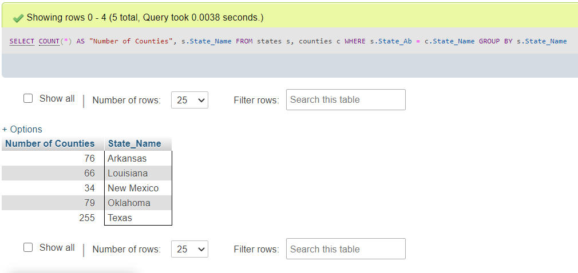

**Q4 Retrieve the names of the states, their capital cities, and the name of their governor for all the states that have more than 70 counties.**

SELECT s.State_Name, s.Capital,s.Governor

FROM states s, counties c

WHERE s.State_Ab=c.State_Name

GROUP BY s.State_Name, s.Capital, s.Governor

HAVING COUNT(*)>70;

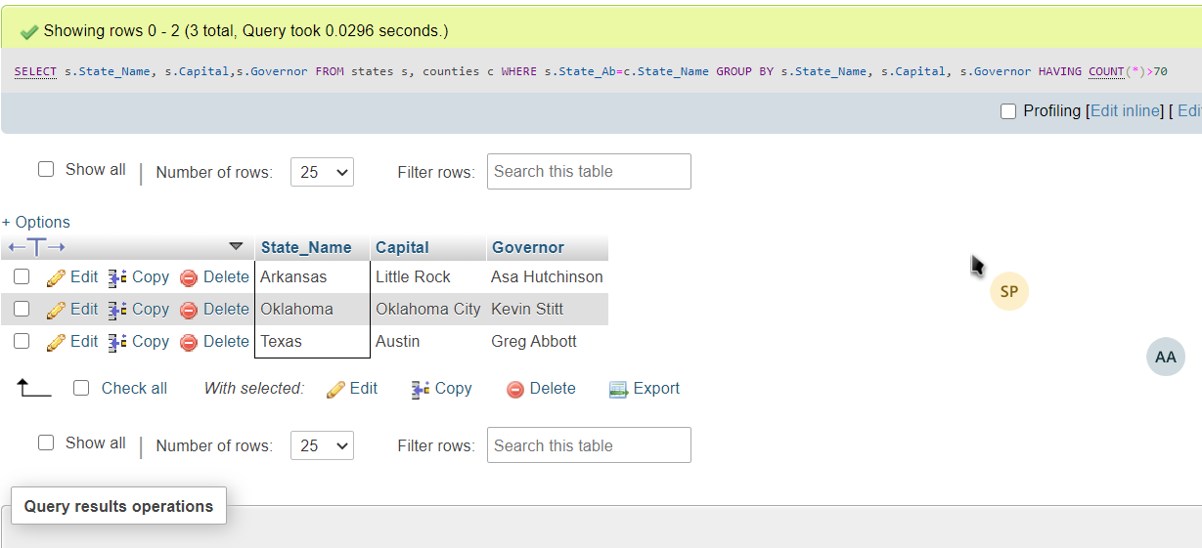

**Q5. Retrieve the names of all the states and their governors if their last name starts with a vowel.**

SELECT DISTINCT s.State_Name, s.Governor

FROM states s

WHERE s.Governor LIKE'% A%' OR s.Governor LIKE'% E%' OR s.Governor LIKE'% I%' OR s.Governor LIKE'% O%' OR s.Governor LIKE'% U%'

GROUP BY s.State_Name, s.Governor;

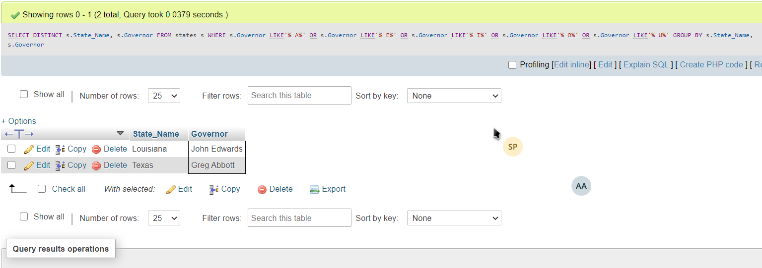

**Q6. Retrieve the names of all the states and the total number of counties for each state for which we have Covid 19 data in our database. Do not take Unassigned data into consideration. Which table will you use and why?**

SELECT S.State_Name, COUNT(*) AS "No. of Counties"

FROM states s, counties c, coviddata d

WHERE s.State_Ab=c.State_Name AND c.County_Name = d.County_Name AND d.County_Name != 'UNASSIGNED'

GROUP BY S.State_Name

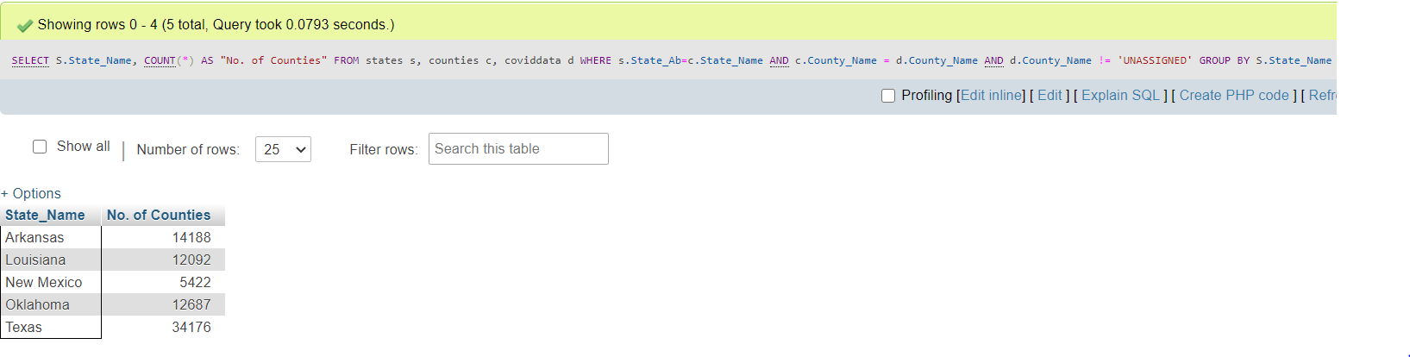

**Q7. Retrieve a list that displays the state, date, SumConfirmed and SumDeaths, SumConfirmed and SumDeaths are the sum of the confirmed Covid cases and the sum of deaths by Covid on the given date in each state. (Hint: use GROUP BY Date, State on the CovidData table.) (Your query will be considered incorrect if it returns the state abbreviation instead of the full state name)**

SELECT s.State_Name, c.CDate, SUM(c.Daily_Count_Cases) AS 'SumConfirmed', SUM(c.Daily_Deaths) AS 'SumDeaths'

FROM coviddata c,states s

WHERE c.State_Name=s.State_Ab

GROUP BY c.CDate, s.State_Name;

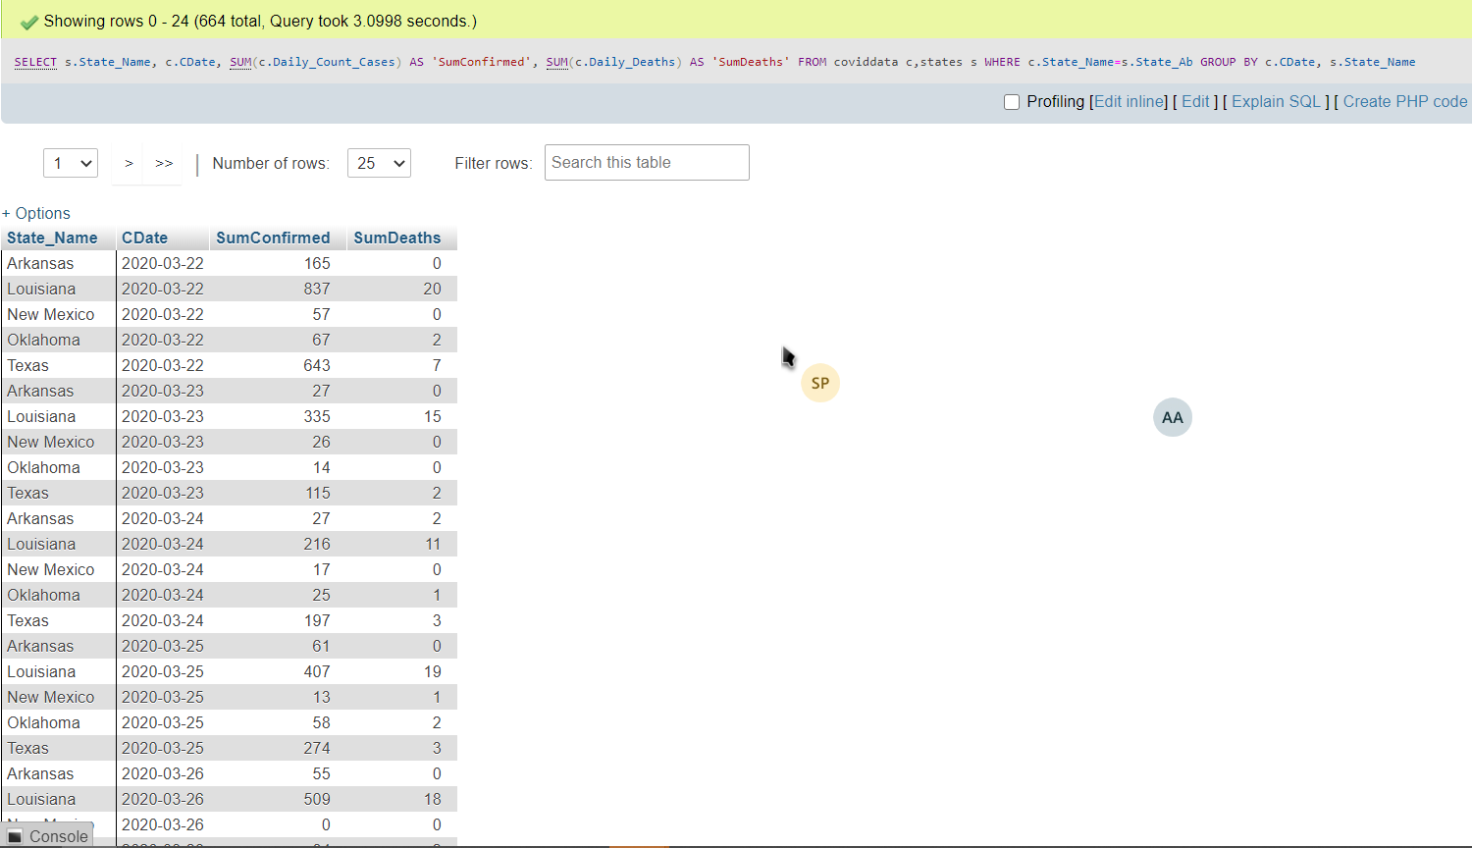

**Q8. Retrieve the states, date, the total number of new Covid infections and deaths on March 22 in each of the state for which we have the data. (Your query will be considered incorrect if it returns the state abbreviation instead of the full state name)**

SELECT s.State_Name, c.CDate, SUM(c.Daily_Count_Cases) AS 'New infections', SUM(c.Daily_Deaths) AS 'Deaths'

FROM coviddata c,states s

WHERE c.State_Name=s.State_Ab AND C.CDate = '2020-03-22'

GROUP BY c.CDate, s.State_Name;

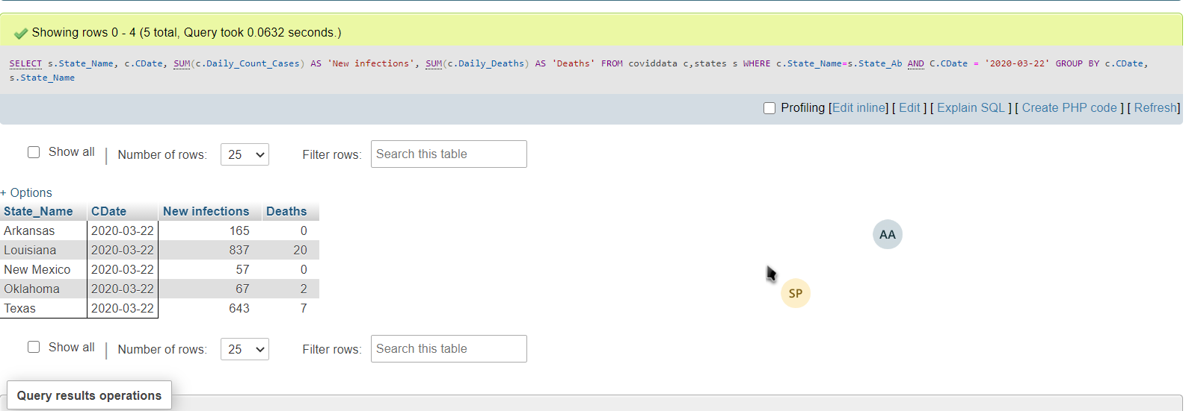

**Q9 Retrieve the state name, date, the total number of new Covid19 infections and deaths on March 22 for the state that had the maximum number of confirmed infections on March 22, 2020.**

SELECT s.State_Name, c.CDate, SUM(c.Daily_Count_Cases) AS 'Confirmed_infections', SUM(c.Daily_Deaths) AS 'Deaths'

FROM coviddata c,states s

WHERE c.State_Name=s.State_Ab AND C.CDate = '2020-03-22'

GROUP BY c.CDate, s.State_Name

ORDER BY SUM(c.Daily_Count_Cases) DESC

LIMIT 1;

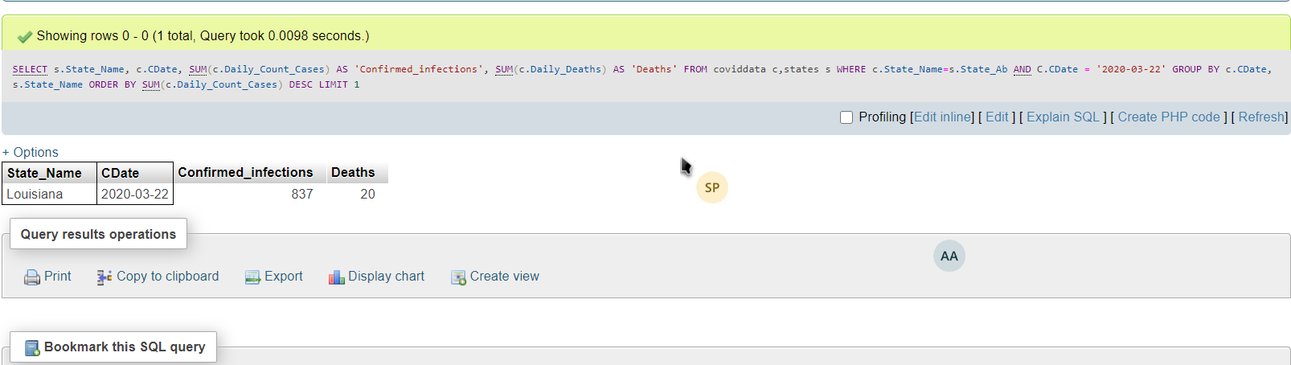

**Q10 Retrieve, the total, average, maximum number of new daily confirmed covid 19 cases in the state of texas in the month of July.**

SELECT SUM(c.Daily_Count_Cases), AVG(c.Daily_Count_Cases), MAX(c.Daily_Count_Cases)

FROM coviddata c

WHERE c.State_Name='TX' AND (CDate BETWEEN '2020-07-01' AND '2020-07-30');

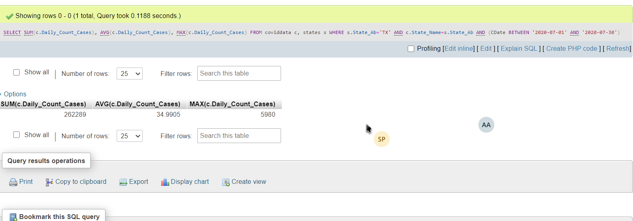

**Q11 Execute 2 insert commands for STATES table that attempt to insert 2 records, such that the records violate the integrity constraints. Make each of the 2 records violate a different type of integrity constraint. Include the insert statements and error messages.**

INSERT INTO states

VALUES (‘Texas’, ‘TX’, ‘London’, ‘John’), (‘Arkansas’, ‘AR’, ‘Berlin’, ‘George’)

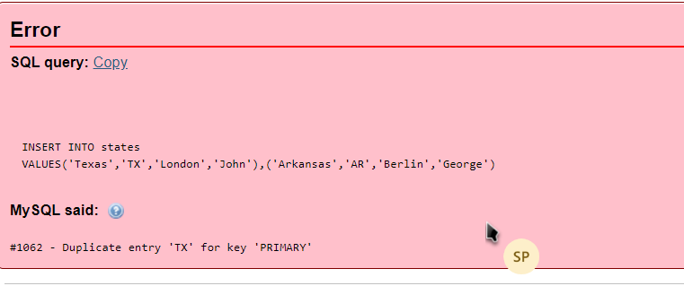

INSERT INTO states

VALUES (Null, ‘TX’, ‘London’, ‘John’)

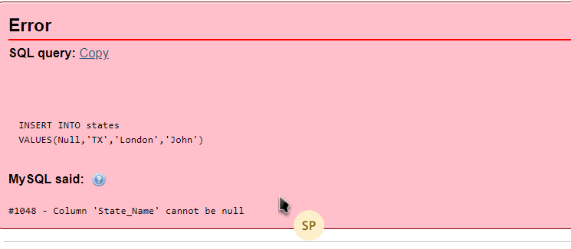

**Q12 Execute an update command for COVIDDATA table that attempts to update records in child rows, such that the record violate the foreign key constraint. Include the update statement and the error message.**

UPDATE coviddata

SET coviddata.County_Name = ‘London’

WHERE coviddata.State_Name = ‘Tx’

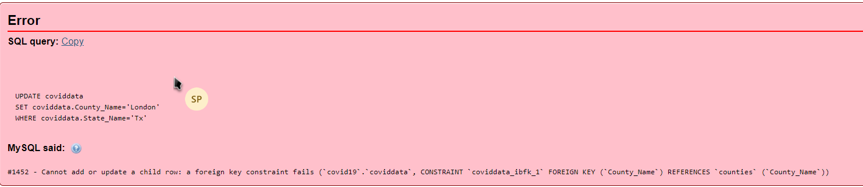

**View based questions**

**Q13 Create a view COVID_BY_MONTH that has the following attributes: Month, State_Name, Sum_Confirmed, Sum_Deaths. The Sum_Confirmed and Sum_Deaths attributes will be the SUM of new confirmed cases and sum of deaths for all the counties in each state by month. The Month field of the view gives the full month name (March, April, etc.) The records should be sorted by the month (March, April, May, … and NOT April, March, May, ..) and the state name (Hint: use GROUP BY Date, State on the original CovidData table.)**

CREATE VIEW COVID_BY_MONTH

AS SELECT MONTHNAME(C.CDate) AS 'Month', S.State_Name, SUM(C.Daily_Count_Cases) AS 'Sum_Confirmed', SUM(C.Daily_Deaths) AS 'Sum_Deaths'

FROM coviddata C,states S

WHERE C.State_Name=S.State_Ab

GROUP by MONTH(C.CDate), S.State_Name;

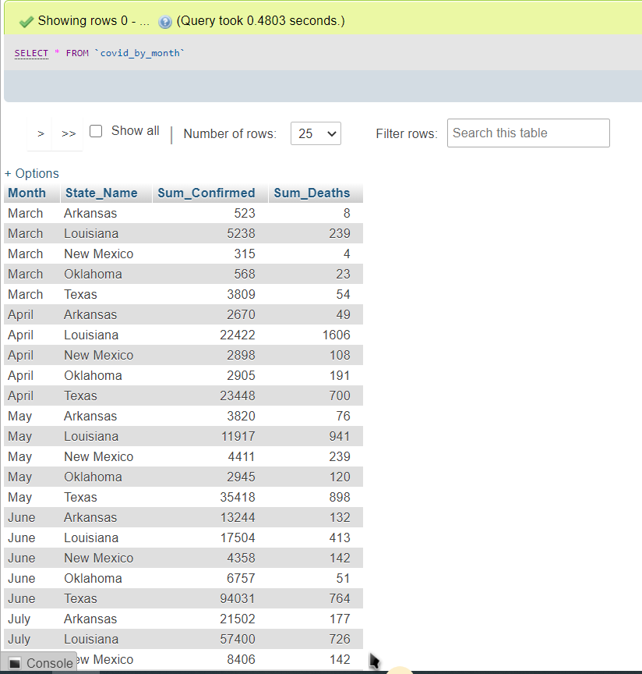

**Q14 Use the view COVID_BY_MONTH to write a query that gives the name of the month, total number of confirmed cases, and the number of deaths for the month that saw the maximum number of confirmed cases in Texas.**

SELECT MONTH AS 'name of the month', Sum_Confirmed, Sum_Deaths

FROM covid_by_month c

WHERE c.State_Name='Texas'

ORDER BY Sum_Confirmed

DESC LIMIT 1;

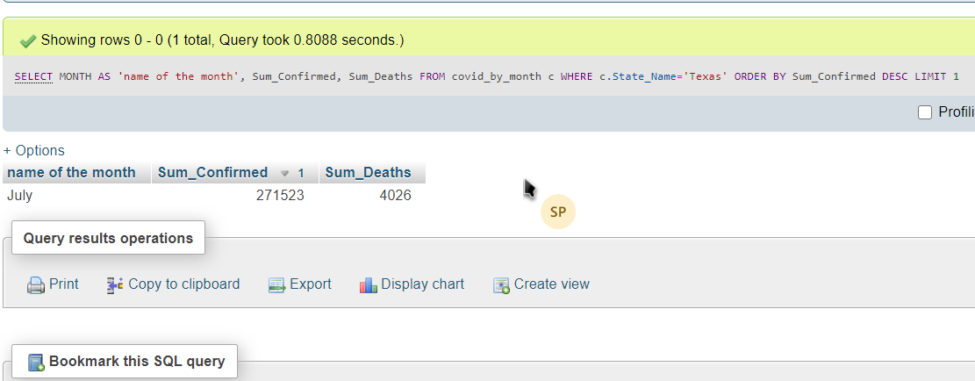

**Q15 Use the view COVID_BY_MONTH to write a query that gives the names of the month, total number of confirmed cases, and the number of deaths for the months that saw the maximum number of confirmed cases in different states.**

SELECT c.State_Name, c.Month AS 'names of the month', c.Sum_Confirmed AS 'total number of confirmed cases', c.Sum_Deaths AS ' number of deaths'

FROM covid_by_month c

WHERE (State_Name, Sum_Confirmed)

IN(SELECT DISTINCT State_Name, MAX(Sum_Confirmed)

FROM covid_by_month cm

GROUP BY State_Name)

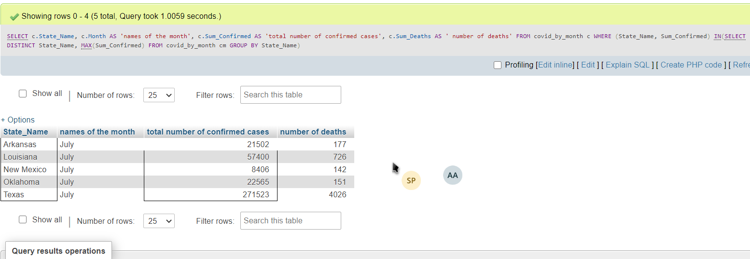

**Q16 Write a query on the view COVID_BY_MONTH that sums the data for each state by using GROUP BY – that is, the result will have one record for each state State_Name, Sum_Confirmed, and Sum_Deaths for the dates provided in the data file**.

SELECT c.State_Name, SUM(c.Sum_Confirmed) AS 'Sum_Confirmed', SUM (c.Sum_Deaths) AS 'Sum_Deaths'

FROM covid_by_month c

GROUP BY c.State_Name

