How to Create Notification Alarm?

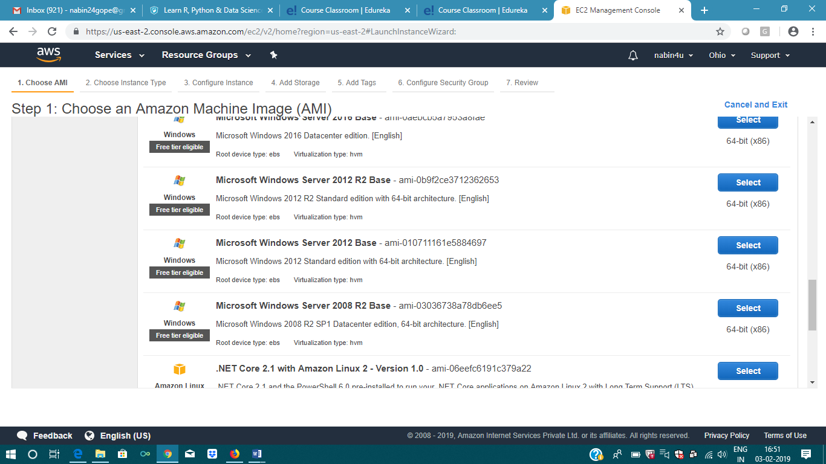

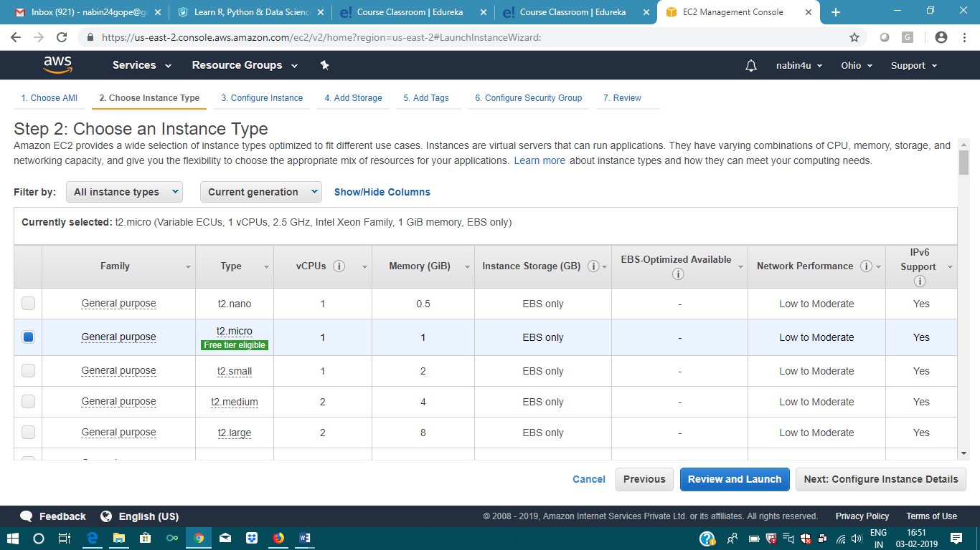

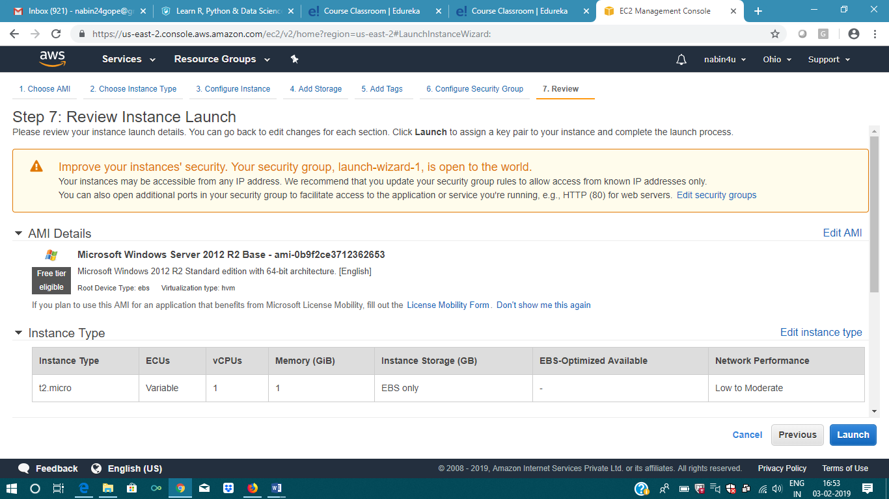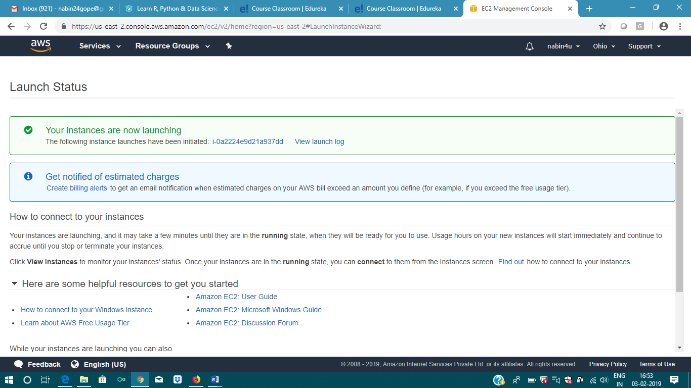

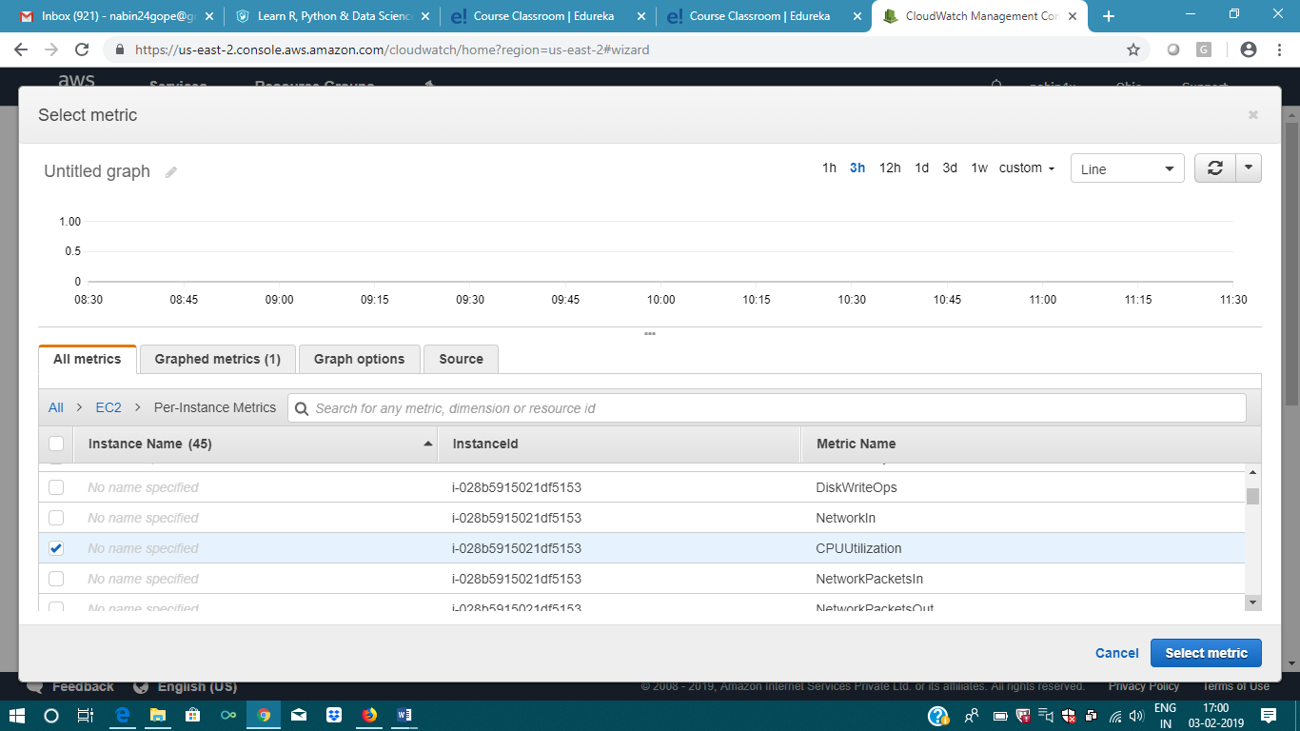

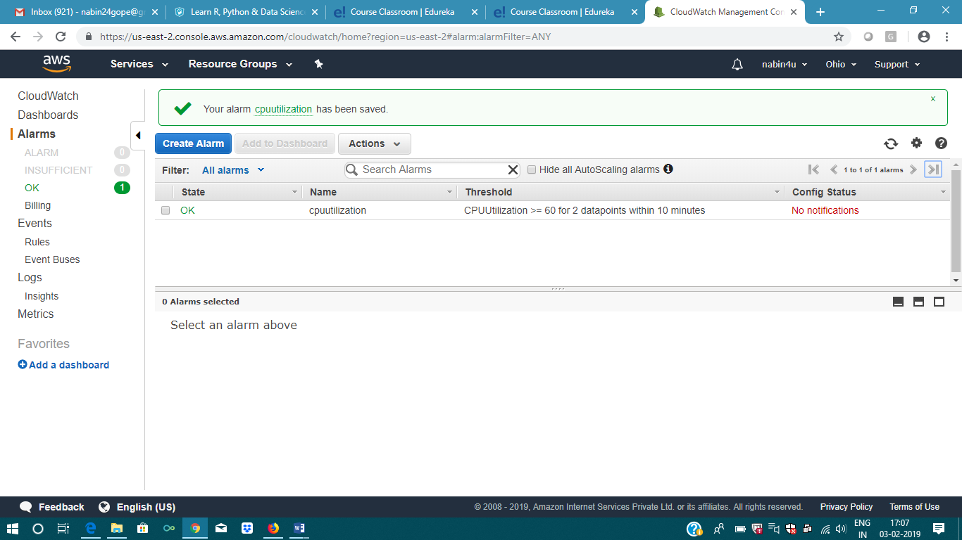

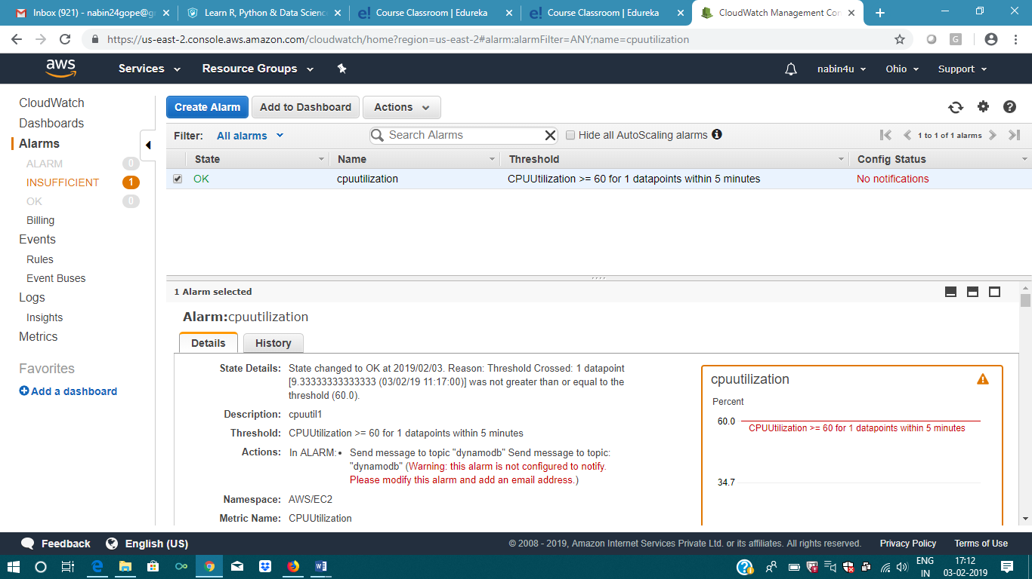

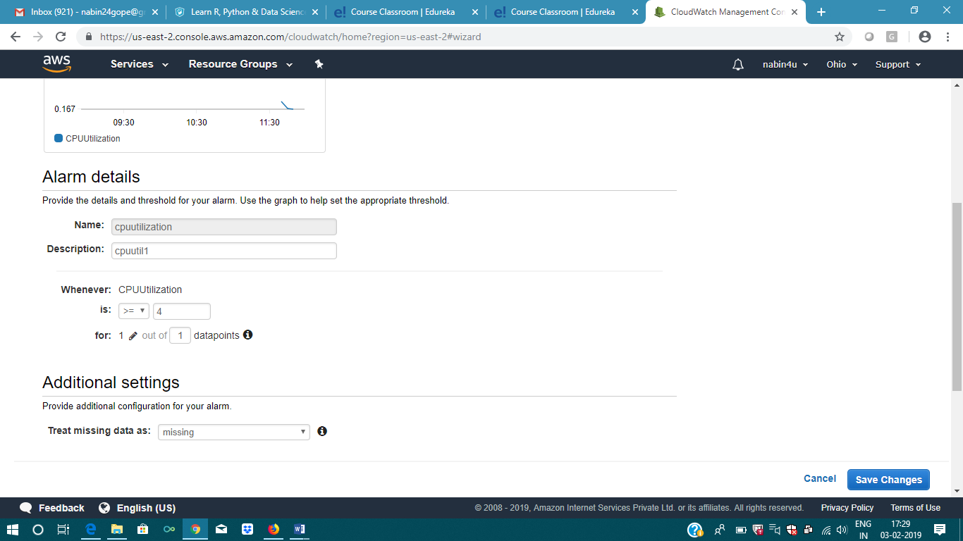

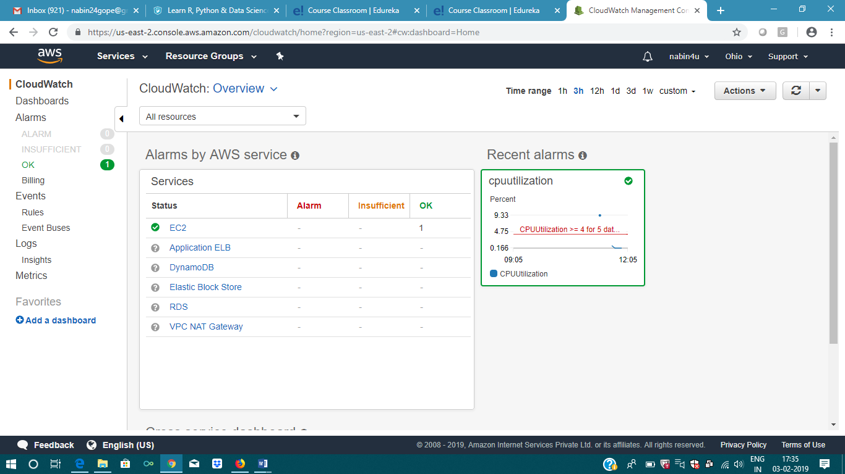

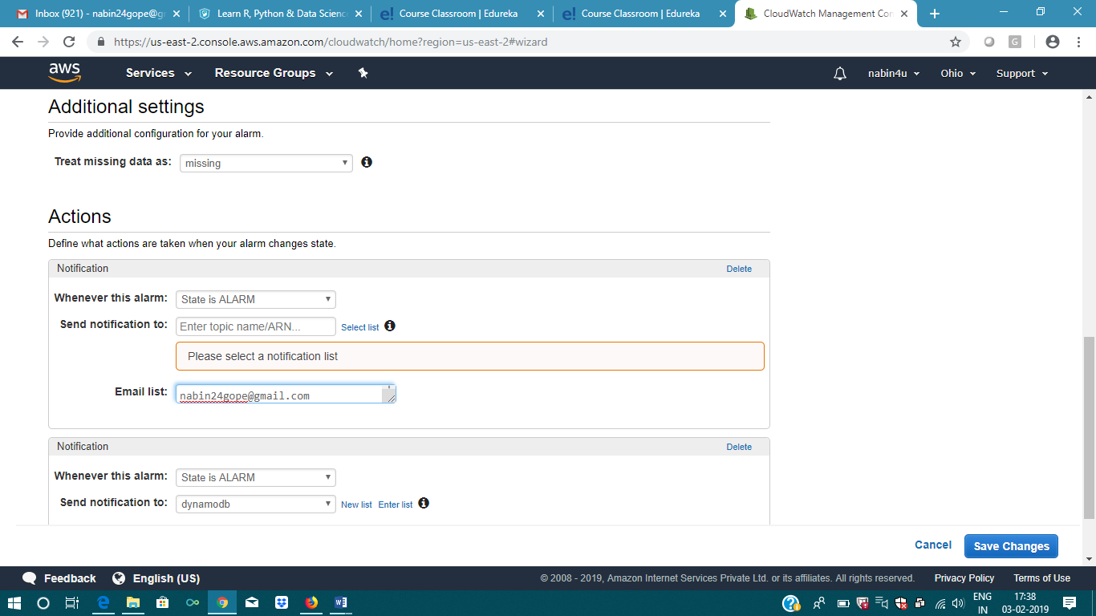

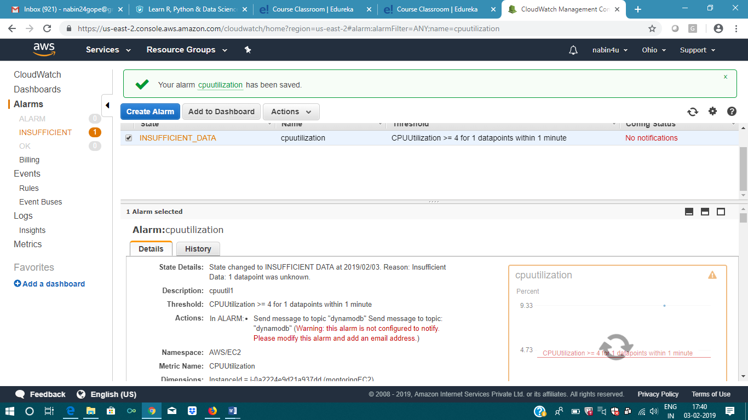

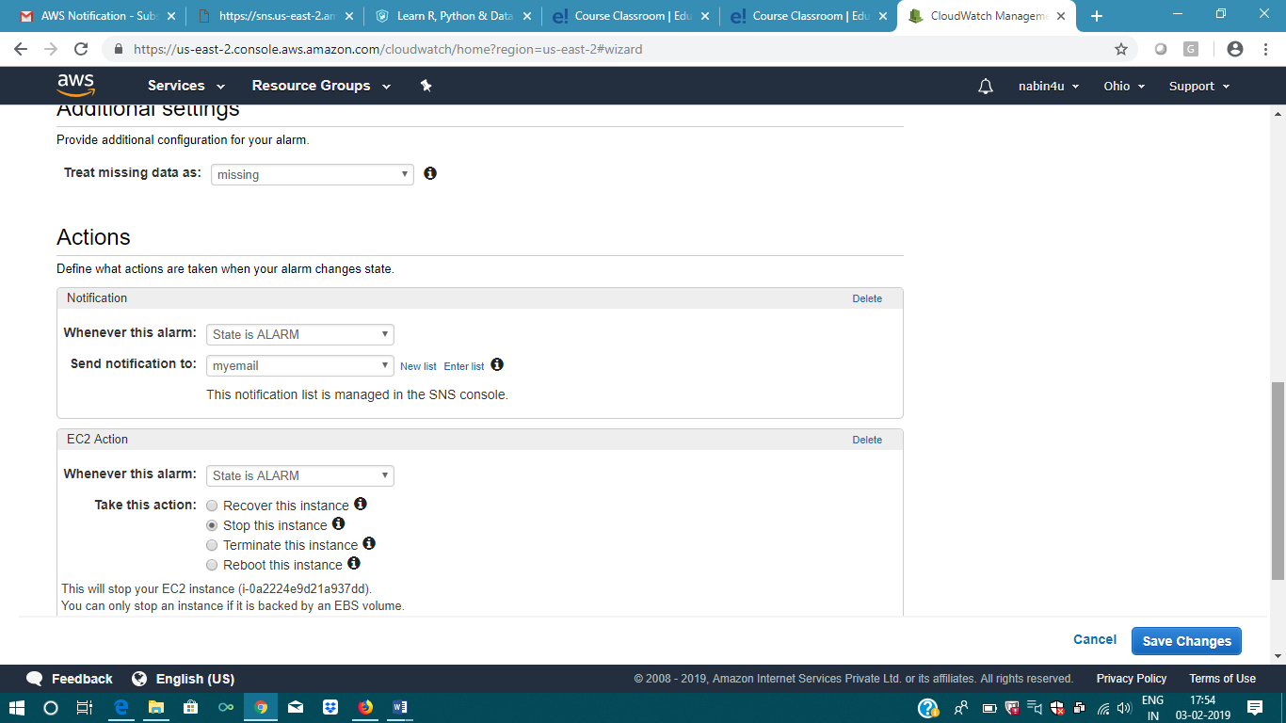

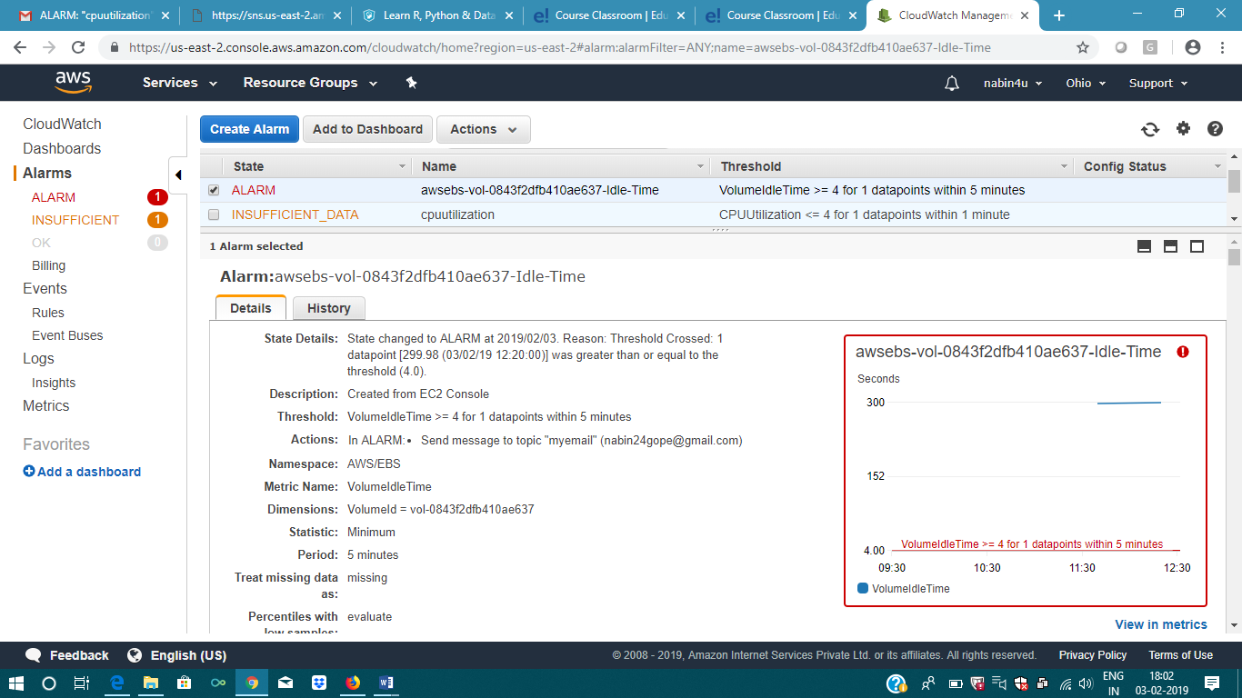

You are receiving this email because your Amazon CloudWatch Alarm "cpuutilization" in the US East (Ohio) region has entered the ALARM state, because "Threshold Crossed: 1 datapoint [0.1333518569973136 (03/02/19 12:20:00)] was less than or equal to the threshold (4.0)." at "Sunday 03 February, 2019 12:26:22 UTC".  
  
View this alarm in the AWS Management Console:  
<https://console.aws.amazon.com/cloudwatch/home?region=us-east-2#s=Alarms&alarm=cpuutilization>  
  
Alarm Details:  
- Name:                       cpuutilization  
- Description:                cpuutil1  
- State Change:               INSUFFICIENT_DATA -> ALARM  
- Reason for State Change:    Threshold Crossed: 1 datapoint [0.1333518569973136 (03/02/19 12:20:00)] was less than or equal to the threshold (4.0).  
- Timestamp:                  Sunday 03 February, 2019 12:26:22 UTC  
- AWS Account:                399380579109  
  
Threshold:  
- The alarm is in the ALARM state when the metric is LessThanOrEqualToThreshold 4.0 for 60 seconds.   
  
Monitored Metric:  
- MetricNamespace:                     AWS/EC2  
- MetricName:                          CPUUtilization  
- Dimensions:                          [InstanceId = i-0a2224e9d21a937dd]  
- Period:                              60 seconds  
- Statistic:                           Average  
- Unit:                                not specified  
  
  
  
State Change Actions:  
- OK:   
- ALARM: [arn:aws:sns:us-east-2:399380579109:myemail]  
- INSUFFICIENT_DATA:   
  
  
--  
If you wish to stop receiving notifications from this topic, please click or visit the link below to unsubscribe:  
<https://sns.us-east-2.amazonaws.com/unsubscribe.html?SubscriptionArn=arn:aws:sns:us-east-2:399380579109:myemail:bc27e80f-8ae7-4351-b680-b6a265847e8d&Endpoint=nabin24gope@gmail.com>  
  
Please do not reply directly to this email. If you have any questions or comments regarding this email, please contact us at <https://aws.amazon.com/support>