City Delivery Variance
New F2B/C – Adjustment to LDC 22 Earned hours based on PKCC/DOIS Base Parcels
Release Date: Tuesday January 24, 2023

The examples below are at the Unit level.
Funding for F2B/C City Delivery Models intended for LDC 22 Earned hours will now be adjusted +/- one minute for each eFlash PKCC parcel over/under DOIS base parcels.
The current LDC 22 Earned hours logic will remain as is. This adjustment is in addition to current LDC 22 Earned logic.
  - When PKCC volumes from eFlash are > DOIS Base parcel volumes, one minute will be added to the LDC 22 Earned hours for each additional reported PKCC parcel over DOIS base parcels.
    - Example
      - LDC 22 Earned = 6.0 to which the new adjustment will be applied
      - DOIS Base parcels = 22
      - Reported eFlash PKCC parcels = 32; 10 parcels > DOIS Base parcels
      - This adjustment will be an Earned time add of 10 minutes
      - 10/60 (convert minutes to hours) this yields an additional 0.17 LDC 22 Earned hours
      - Add 0.17 adjustment to LDC 22 Earned 6.0
      - For a total of 6.17 Earned LDC 22 hours

  - When PKCC volumes from eFlash are < DOIS Base parcel volumes, one minute will be subtracted from the LDC 22 Earned hours for each additional reported PKCC parcel less than DOIS base parcels.
    - Example
      - LDC 22 Earned = 6.0 to which the new adjustment will be applied
      - DOIS Base Parcels = 62
      - Reported eFlash PKCC parcels = 30; 32 < DOIS Base parcels
      - This adjustment will be an earned time reduction of 32 minutes
      - 32/60 (convert minutes to hours) this yields a reduction of 0.53 LDC 22 Earned hours
      - Subtract 0.53 adjustment from LDC 22 Earned 6.0
      - For a total of 5.47 LDC 22 Earned hours

Below the Workload Analysis Summary found on the Unit Variance page in CDV will now include the workload for DOIS Base and Actual PKCC parcel volumes.
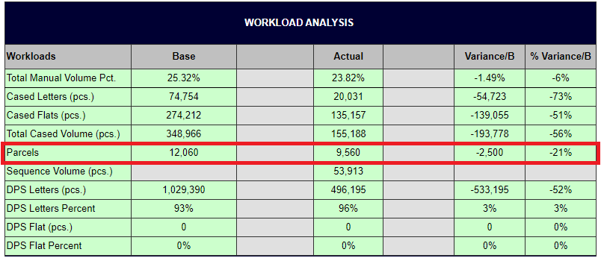
Below the Unit Data Stream page found in CDV will now include DOIS Base parcels and Actual parcels.
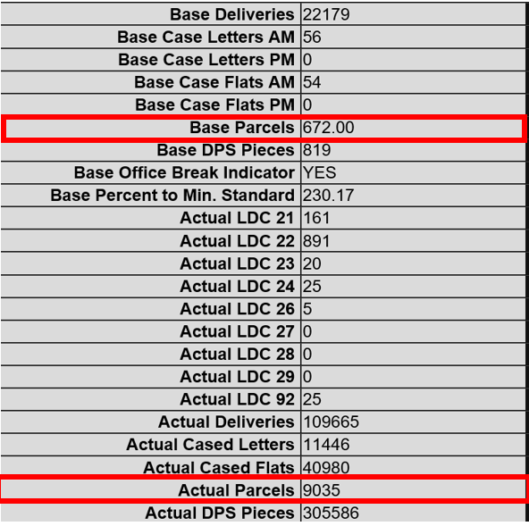

Below the weekly Pivoting Opportunity Performance Trend graphs found in City Delivery Pivoting Opportunity Model (CDPOM) will now include volumes for PKCC SPLY, PKCC Current Actual and DOIS Base parcels.
