

**Tribhuvan University**

**Nepalaya College**

**A Second Year Project Report**

**On**

**“Ecommerce website”**

**Under the Supervision of**

**Narayan Chalise**

**Submitted To:**

**Department of Computer Application**

**Nepalaya College**

**In partial fulfillment of the requirement for the Bachelor Degree in Computer Application**

**Submitted By:**

**Akriti Subedi (6-2-577-36-2019)**

**Sangita Singh (6-2-577-61-2019)**

**August, 2021**

# SUPERVISORS RECOMMENDATION

I hereby recommend that this project prepared under my supervision by **AKRITI SUBEDI** and **SANGITA SINGH** entitled “**Ecommerce website”** in partial fulfillment of the requirement for the degree of Bachelor of Computer Application be processed for the evaluation.

…………………

Narayan Chalise

SUPERVISOR

# LETTER OF APPROVAL

This is certified that this project is prepared by **AKRITI SUBEDI** and **SANGITA SINGH** entitled “**Ecommerce website**.” in partial fulfillment of the requirements for degree of Bachelors of Computer Application (BCA) has been well studied. In our opinion it is satisfactory in the scope and quality as a project for the required degree.

|  |  |
| --- | --- |
| **.........................**  Narayan Chalise  Supervisor | **.........................**  Mr. Saila Mitra Neupane  Head of Department (BCA)  Nepalaya College  Kathmandu, Nepal |
| -------------------------  **External Examiner**  Tribhuvan University  Kirtipur, Nepal | |

**ACKNOWLEDGEMENT**

The success and final outcome of this assignment required a lot of guidance and assistance from many people and we feel extremely fortunate to have got all this all along the completion of our assignment work. Whatever we have done is only due to such guidance and assistance and we would not forget to thank them. We take this opportunity to express our profound gratitude and deep regards to our supervisor **Mr.Narayan Chalise** for his exemplary guidance, monitoring and constant encouragement throughout the course of this thesis. The blessing, help and guidance given by him time to time shall carry me a long way in the journey of life on which we were about to embark.

We could not have completed this project without help from our college **“Nepalaya”** which gave the supportive hands before us academically, also regarding other activities related to Information Communication Technology as well as extra curriculum activities that we got to participate in. It gave us family like environment.

We also take this opportunity to express a deep sense of gratitude to **Mr. Narayan Chalise**

Project guide, and **Mr.Saila Mitra Neupane,** coordinator, Nepalaya College, for his cordial support, valuable information and guidance, which helped us in completing this task through various stages.

Finally, we would like to acknowledge our friends who supported us and provided some guidance for completing this project.

# ABSTRACT

The Online Shopping is a web based application which is the most visible business use of the World Wide Web. The primary goal of online business site is to sell goods and services online. It is use to make it interactive and easy to use. It would make searching, viewing and selection of a product easier. It contains a sophisticated search engine for users to search for products specific to their needs. The search engine provides an easy and convenient way to search for products where a user can Search for a product interactively and the search engine would refine the products available based on the user’s input. The user can then view the complete specification of each product. They can also view the product reviews and also write their own reviews. The application also provides a drag and drop feature so that a user can add a product to the shopping cart by dragging the item in to the shopping cart. The main emphasis lies in providing a user friendly search engine for effectively showing the desired results and its drag and drop behavior.

**Keywords: -** e-payment, online store, etc

**LIST OF ABBREBIATIONS**

CSS Cascading Style Sheet

DFD Data Flow Diagram

EC e-Commerce

HTML Hypertext Markup language

HTTP Hypertext transfer protocol

MYSQL My structure query language

PHP Hypertext pre-processor

SEO Search Engine Optimization

TABLE OF CONTENTS

SUPERVISORS RECOMMENDATION ii

LETTER OF APPROVAL iii

ABSTRACT v

LIST OF FIGURES ii

CHAPTER 1: INTRODUCTION 1

1.1 Background 1

1.2 Problem Statement 2

1.3 Objectives 2

1.4 Project Features 3

1.5 Scope and limitations 3

1.6 Report Organization 3

1.7 Feasibility Analysis 4

1.7.1 Economic Feasibility 4

1.7.2 Technical Feasibility 5

1.7.3 Operational Feasibility 5

1.7.4 Time Feasibility 5

1.8 System Requirement 5

1.8.1 Software Requirement 5

1.8.2 Hardware Requirement 6

CHAPTER 2: LITERATURE REVIEW 7

2.1 Project Research 7

CHAPTER 3: SYSTEM ANALYSIS AND DESIGN 9

3.1 System Analysis 9

3.1.1 Requirement Analysis 9

3.1.4 Process modeling 12

3.1.1 Architecture Design 14

3.1.2 Physical DFD 14

3.1.3 Flow chart 16

3.1.4 Testing 18

CHAPTER 4: CONCLUSION AND FUTURE RECOMMENDATION 19

4.1 CONCLUSION 19

4.2 FUTURE RECOMMENDATION 19

REFERENCES 20

# LIST OF FIGURES

**FIGURE PAGE**

Figure 1. Use Case Diagram………………………………….……10

Figure 2. Project Schedule…………………………………………12

Figure 3. E-R Diagram…………………………………..…………12

Figure 4. Logical DFD……………………………...………………13

Figure 5. System Architecture Design………………………………14

Figure 6. Physical DFD……………………...………………………15

Figure 7. Agile methodology………………………..………………16

Figure 8: Flow chart for E-commerce……………………………… 17

# INTRODUCTION

## Background

E-Commerce or Electronics Commerce is a methodology of modern business, which addresses the requirements of business organizations. It can be broadly defined as the process of buying or selling of goods or services using an electronic medium such as the Internet. The E-commerce Services department strives to provide solutions to develop and transfer easy and efficient way in the digital age and to help reduces the human pressure and time. To help support shop collections, the digital initiatives, and external partner institution digital projects, it provide services that include the digitization of analog objects, metadata management, digital preservation, and discovery and access of digital collections This software is easy to use for both beginners and advanced users. It features a familiar and well thought out, an attractive user interface, combined with strong searching Insertion and reporting capabilities. The report generation facility of shop system helps to get a good idea of which are the various items brought by the members, makes users possible to get the product easily E-commerce There are various types of E-commerce in real world some of them are Business to Business(**B2B**), Business to Customer(**B2C**),Government to Customer(**G2C**) and more. We will do this project based on **B2C**.

E-commerce is fast gaining ground as an accepted and used business paradigm. More and more business houses are implementing web sites providing functionality for performing commercial transactions over the web. It is reasonable to say that the process of shopping on the web is becoming commonplace. However, for implementation purposes, this paper will deal with an online e-commerce store. An online store is a virtual store on the Internet where customers can browse the catalog and select products of interest. The selected items may be collected in a shopping cart. At checkout time, the items in the shopping cart will be presented as an order. At that time, more information will be needed to complete the transaction. Usually, the customer will be asked to fill or select a billing address, a shipping address, a shipping option, and payment information such as a credit card number.

## Problem Statement

Traditional commerce is a branch of business which focuses on the exchange of products and services, and includes all those activities which encourages exchange, in some way or the other. Customer buy a product on the basis of **face to face** presence and all activities to be done manually with limited time boundary as well as limited to particular area only. E-commerce provides an easy way to sell product to a large customer base. However, there is a lot of competition among multiple e-commerce sites. When users land on an e-commerce site, they expect to find what they are looking for quickly and easily. Also users can not sure about the brands or the actual products they want to purchase. They have a very broad idea about what they want to buy. Many customers nowadays search for their products on Google rather than visiting specific e-commerce sites. They believe that Google will take them to the e-commerce sites that have their product.

Another problem is that we do not know what problem the customer is searching for a site that displays a huge list of products from different categories, such as electronics, mobiles, clothes or books needs to be able to identify what the customer is searching for. A customer can be searching for Samsung, which can be in mobiles, tablets, electronics, or computers. There site should be able to identify whether the customer has input the author name or the book name. Identifying the input would help in increasing the relevance of the result set by increasing the precision of search results.

So E-commerce provides an easy way to sell or buy a products as customer need with customer warranties, e-commerce sites provide search suggestions and includes the category to help customer target the right category during their search.

## Objectives

* To develop an e-commerce store where any product (such as books, CDs, computers, mobile phones, electronic items, and home appliances) can be bought from the comfort of home through the Internet.
* To provide easy shopping and shipping.

## Project Features

An E-commerce that will allow online shoppers to buy wares

* A secure online transaction system that will allow users to purchases goods safely
* Optimized and safe service delivery.
* Provide goods information
* E- Payment
* Advanced e-commerce SEO capabilities.

## Scope and limitations

People are too busy nowadays to visit shopping mall to buy their daily needs. We believe that online shopping website will become even more popular in the future for the obvious reason that they save users, time and money with best price and services. Most of the people do not like waiting for long line in the shopping mall and also some people hesitate to ask detailed information like price and etc so this system will help us to avoid the long queues at the counter of mall.

Limitations:

* It is not helpful for illiterate people.
* It needs network connections.
* User won’t be able to change any functionality of system. `

## Report Organization

The outline of the documentation is shown below:

**Chapter 1**

This chapter explains the system thoroughly. Its problem statements, objectives of the project and scope & limitations.

**Chapter 2**

It discusses the background study for the project and the literature survey of the existing system/ related works.

**Chapter 3**

System design, feasibility analysis and requirement analysis with ER-diagram, DFDs, architectural design, database schema and UI interface.

**Chapter 4**

It explains about the tools used, how the project was carried out and the system’s testing.

**Chapter 5**

This chapter discusses about conclusion of the project, lesson learnt and future recommendations.

## Feasibility Analysis

A feasibility analysis is an evaluation and analysis of a project or system. It tries to determine the project is economically, operationally, technically and financially feasible.

It aims to objectively and rationally uncover the strengths and weakness of the existing software, opportunities and threats as presented by the environment, the resources required to carry through, and ultimately the prospects for success.

### Economic Feasibility

One of the first and foremost thing to carry out any project is the availability of the cash flow. For this project, we are using the free data and the cost to perform this project needs free of costs software that can be easily installed on any of the modern computers. It is a measure of the cost-effectiveness of the project or solution. This is often called a cost-benefit analysis. The software produce must be cost effective so that its users can purchase it. Sometimes the selling of large of a software product in low price will be more beneficial than that of high cost selling in the prospective of popularity and benefit.

### Technical Feasibility

The software product must be technically feasible by the use of present and near future hardware and techniques. It is technically feasible, since the whole system is designed into the technology evolved with MySQL and language with PHP and http. The resources required for this project are enough available with all the information and enquiries that makes the marketing sites well built, easy and convenient

### Operational Feasibility

It is a measure of how well the solution will work on the organization. It is also a measure of how people feel about the system or project.

Our system can easily be operated by a nonprofessional person. Unusual training and presentations are not required. Ordinary person can visit the site just with a device and good internet connection. One can simply order the goods with a single click. Thus, it is operationally feasible too.

### Time Feasibility

Time feasibility is a measure of how reasonable the project timetable. This project saves the time after its complete completion. We can complete this project in three months.

## System Requirement

### Software Requirement

* Any operating system (Linux, Windows, Mac).
* Web Browser: Chrome, Firefox, Opera etc.
* Code Editor: VS Code, sublime text, etc.
* XAMPP server

### Hardware Requirement

* A PC (min RAM 4GB, HDD 500GB, SSD adds value)

# LITERATURE REVIEW

In this book [1] authors there has been a lot of media coverage on online shopping in recent years. However, the Nowadays, online sector plays a significant role on both in developed and developing countries. Although traditional marketing methods have been successful in the past, they all have disadvantages, especially with the rapid increase in internet usage. It was physical stress, slower, time consuming, risky and costly whereas online marketing provides faster response, reduction in costs through automation and use of electronic media. Extremely low risk, faster response to both marketers and the end users. We can buy anything from anywhere at any time from our own place at sufficient price.

In this research paper [2] the advantages of e-commerce like around the clock availability, the speed of access, a wider selection of goods and services, and international reach are make it a candidate to be one of the great economic developments of the 22st Century. Beside this it has some drawbacks like necessitated wait time for product shipping and not being able to see or touch a product prior to purchase.

In this journal paper [3] writer’s studies e-commerce are very comprehensive, studies related to online marketing are scattered into various journals and database. In this paper, a classification framework which consist of main and sub field is presented and online marketing literature is reviewed and categorized according to this framework. It can be concluded from the study that online marketing studies will increase with rising acceleration in term of number in the coming years. We also have to note that training and legal issues can be considered as a silent areas of EC. Despite the fact that this literature review is not extensive, we hope that it serves as a comprehensive base for researches interested in online marketing.

## Project Research

In this journal paper [4] Firms across the globe have adopted e-commerce (EC) in their operations and have reaped benefits thereof. While firms in technologically developed countries like US and UK has deployed EC to its advantage, whereas firms in developing countries like India failed to follow the suit. Though it has been widely acknowledged by the researchers that the adoption of EC by businesses in developing.

countries is an important economic indicator of growth; many firms in India still have not realized the potential benefits of EC. This study examines the existing status of EC in India and reviews the available literature on E-commerce adoption in India and puts forth opportunities for future research. The study might serve as a starting point for further research in e-commerce in India.

# SYSTEM ANALYSIS AND DESIGN

## System Analysis

### 3.1.1 Requirement Analysis

**i. Functional Requirement**

There are several things that we need for this project. We want to improve the User Interaction and User Experience.

* + - There will be Login Signup for both Shop Admin and Customers.
    - Customers can search for the products and buy the required ones.
    - On the Website, products are according to the categories.
    - All users will be able to track their products.
    - They can order the product whenever they want.
    - Shop admin can post their product according to their needs in a category wise.

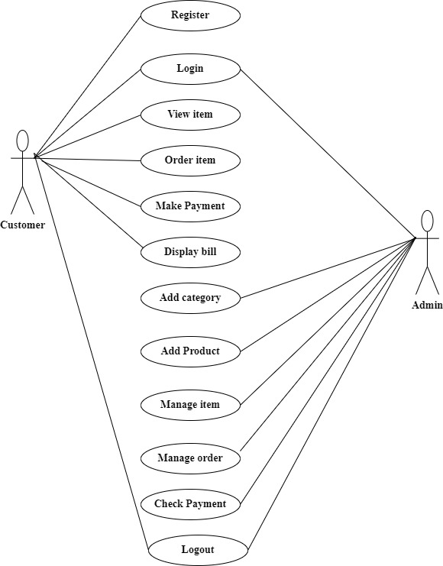

Figure 1: Use case diagram

**ii. Non functional Requirements:**

* The system is easy to maintain.
* The system is compatible with different platform.
* The system is fast as customer always needs speed.
* The system is available online all time.
* The system is secure. Data in the database of system should not loss or damage even if the system unexpectedly get crashed.
* The system is easy, navigable and user friendly interfaces.
* The system is accessible to online users.

**3.1.3 Data Modeling**

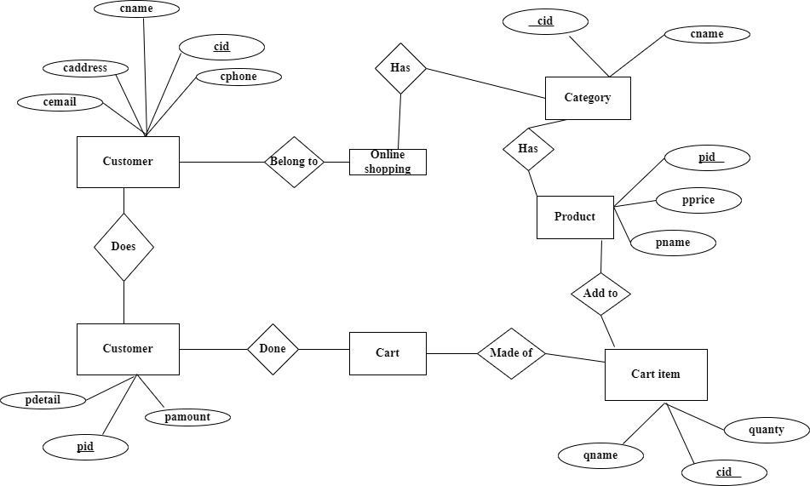

Figure 3: ER diagram

### 3.1.4 Process modeling

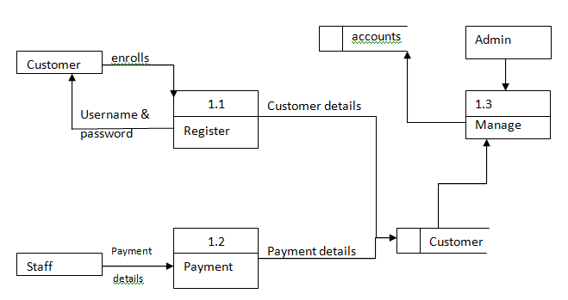

Figure 4: Logical DFD

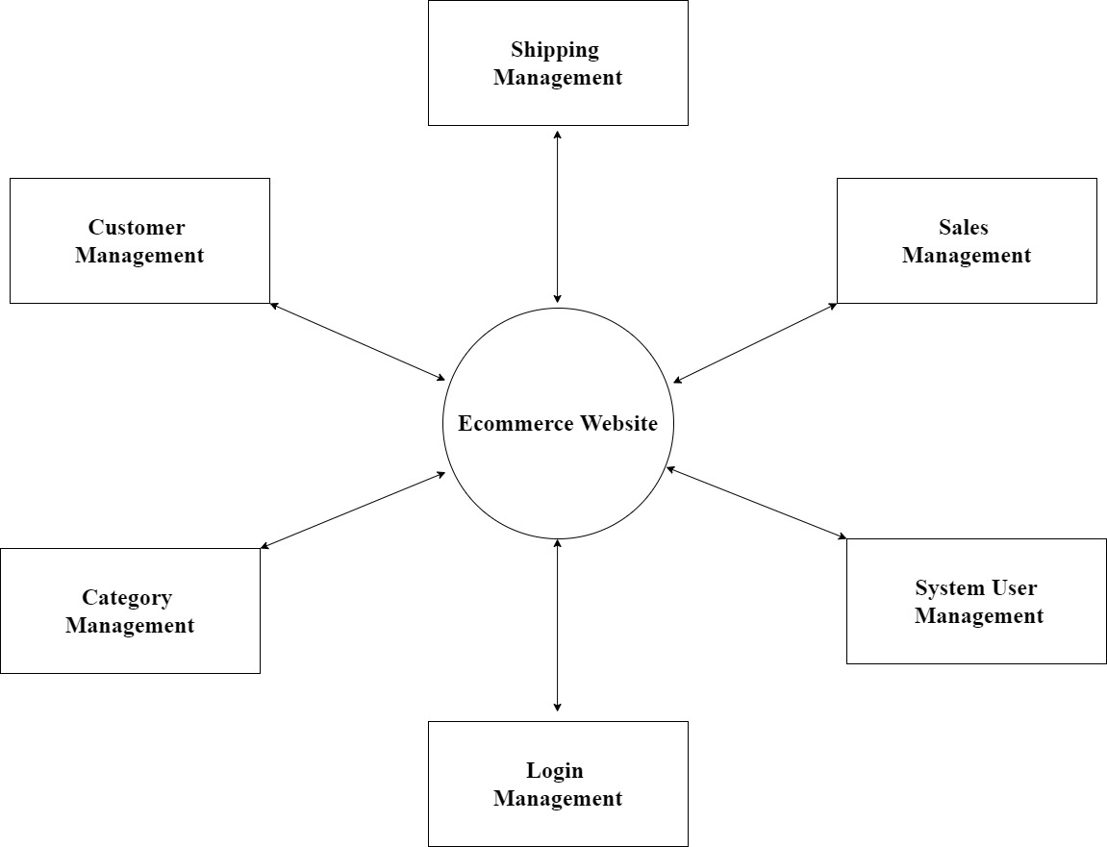

Fig 5: Zero level DFD

System Design

### Architecture Design

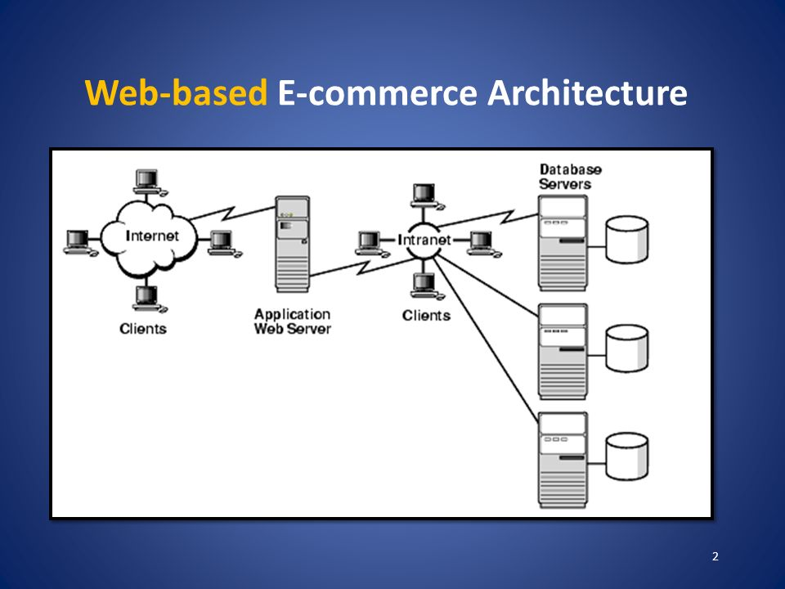

Figure 5: System Architecture Design

### Physical DFD

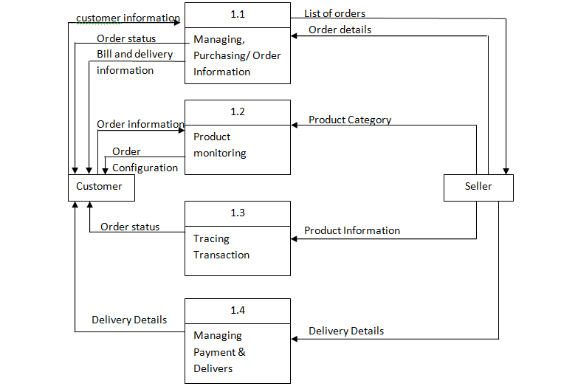

Figure 6: Physical DFD

Agile software development also referred to simply as agile is a type of development methodology that anticipates the need for flexibility and applies a level of pragmatism to the delivery of the finished product.

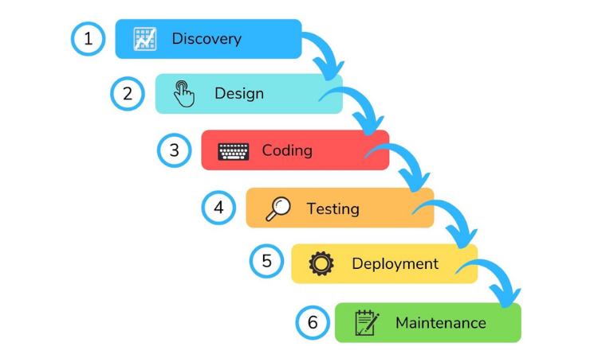

Figure 7. Agile methodology

### Flow chart

Flow chart is a visual representation of all processed in sequential order. Flowchart is the most widely used graphical representation of an algorithm and procedural design workflows. The system flow chart diagram is a graphical representation of the relation between major parts or step of the system. Flow chart of e-commerce as below mention.

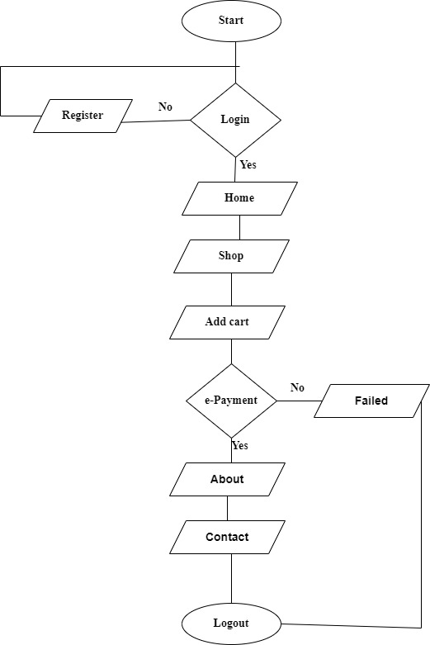

Figure 8: Flow chart for E-commerce

### Testing

Software testing is a method to check whether the actual software product matches expected requirements and to ensure that software product is defect free.It involves execution of software/system components using manual or automated tools to evaluate one or more properties of interest.

**3.1.4 Unit Testing**

Unit testing is performed by the developers on the individual units of the source code assigned areas.

**3.1.5 System testing**

System testing is the first level in which **the complete application is tested as a whole.** The goal at this level is to evaluate whether the system has complied with all of the outlined requirements and to see that it meets Quality Standards.

**3.1.6 Integration Testing**

Integration testing allows individuals the opportunity to combine all of the units within a program and test them as a group. This testing level is designed to **find interface defects between the modules/functions.**

# CONCLUSION AND FUTURE RECOMMENDATION

## CONCLUSION

E-commerce still represents one of the business methods that take advantage if done the right way. This project is only a humble venture to satisfy the needs in a shop. Several user friendly coding have also adopted. The objective of software planning is to provide a frame work that enables the manger to make reasonable estimates made within a limited time frame at the beginning of the software project and should be updated regularly as the project progresses. This website provides a computerized version of shop manipulate system which will benefit the users as well as the visitor of the shop. It makes entire process online where users can search product, and buy various product. It also has a facility for common user by login into the system where user can login and can see status of ordered item as well request for items or give some suggestions. It provide the facility of admin’s login where admins can add various item, review users activity and also add info about different events for the customer.

## FUTURE RECOMMENDATION

This project has initialized the outline of the system and software by the help of limited resources and time available which is the main achievement of the project. The project has a very vast scope in future. The project can be implemented on intranet in future. Project can be updated in near future as and when requirement for the same arises, as it is very flexible in terms of expansion. With the proposed software of database Space Manager ready and fully functional the client is now able to manage and hence run the entire work in a much better, accurate and error free manner. The following are the future scope for the project.  
  
Should be added payment gateway Can be added inventory management system Can be added multiple branches Can be added multilingual to this site and many features can be added this project to make it more robust.

# REFERENCES

|  |  |
| --- | --- |
| [1] | C. T. KC Laudon, E-commerce, Us: academia.edu, 2013. |
| [2] | Z. Vladimir, "Electronic Commerce: Structures and Issues," *e-commerce,* vol. 1, no. 1, pp. 3-23, 1996. |
| [3] | L. S. S Burt, "E-commerce and the retail process: a review," *E-commerce ,* vol. 10, no. 5, pp. 275-286, September 2003. |
| [4] | "A review of e-commerce literature on India and research agenda for the future," in *S Vaithianathan* , new delhi, 21 February 2010. |

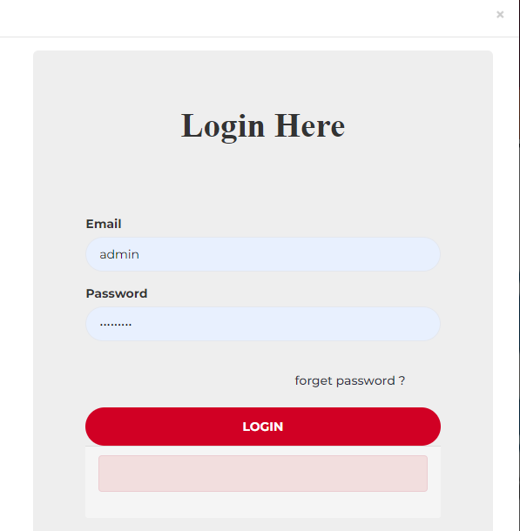

Fig: Admin login

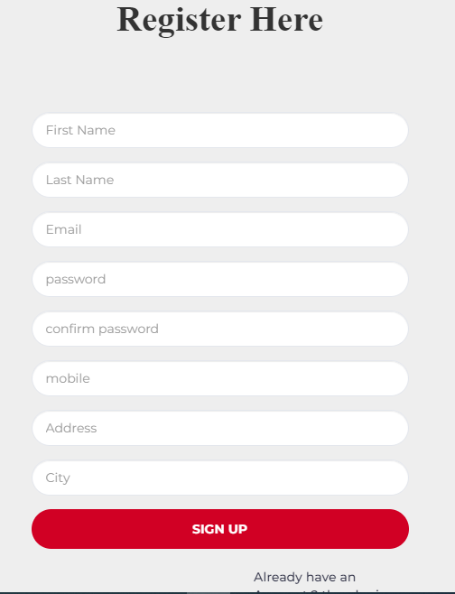

Fig: User Register

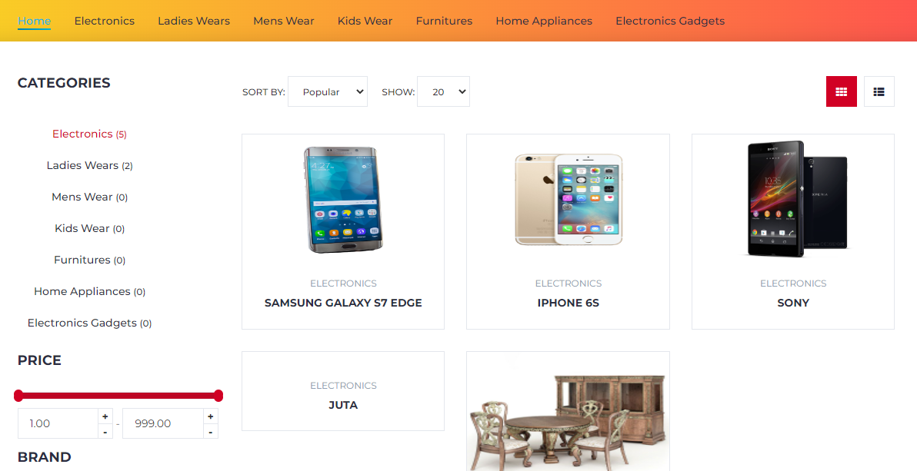

Fig: Dashboard

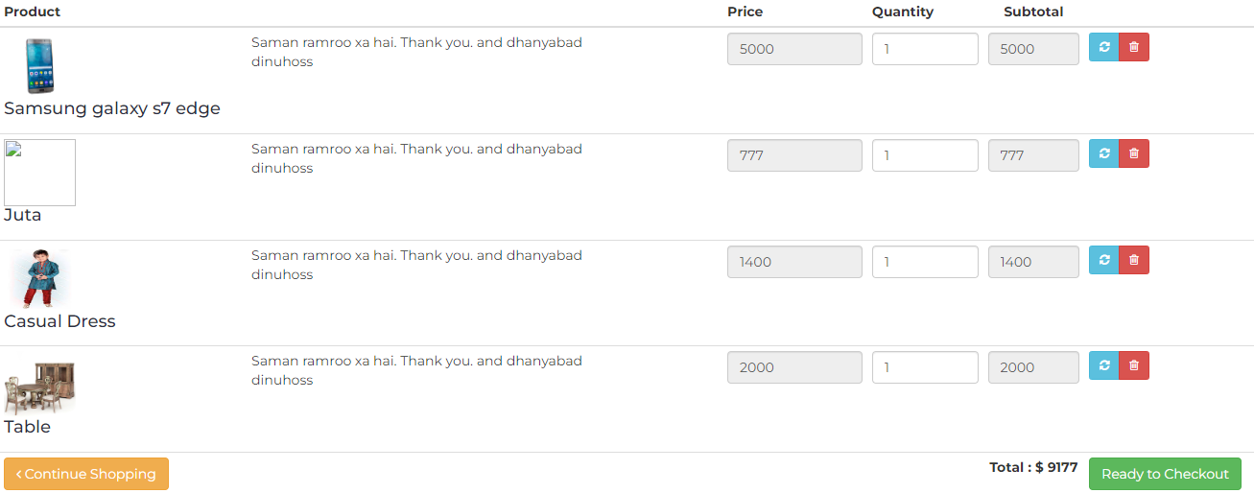

Fig: order in cart

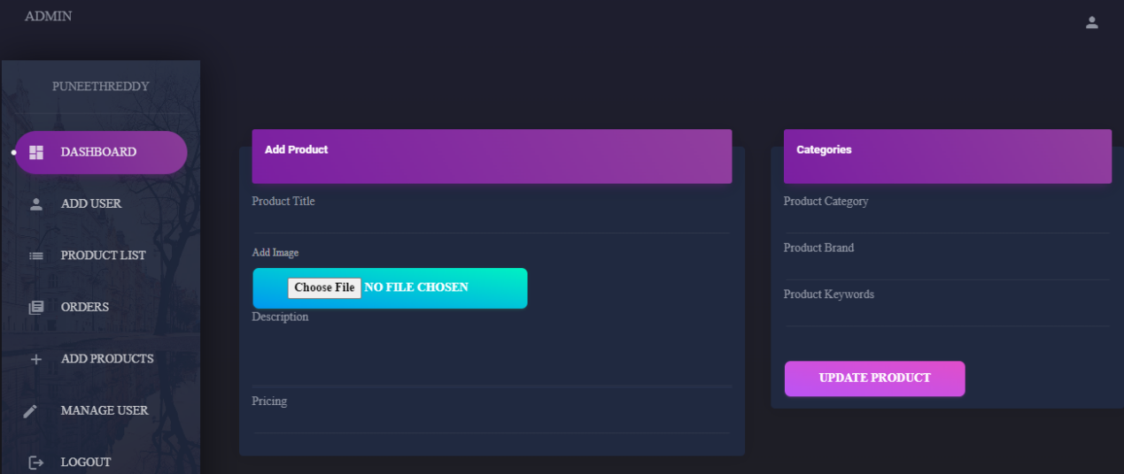

Fig: Admin dashboard