

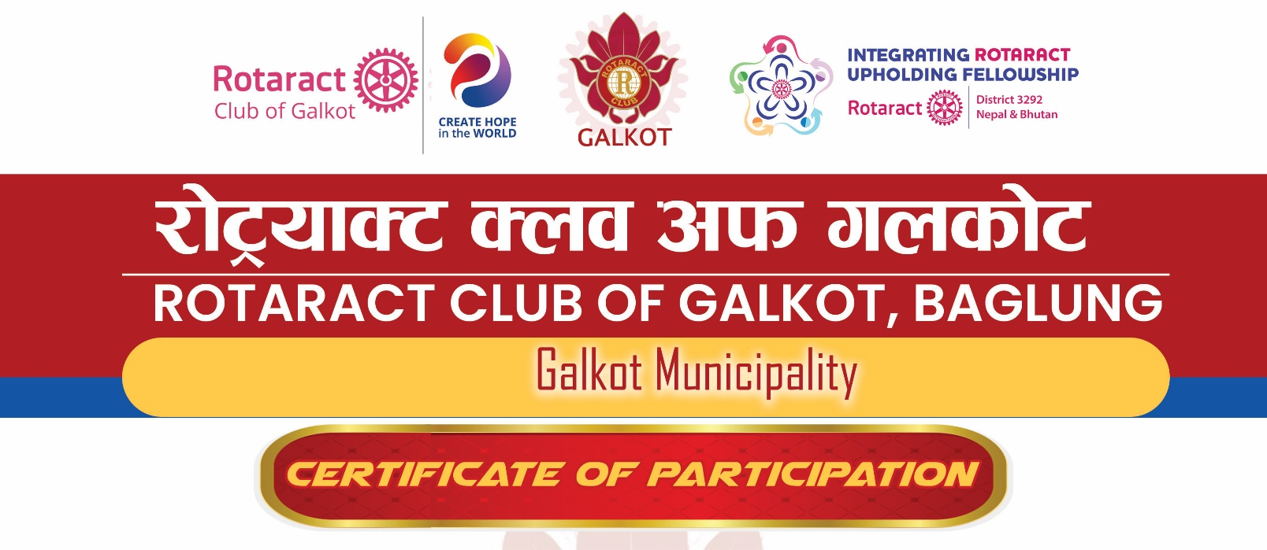

This is to certify that RTR. LAXMI PUN has successfully completed the
Internal Club Officer Training Session (COTS)
on July 25, 2026
conducted by
ROTARACT CLUB OF GALKOT BAGLUNG
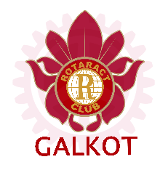
This training session covered the following topics:
- Club Officer Roles and Responsibilities
- Effective Communication within the Club
- Membership Growth and Retention
- Club Meeting Management
- Leadership and Team Building
RTR. LAXMI PUN showed exceptional enthusiasm and engagement during the training session, displaying a strong dedication to improve the skills and knowledge of member (RAC Galkot).
We want to extend our sincere appreciation to RTR. LAXMI PUN for her unwavering commitment to personal and professional growth.

Date: [July 15th, 2026]
...................................
Rtr. Nabin Chalise
President
RY. 2026-27

...................................
Rtr. Madan Subedi
Secretary
RY. 2026-27

