

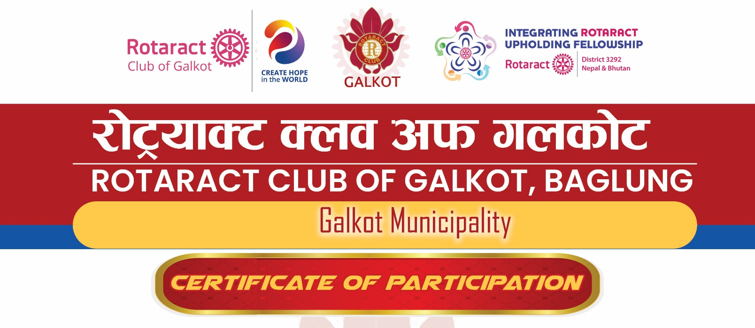

CERTIFICATE OF APPRECIATION

This is to certify that RTR. ANIL SHRESTHA successfully served as the Learning Facilitator for the Internal Club Officer Training Session (COTS) held on July 25, 2026, conducted by the Rotaract Club of Galkot Baglung.
During the training session, RTR. ANIL SHRESTHA effectively facilitated discussions and shared valuable insights on the following topics:
- Club Officer Roles and Responsibilities
- Effective Communication within the Club
- Membership Growth and Retention
- Club Meeting Management
- Leadership and Team Building
RTR. ANIL SHRESTHA demonstrated outstanding leadership, extensive knowledge, and exceptional facilitation skills throughout the training. His dedication to empowering club officers and strengthening their leadership capacity greatly contributed to the success of the Internal Club Officer Training Session (COTS).
The Rotaract Club of Galkot Baglung extends its sincere appreciation to RTR. ANIL SHRESTHA for his valuable contribution, inspiring guidance, and unwavering commitment to developing capable leaders and fostering excellence within the club.

Date: [July 25th, 2026]
.......................
Rtr. Madan Subedi
Secretary
RY. 2026-27

.......................
Rtr. Nabin Chalise
President
RY. 2026-27

