**DEERWALK INSTITUTE OF TECHNOLOGY**

**Tribhuvan University**

**Institute of Science and Technology**



**OneScore: Live scores and fantasy football**

**Project Work Report**

**Submitted to**

**Central Department of Computer Science and Information Technology**

**Tribhuvan University**

**In partial fulfillment of the requirements for the Bachelor’s Degree in Computer Science and Information Technology**

Submitted By

Nabin Katwal

20619

2023/Feb/04

# Supervisor’s recommendation

I hereby recommend that this project prepared under my supervision by NABIN KATWAL

entitled “ONESCORE: LIVE SCORES AND FANTASY FOOTBALL” in partial fulfillment of the requirements for the degree of B.Sc. in Computer Science and Information Technology be processed for the evaluation.

…………………………………………

Mr. Ritu Raj Lamsal

Faculty, Assistant Director of Research Programs

DWIT College

Deerwalk Institute of Technology

# student’s declaration

I hereby declare that I am the only author of this work and that no sources other than that listed here have been used in this work.

…………………………………………

Nabin Katwal

February 20, 2023

# letter of approval

This is to certify that this project prepared by NABIN KATWAL entitled “ONESCORE: LIVE SCORES AND FANTASY FOOTBALL” in partial fulfillment of the requirements for the degree of B.Sc. in Computer Science and Information Technology has been well studied. In our opinion it is satisfactory in the scope and quality as a project for the required degree.

|  |  |
| --- | --- |
| …………………………………………  Mr. Ritu Raj Lamsal  Faculty, Assistant Director of Research Programs  DWIT College  Deerwalk Institute of Technology | ………………………………………….  [Examiner]  Academic Designation  IOST, TU |

# Acknowledgement

I would like to express my deepest appreciation to all those who have contributed to the successful completion of this project. My sincere gratitude goes to my project supervisor, Mr.Ritu Raj Lamsal for his invaluable guidance and support throughout the development of this project. It would not have been possible without his support during the entire phase.

I would also like to thank all the other supervisors who have contributed their time, effort, and expertise during this project.

Finally, I would like to express my gratitude to Deerwalk Institute of Technology for providing me with the resources and support needed to complete this project.

Nabin Katwal

20619

February 20, 2023

# Abstract

The OneScore app provides users with real-time updates on ongoing matches across various leagues worldwide. The fantasy football app, on the other hand, allows users to create their virtual team by selecting real-life football players and competing with other users based on the actual performances of the players on the field.

This report presents the design and development of a comprehensive fantasy football application that incorporates the functionality of livescore. The app aims to provide a one-stop-shop for football enthusiasts, providing them with a seamless experience of accessing live scores and player data in real-time, along with creating their own virtual team and competing with other users.

The report covers various aspects of the application development process, including data collection, point calculation, and user interface design. The system is built on a robust technology stack and follows the best practices of software development.

Overall, the project has successfully demonstrated the implementation of a comprehensive and functional football application that caters to the needs of both football enthusiasts and casual users alike.

Keywords: *score; football; team; players; live scores;*

# table of content

# list of figures

# list of tables

# list of abbrevations

# Introduction

## Overview

Fantasy football is a game in which participants serve as the owners and general managers

of a football team. It is a popular way of competing amongst a group or as individuals.

## Background and Motivation

Along with the growing popularity of football worldwide, there have been an increase of

people who are interested in fantasy football but cannot find a stable platform to play and

learn it. Various platforms have emerged but they seem to have a steep learning curve. This

project intends to combine all the players from different teams and bring them into one

single team, which encourages players to focus on all teams instead of just watching a

single team.

## Problem Statement

In fantasy football apps, there is a problem while checking the live scores and there is a constant need of changing apps just to check scores. Also these applications lack head to head competitions which leads into players creating groups outside of application in order to complete.

## Objectives

The Objectives of this project are listed below:

* To build a system with efficient fantasy engine and leagues.
* To build a system which fetches real time match data with low latency.

## Scope and Limitation

This project targets the people who follow football on regular basis and want to get updated on latest football score. It can be used by people who have interest to get started in fantasy football and start playing competitively in a league.

This project only covers live scores for top 5 European leagues and fantasy game for only English Premier League.

## Development Methodology

Development of this project utilized the Incremental Model of the SDLC. The system requirements were divided into distinct modules, including researching the implications of data scraping, creating a schema, experimenting with different fantasy engine approaches and integrating the data to build an efficient fantasy football application.

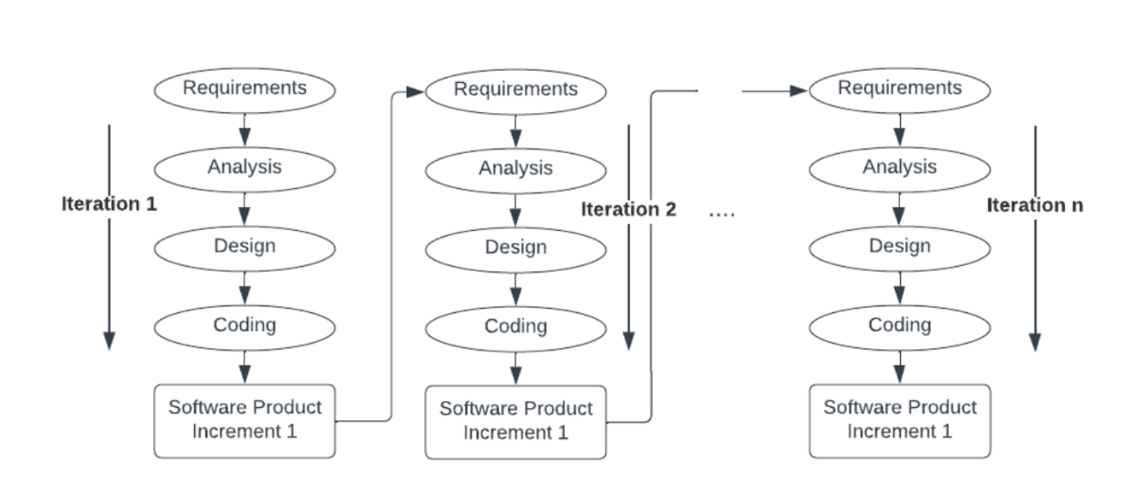

## Outline

**Preliminary Section:** This section contains the title page, abstract, table of contents, list of figures, and list of tables.

**Introduction Section:** In this section, the overview of the project, the background and motivation of the project, problem statement, its objectives and scope are discussed.

**Literature Review Section:** This section includes description, summary and critical evaluation of all the research papers studied to build a foundation of knowledge required for this project.

**Requirement and Feasibility Analysis Section:** Requirement analysis, and feasibility analysis make the bulk of this section.

**System Design Section:** The section consists of description of data used, algorithms implemented and the system design as well.

**Development Methodology Section:** This describes the software development lifecycle followed to build this system.

**Implementation and Evaluation Section:** The section comprises of the tools and technologies used to build the system, description of implementation, and results obtained after system testing.

**Conclusion and Recommendation Section:** The section is composed of the final findings and the recommendations that can be worked on to improve the project.

# Background study and literature review

## Background Study

It is a game that casts users in the role of fantasy manager. User’s task is to pick a squad of

players who then score points based on their real life performances. However, once the first

week expires, users are limited to one free transfer per week[1].

## Literature Review

At the start of every season each individual is given 100M to create a team of 15 players which include 2 goalkeepers, 5 defenders, 5 midfielders and 3 attackers[2]. The points are based on player’s performances. The point system is as follows:

* For playing up to 60 minutes: 1 pt.
* For playing 60 minutes or more(Excluding stoppage time): 2pt
* For each goal scored by goalkeeper or defender: 6pt
* For each goal scored by a midfielder: 5pt
* For each goal scored by a forward: 4pt
* For each assist for a goal: 3pt
* For clean sheet by a goalkeeper or defender: 4pt
* For clean sheet by a midfielder: 1pt
* For every 3 shots saved by a goalkeeper: 1pt
* For each penalty save: 5pt
* For each penalty miss: -2pt
* Bonus points for best players in match: 1-3pt
* For every 2 goals conceded by a goalkeeper or defender: -1pt
* For each yellow card: -1pt
* For each red card: -3pt
* For each own goal: -2pt

Apart from this, special chips are also featured in game. They are:

Wildcard: The wildcard allows users to transform the squad by an unlimited number of free

transfers in that gameweek. It lasts beyond that week and is a new team.

Free Hit: This is like the wildcard but for just one gameweek, allowing unlimited free

transfers for that round of games. The old team is resumed afterwards[2].

Triple captain: For one gameweek, captains earn 3x the normal points instead of 2x.

Bench Boost: If users are having trouble getting 4 players on bench, users can use this chip

to score points from all 15 players. Just for one round.

## Current System

There are fantasy football applications all over the world, some of them are: Premier

League Fantasy, UCL Fantasy, La Liga fantasy, NFL Fantasy etc.

## Problem with Current System

The current system has several problems, major one being the lack of customization. Fantasy football can be a complex and time consuming activity, and some cannot do enough to simplify the process for users, leading to confusion or frustration. Fantasy football apps rely heavily on technology, and technical issues can disrupt the user experience, leading to frustration or even loss of important data. When users encounter issues or have issues about app, they may struggle to find helpful resources or receive timely support from app’s customer service team.

# System analysis

## Requirement Analysis

### Functional Requirement

* Users shall be able to see live scores.
* Users shall be able to create a fantasy team.
* Users shall be able to manage a fantasy team.
* Users shall be able to compete in league.
* Users shall be able to create and edit their account.
* Users shall be able to view in depth statistics of players.

### Non-Functional Requirement

* The system must be responsive.
* The system must be fast.
* The system must work on real time.
* The system must have low latency.

## Feasibility Analysis

After collecting the required data set and classification of the most reliable algorithm, the feasibility analysis was carried to check the feasibility of the project.

### Technical Feasibility

The application uses Javascript as main programming language, socket.io for real time

Activity and python for data collection. Next.js will be used as backend library and React.js will be used as front end library.

### Operational Feasibility

This application is operationally feasible as it directly run on browser and has no special

Hardware requirements

### Economic Feasibility

All of the languages and IDE used in the development of this project are free of cost or

open source. This makes the project cost-effective as well as economically feasible. For in depth stats of football matches, we need to pay for football data api on monthly basis.

### Schedule Feasibility

This project has schedule feasibility as it has been planned out with respect to the deadline. The Gantt chart for the development of this project is shown below:

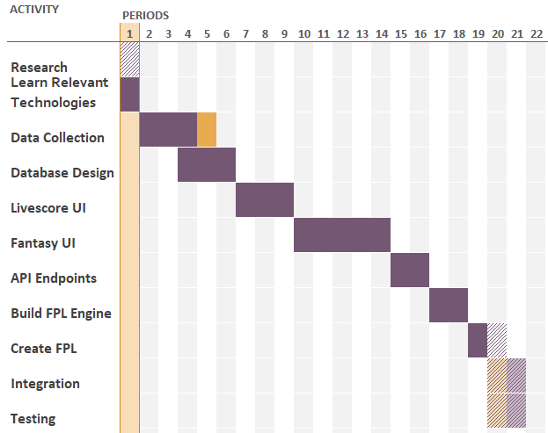

Figure 1 Gantt Chart

## Analysis

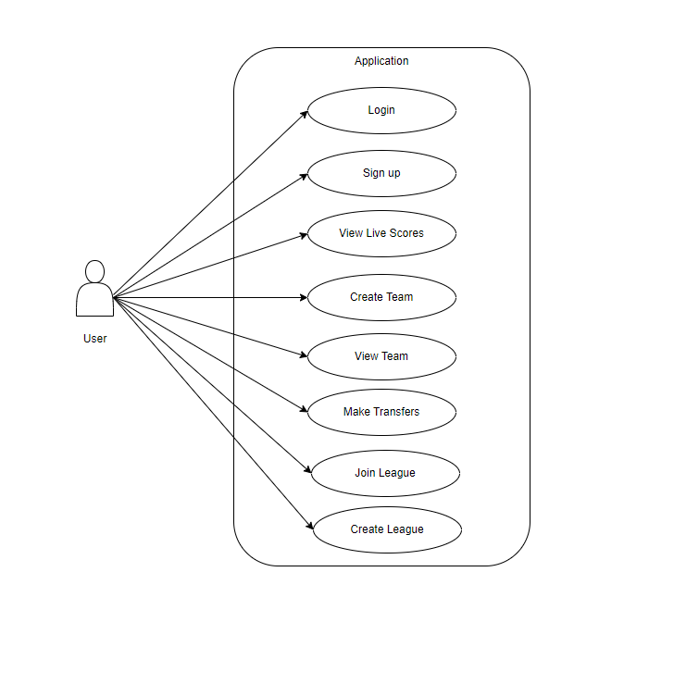

Figure 2 Use case diagram

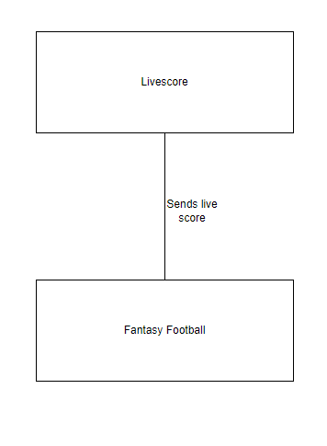

Figure 3 Level 0 DFD

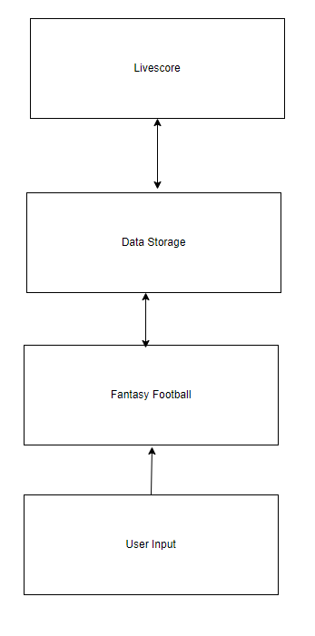

Figure 4 Level 1 DFD

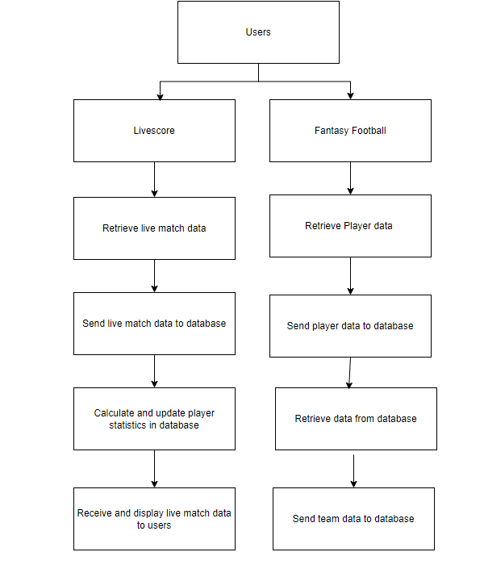

Figure 5 System Flow Diagram

# System Design

## Design

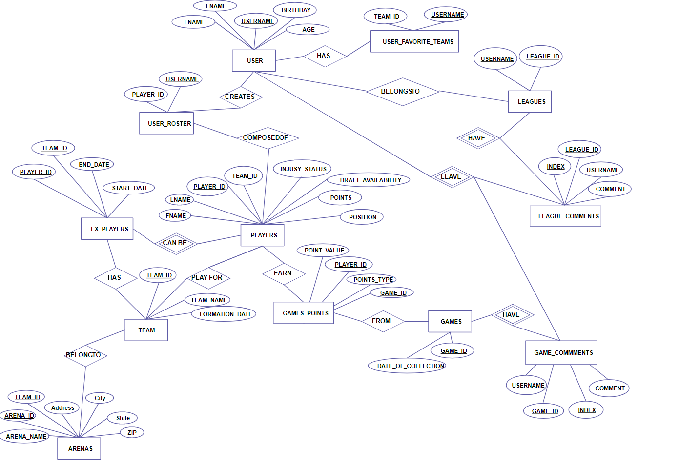

Figure 6 ER Diagram

## Algorithm Details

### Fantasy Score Calculator

In fantasy football, the score of a player is calculated based on their performance in the real-life matches. The rules used for building fantasy football are discussed below:

1. Goals: Goals scored by a player in a real-life match are usually the most important factor in calculating their fantasy score. The number of points awarded for a goal can vary, but it is usually around 4-6 points depending upon player position.
2. Assists: Assists, which are passes that lead directly to a goal, are also usually worth a significant number of points (usually around 3-4 based on player position).
3. Clean Sheets: Defenders and goalkeepers can earn points for keeping a clean sheet, which means that their team did not concede any goals during the match. The number of points awarded for a clean sheet can vary.
4. Saves: Goalkeepers earn points for making saves, with more points usually awarded for more difficult saves.
5. Yellow and Red cards: Players can lose points for receiving yellow or red cards, as these indicate a lack of discipline and can harm their team's chances of winning.
6. Bonus Points: bonus points are awarded to players who perform well in a match, based on a variety of factors such as the number of passes completed, successful tackles made, or shots on goal. The top 3 performers are awarded with bonus points[3].

**Headless Browser**

A headless browser is a web browser without a graphical user interface (GUI). It is designed to automate web page interaction and can be used to scrape data from websites. Headless browsers can navigate to a website, click on links, fill out forms, and extract data without any human interaction.

In collecting player stats for fantasy football, headless browsers can be used to navigate to various football statistics websites, such as the official Premier League website or third-party statistics websites, and extract player data such as goals, assists, clean sheets, and other relevant statistics. The headless browser can simulate user interaction with the website, such as clicking on links and buttons, scrolling through pages, and filling out search forms to find specific player statistics.

Once the headless browser has extracted the desired data, it can be saved in a structured format such as JSON or CSV for later processing and analysis. The data can then be used to populate a fantasy football team and help users make informed decisions about which players to select based on their performance statistics.

# implementation and testing

### Implementation

The data collection phase for this project was of paramount importance, as the generation of a statistics dataset for players that would be employed in fantasy football was required to have a real-time functionality. Given this constraint, it was determined that web scraping of football websites was the most viable approach for data acquisition. In particular, the widely-recognized football score application Whoscored was identified as a primary source for scraping data. However, it was found that the scraped data alone was inadequate, as goalkeepers' statistics, which are essential to point calculations, were not available. Therefore, a complementary source was required to supplement the data collected. Consequently, Fotmob was employed to obtain goalkeepers' statistics, enabling a comprehensive dataset of 750 players to be generated.

It should be noted that the data scraping process was complex, and numerous issues had to be resolved before the scraping could be completed successfully. Moreover, the extraction of live scores from football matches posed a significant challenge due to the need to monitor multiple European and South American leagues. Nonetheless, the project's data collection strategy was carried out with exceptional care, resulting in a comprehensive database of football players' statistics that can be relied upon for future data analyses.

A monolithic architecture was set up using next js for seamless development of both the frontend and backend on the local machine. The frontend of the project, a web application, was developed in ReactJS. For improved functionality and ergonomic visibility during development, pure CSS styling was used, with the glassmorphism design pattern applied in the web app.

### Tools Used

* Next JS: Next JS was used to package the entire web application into a single bundle. The primary library in next js is React JS with some default routing.
* Node JS: Node JS was used to build the backend services and logics.
* Mongo DB: MongoDB was used to create database schemas.
* Express JS: Express JS was used to create endpoints in the server from which the backend can interact with database and front end.
* Python: Python was used to scrape websites to collect player’s data.

### Implementation Details of Modules

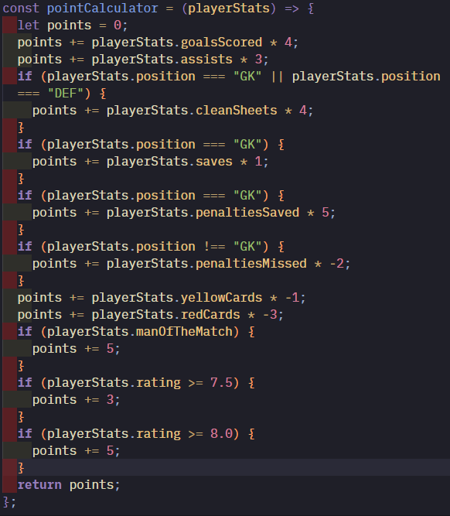

Figure 7 Points Calculation

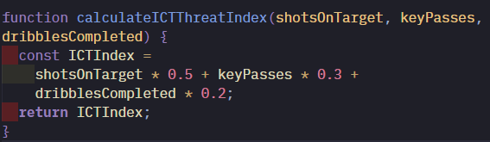

Figure 8 ICT Index calculation

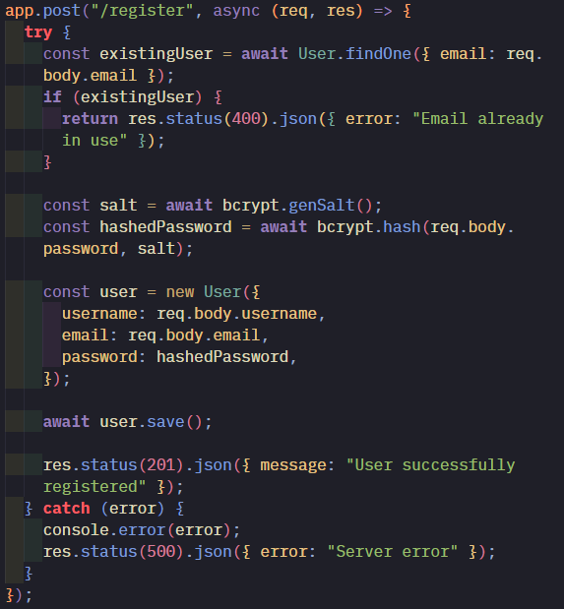

Figure 9 User Creation

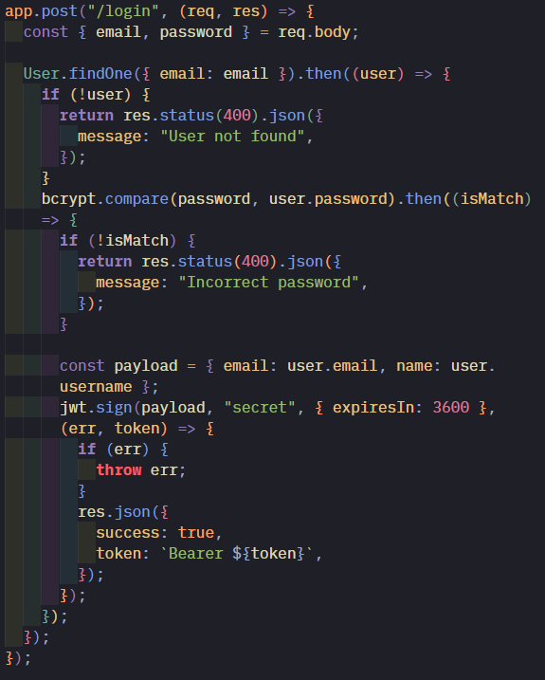

Figure 10 Login