**DEERWALK INSTITUTE OF TECHNOLOGY**

**Tribhuvan University**

**Institute of Science and Technology**

**MUSIC RECOMMENDATION USING CNN**

**A PROJECT II REPORT**

**Submitted to**

**Department of Computer Science and Information Technology**

**DWIT College**

***In partial fulfillment of the requirements for the Bachelor’s Degree in Computer Science and Information Technology***

Submitted by

Nabin Katwal

20619/075

12th June 2022

**DWIT College**

**DEERWALK INSTITUTE OF TECHNOLOGY**

# SUPERVISOR’S RECOMMENDATION

I hereby recommend that this project prepared under my supervision by NABIN KATWAL entitled **“MUSIC RECOMMENDATION USING CNN”** in partial fulfillment of the requirements for the degree of B.Sc. in Computer Science and Information Technology be processed for the evaluation.

…………………………………………

Mr. Hitesh Karki

Campus Chief

DWIT College

Deerwalk Institute of Technology

**DWIT College**

**DEERWALK INSTITUTE OF TECHNOLOGY**

# STUDENT’S DECLARATION

I hereby declare that I am the only author of this work and that no sources other than that listed here have been used in this work.

…………………………………………

Nabin Katwal

12th June 2022

**DWIT College**

**DEERWALK INSTITUTE OF TECHNOLOGY**

# LETTER OF APPROVAL

This is to certify that this project prepared by NABIN KATWAL entitled **“MUSIC RECOMMENDATION USING KNN”** in partial fulfillment of the requirements for the degree of B.Sc. in Computer Science and Information Technology has been well studied. In our opinion it is satisfactory in the scope and quality as a project for the required degree.

|  |  |
| --- | --- |
| ……………………………………   Mr. Hitesh Karki  Campus Chief  DWIT College | …………………………………………..  Mr. Shyam Sundar Khatiwada  Year In Charge  DWIT College |

# ACKNOWLEDGEMENT

I cannot express enough thanks to my supervisor, Mr. Hitesh Karki, for his continued support and encouragement. I got to learn more about machine learning and system design through his motivation. His vision was aspired as well as inspiring, and a corner stone for the completion of this project.

I offer my sincere appreciation for the learning opportunities provided by the Deerwalk Institute of Technology, as well as by micro project supervisor committee.

Nabin Katwal

20619/075

12th June 2022

ABSTRACT

With the release of tens of thousands of new songs each year, we often find it difficult to discover new music that matches our interests. Streaming music services have attempted to tackle this issue with recommendation systems based on machine learning techniques. While those companies have made notable progress, we hope to further improve the quality and diversity of recommendations. My approach to this problem is involved implementing K Nearest Neighbors model. Although Item-Item Collaborative filtering, Matrix Factorization and ensembling also works well with music recommendation, KNN does not assume a particular boundary between the classes and chances of overfitting the training data is minimal.

**Keywords**: *Recommendation Systems; Machine Learning; K Nearest Neighbors; Item-Item Collaborative Filtering; Matrix Factorization; Ensembling*

# TABLE OF CONTENTS

ABSTRACT ii

TABLE OF CONTENTS iii

LIST OF FIGURES v

CHAPTER 1: INTRODUCTION 1

1.1. Overview 1

1.2. Background and Motivation 1

1.3. Problem Statement 1

1.4. Objectives 1

1.5. Scope 2

1.6. Development Methodology 2

1.7. Outline 2

CHAPTER 2: BACKGROUND STUDY AND LITERATURE REVIEW 2

2.1. Background Study 2

2.2. Literature Review 3

2.3. Current System 3

2.4. The problem with Current System 3

CHAPTER 3: SYSTEM ANALYSIS 4

3.1. Requirement Analysis 4

3.1.1. Functional Requirement 4

3.1.2. Non-Functional Requirement 4

3.2. Feasibility Analysis 4

3.2.1. Technical Feasibility 4

3.2.2. Operational Feasibility 4

3.2.3. Economic Feasibility 4

3.2.4. Schedule Feasibility 4

3.3. Analysis 5

REFERENCES 6

# LIST OF FIGURES

Figure 1: E-R diagram 5

Figure 2: Use Case Diagram 5

**LIST OF ABBREVIATIONS**

API: Application Program Interface

AWS: Amazon Web Services

KNN: K Nearest Neighbors

# CHAPTER 1: INTRODUCTION

## 1.1. Overview

Music is one of the popular entertainment media in the digital era. Music is considered as the work of human creativity to express ideas and emotions in the form of sounds that consist of melody, harmony and rhythm [1]. Therefore, it is very useful to develop a music recommender system that can search music libraries automatically and suggest songs that are suitable for users.

## 1.2. Background and Motivation

As online music streaming becomes dominant medium for people to listen to their favorite songs, it is only wise to use better technology to keep up with it. Music streaming services are now able to collect large amounts of data on the listening habits of their customers. These streaming services, like Spotify, Apple Music or Pandora, are using this data to provide recommendations to their listeners. These music recommendation systems are part of a broader class of recommender systems, which filter information to predict a user’s preferences when it comes to a certain item. Think Netflix movie recommendations or Pandora radio. This project aims to build a music recommendation system that can recommend music based on user’s listening history and recommend similar music that they are used to listening and get a preview of the song they have been recommended.

## 1.3. Problem Statement

Many recommendation models only have recommended sections but users still have to go to different platform just to listen to the recommended music. This system aims to solve that issue by allowing users to listen to the preview of music to decide whether they like it or not.

## 1.4. Objectives

Aim of the project is to recommend music to the users according to the choices they make.

Objective will be achieved by using K Nearest Neighbor algorithm and Spotify API.

## 1.5. Scope

This system is concerned with K Nearest Neighbor algorithm which is a non-parametric supervised machine learning algorithm.

System can always be modified to get personalized recommendations.

## 1.6. Development Methodology

Agile development method will be used to reach the objectives throughout the project.

## 1.7. Outline

This project recommends music of different genres to the user.

1. **Preliminary Section:** This section consists of the title page, abstract, table of contents, list of figures, and list of tables.
2. **Introduction Section:** In this section, the overview of the project, the background and motivation of the project, problem statement, its objectives and scope are discussed.
3. **Background Study and Literature Review:** This section discuss about K Nearest Neighbor algorithm which is a non-parametric supervised learning algorithm.
4. **System Analysis:** This section shows the flowchart and Use case diagram of the project.

# CHAPTER 2: BACKGROUND STUDY AND LITERATURE REVIEW

## 2.1. Background Study

KNN is a machine learning algorithm to find clusters of similar users based on common music ratings, and make predictions using the average rating of top-k nearest neighbors. The principle is that known data are arranged in a space defined by the selected features. When a new data is supplied to the algorithm, the algorithm will compare the classes of the k closest data to determine the class of the new data. Analysis consists in the observation of the impact of parameters such as distance and classification rules on classification results. The major advantage of the KNN classification is its simplicity, it is also an efficient method. However, despite its efficiency, computation times can be long with large databases, the determination of the number of neighbors to use (k) requires trial and error and the algorithm is weak with outliers which can strongly impact its efficiency [2].

## 2.2. Literature Review

The Recommender System is a software application and algorithm that makes recommendations for the products that a user is most interested in. In recent years, the music industry's business model has shifted away from commodity sales and toward subscriptions and streaming. In comparison to prior eras, the availability of digital music is now abundant due to the new business model in the music industry. As a result, the importance of a music recommender system for music suppliers cannot be overstated.

It can forecast what songs their customers would like and then recommend them to them; as a result, music suppliers may boost user satisfaction and sell more diversified music. Generally, music recommender system can be divided into three main parts, that is: (i) users, (ii) items and (iii) user-item matching algorithms [3]. Firstly, to differentiate user’s music tastes, we can develop user modelling based on user profiling such as geographic region, age, gender, life styles, and interests. User modelling will model the difference in user profile to determine their choices of music [2]. Finally, the matching algorithm should be able to automatically recommend personalized music to listeners. There are two main approaches of matching algorithm, that is collaborative filtering and content-based filtering.

## 2.3. Current System

There are several music streaming platforms like Spotify, Apple Music, Amazon music etc. They let users to listen to music and get custom recommendations.

## 2.4. The problem with Current System

Most of these streaming platforms are paywall protected. So even if user has to listen to a newly recommended songs, they have to pay for the whole song. Music Recommendation System aims to solve this problem by allowing users to get a preview of the song without paying.

# CHAPTER 3: SYSTEM ANALYSIS

## 3.1. Requirement Analysis

### 3.1.1. Functional Requirement

* The user shall be able to create their account.
* The user shall be able to log in.
* The user shall be able to select their favorite genres of music.
* The user shall be able to listen to music preview.
* The user shall be able to browse different music categories.

### 3.1.2. Non-Functional Requirement

* Audio quality must be high.
* The system must be scalable.
* The model must have high accuracy.
* The system must be easy to use.
* The system must be fast.

## 3.2. Feasibility Analysis

### 3.2.1. Technical Feasibility

Python will be used as main language in this project as it has wide range of support for Machine learning and web development. The system will run on a web browser while being powered by data and recommendation model.

### 3.2.2. Operational Feasibility

Since the user does not directly interact with recommendation model, operation will only require user having knowledge to navigate a web app.

### 3.2.3. Economic Feasibility

This project will be hosted on a local server so the operational costs are minimal. In the future, Vercel or Netlify can be used to host it for free or AWS can be used to increase the speed of web app but it will be costly.

### 3.2.4. Schedule Feasibility

The project is estimated to be completed within 6 to 7 weeks of programming and 2 weeks of testing.

## 3.3. Analysis

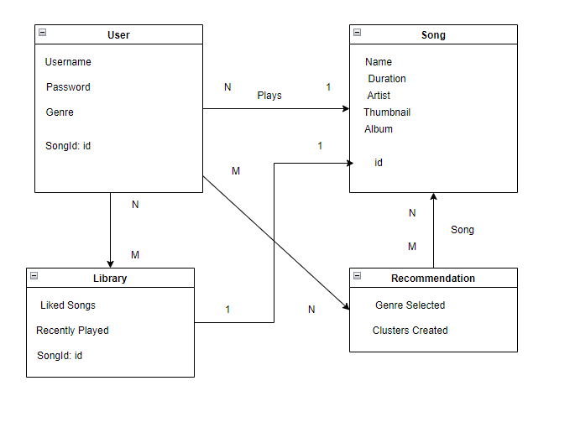

Figure 1: E-R diagram

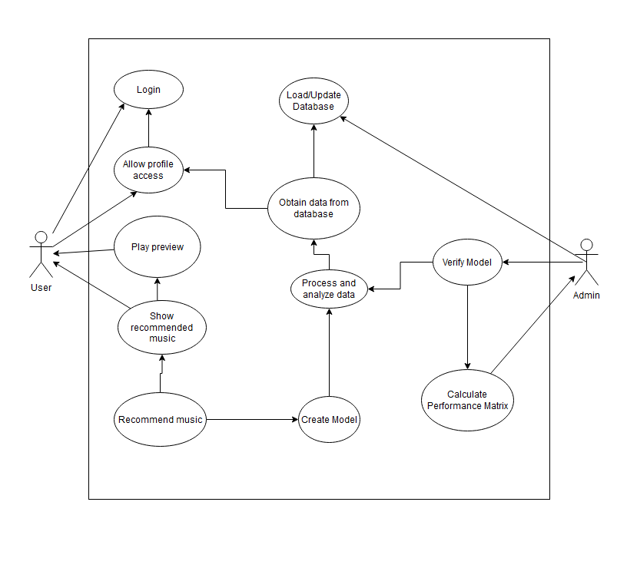

Figure 2: Use Case Diagram

# REFERENCES

|  |  |
| --- | --- |
| [1] | V. Khuat, "Music Recommendation Using Collaborative Filtering," pp. 2-3. |
| [2] | A. A. S. Gunawan, "Music Recommender System Based on Genre using Convolutional," *Science Direct,* pp. 5-6, 2019. |
| [3] | M. Ogihara, "NEXTONE PLAYER: A MUSIC RECOMMENDATION SYSTEM BASED ON," *12th International Society for Music Information Retrieval Conference (ISMIR 2011),* pp. 1-3, 2011. |
| [4] | S. D. B. S. A ̈aron van den Oord, "Deep content-based music recommendation," *Electronics and Information Systems department (ELIS), Ghent University,* 2017. |