Individual Assigned Task – Anurodh Humagain (E2400141)

Assigned Use Cases
- Register User and Privacy Settings
- Food Analytics

Overview of Individual Contribution
This is Anurodh Humagain (E2400141) individual submission for Assignment 1 Task 2 in BIT216. Anurodh is to work on use case 1 (Iteration 1) and use case 4 (Iteration 2) as per the recommended use cases distribution given in the assignment.

Use Case-1: Register User and Privacy Settings

Epic-1: Register User and Privacy Settings
This epic is about everything to do with creating a new user account, verifying their email, setting up 2FA (two factor authentication), securing login attempts and the management of the user's privacy/security settings on the WasteZero web platform. All users are able to register, check their email and securely log in before using any food management feature. Security and privacy controls are put in place to ensure user information and donation listings are suitably protected.

Appendix A: User Story Template
Example:
Student Name & ID: Anurodh Humagain (E2400141)
[Epic 1]: Features or functionalities
[User Story 1.1] | As a household user,  I need to create an account on WasteZero with my details like full name, email, password, and others details,  so that I can use or access the features of the food management system.
Acceptance Criteria | Given the user enters valid registration information,  when user fills in full name, valid email, password (min 8 characters), optional household size and clicks Register,  then the system will register a user account.  And an e-mail confirmation link shall be sent from the system.
MoSCoW | M – Must Have
Tasks | - Design registration interface.  - Validate user input.  - Store user information.  - Display registration confirmation.  - Write an API endpoint to accept a user to register them.  - Ensure passwords are strong enough (min 8 chars, 1 number, 1 special char).  - Store user’s data in MySQL Database.  - Choose random 6-digits verification code.
Test Cases | ----
[User Story 1.2] | As a registered user,  I need to confirm my email address or using 6-digit code sent to me,  so that I can be able to activate my account safely and log-in into the system.
Acceptance Criteria | Given the user has registered and the verification email or 6-digit code is received,  when the user clicks the links to verify,  then the account should be activated successfully and redirects to login.
MoSCoW | M – Must Have
Tasks | - Generate verification token  - Email verification link/verification code  - Validate token  - Activate user account  - Add endpoint for putting any email as verified at /api/verify-email.
Test Cases | ----

[User Story 1.3] | As an authenticated user,  I need to control, manage and enable Two-Factor Authentication from settings,  so that I can control and secure over my account from unauthorized access.
Acceptance Criteria | Given the user is logged in ,  when I click on enable Two-Factor Authentication(2FA),  so then my account is better protected and the new settings will saved and applied successfully.
MoSCoW | S – Should Have
Tasks | - Update user preferences  - Save settings in database  - Display update confirmation  - Create backend API endpoint POST /api/enable-2fa  - Add Two Factor Authorization toggle button in the set-up page.
Test Cases | ----
[User Story 1.4] | As a authenticated user,  I need to manage my privacy control ,  so that can control my information how it has been shared and saved.
Acceptance Criteria | Given user is in the privacy setting tab,  when the users updated the privacy setting,  then the new updated setting should be saved successfully.
MoSCoW | C – Could Have
Tasks | - Privacy setting page is created.  - Update user preferences.  - Updated settings is saved in database.  - Display update confirmation when the user update and saves data.
Test Cases | ----

Use Case 4: Food Analytics
[Epic 4] This epic module combines the ability to collect, view, and report on user food rescue activities on the WasteZero platform. The intuitive dashboard displays a bar chart of food savings (in kilograms) and an overview of the total amount donated each month. Users can filter by "week", "month", "total", and food category. Additionally, it offers monthly progress comparison charts and a performance system with milestone badges. It cleverly addresses users' urge to collect and motivates them to regularly organize their food inventory in a manage way.

[User Story 2.1] | As a logged-in household user,  I need to see my "reducing food waste" dashboard I want to see at a glance in the statistics how much I have saved by reducing food waste,  so that I can see the positive or negative impact of how much food have been saved.
Acceptance Criteria | Given user is logged-in and can see the food inventory data exits,  when clicked on View my impact or Report in the dashboard and opened it,  then the food saved data and statistics shall be displayed.
MoSCoW | M – Must Have
Tasks | - Design the analytics dashboard page.  - Collect inventory data  - Calculate food saved  - Generate dashboard statistics  - Create Backend API Endpoint GET /api/analytics/summary
Test Cases | -----
[User Story 2.2] | As a household user,  I need to view and filter my analytics report made by time period and food category,  so that I can predict and track my food-saving activities for specific periods and food types of my food management system.
Acceptance Criteria | Given user is on the food analytics dashboard with existing data,  when user selects a time-period(this week, this month, this year etc.) or food category from the dropdowns,  then all the data should be updated and statistics should be displayed in the system.
MoSCoW | M – Must Have
Tasks | - Add time period dropdown (This Week, This Month, All Time) to the analytics page.  - Add food category dropdown based on user's item categories.  - Add query parameters to GET /api/analytics time-period and category.  - Update chart data on front end as filters change.  - Add “Reset Filters” button to clear all the filters.  - Add a Reset Filters button
Test Cases | -----

[User Story 2.3] | As a household user,  I need to compare month on month progress and so on,  so that I can evaluate and track whether my food savings is improved or not over time.
Acceptance Criteria | Given user has analytics data and activity data available at least 2 months,  when the monthly comparison is selected in the dashboard,  then the system should display food saved this month compared to last month.
MoSCoW | S – Should Have
Tasks | - Add a new feature for calculating a month-to-month comparison in the GET /api/analytics endpoint.  - Calculate the total amount of food saved for the current month, compared to total amount saved at the previous month.  - Compare statistics  - Display comparison charts  - Compare and summarize.
Test Cases | ----
[User Story 2.4] | As a household user,  I could earn achievement progress badges ,  so that I can feel motivated and continue to reduce food waste.
Acceptance Criteria | Given a user achieves predefined milestones,  when the target is reached and view in the dashboard,  then the corresponding badge will be awarded.
MoSCoW | C – Could Have
Tasks | - Create badge system  - Define achievement rules  - Award badges automatically  - Display earned badges in the dashboard
Test Cases | -----

6. Entity Relationship Diagram (ERD)

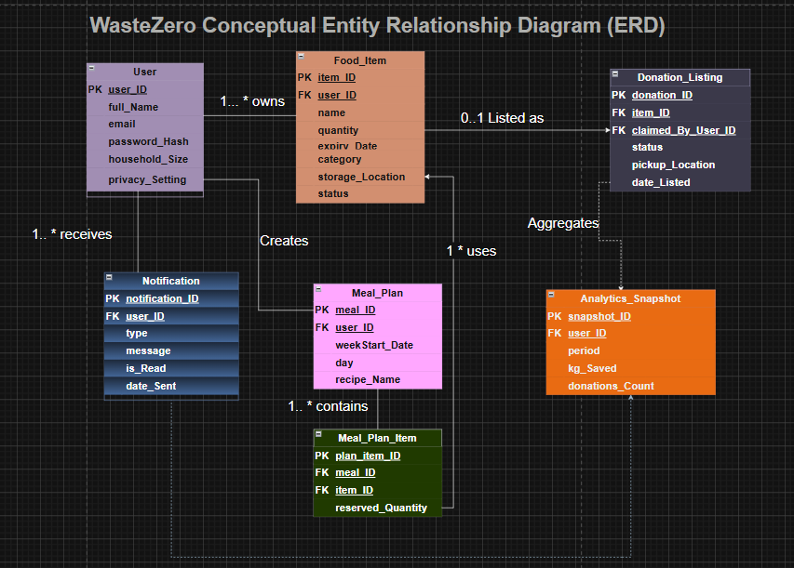
Figure 3: ERD Diagram
Link: https://drive.google.com/file/d/1daF2afDOhy6DGBe2HVoWecgmOoZ0986Q/view?usp=sharing
Relationships summary:
Relationship | Cardinality | Description
User → FoodItem | 1 : M | One user may have many food items in his/her house catalog.
FoodItem → Inventory | 1 : M | Many inventory stock entries are possible for a single food item (e.g., different expiry dates for different batches of the same item).
User → MealPlan | 1 : M | User can create many meal plan entries per week.
User → Notification | 1 : M | One user can receive many notifications.
User → AnalyticsLog | 1 : M | Many analytics snapshots can be recorded over time for a single user.
Inventory →Donation Listing | 1:0..0 | One inventory can be converted into at most donation listing.
User → DonationListing | 1 : M | One user can create many donation listing.

