**Python for Computer Science and Data Science 1 (CSE 3651)**

**MAJOR ASSIGNMENT-2: MUTABLE AND IMMUTABLE OBJECTS**

**Operation Navjeevan**

**Name : Nabin Kumar Shaw**

**Regd. No. : 2241019424**

**Section : 2241027**

**Branch : CSE**

Mission 1

MMMMMmmmmmmmmmmmmmmmmmmmmmmmmmmmmmmmmmmmmmmmmmmmmmmmmmmmmmmmmmmmmmmmmmmmmmmmmmmmmmmmmmmmmmmmmmmmmmmmmmmmmmmmmmmmmmmmmmmmmmmmmmmmmmmmmmmmmmmmmmmmmmmmmmmmmmmmmmmmmmmmmmmmmmmmmm

Mission 2

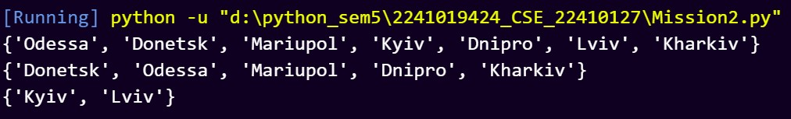

Mission 3

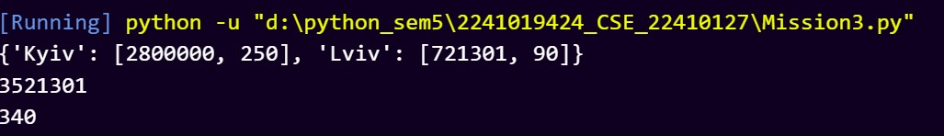

Mission 4