Analysis Specification on Classified Advertising Website

Nabin Thapa

0174393

Computing Project

Level 5 Diploma in Computing

Softwarica College of IT & E-Commerce

Kathmandu, Nepal

8th May 2019

Introduction

Analysis in software development is the vital phase as it gathers the needs and requirements of the customers. The product we are developing is for the customer and by the customer. Analysis fulfills the desire of the customer and their product. In this phase customers are directly or indirectly involved in the developing process to analyze and collect the specifications. Analysis helps to decompose the current scenario and analyze the problems or redundancy the customer might be facing and produce the problem statement in the future work.

Reasons to use analyze method in our project:

* To collect the requirements and understand it.
* To collaborate with the customer.
* Decompose the scenario and understand the problem.
* Provide problem statement

There are lots of ways to analyze and gather information from customer. Many activities are involved in this process. Some of the information gathering methods we will be using are:

* **Questionnaire**: In this method many questions are presented to the customer regarding the product specifications. It may be for one or for group of people. Objective type questions are practiced more as they are simpler, fast and easy for both parties which make the questionnaire more effective. Long questions shouldn’t be stated as the answer may be out of topic and we cannot get what we asked for. For these types of question there is another method which involves interview.
* **Interview**: It is the most relevant way of gathering analysis as both the parties meet face to face and discuss about the requirements. This way collects more information which may be beneficial in understanding the specifications correctly and also brings the two parties to a mutual understanding.

Rich Picture

To understand and analyze the overview of the project a simple rich picture is proposed for both developers and customers.

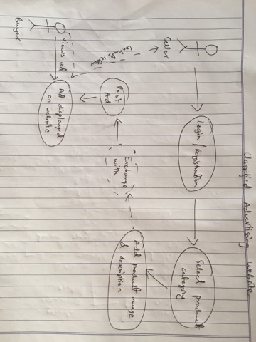

Fig: Rich picture

CATWOE analysis

This analysis helps to know the stake holders who are directly or indirectly involved in the project. It also analyzes the impact that will be on the stake holders if some decision are made upon the project or changed. The CATWOE analysis breaks down into:

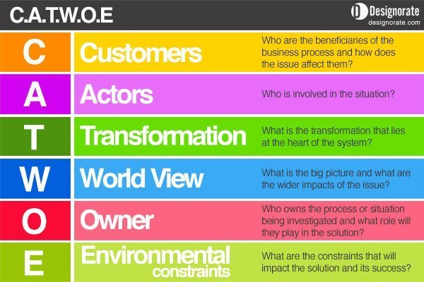

Fig: CATWOE analysis

* **Customer**: They are the active stake holders of the system where system requirements and needs should be taken care of. The system we will be building will directly benefit them as the system is proposed by them and it is for them. This stage in CATWOE analysis sorts out how the system is going to affect the client. In our project customer states as the end users who will be using our web application.
* **Actors**: Actors defines the parties involved in implementation of the system as proposed in development. They are directly involved in the process of developing the system. Admin of the project can be stated as actor in our project.
* **Transformation**: This defines the input and output data and information processed in the system that comes from users. What kind of input are taken and what outputs are presented should be analyzed. Furthermore, where this information should be stored is important. These processing should be made easily accessible, fast and secure in our system. Since our application is an advertising application, images of the products and their descriptions are taken as input and according to these data matching exchange outputs are presented in the website.
* **World View**: World view analyzes the situation outside and inside the organization or in our case the local place of the deployment. It studies the impact that will be upon the implementation of the project. Our project offers local product advertising in the market which eases the users in the area but value of similar products may be lessen by the implementation of the project.
* **Owner:** The owner of the project holds all the rights to make amendment changes in the system development. In our case admin holds the ownership of the project and all its behavior. Identification of owner is the vital phase of analysis in the development cycle.
* **Environment**: In this phase all the norms and values of the project should be in relation to the surroundings culture. It includes all the law, ethics and legal term agreements of the government. This conducts should cover the places where the product will be deployed.

Feasibility Study

This study holds the overall analysis of the project and states how to implement or whether the project is suitable to proceed further for the developing phase or not. It studies all the aspects of the project from start to the end and even after the deployment process, so this study is very vital phase in the analysis process. It studies the cost and budgeting of the developing and deployment of the project. Socio economic and legal terms are also discussed if the project is fit in the environment where it is going to be deployed. It also analyzes the technical aspects if there is skilled manpower to develop the system and operator to operate the system. So, considering this study, our project should be built upon. There are many aspects to be feasible in the project and even if one holds false then possible solutions must be figured and develop the system according to it.

* Economic Feasibility: It studies the financial matter and budgeting required in developing and deploying the system. This study helps the stake holders to invest the finance wisely and also pre calculates the overall financial matters. Without this study, an organization cannot build a successful project.
* Technical Feasibility: A proposed project should have skilled manpower to develop it. Not only in developing but also to operate it there should be knowledge to operate. This study studies the developers and user they are going to operate and makes the system user friendly.
* Social Feasibility: This feasibility varies whether the system is socially fit in the environment. Social norms and values, ethics and moral code and conducts must be kept in mind that the system will not hinder the surrounding’s code. This study should be done very carefully as it is a really sensitive matter.
* Legal Feasibility: Government decisions in the system matters and there should be a proper study done regarding the terms and conditions of the state. Organization cannot step out of the boundary from these rules and regulations otherwise the project can be terminated.

Use case

It is the graphical demonstration of the system where the stake holder’s activity and their access are shown in the form of stick actors. Use case diagram explains the overall system and what a user can do, access and function in operating the system in a very simple terms and figures.

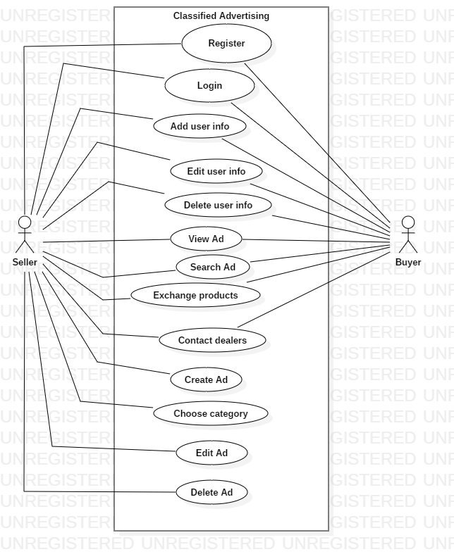

Fig: Use Case diagram

In our project basically there are two types of end users who use our system i.e. Buyer and Seller. First, the seller wishes to post their ad on the website from which the content in our website fills up and viewers can view the products in the application. During the post of the ad, seller can wish to add exchange products to their products. The ads can be then seen by the buyers who wish to buy the products. They can advance search the product according to the category, prices or distance range and can contact with the dealers.

* Register- To post a new ad or to contact/comment the dealers/products, user need to register on the system and create their unique identity. In the registration process, users need to provide email address, contact number and their location. User can also register through their existing Facebook.
* Login- After the successful registration, user can login by providing correct email and password.
* User info- During registration or after successful login, user can add their added details on their profile to gain trust towards their customer. On their profile users can view all their ads posted. User can wish to edit or delete this information according to their wish.
* View Ad- All users can view the ad without prior to register or login in the system, but they need to be logged in if they wish to comment or contact the dealer.
* Search product- Users can search the product in the application as their query and advanced search allows users to find appropriate match according to price range, distance and category. They can also search appropriate exchange products.
* Exchange products- Products can be exchanged by searching and filtering their products to the desired products in the system. After they have found the matching results, it depends upon the two parties to deal by them.
* Create Ad- In order to create ad, user needs to be logged in. To create ad user must provide at least a picture of their product, description about their product and select the category under which their product falls. They can edit or delete these ads according to their will.
* Contact dealers- Users who wish to be in contact with the dealers either for buy/sell or exchange can comment in the section if they are logged in or can directly call on their contact info.

Requirements Analysis

Reasons to use analyze method in our project:

* To collect the requirements and understand it.
* To collaborate with the customer.
* Decompose the scenario and understand the problem.
* Provide problem statement

Many activities are involved in this process. Some of the information gathering methods we used are:

* Questionnaire
* Interview

Furthermore, CATWOE analysis technique has been introduced in the process of analysis stage.

Two types of requirements, functional and non-functional requirements are analyzed and proposed as below.

Functional Requirements

|  |  |  |  |  |  |
| --- | --- | --- | --- | --- | --- |
| Function ID | Title | Description | Rational | Dependencies | Impact  (MoSCoW) |
| F01 | Registration | New user who wish to post ad or contact the dealers need to register in the system by providing email, location, password and contact no. | In order to save the user credentials in the system and create unique identity in the system. | F02 | Must have |
| F02 | Login | After registration, user can login through the provided email and password. Ad and contacts/comments can also be made if the users are logged in. | To provide security and distinguish user. | F01 | Must have |
| F03 | Add user info | Users can add detailed information about their ad on their profile or can delete/edit these info in order to gain trust from customers. | To provide detailed information about the user or products. | F02 | Should have |
| F04 | Create Ad | To create ad, user need to select their product that falls under the category and upload a pic of their product with detailed info. | To display the product ad in the website with detailed info. | F02 | Must have |
| F05 | View Ad | Anyone can view the ad created by the user in the website. | Share and advertise their product. | F04,F06 | Must have |
| F06 | Search Ad | User can search products to their appropriate choices without logging. | To simplify the searching product method. | F04,F05 | Must have |
| F07 | Exchange products | Without paying users can exchange products with their appropriate match. | To minimize paying system and increase exchanging tradition. | F03,F04,F05,F06 | Should have |
| F08 | Contact dealers | After users have matched their wishes on the product requirements, they can contact the dealers on their contact no or by commenting on the website. | Helps to connect the buyer and seller easily. | F02,F03,F05,F06 | Should have |

Nonfunctional requirements

**Performance**- The performance level of the application should be fast and efficient as the user requires quick and fast search products. Many users send query at the same time and the performance of the system should not be degraded and have bottleneck issue. In order to maintain performance of the system, OOAD approach should be used so that the implementation can be optimized and reused.

Function ID-NF01

Title- Boost Performance

Description- User should be able to use the services fast and efficient.

Purpose- To upgrade user experience

Dependencies-F02, F04, F05, F06, F07

**Reliability**- The system should be reliable and user friendly to the users. Any errors in the system should response accordingly and should be informed to the users. Validation in the system should be strictly maintained as it leads to chaos to the user.

Function ID-NF02

Title- Provide continuous service with better versions

Description- User should be able to use the services at anytime with continuous upgrades and better services.

Purpose- To upgrade user experience

Dependencies-F02, F04, F05, F06, F07, F08

**Availability**- The application should be accessible to the user anytime they desire to use. There may be frequent maintenance in the system and the time period when the user accesses the application least should be targeted for maintenance period.

Function ID-NF03

Title- Provide up to date service

Description- User should be able to use the services in updated versions.

Purpose- To upgrade user experience

Dependencies-F02, F04, F05, F06, F07, F08

**Security**- For security purpose, login system with password is enabled to keep all their individual products to themselves. User can publicly display or deny displaying about their information. Each seller have their own profile where they can view their product history and make changes according to their will.

Function ID-NF04

Title- Secure user privacy

Description- User should be able to use the services in secure and private means.

Purpose- To provide security in the system.

Dependencies-F02, F03, F08

Prioritization

Before in system development process, time and cost used to be variable and feature would be constant which would lead to unsuccessful project. Now the system development process emphasizes of constant time and cost but variable features. This makes the project easy and client can have clear vision towards the project. Proper prioritization with client is the most effective way to success a project. Doing this client can judge time and cost and get all the necessary features with ease.

MoSCoW prioritization technique stands for Must have, Should have, Could have and Wont Have. These have refers to the features in the system and are prioritized accordingly.

Must Have- This refers that certain feature must be there in the system and cannot be neglected.

Should Have- This requirement should be in the system to support other features.

Could Have- These are the requirements that may be or may not be in the system and can be built upon later in time period.

Won’t Have- These are the features that don’t affect the current system even if it is not applied. They are prioritized at last in the development.

For example, in our project we have analyzed different requirements and features to build in the software. All these features are not completely necessary to function the system. We need to view different ad in the website by searching the content in the system. After finding the appropriate product in the application, user wishes to deal with the dealer either to contact or negotiate the product. After the finalization of the deal the two parties make a deal and finalize the deal. The buyer even may wish for home delivery and product testing feature.

According to the MoSCoW prioritization the priority for this scenario would be:

Must have- Search Ad, View Ad

Should have- Advanced search option to search products

Could have- Contact dealer directly in the application (online chat)

Won’t have- Home delivery and testing of the product

|  |  |  |
| --- | --- | --- |
| ID | TITLE | PRIORITY |
| F01 | Registration | Must Have |
| F02 | Login | Must Have |
| F03 | Add User info | Should Have |
| F04 | Create Ad | Must Have |
| F05 | View Ad | Must Have |
| F06 | Search Ad | Must Have |
| F07 | Exchange Products | Should Have |
| F08 | Contact dealers | Should Have |

Architecture

System architecture

To improve nonfunctional requirements that boost the overall functional features in the system, OOAD approach is very much reliable in the project. Design patterns like MVC architecture pattern is to be applied in the system as this pattern separates each role in three different layer and each layer works on its responsibilities, making the system easily maintainable and reusable by optimizing the properties.

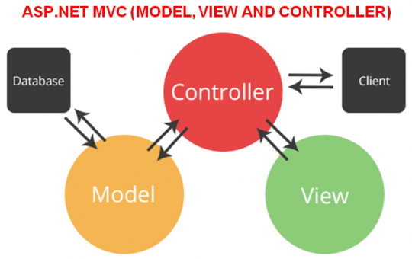

Fig: MVC pattern

The Model View Controller (MVC) design pattern specifies model (model), presentation information (view), and control information (control) in our application. Since the project is web based application, httprequests are handled by controller, frontend design are processed by view and model holds certain business logics which makes the architecture of the application independent to each other. The pattern requires that each of these be separated into different objects.

Furthermore, 3 tier architecture is to be implemented in the development project. 3-tier application architecture is a modular client-server architecture that consists of a client tier, an application tier and a data tier.

We use this system architecture in our project as this architecture divides tasks in our client server based application where each task is handled by each layer. Client tier holds the interface services to view our users, application tier holds certain business logics whereas data tier provides/receives information from the server. This enchances the performance and security of our application.

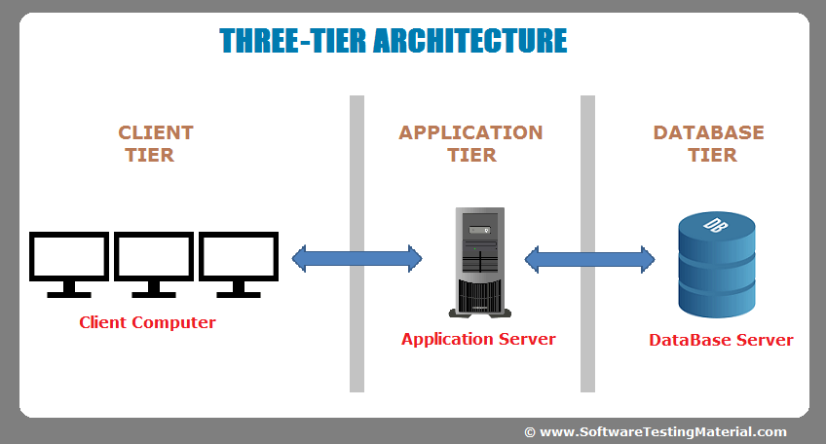

Fig: System Architecture