Project Proposal Report on

Classified Advertising Website

Submitted By: Nabin Thapa

NCC ID: 00174393

Level 5 Diploma in Computing

Batch-22’B’

Softwarica College of IT and E-Commerce

Dillibazar, Kathmandu

Submitted To :Niman Maharjan

Date: 10th April 2019

Contents

Chapter 1 3

Introduction 3

1.1) Project Introduction 3

1.2) Justification for the project 3

A) Background 3

B) Problem Statement 3

1.3) Description of the project 3

Features of Project 4

1.4) Overview of the Project 4

Chapter 2 5

Scope of the project 5

2.1) Scope 5

2.2) Limitation 5

2.3) Aims 5

2.4) Objectives 5

2.5) Overview of the scope 6

Chapter 3 7

Development Methodology 7

3.1) Development Methods 7

3.2) Design Pattern 8

3.3) System Architecture 9

Chapter 4 10

Project Plan 10

4.1) Work Breakdown Structure 10

4.2) Milestones 11

4.3) Scheduling 13

A) Time estimation table 13

B)GANNT CHART 14

Chapter 5 15

Risk Management 15

Chapter 6 17

Configuration Management 17

Conclusion 19

References 20

# Chapter 1

# Introduction

## Project Introduction

Classified advertising is a web application that offers users to advertise their sell, new or used item on their own deal and price. This platform offers sales, buying and exchange, all market demanded by the end users themselves. Just register and advertise goods quickly and more efficiently. We can now easily exchange goods with just one search. This application offers selling agent in fast, easy and convenient matter, all in no cost.

## Justification for the project

### Background

Advertising is a powerful method to attract and sell any products. Whether it is new or used goods, everyone has something to offer a sale. Sales can be difficult to achieve, especially if you are not full time seller and want to sale things from your home. People may not grab your sales offer due to lack of advertising and your goods can be gone unheard. Many people want to exchange goods rather than buy it, this application helps to find the perfect match for you to exchange goods.

### Problem Statement

The application is proposed to overcome the issue of the unheard products that are required to sell in the market from home and difficulty on finding people to exchange products. Mostly people want to exchange products rather than pay for it. Our project provides unique feature to simply find match to exchange products for suitable goods for both parties. This feature lets both parties in contact and from that point they can deal for the product.

## Description of the project

The aim of this project is to help people offer sales advertisement, discover sales and provide easy way to exchange goods by removing the old method of selling and dealing goods. Simply register and login to sell or exchange with suitable products.

### Features of Project

What’s there in the application:

* Register with facebook.
* Advertise products with detailed information and pictures.
* Advanced search option to get the suitable products.
* Find desirable exchange products with one search.
* Notification enabled to view activity.
* Advertisement history
* Contact seller/buyer or exchanger.

## Overview of the Project

This platform offers sales, buying and exchange, all market demanded by the end users themselves. Just register and advertise your goods quickly and more efficiently. You can now easily exchange goods with just one search. This application offers selling agent in fast, easy and convenient matter, all in no cost.

# Chapter 2

# Scope of the project

## 2.1) Scope

The main scope of this project is to help people offer sales advertisement, discover sales and provide easy way to exchange goods by removing the old method of selling and dealing goods. Easy search for suitable goods sale or exchange should be enabled to achieve the success of the project. Whenever the users feel easy to sell or exchange items then only our project will come to a level of success.

## 2.2) Limitation

* may be convinient in local country only.
* fraud seller may be involved.
* the deal between two parties may be uneasy

## 2.3) Aims

The main aim of this project is to implement advertise your goods and help people find suitable match for exchange in fast and convenient way that includes:

* To build web based application for a sales advertisement
* Deliver easy match to exchange products
* To be a bridge between buyer and seller.

## 2.4) Objectives

The objectives of this project are:

* To advertise products with detailed information and pictures.
* Provide advanced search option to get the suitable products.
* Help find desirable exchange products with one search.
* Enable notification to view activity.
* Show advertisement history
* Help contact seller/buyer or exchanger.

## 2.5) Overview of the scope

This project offers sales, buying and exchange; all market demanded by the end users themselves but may be limited only in local country. User need to just register and advertise their goods. Users can easily exchange goods with just one search. This application offers selling agent in fast, easy and convenient matter, all in no cost. The application is proposed to overcome the issue of the unheard products that are required to sell in the market from home and difficulty on finding people to exchange products by removing the old method of selling and dealing goods.

# Chapter 3

# Development Methodology

## 3.1) Development Methods

For the development of the project Object Oriented Methodology will be used as it is project based development. Since the project is small based, waterfall model along side with object oriented methodology will be suitable for the development of this project. Each step will be carried out very carefully and one step cannot be carried out without completing the step before it.

The waterfall model is the earliest SDLC approach that was used for software development. The waterfall model is easy and small project based method. Each phase should be completed before the implementation of next phase.

The following illustration is a representation of the different phases in the Waterfall Model:

**Requirement Analysis**

**System Design**

**Implementation**

**Testing**

**Maintenance**

Fig: Waterfall Model

Advantages of waterfall model for the project:

* Works well for our project as requirements are very well understood.
* Suitable for small based project.
* Phases are processed and completed one at a time.
* Completed result visible of the project.
* Well understood milestones.
* Easy to arrange tasks in our project.
* Process and results are well documented in the project.

## 3.2) Design Pattern

Design patterns technique makes the implementation of complex functionality easy and efficient. Different designe patterns may be used in the development of the project but for the architectural pattern the project is going to be using MVC pattern and object oriented approach using framework (ASP.NET MVC) for faster, maintainable and reusable development of the project.

The Model View Controller (MVC) design pattern specifies model (model), presentation information (view), and control information (control) in our application. Since the project is web based application, httprequests are handled by controller, frontend design are processed by view and model holds certain business logics which makes the architecture of the application independent to each other. The pattern requires that each of these be separated into different objects.

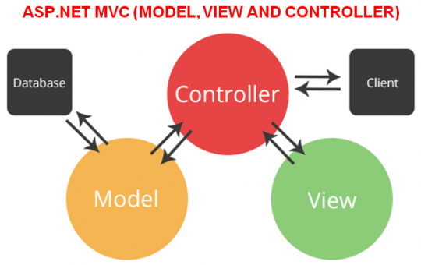

Fig: MVC Pattern diagram

## 3.3) System Architecture

Architecture serves as a skeleton diagram for a system. It provides an abstraction to manage the system complexity and establish a communication and coordination.

3 tier architecture is to be implemented in the development project. 3-tier application architecture is a modular client-server architecture that consists of a client tier, an application tier and a data tier.

We use this system architecture in our project as this architecture divides tasks in our client server based application where each task is handled by each layer. Client tier holds the interface services to view our users, application tier holds certain business logics whereas data tier provides/receives information from the server. This enchances the performance and security of our application.

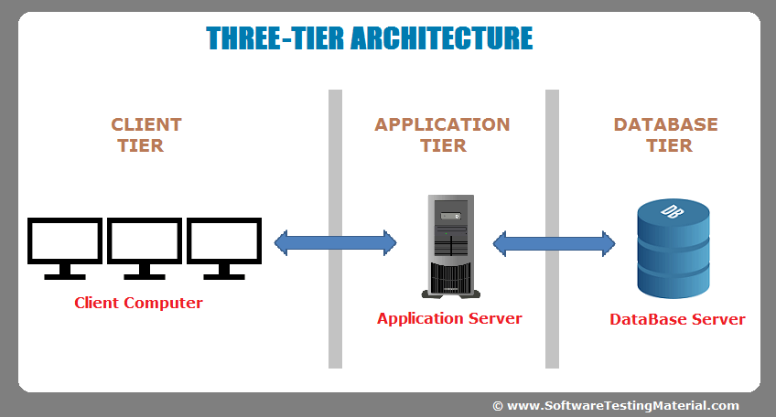

Fig: System Architecture

# Chapter 4

# Project Plan

## 4.1) Work Breakdown Structure

Work breakdown structure helps to decompose a project into manageable sections that divides the roles and helps in management. It helps in the detailed development and co ordination of a project.

**Advertising System**

**Proposal**

**Scoping**

**Planning**

**Monitoring**

**Analysis**

**Requirement Gathering**

**Requirement Analysis**

**Use Case Diagram**

**Design**

**Class Diagram**

**Sequence Diagram**

**User Interface**

**Coding**

**Testing**

**Unit Testing**

**Integration Testing**

**Documentation**

**Final Report**

**User Manual**

Figure : Work Breakdown Structure

## 4.2) Milestones

|  |  |  |  |
| --- | --- | --- | --- |
| **Milestones** | **Start Date** | **End Date** | **No. of Days** |
| Project proposal submission | 3/26/19 | 4/10/19 | 16 days |
| Planning |  |  |  |
| Scoping |  |  |  |
| Monitoring |  |  |  |
| Submission |  |  |  |
| Analysis specification | 4/11/19 | 4/29/19 | 19 days |
| Requirement Gathering |  |  |  |
| Requirement Analysis |  |  |  |
| Use Case Diagram |  |  |  |
| Analysis Specification |  |  |  |
| Design | 4/30/19 | 5/24/19 | 25 days |
| Class Diagram |  |  |  |
| Sequence Diagram |  |  |  |
| User Interface |  |  |  |
| Design Specification |  |  |  |
| Implementation | 5/25/19 | 6/20/19 | 27 days |
| Coding |  |  |  |
| Testing | 6/21/19 | 6/30/19 | 10 days |
| Unit Testing |  |  |  |
| Integration Testing |  |  |  |
| Documentation | 7/1/19 | 7/11/19 | 11 days |
| User Manual |  |  |  |
| Final Report |  |  |  |
| Report Submission |  |  |  |
| Final Deadline 7/11/2019 | | | |

Here we have following milestone points for this project. This milestone maps each phases of the SDLC cycle.

1. Project Proposal: 10th April 2019

This points the milestone for proposal which involves planning, review and scoping. These are the fundamental planning of the project and holds that the planning phase is complete.

1. Analysis Specifications: 29th April 2019

After the proposal is approved, then the beginning of the project initiates. This phase involves high analysis study and requirements specifications of the project. Static and dynamic analysis of the system is analyzed.

1. Design: 24th May 2019

The designing phase begins after all the requirements are analyzed and specified. This includes the architecture design, system design and interface of the application.

1. Implementation: 20th June 2019

According to the design of the system, source code of the application is implemented. OOP method is used to implement our project. Finally as the code is implemented, this would mark the milestone for implementation.

1. Testing: 30th June 2019

The final product is tested numerous times with wide range of data to ensure the quality of the product to be delivered. This holds a crucial milestone in the development process as this defines the standard of the project.

1. Final report (soft copy): 10th July 2019

After all the product is ready, the soft copy of the product and documentation is submitted for the inspection. When the project is approved, it will mark the milestone for final report.

1. Report submission: 11th July 2019

After the entire documentation process and complete project result, the application will be ready to be deployed and repeatedly feedbacks will be collected to enhance the features of the application in the future.

## 4.3) Scheduling

### A) Time estimation table

|  |  |  |
| --- | --- | --- |
| **Task Number** | **Task Name** | **Task Estimation** |
| 1 | Proposal | 16 days |
| 2 | Analysis | 19 days |
| 2.1 | Requirement Gathering | 8 days |
| 2.2 | Requirement Analysis | 7 days |
| 2.3 | Use Case Diagram | 3 days |
| 2.4 | Analysis Specification | 1 day |
| 3 | Design | 25 days |
| 3.1 | Class Diagram | 9 days |
| 3.2 | Sequence Diagram | 9 days |
| 3.3 | User Interface Design | 6 days |
| 3.4 | Design Specification | 1 day |
| 4 | Implementation | 27 days |
| 4.1 | Coding | 27 days |
| 5 | Testing | 10 days |
| 5.1 | Unit Testing | 6 days |
| 5.2 | Integration Testing | 4 days |
| 6 | Documentation | 11 days |
| 6.1 | User Manual | 5 days |
| 6.2 | Final Report | 5 days |
| 6.3 | Report Submission | 1 day |
|  | Total Days | 108 days |

Fig: Time estimation table

### B)GANNT CHART

Gantt chart provides a graphical illustration of a schedule of our project that helps to plan, schedule, coordinate, and track specific tasks in a project. Gantt chart gives a clear illustration of project status and its management, but doesn’t involve schedule routine if a section falls back.

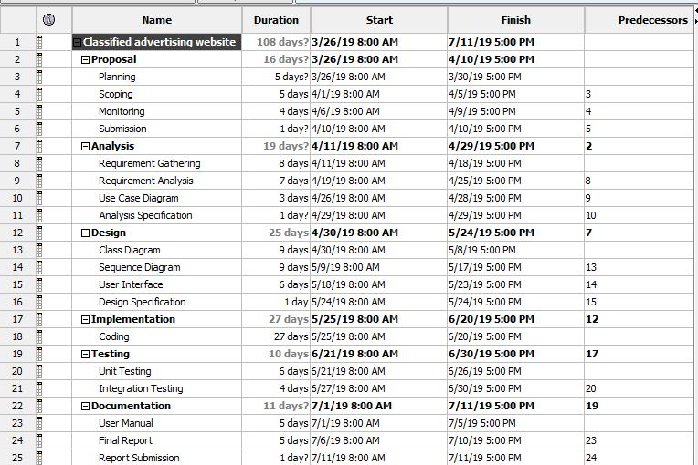

Fig: Gantt chart table

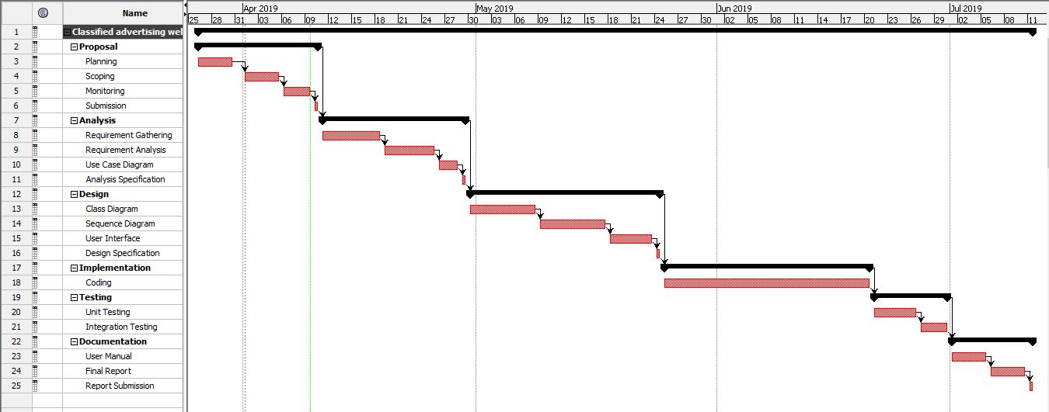

Fig: Gantt chart

# Chapter 5

# Risk Management

It is the process of identifying, assessing and controlling threats in our project. These threats may generate from financial, changes, uncertainty, legal liabilities, strategic management errors, accidents and natural disasters. These risks need to be analyzed before they may arrive and should be documented for its possible solutions. In order to manage the risk, they must be identified with its level of impact of risk and then proper solution should be figured out. Some steps can be used to minimize the risk:

**Risk identification**

This step involves the identification of risks and threats which may get in the way in the development process of the project. We try to uncover, recognize and describe risks that might affect the project outcome. There are number of techniques that we can use to identify the risk.

**Risk analysis**

After the risk is identified, likelihood and consequences of each risk should be calculated. In this way we can develop understanding of the nature of the risk and its affect to the project.

[**Risk assessment**](https://searchcompliance.techtarget.com/definition/risk-assessment)**and evaluation**

In this phase, the risk is ranked by determining the risk magnitude, which is the combination of likelihood and consequences. We make decision about whether the risk is acceptable or whether it is serious enough to warrant the treatment.

**Risk mitigation**

In this phase we assess our highest ranked risks and set out a plan to treat or modify this risk to achieve acceptable risk level.

**Risk monitoring**

Here we monitor, track and review the risk that occurs during the time of project. Risks should be managed in time before they become a problem. We resolve this problem by identifying and planning counter measures.

**Likelihood table:**

|  |  |
| --- | --- |
| **Likelihood** | **Value** |
| Low | 1 |
| Medium | 2 |
| High | 3 |

Table: Risk likelihood values

**Risk consequences table:**

|  |  |
| --- | --- |
| **Consequence** | **Value** |
| Very low | 1 |
| Low | 2 |
| Medium | 3 |
| High | 4 |
| Very high | 5 |

Table: Risk consequence values

**Risk management table:**

|  |  |  |  |  |  |
| --- | --- | --- | --- | --- | --- |
| **S.No** | **Risk** | **Likelihood** | **Consequence** | **Impact** | **Action** |
| 1 | Change in requirements | 3 | 3 | 9 | try to address the change requirement |
| 2 | Unqualified employee | 2 | 3 | 6 | Train employees |
| 3 | Inaccurate estimation | 2 | 4 | 8 | Fulfill major features |
| 4 | Unrealistic budget | 2 | 3 | 6 | Breakdown expenses and cut down unnecessary expenses |
| 5 | Server failure | 1 | 5 | 5 | Backup data and backup power |
| 6 | Virus threats | 2 | 3 | 6 | Install antivirus and scan |

# Chapter 6

# Configuration Management

Files and the folder related to the project are arranged in systematic way so that it will be easier to access the file whenever necessary. The SDLC are divided and managed in different folders. A backup of these files are backed up for future reference. Also **GitHub** is used to store the data for regular backup.

The folder of classified advertising contains 5 subfolders. All the required materials are managed and stored in those directories.

Project can be directly accessed by using the following link for the github:

<https://github.com/nabinmgr/Computer-Project>

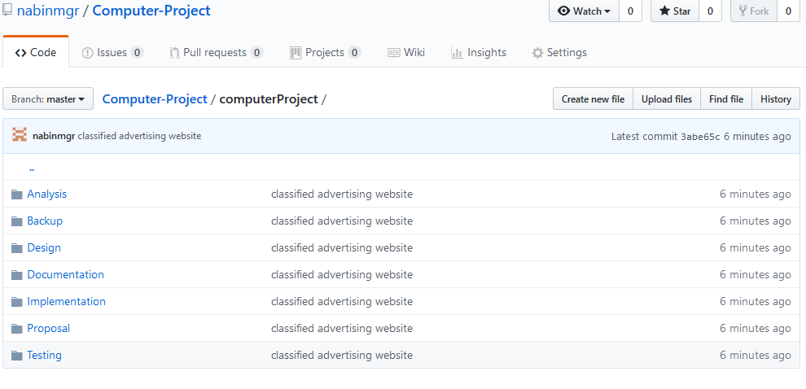

Fig: Project Uploaded in github

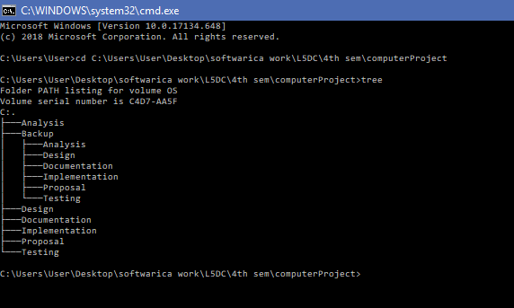

Fig: Configure Management tree

# Conclusion

In this way, the project can be built for the management of the customer’s product advertising. This platform offers sales, buying and exchange, all market demanded by the end users themselves. This application is going to solve the traditional way of dealing with new or used products in the market without any waste of time effort and money. To complete the project I have also done many analysis, time estimation, risk management, work breakdown structure etc. so that the project will be complete successfully without any initiation. I want to conclude that now I am ready to start my project using ASP.NET MVC as backend and JavaScript (react) as frontend.

# References

* Airbrake (2019) **Waterfall model** [Online] Available at: <https://airbrake.io/blog/sdlc/waterfall-model> [Accessed 7th April 2019]
* Tutorialspoint (2019) **MVC pattern** [Online] Available at: <https://www.tutorialspoint.com/design_pattern/mvc_pattern.html> [Accessed 7th April 2019]
* softwaretestingmaterial (2019) **software-architecture** [Online] Available at: <https://www.softwaretestingmaterial.com/software-architecture/> [Accessed 7th April 2019]
* Workbreakdownstructure (2019) **Workbreakdownstructure** [Online] Available at: <https://www.workbreakdownstructure.com> [Accessed 8th April 2019]
* searchsoftwarequality (2019) **Gantt-chart** [Online] Available at: <https://searchsoftwarequality.techtarget.com/definition/Gantt-chart> [Accessed 8th April 2019]