APPROVAL CERTIFICATE
The project report entitled " Hospital Management System", submitted by Nabin Panday, Sarthak Kuikel, Sushant Basnet in partial fulfillment of the requirements for the Bachelor of Information Technology (BIT) degree, has been examined and is hereby approved for academic credit.

Project Supervisor

External Examiner

Head of Department

Date: October 6, 2026

ACKNOWLEDGEMENTS
The successful completion of this project was possible because of the continuous support, guidance, and encouragement received from different individuals throughout the project duration. We would like to express sincere gratitude to our project supervisor and faculty members for their valuable suggestions, technical guidance, and motivation during the development process. We are also thankful to Kathmandu Don Bosco College and Paranuchal University for providing the academic environment and resources required for completing this project successfully.

Appreciation is also extended to the faculty members of the BIT department for providing academic support and necessary resources during the project work. Finally, heartfelt thanks are given to friends and family members for their continuous motivation and support.

ABSTRACT
The Hospital Management System (HMS) is a C++-based application developed using Object-Oriented Programming (OOP) concepts to simplify and organize basic hospital management activities. The primary purpose of the system is to maintain patient records, manage appointments, store medical history, handle billing, and provide role-based access for hospital staff.
The system provides separate login access for Admin, Receptionist, and Doctor, with different permissions according to their responsibilities. Admin and Receptionist users can register and update patient information, while Doctors can view patient records and medical history and add new medical visits, diagnoses, notes, tests, and procedures. The system maintains a chronological medical history for each patient, allowing previous visits and medical information to be accessed when required.
A key feature of the system is the connection between the doctor's medical recommendations and the billing module. When a Doctor suggests a test or procedure, the corresponding service and predefined cost are automatically added to the patient's bill. This reduces manual calculation and keeps the patient's medical and billing records connected.
The project is designed with simplicity, usability, and clear implementation in mind. It demonstrates important C++ OOP concepts such as classes and objects, encapsulation, inheritance, abstraction, polymorphism, constructors, destructors, and access control. The system is intended as an academic project to demonstrate how object-oriented programming can be applied to a practical real-world management problem.

CHAPTER 1: INTRODUCTION

1.1 Background of the Study
Hospitals manage important information such as patient records, appointments, medical history, and billing. Managing these records manually can make it difficult to store, update, and access information efficiently.
This project develops a simple Hospital Management System using C++ and Object-Oriented Programming concepts. The system provides separate access for Admin, Receptionist, and Doctor and connects important activities such as patient management, appointments, medical history, and billing.

1.2 Problem Statement
Manual management of patient records, appointments, medical history, and billing can lead to difficulty in maintaining and accessing information.
There is also a need to control access according to user roles and connect medical services with billing. Therefore, this project aims to develop a simple system that organizes hospital records and provides role-based access for Admin, Receptionist, and Doctor.

1.3 Project Objective
The main objective of this project is to develop a simple Hospital Management System using C++ and OOP concepts to manage patients, appointments, medical history, tests, procedures, billing, and basic reports.

1.3.1 General Objective
To develop a simple and user-friendly Hospital Management System that organizes basic hospital records and activities using C++ and Object-Oriented Programming concepts.

1.3.2 Specific Objectives
- To provide role-based login for Admin, Receptionist, and Doctor.
- To manage patient and doctor information.
- To manage patient appointments.
- To maintain patient medical history.
- To record tests, procedures, and diagnoses.
- To automatically calculate patient bills.
- To generate basic hospital reports.
- To demonstrate important C++ OOP concepts.

1.4 Scope of the Project
The project covers:
- User login and role-based access.
- Patient management.
- Doctor and receptionist management.
- Appointment management.
- Medical history and visit records.
- Tests and procedures.
- Automatic billing.
- Basic reports.
The system is designed for academic use and focuses only on basic hospital management functions.

1.5 Limitations of the Project
- The system is designed for academic purposes.
- It does not provide advanced security features.
- It does not support online payment.
- It does not include AI or advanced analytics.
- It does not include pharmacy, insurance, or inventory management.
- It does not connect with external hospital systems.

1.6 Features of the System
- Role-based login system.
- Patient registration and management.
- Doctor and receptionist management.
- Appointment scheduling.
- Patient medical history.
- Test and procedure management.
- Automatic billing.
- Payment status tracking.
- Basic report generation.
- Simple and user-friendly interface.

CHAPTER 2: LITERATURE REVIEW

2.1 Existing Systems
Existing Hospital Management Systems are used to manage patient records, appointments, doctor information, medical history, and billing. These systems reduce the need for manual record keeping and make information easier to manage.
However, many existing systems include advanced features such as online services, complex databases, analytics, and external integrations. This project focuses on a simpler system suitable for academic purposes, with basic hospital management functions and role-based access.

2.2 Background
Hospital management requires proper handling of patient, doctor, appointment, medical, and billing information. Computer-based systems provide a structured way to store and manage these records.
This project applies C++ Object-Oriented Programming concepts to develop a simple Hospital Management System. The system focuses on essential hospital activities while keeping the implementation easy to understand and maintain.

2.3 Research Based on Similar Projects
Similar Hospital Management System projects commonly include patient management, doctor management, appointments, medical records, and billing. The study of these projects helped identify the basic functions required for a hospital management system.
Based on these observations, this project includes the essential features while keeping the system simple. It also focuses on applying C++ OOP concepts such as inheritance, encapsulation, abstraction, and polymorphism.

2.4 Functional and Non-Functional Requirements
Functional Requirements
- Provide login for Admin, Receptionist, and Doctor.
- Add, search, view, and update patient records.
- Manage doctor and receptionist information.
- Create and manage appointments.
- Maintain patient medical history.
- Manage tests and procedures.
- Calculate patient bills automatically.
- Generate basic reports.
Non-Functional Requirements
- User-friendly: Easy to understand and operate.
- Reliable: Maintain accurate records and calculations.
- Maintainable: Use a simple and organized program structure.
- Secure: Provide role-based access to system functions.
- Efficient: Perform basic operations within reasonable time.

2.5 Feasibility Study
A feasibility study determines whether the proposed Hospital Management System can be developed successfully within the available resources and time.
I. Technical Feasibility
The system can be developed using C++ and standard programming tools. The required hardware and software are easily available, making the project technically feasible.

II. Economic Feasibility
The project requires minimal cost because it can be developed using available hardware and commonly available development tools. Therefore, it is economically feasible for an academic project.
III. Operational Feasibility
The system provides simple functions and role-based access, making it easy for Admin, Receptionist, and Doctor users to operate. Therefore, the system is operationally feasible.
IV. Schedule Feasibility
The project contains a limited number of modules and can be developed within the available academic project period. Therefore, it is schedule feasible.

CHAPTER 3: SYSTEM DESIGN AND METHODOLOGY

3.1.1 Used Model
The project uses the Waterfall Model as its development methodology. The Waterfall Model follows a step-by-step development process where each stage is completed before moving to the next stage.
The main stages used in this project are:
- Requirement Analysis
- System Design
- Implementation
- Testing
- Deployment
- Maintenance
This model is suitable for the project because the system has a defined scope and a limited number of requirements.

3.2 Context Diagram
The Context Diagram represents the Hospital Management System as a single main process and shows how external users interact with the system.
The main external entities are:
Admin – Manages users, patients, doctors, appointments, billing, and reports.
Receptionist – Manages patients, appointments, and billing.
Doctor – Views patient information and records medical visits, tests, and procedures.
The users provide information to the system and receive the required records and results from the system.

3.3 Data Flow Diagram
The Data Flow Diagram (DFD) represents how information moves between users, system processes, and data storage within the Hospital Management System.
- The main processes of the system are:
- User Authentication
- Patient Management
- Appointment Management
- Medical History Management
- Tests and Procedures
- Billing Management
- Report Generation

3.4 Entity-Relation Diagram
The Entity-Relation Diagram (ERD) represents the main entities of the Hospital Management System and their relationships.
The main entities are:
- User
- Patient
- Doctor
- Receptionist
- Appointment
- Medical Visit
- Test
- Procedure
- Bill
The ER diagram shows how patient records are connected with appointments, medical visits, tests, procedures, and billing records.

3.5 Use Case Diagram
The Use Case Diagram represents the interaction between system users and the Hospital Management System.
The main actors are:
- Admin: Manages users, patients, doctors, appointments, billing, and reports.
- Receptionist: Manages patients, appointments, and billing.
- Doctor: Views patients and appointments and manages medical visits, tests, and procedures.
The diagram shows the main functions available to each user according to their role.

3.6 Sequence Diagram
The Sequence Diagram shows the sequence of interactions between users and the Hospital Management System.
A basic process is:
User → Login → System Verification → Dashboard → Select Function → Process Request → Update/Display Data
For example, during a medical visit, the Doctor selects a patient, enters diagnosis and medical notes, adds tests or procedures, and the system updates the patient's history and billing information.

3.7 Activity Diagram
The Activity Diagram represents the workflow of the Hospital Management System from login to completing a hospital activity.
The basic workflow is:
Start → Login → Verify User → Select Role → Dashboard → Select Module → Perform Operation → Save Data → Display Result → Logout → End
The diagram helps to show the sequence of activities and decision points within the system.

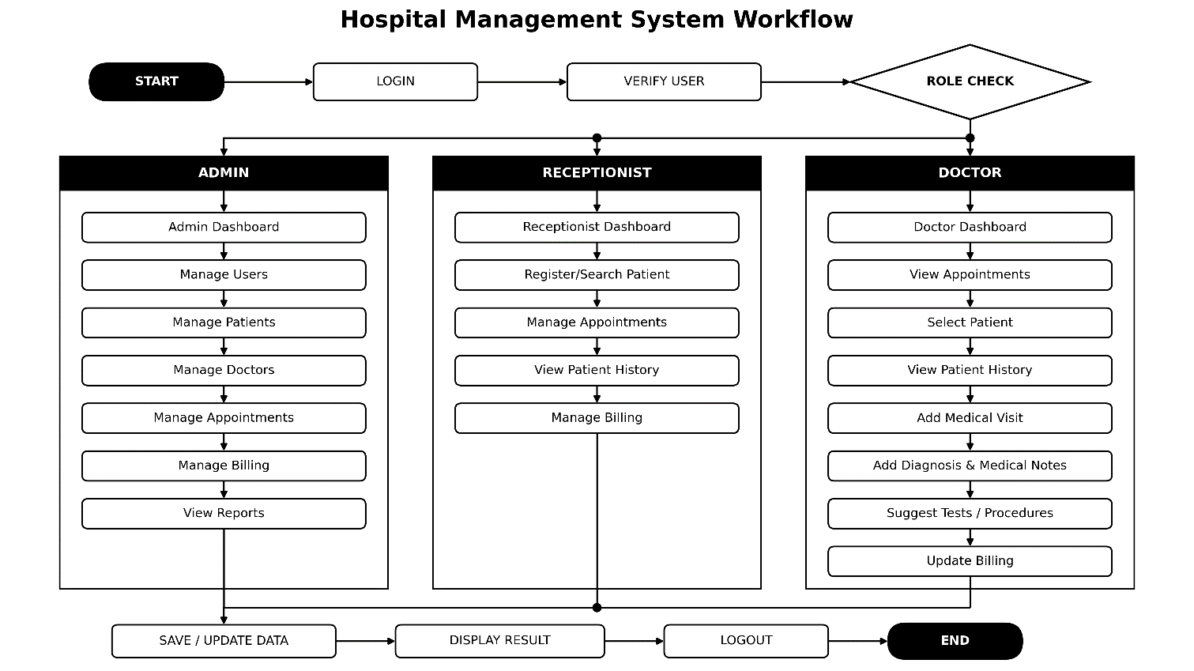

Chapter4: IMPLEMENTATION

4.1 Software and Hardware Requirements
The Hospital Management System is a browser-based application that can be accessed through a web browser. The system requires basic hardware and software resources for development, testing, and use.
Software Requirements:
- Operating System: Windows 10/11
- Frontend: HTML, CSS, JavaScript
- Backend: C++
- Data Storage: TXT files
- Web Browser: Google Chrome, Microsoft Edge, or Mozilla Firefox
- Code Editor/IDE: Visual Studio Code
- Compiler: MinGW / appropriate C++ compiler
- Version Control: Git

Hardware Requirements:
- Processor: Intel Core i3 or equivalent
- RAM: Minimum 4 GB
- Storage: Minimum 10 GB free space
- Display: Standard monitor
- Keyboard and Mouse
- Local network or internet connection, depending on the deployment setup

4.1.1 Language Used
The Hospital Management System is developed as a browser-based application using HTML, CSS, JavaScript, and C++. HTML is used to create the structure of the web pages, CSS is used for styling and layout, and JavaScript is used for user interaction and client-side functionality.
C++ is used for the main system logic and to demonstrate Object-Oriented Programming concepts such as classes, objects, encapsulation, abstraction, inheritance, and polymorphism. TXT files are used to store and retrieve system data, including patient information, doctor information, appointments, medical history, and billing records.

4.2 Testing
Testing is performed to ensure that the browser-based Hospital Management System works correctly and produces the expected results. Each major module is tested separately, followed by testing the interaction between connected modules.
The main testing areas include login, patient management, doctor management, appointments, medical history, tests and procedures, billing, and report generation. The system is tested through a web browser using both valid and invalid inputs.
Testing Method:
- Enter valid and invalid inputs.
- Check whether the expected output is displayed.
- Test each module separately.
- Check whether data is correctly saved in TXT files.
- Check whether stored data can be retrieved correctly.
- Test the connection between different modules.
- Check error messages for incorrect input.
- Correct identified errors and test the system again.

CHAPTER6: CONCLUSION & FUTURE RECOMMENDATION

5.1 Programming Platform (Tools & Technologies)
The backend logic of the Hospital Management System is implemented in **C++** using Object-Oriented Programming principles. The system uses flat **TXT files** for persistent data storage and retrieval. The frontend interface is designed using **HTML, CSS, and JavaScript** to provide a browser-based user experience. Communication between the web frontend and C++ backend functions is maintained through local server handling/CGI scripts.

5.2 Operating Environment (Minimum Requirements)
Hardware Requirements:
- Processor: Intel Core i3 (or equivalent)
- RAM: 4 GB minimum
- Disk Space: 500 MB available storage for TXT record files
Software Requirements:
- Operating System: Windows 10/11 or Linux
- Compiler: GCC / MinGW (C++11 or higher support)
- Web Browser: Google Chrome, Mozilla Firefox, or Microsoft Edge

5.3 Testing and Debugging (Test Cases)
During development, various testing methodologies—including unit testing and system integration testing—were executed:
- User Authentication: Verified role-based login credentials for Admin, Receptionist, and Doctor roles.
- File Handling: Tested data persistence to ensure patient records, appointments, and billing data accurately append and read from `.txt` files without corruption.
- Input Validation: Tested system behavior with invalid or incomplete user inputs (e.g., incorrect date formats or invalid IDs) to ensure proper error messages appear.
- Module Integration: Debugged interface-to-backend communication errors when connecting medical visits, tests, procedures, and generated bills.

5.4 Implementation and Result Analysis
The implemented system successfully organizes core hospital activities:
Patient & Doctor Management: Allows creation and updating of patient profiles and doctor schedules.
- Appointments & Medical History: Tracks medical visits, associated test records, and procedures.
- Billing & Reports: Automatically calculates visit charges and generates basic analytical reports for administrators.
- Result Analysis: The system operates efficiently under low resource overhead due to lightweight C++ file processing, providing a responsive experience in the browser interface for basic academic demonstration.

CHAPTER 6: CONCLUSION AND FUTURE ENHANCEMENT

6.1 Conclusion
The Hospital Management System was successfully developed as a functional, browser-based application demonstrating the practical application of C++ and Object-Oriented Programming concepts (classes, encapsulation, inheritance, and polymorphism). By integrating frontend web technologies with a C++ backend and flat-file data storage, the application demonstrates a streamlined approach to managing patient records, appointments, medical history, and billing within an academic scope.

6.2 Limitations
- Data Storage: Uses simple `.txt` files instead of a relational database management system (RDBMS), making it unsuitable for concurrent high-volume transactions.
- Security & Authentication: Lacks advanced encryption and token-based security protocols for sensitive healthcare data.
- Scope Constraints: Does not include modules for pharmacy/inventory management, laboratory systems, insurance processing, or AI-assisted diagnostic tools.
- Integration: Operates strictly as a standalone application without external hospital API or hardware device integration.

6.3 Future Enhancement
- Database Migration: Replace flat `.txt` file storage with an SQL database (such as MySQL or PostgreSQL) for improved concurrency, security, and query efficiency.
- Enhanced Features: Incorporate pharmacy inventory tracking, laboratory management modules, online appointment scheduling, and digital payment gateways.
- Notifications & Cloud Services: Add automated SMS/email appointment alerts and deploy the system on cloud infrastructure for cross-platform and mobile device accessibility.

REFERENCES
Books and Online Documentation
- Stroustrup, B. The C++ Programming Language. Addison-Wesley.
- Deitel, P. and Deitel, H. C++ How to Program. Pearson.
- MDN Web Docs. HTML, CSS, and JavaScript Documentation.
- W3Schools. HTML, CSS, and JavaScript Tutorials.
YouTube Resources
- YouTube tutorials and educational videos related to C++, Object-Oriented Programming, HTML, CSS, JavaScript, and web application development were referred to during the development of the project.
- Various programming and web-development YouTube channels were used for learning concepts, implementation techniques, debugging, and project development.
AI-Assisted Development Tools
- OpenAI. ChatGPT. Used for understanding programming concepts, generating ideas, debugging assistance, documentation, and project guidance.
- Anthropic. Claude. Used for programming assistance, code suggestions, debugging, and project development guidance.
- Google. Gemini. Used for programming assistance, research support, ideas, and project development guidance.

