Inforce Premium Sales feed

Contents

DataStage Job 2

Sequence Job Variable 4

Query for Report Date 5

Change Ticket 10

Table and Store Proc 10

Queries 11

Control-M 11

# DataStage Job

seqSourceToMartInforcePremiumDetailSalesWithStoreProc

pjSourceToMartInforcePremiumDetailSalesWithStoreProc

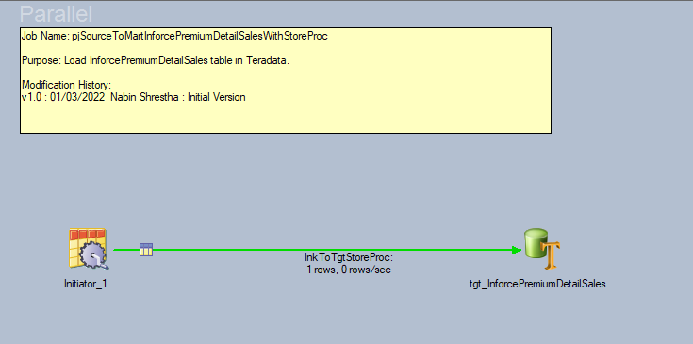

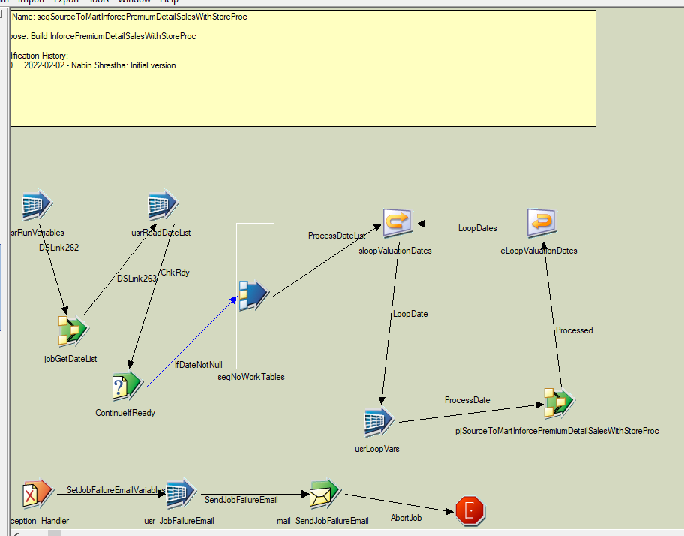

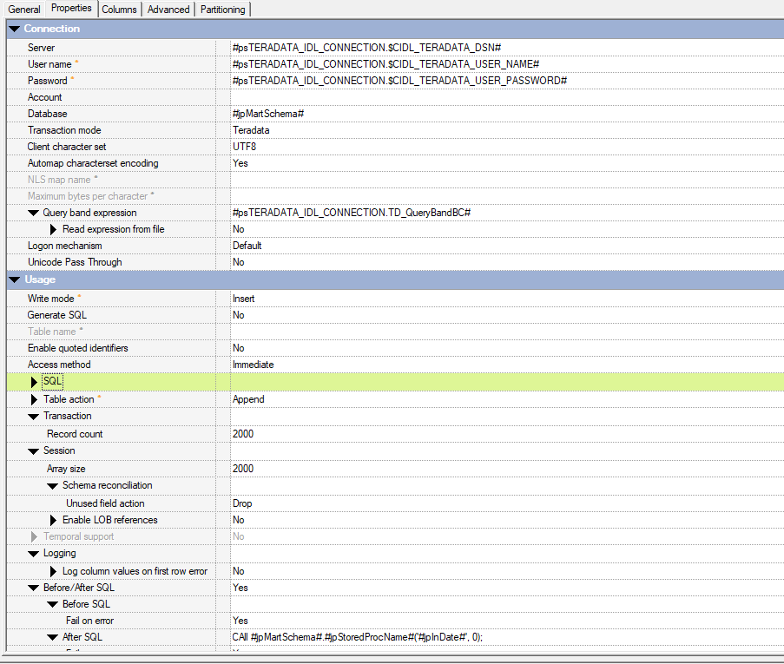

# Sequence Job Variable

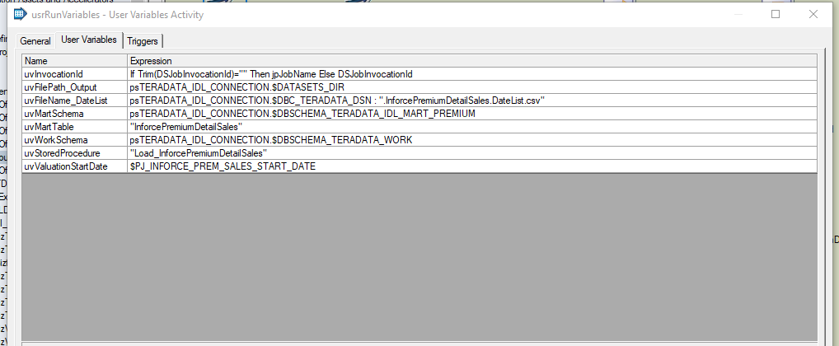

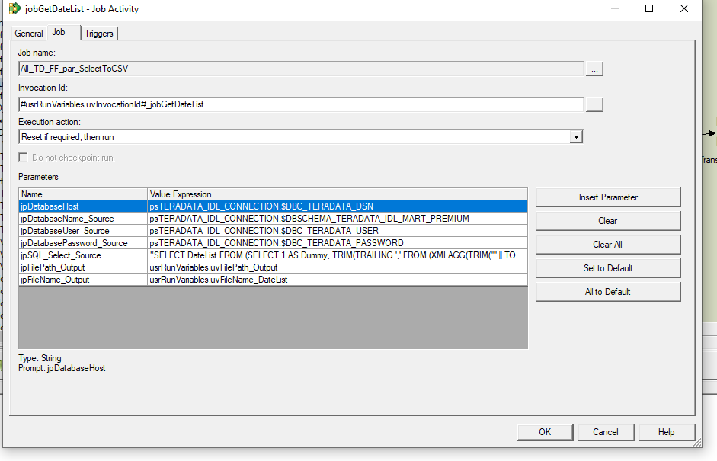

# Query for Report Date

"SELECT DateList FROM (SELECT 1 AS Dummy, TRIM(TRAILING ',' FROM (XMLAGG(TRIM('''' || TO_CHAR(CalendarDate,'YYYY-MM-DD') || '''') ORDER BY CalendarDate) (LONG VARCHAR))) AS DateList FROM (select * from (select calendar_date as CalendarDate, ADD_MONTHS((CalendarDate-EXTRACT(DAY FROM CalendarDate)+1),1)-1 AS EOM_Date from Sys_Calendar.Calendar) x where x.CalendarDate = x.EOM_Date) y Where y.CalendarDate BETWEEN (SELECT COALESCE(TD_MONTH_END(ADD_MONTHS(MAX(RPT_DATE),1)), DATE '" : usrRunVariables.uvValuationStartDate : "') FROM " : usrRunVariables.uvMartSchema :".": usrRunVariables.uvMartTable : ") AND (SELECT TD_MONTH_END(ADD_MONTHS(CURRENT_DATE, -1))) GROUP BY Dummy) AS r"

Motified:

"SELECT DateList FROM (SELECT 1 AS Dummy, TRIM(TRAILING ',' FROM (XMLAGG(TRIM('''' || TO_CHAR(CalendarDate,'YYYY-MM-DD') || '''') ORDER BY CalendarDate) (LONG VARCHAR))) AS DateList FROM (select * from (select calendar_date as CalendarDate, (CalendarDate-EXTRACT(DAY FROM CalendarDate)+1) AS EOM_Date from Sys_Calendar.Calendar) x where x.CalendarDate = x.EOM_Date) y Where y.CalendarDate BETWEEN (SELECT COALESCE(TD_MONTH_END(ADD_MONTHS(MAX(RPT_DATE),1)), DATE '" : usrRunVariables.uvValuationStartDate : "') FROM " : usrRunVariables.uvMartSchema :".": usrRunVariables.uvMartTable : ") AND (SELECT TD_MONTH_END(ADD_MONTHS(CURRENT_DATE, -1))) GROUP BY Dummy) AS r"

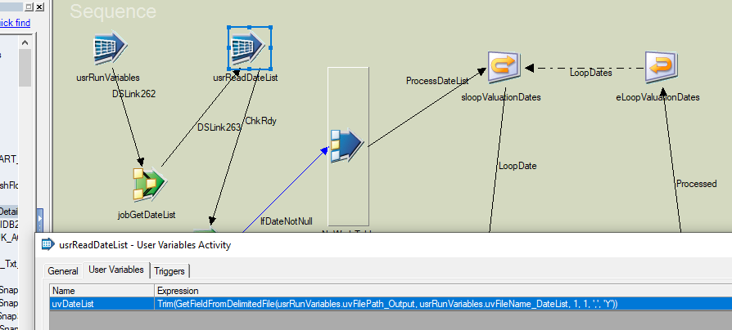

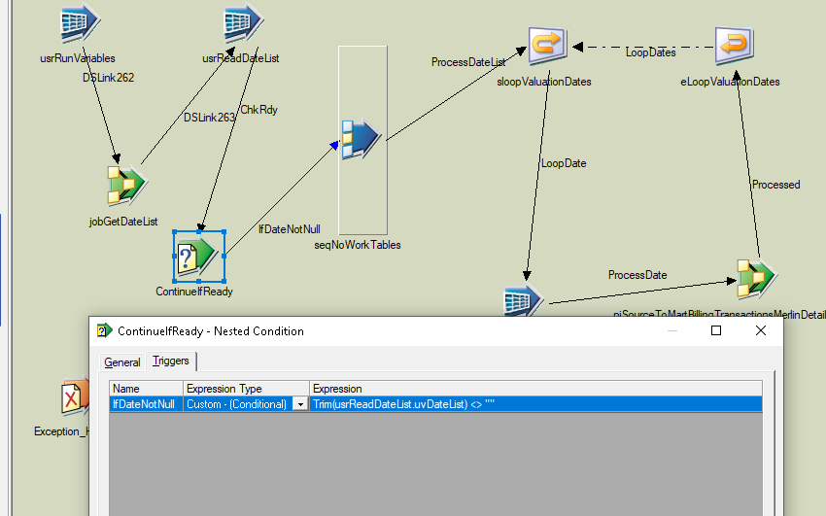

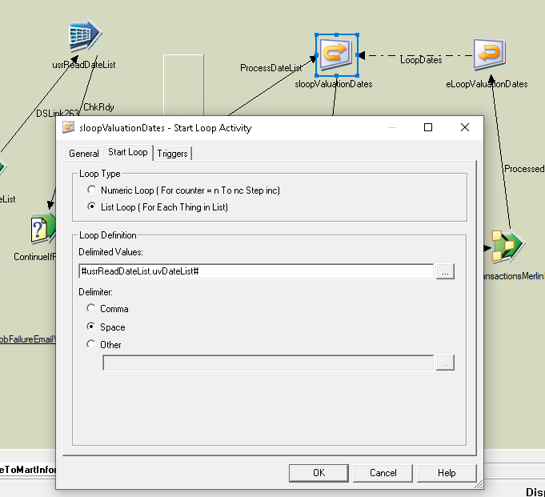

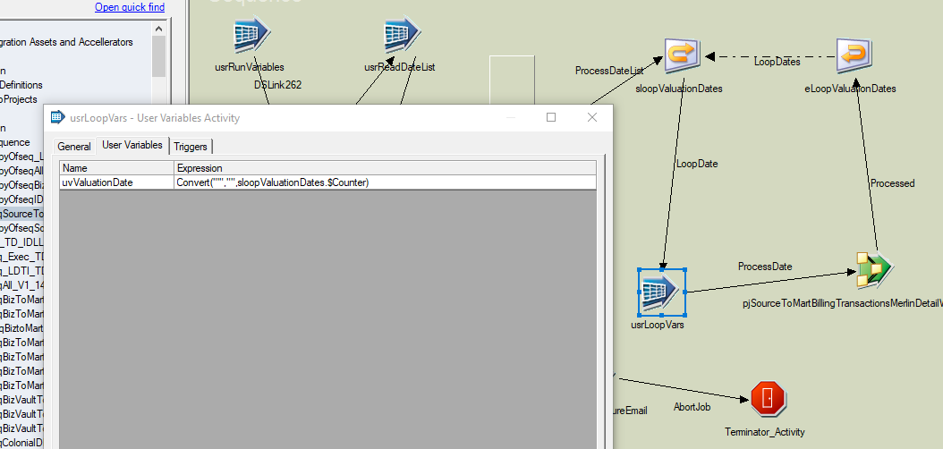

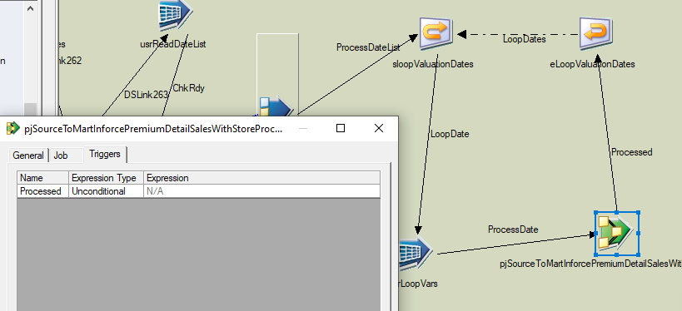

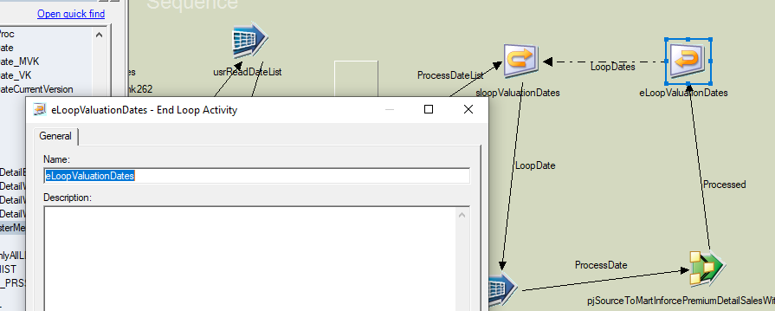

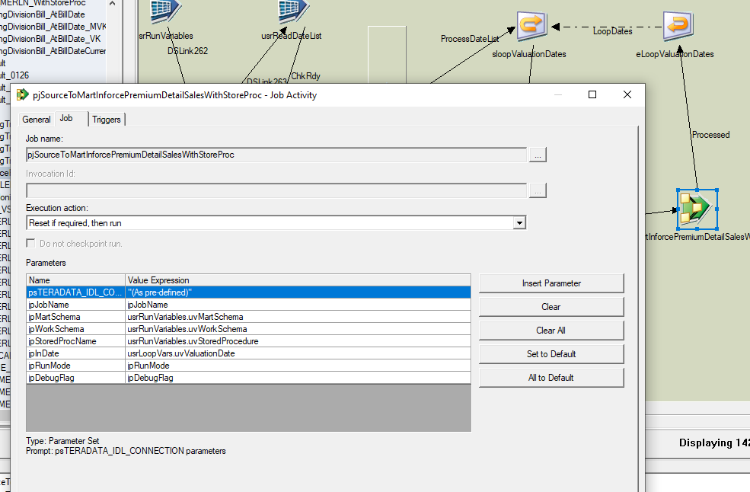

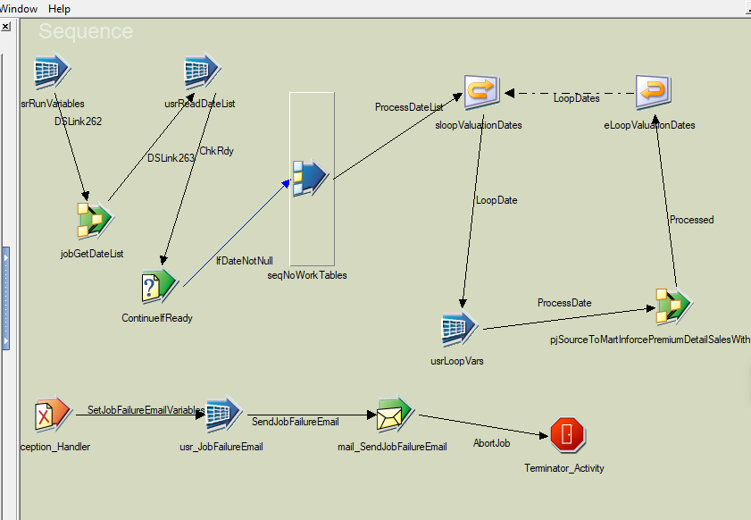

# Change Ticket

[RLSE0019294](https://unumprod.service-now.com/rm_release.do?sys_id=6aec4b1b1b9101100187ea8a234bcb4d&sysparm_record_target=rm_release&sysparm_record_row=18&sysparm_record_rows=18&sysparm_record_list=sys_class_name%3Drm_release%5Eassigned_toDYNAMIC90d1921e5f510100a9ad2572f2b477fe%5EORDERBYnumber)

[CHG0160984](https://unumprod.service-now.com/change_request.do?sys_id=a6f2f0331b59c9100187ea8a234bcb2a&sysparm_record_target=change_request&sysparm_record_row=1&sysparm_record_rows=3&sysparm_record_list=parent%3D6aec4b1b1b9101100187ea8a234bcb4d%5EORDERBYDESCend_date)

[CHG0160983](https://unumprod.service-now.com/change_request.do?sys_id=0defecbb1b95c9100187ea8a234bcb51&sysparm_record_target=change_request&sysparm_record_row=2&sysparm_record_rows=3&sysparm_record_list=parent%3D6aec4b1b1b9101100187ea8a234bcb4d%5EORDERBYDESCend_date)

[CHG0160858](https://unumprod.service-now.com/change_request.do?sys_id=398d871f1b9101100187ea8a234bcb9d&sysparm_record_target=change_request&sysparm_record_row=3&sysparm_record_rows=3&sysparm_record_list=parent%3D6aec4b1b1b9101100187ea8a234bcb4d%5EORDERBYDESCend_date)

# Table and Store Proc

IDLPremiumMart_PDBO.Load_InforcePremiumDetailSales

IDLPremiumMart_PDBO.InforcePremiumDetailSales

PRODWRK.PREM_JRNY_TABLE_INSERT_EOR

PRODWRK.PREM_JRNY_INSERT_TABLE_CONTROL

# Queries

See in folder.

[Corporate Applications - Inforce Prem Sales - All Documents (sharepoint.com)](https://unum.sharepoint.com/sites/CDI/CorpApp/Shared%20Documents/Forms/AllItems.aspx?e=5%3Ad55be47160984157aac0892ca4dcbb1f&at=9&FolderCTID=0x01200058FC027002E6A6408886BEA44BB92DCC&id=%2Fsites%2FCDI%2FCorpApp%2FShared%20Documents%2FTeam%20Knowledge%20Development%2FPremium%20Mart%20%2D%20Merlin%2FNabin%20KT%2FInforce%20Prem%20Sales&viewid=29019879%2D4ed1%2D4f86%2Db364%2Dbc42548677bf)

# Control-M

Link: <https://caexvp0548.upc:8446/ControlM/#Planning>

[RITM0581203](https://unumprod.service-now.com/it?sys_id=0db235231be181508a9bca6a234bcb02&view=sp&id=standard_ticket&table=sc_req_item)

Added a scheduling record DSCD0420P to run LWD OF MONTH AFTER DW525

