**Lab sheet 1**

**HTML**

1. Design a webpage by writing “This is my First web page” with proper HTML Structure.
2. Design a webpage showing the use of heading tag(<h1> to <h6>) with background color “blue” and text color “red”.
3. Design a webpage showing the use of <font> tag by using the attributes size and color.
4. Design a webpage with three paragraphs with left, right and center alignment respectively. The color of first, second and third paragraph should be different as your wish. Also draw horizontal line between each paragraph.
5. Design a webpage showing the use of Text formatting tags.
6. Try to make this design using Heading and text formatting with proper attributes:

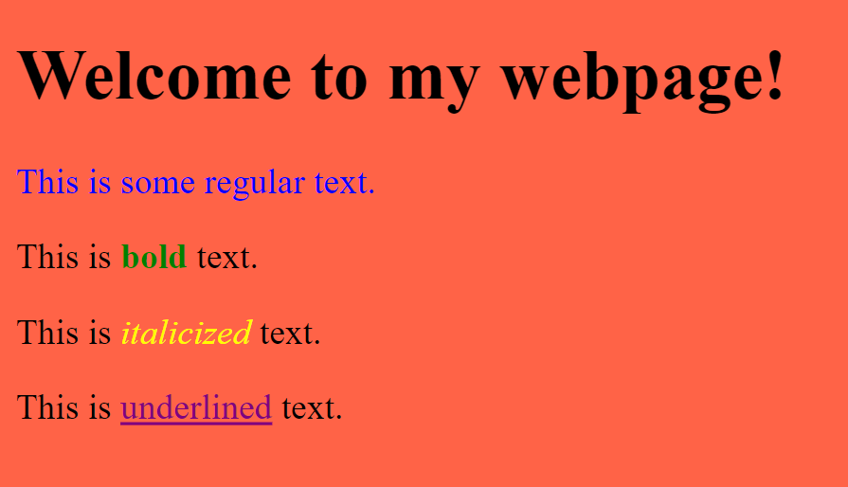

1. Create two hyperlink using <a> tag like below and also *tells the browser to open the link in a new window or tab.*

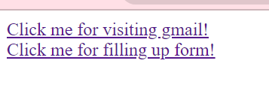

1. Display Image on a webpage using <img> tag with its proper attributes like (src, alt, height, width and title).
2. Display Favicon next to the page title in the browser tab.
3. Design a webpage using unordered list, ordered list and description list like given below:

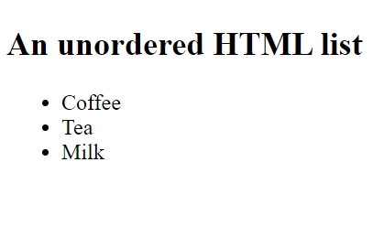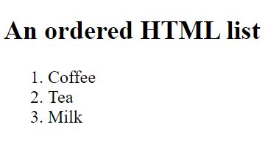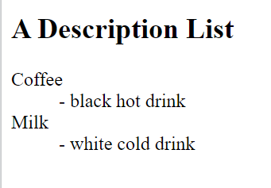

1. Design a webpage using nested list like given below:

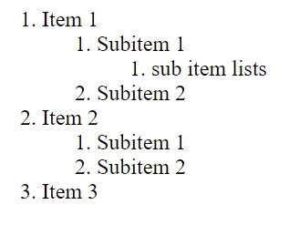

1. Design a webpage using HTML Quotation and Citation Elements like<abbr>, <address>, <bdo>, <blockquote>, <cite>, <q>.
2. Design a webpage using HTML <table> tag like below:

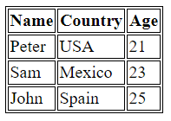

1. Design a webpage using HTML <table> tag like below:

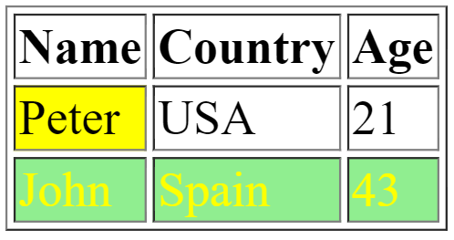

1. Merge table using rowspan and colspan attribute like below:

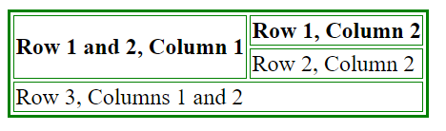

**Part 2**

1. Design a webpage using <form> tag like below:

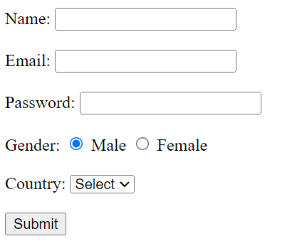

1. Design a webpage using <form> tag like below:

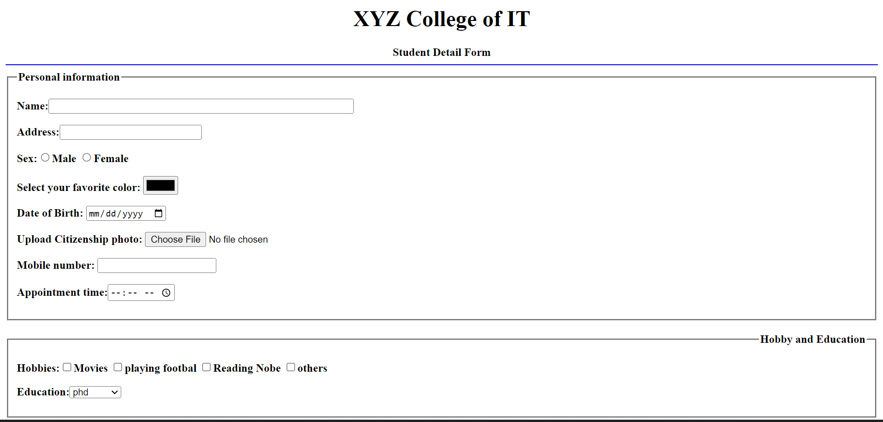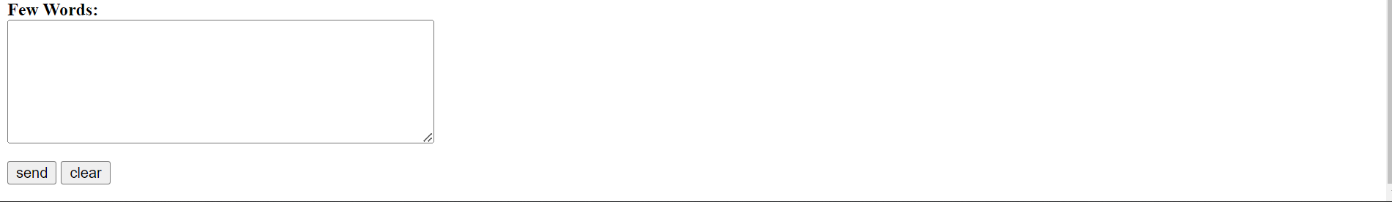

1. Design a webpage using <iframe> tag. (You can embed YouTube videos, local HTML files and websites).
2. Design a webpage using <audio> and <video> tag.
3. Design a webpage using HTML Sectioning elements. Try to make like this:

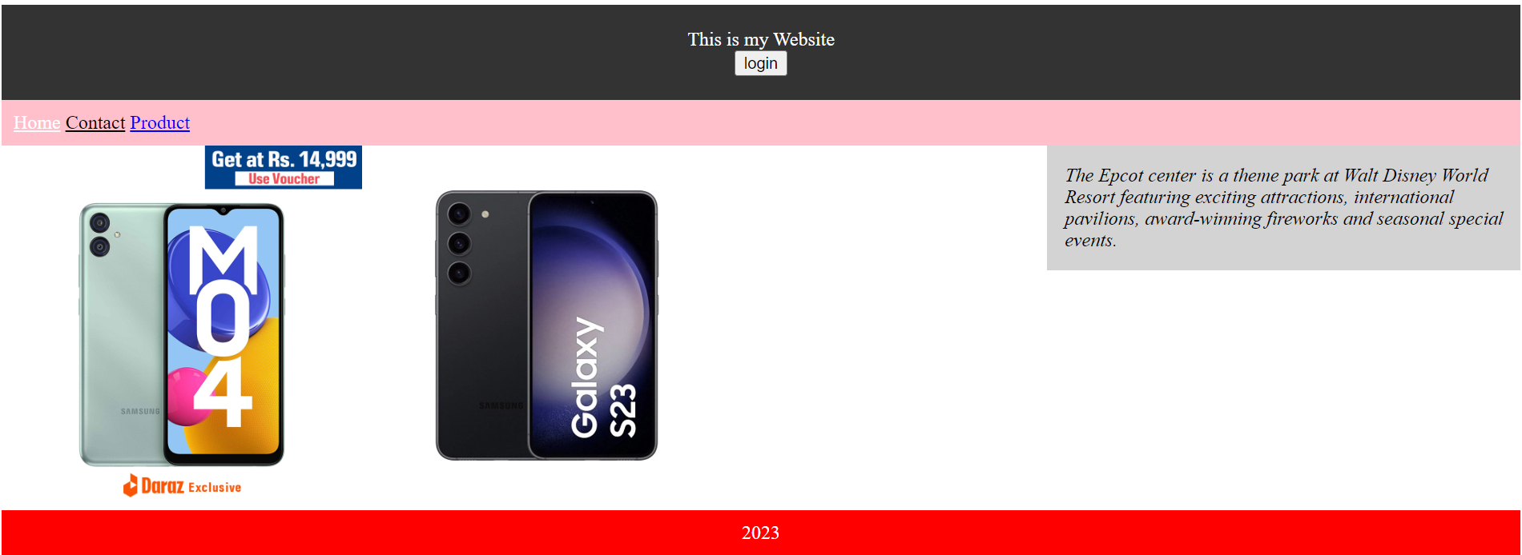

1. Use your own creativity and design a webpage using HTML sectioning elements.
2. Design a webpage using <div> tag using class attribute.
3. Design a webpage using <div> tag using id attribute.
4. Design a webpage using <div> tag using class and id attribute.
5. Design a webpage using HTML <div> tag. Try to make like this:

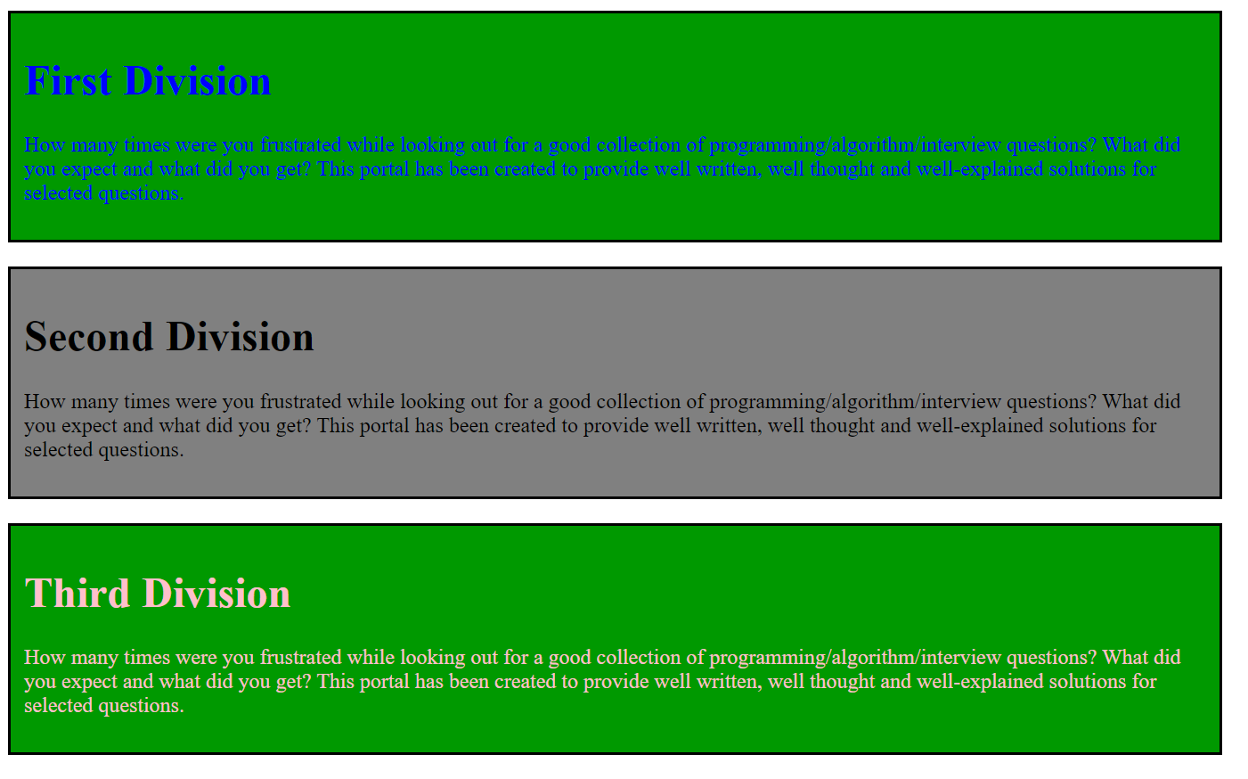

1. Design a webpage using HTML <button> tag and show the alert message when button is clicked.

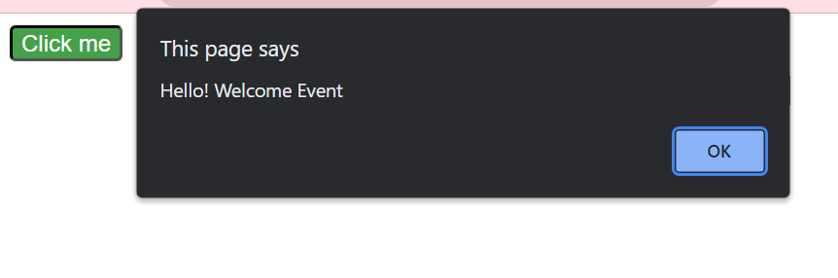

1. Design a website using <div> tag, <table> tag and using internal css.

