**Lab sheet 3**

**JavaScript**

**Part 1**

1. Write a java script program to demonstrate variable like var, let and const with different datatypes.
2. Write a java script program to demonstrate document.write() and console.log().
3. Write a program in JavaScript to print a number from 1 to 100.
4. Write a program in JavaScript to print an even number only from 1 to 100.
5. You have sequence of number from 1 to hundred but condition is that you have to print only that number which is not divisible by 5. Write a JavaScript code for it.
6. Write a program that finds sum of only even number from 1 to 200.
7. Create one paragraph and add some text on it. After this create one button, if button is clicked then the content of paragraph should be changed.
8. Create three divisions in which first division should be red, second should be blue and third should be green. After this create a button with name change. When button is clicked change the background of all division, border of division 1 should be green, border of division two should be yellow, border of 3rd division should be blue, change the radius of border for any two divisions.
9. Write a program in JavaScript to take a two number as input from user and calculate sum, difference and multiplication.
10. Write a java script program to demonstrate mouse event. You can use button, division, paragraph etc.
11. Write a java script program to demonstrate keyboard event.
12. Write a java script program to demonstrate window event.
13. Write a java script program to demonstrate different string handling function.
14. Write a java script code to demonstrate String methods like below:

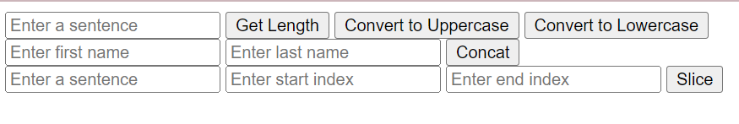

1. Write a java script code to demonstrate replace() method like below:



1. Write a java script program to declare variable as number and convert it into string. Check datatype using typeof operator.
2. Write a Java script program to take one string input from user and reverse the string.
3. Write a java script code that ask user to take two string and checks them of equality. If both strings are equal then display the first string in uppercase else print two string are not equal.
4. Provide example on all the inbuilt array handling methods.
5. Write a java script program to take size of array, value from user and display the value.

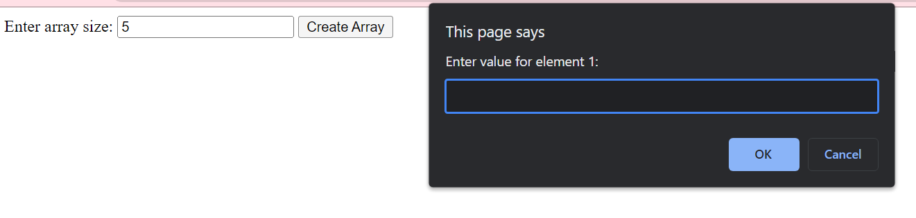

1. Write java script code to create an array that hold the name of 10 students. Convert the array into string and print that array.
2. Write a java script code to create an string which contain “name of 5 students separated with comma. Convert the string into array and display the result.
3. For the string “web programming is amazing and exciting to learn”. Find out length of string, reverse a string, search a word “exciting”, remove extra white space if present, convert the string into array and display, find the character present on position 8, extract the part of the string from position 2 to 10, replace the word programming with technology
4. For the string “Web programming is fun to learn but at the same time programming is difficult too. Web programming is core course in BIM third semester”. Find out no. of times a word programming is repeated.
5. Create an array of size 10, add some element on it of your choice. Now add any three element at last, remove one element from last, add 3 new element from first position, add 5 new element from position 6 onward, delete any 2 elements from position 2 to 4. Convert final array into string and display the result.
6. Create any two array of size 5 each and merge those arrays, extract element from position 4 to 8 of merged array, sort the merged array in ascending order.
7. Write a javascript to create an array of fruits with values apple, orange, mango. Then add three more items in the form of array using javascript function and remove two items from the back of the array. Now display the items of array in string format.