

**TRIBHUVAN UNIVERSITY**

Faculty of Management

**National College of Computer Studies**

Paknajol, Kathmandu

**Lab Assignment of Web Technology I**

**Assignment no. 1**

**Submitted To:** Ms. Sachita Maharjan

Mr. Yachu Shakya

**Submitted By:**

Name: Nabin Upreti

Programme: BIM 3rd

Sec: B

Roll no.: 10

Submission Date: 5/14/2023

**HTML web pages**

**Lab Sheet 1**

Ans. 1

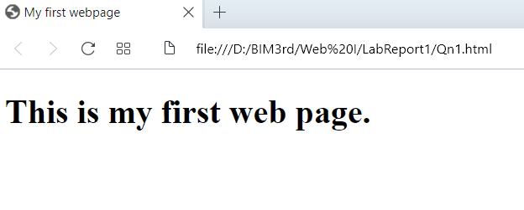

Ans. 2

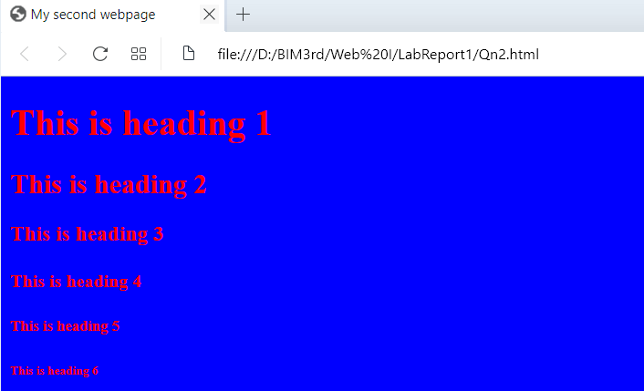

Ans. 3

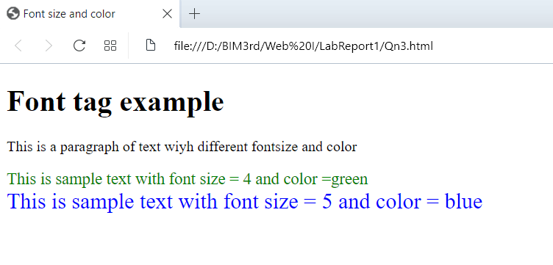

Ans. 4

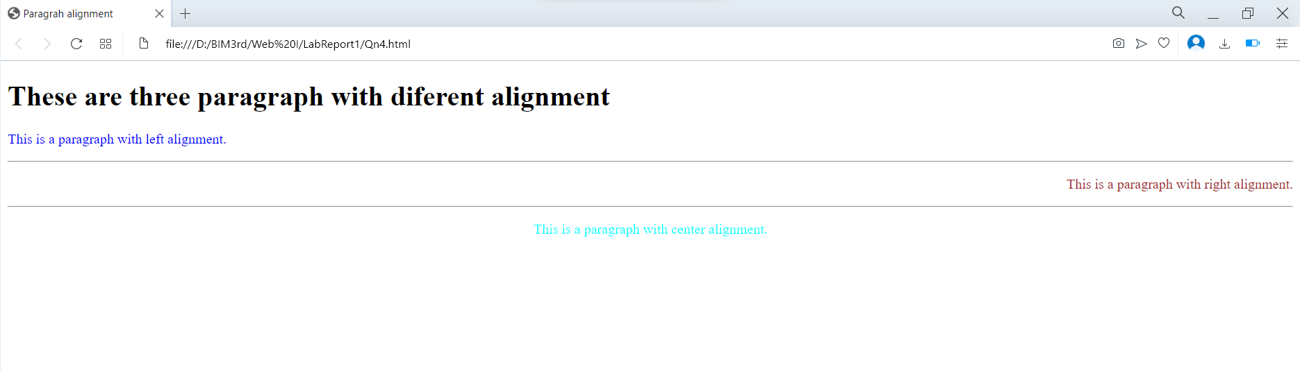

Ans. 5

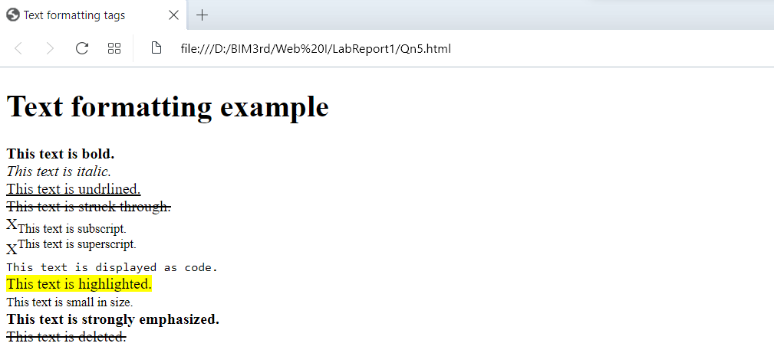

Ans. 6

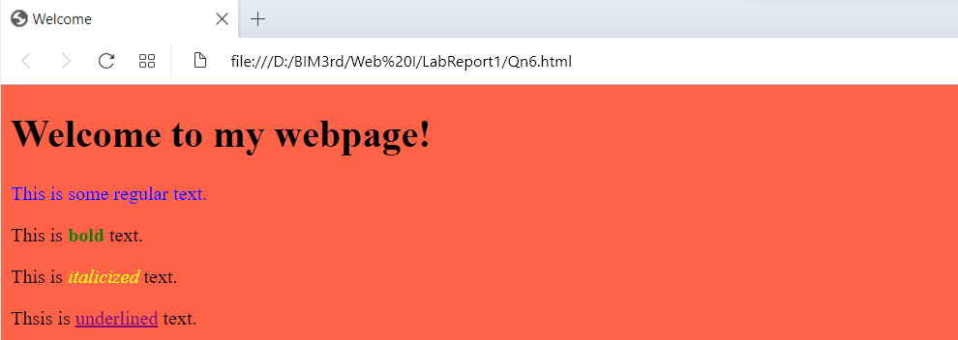

Ans. 7

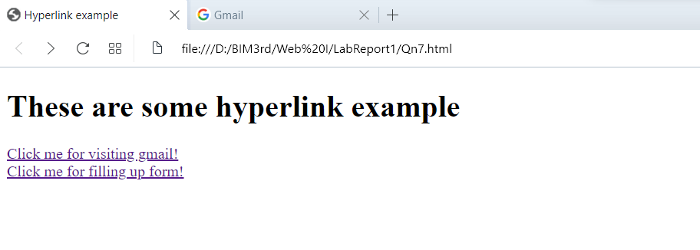

Ans. 8

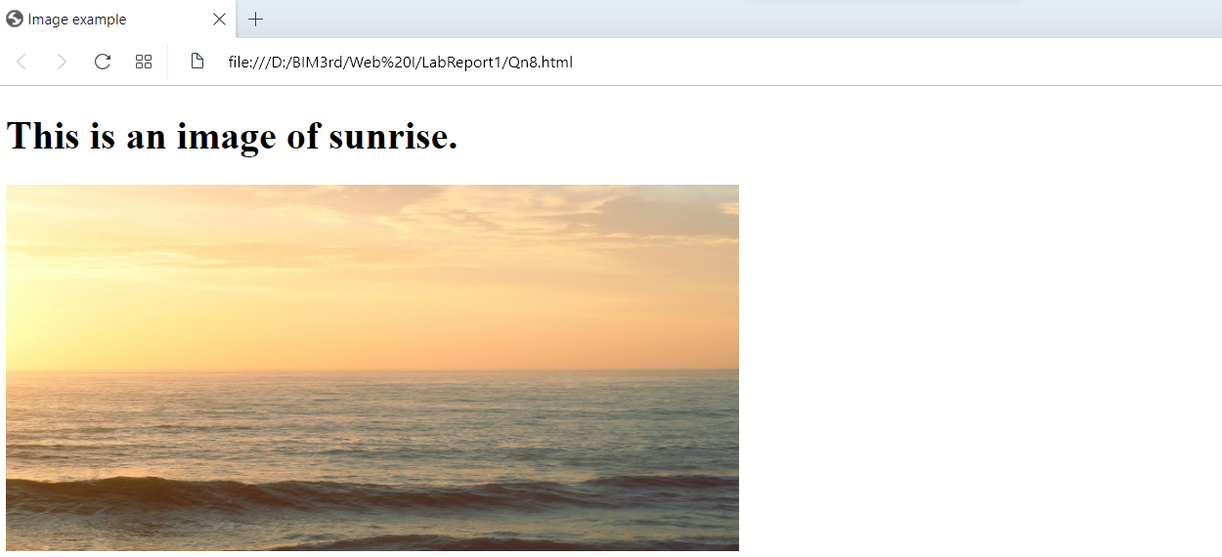

Ans. 9

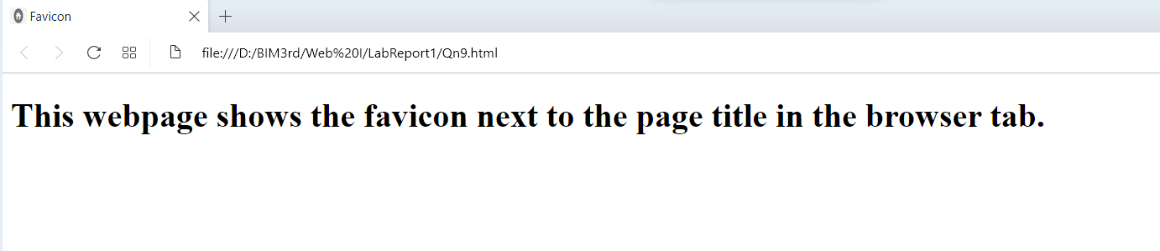

Ans. 10

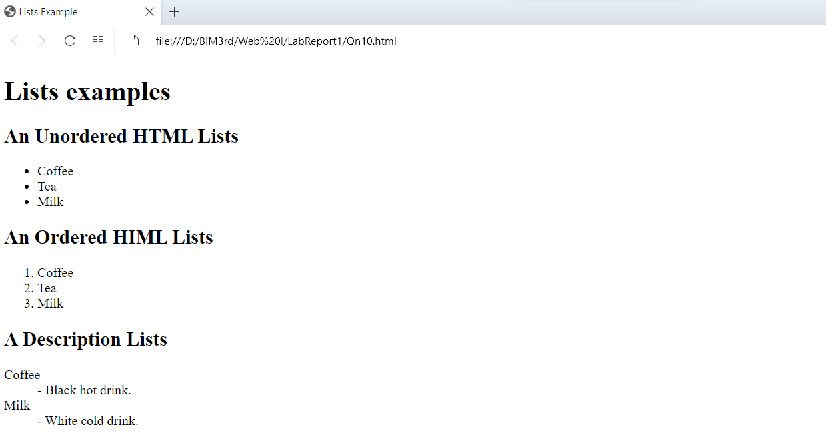

Ans. 11

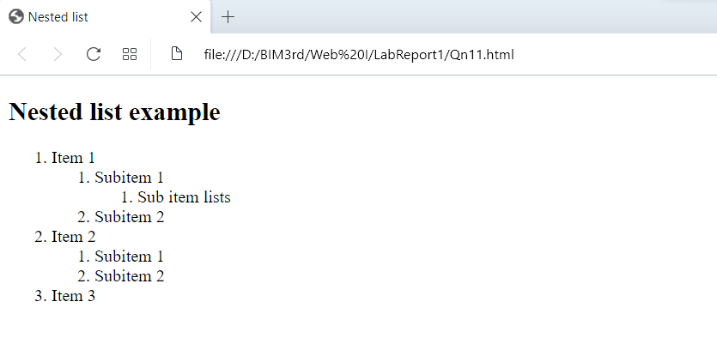

Ans. 12

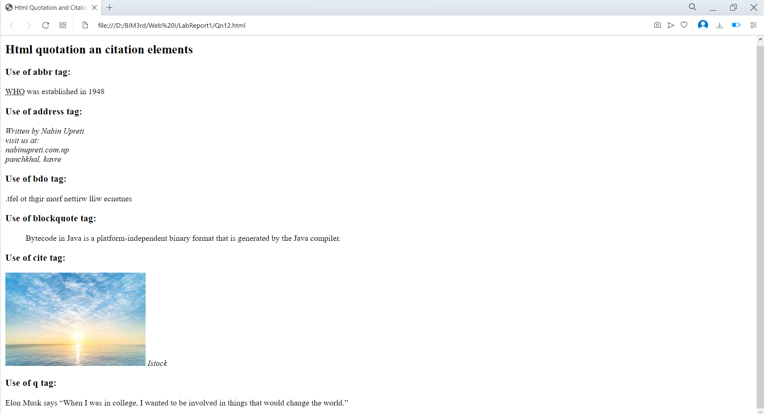

Ans. 13

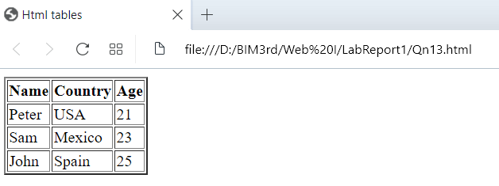

Ans. 14

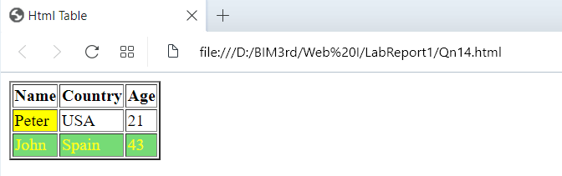

Ans. 15

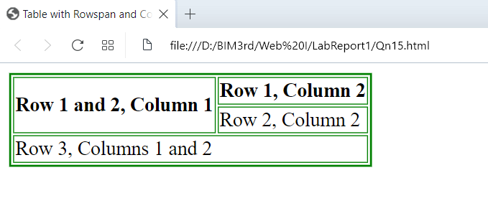

Ans. 16

